# **Checks for Understanding**

## **About: Check for Understanding**

**Use this table to answer the following questions:**

**✓ = Required training**

### **Question 1**

**If you plan to use CASAS eTests, you are required to complete which two training modules…**

Please choose two answers

1. **Module 1: CASAS Implementation Basic**
2. **Module 2: CASAS eTests Implementation**
3. Module 3: Paper Test Implementation
4. Module 4: Test Results and Reports

**Feedback:** Module 1 and 2 are required for implementing CASAS eTests.

### **Question 2**

**If you *only* plan to paper test, which two training modules are *required*?**

Please choose two answers

1. **Module 1: CASAS Implementation Basic**
2. Module 2: CASAS eTests Implementation
3. **Module 3: Paper Test Implementation**
4. Module 4: Test Results and Reports

**Feedback:** Module 1 and 3 are required for paper test implementation.

### **Question 3**

**Which two training modules are recommended for instructors, counselors, career coaches, and other interested staff?**

Please choose two answers

1. **Module 1: CASAS Implementation Basic**
2. Module 2: CASAS eTests Implementation
3. Module 3: Paper Test Implementation
4. **Module 4: Test Results and Reports**

**Feedback:** Module 1 and 2 are required for implementing CASAS eTests.

## **Unit 1. Check for Understanding**

### **Question 1**

**CASAS assessments may be used with which populations?**

Select one:

1. Adult basic education
2. Adult English learners
3. Youths in high school courses or ESL classes
4. **All of the above**

### **Question 2**

**Currently CASAS assessments are only available electronically.**

Select one:

True

**False**

**Feedback:** CASAS offers the same tests in both booklet and electronic format.

### **Question 3**

***TOPSpro Enterprise* software automatically scores CASAS tests and allows users to generate reports.**

Select one:

**True**

False

## **Unit 2. Check for Understanding**

### **Question 1**

**Complete the following:**

CASAS **progress** tests (pretests and post-tests) have four principal uses:

* to identify a student’s **skill** level
* to guide **instruction**
* to **measure** learning progress
* for **accountability** reporting

### **Question 2**

**Which test delivery method requires a *Test Administration Manual* (TAM)?**

Select one:

1. Paper tests only CASAS eTests only
2. **Both paper tests and eTests**
3. A TAM is not required for paper tests or eTests.

### **Question 3**

**A Test Administration Manual (TAM) contains:**

1. **Answer** Keys
2. Score **Conversion** Charts
3. Next Assigned **Test** Charts
4. CASAS Competencies and CASAS **Content** Standards
5. Class and Student **Profiles**
6. Standardized Test **Administration** Procedures and Policies
7. Test Security **Protocols**

### **Question 4**

**CASAS eTests works with iPads and Chromebooks.**

Select one:

**True**

False

### **Question 5**

**All CASAS tests have recommended test administration times.**

* A clear understanding of the maximum testing time is essential for planning your testing schedule.

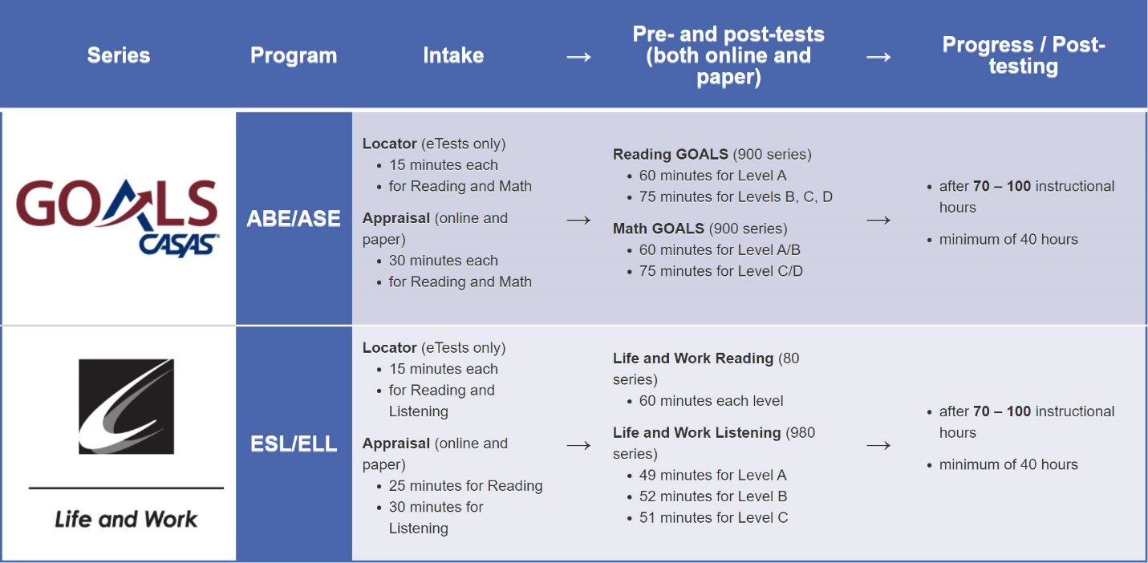

**What is the maximum time allowed at intake for an ABE student who takes the following?**

* Reading GOALS Locator + Reading GOALS, Level A

*AND*

* Math GOALS Locator + Math GOALS, Level A/B

Select one:

1. 2 hours
2. **2 1/2 hours**
3. 3 1/2 hours
4. 4 hours

## **Unit 3. Check for Understanding**

### **Question 1**

**What is the purpose of a Locator or Appraisal?**

Select one:

1. Document completion of educational functioning levels
2. Identify instructional needs
3. **Determine an appropriate pretest**
4. All of the above

### **Question 2**

**You may use a Locator or Appraisal as a Pretest.**

Select one:

True

**False**

### **Question 3**

**How is an Appraisal different from a Locator?**

Select one:

1. It has more questions and takes longer.
2. It can be used with Paper and eTests.
3. It can be used for instructional program placement.
4. It can be used to determine eligibility for job-training programs.
5. **All of the above**

### **Question 4**

**Testing new students is usually faster with eTests.**

Select one:

**True**

False

### **Question 5**

**What is the purpose of the Intake Screening?**

Select one:

1. It determines if a locator or appraisal is suitable for a student.
2. It determines which pretest to give a student with beginning level skills.
3. It can provide valuable information about a student’s speaking and writing skills and previous education.
4. **All of the above.**

### **Question 6**

**Which type of assessment presents test items widely distributed along the CASAS scale?**

Select one:

1. **Appraisal or Locator**
2. Intake Screening
3. Pretest
4. Post-test

### **Question 7**

**Which type of assessment presents test items clustered at a specific level?**

Select one:

1. Locator
2. Appraisal
3. **Progress test (Pre- and Post-tests)**
4. Intake Screening

**Question 8**

**What provides general information about what a scale score means in terms of job and life skills functioning?**

Select one:

1. Answer sheet demographics
2. Next Assigned Test report
3. **CASAS Skill Level Descriptors**
4. Scale Score Conversion charts

### **Question 9**

**Based on the Next Assigned Test chart...**

**1.** What is the scale score of a student with a raw score of 7 on the Reading GOALS Appraisal? **A scale score of 200**

**2.** What Reading GOALS level test should you give a student with a scale score of 228? **Level C**

**3.** What Reading GOALS pretest form should you administer to a student with a raw score of 11? **Form 903R**

## **Unit 4. Check for Understanding**

### **Question 1**

**What is the general term for pre- or post-tests?**

Select one:

1. Appraisals
2. Equivalency tests
3. Intake screenings
4. **Progress tests**

### **Question 2**

**You must use the same assessment series (e.g., Reading GOALS) when progress testing a student in the same test modality.**

Select one:

**True**

False

### **Question 3**

**Which assessment should you use for post-testing?**

Select one:

1. A locator or appraisal from the same series as the pretest.
2. Any CASAS series at the same level of difficulty as the pretest.
3. The same series and form number used in the pretest.
4. **The same series you used for the pretest but not the same form.**

### **Question 4**

**Select the correct term for each score description.**

**1.** **Raw score** indicates the number of correct answers.

**2.** **Asterisk score (*)** indicates a score below the accurate range.

**3.** **Scale score** indicates a score used for measuring progress.

**4.** **Diamond score (♦)** indicates a conservative estimate score (above the accurate range).

### **Question 5**

**Which of the following scores can be used for reporting purposes?**

1. Asterisk score
2. Raw score
3. **Scale score**
4. None of the above

## **Unit 5. Check for Understanding**

### **Question 1**

**Which activities are appropriate to prepare students for testing?**

(Choose 3 correct responses)

1. **Teaching using instructional material suggestions from QuickSearch**
2. Teaching to particular test items
3. Teaching only what the test covers
4. **Targeting instruction using diagnostic information from test results**
5. **Using CASAS Sample Test Items**
6. Teaching specific vocabulary in a test item

### **Question 2**

**How many hours of instruction does CASAS recommend between pre- and post-tests?**

Select one:

1. A minimum of 40 hours – if a student needs to leave the program early
2. 70 – 100 hours
3. 100 - 200 hours for students who are in class 20 or more hours/week
4. **All of the above**

### **Question 3**

**CASAS assists with curriculum support by providing...**

Select one:

1. Publications that teach basic skills to adult students
2. Free online classes in reading and math geared to adult students
3. **A searchable database of instructional resources**
4. A recommended curriculum for classes at all levels

### **Question 4**

**CASAS instructional reports identify Content Standards, Competencies and Task Areas for each test item.**

Provide the correct term for each description:

4.1 A measurable learning objective in a functional life skills context (e.g., Read an activity schedule) **Competency**

4.2 Format of the test item prompt (e.g., Read a chart) **Task Area**

4.3 Academic skill measured (e.g., Locate detail) **Content Standard**

### **Question 5**

**Select the correct term for each definition:**

A CASAS publication containing test keys and score conversion charts **Test Administration Manual (TAM)**

A free placement test offered with CASAS eTests **Locator**

A placement test for paper test users **Appraisal**

An initial test that identifies instructional needs **Pretest**

An assessment that measures learning gains **Post-test**

The number of items a student marked correctly on a CASAS assessment **Raw score**

A 3-digit number that can be used to report CASAS test results **Scale score**

Software to score and track student test scores and generate reports **TOPSpro Enterprise**

A free resource to find instructional materials **QuickSearch Online**