Module 1 is an introduction to CASAS. This is an overview of the components of the CASAS system, including how to administer and score tests and interpret results. The module covers the materials that agencies need to order to get started with CASAS.
Time / Min. | Module / Slide | Content / Notes | Talking Points
 |  | Trainer 1:  START Screen Share. | Module 1: CASAS Implementation Basics
9:50  10 min. | Slide 1  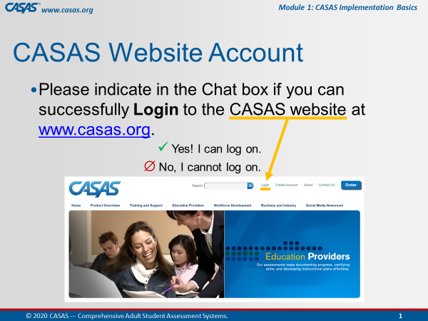 | Participant Arrivals:  Host admits participants into the web conference meeting from the waiting room.  Welcome participants as they arrive in the meeting room.  Confirm CASAS website logins. | Hi [participant name] and welcome to the training.  Please use the Chatbox to let us know if you can successfully log on to the CASAS website.  [Trainer 1: send anyone to the Tech Breakout Room (BOR) with Trainer 2 to assist with logins if needed.]
 | Slide 2  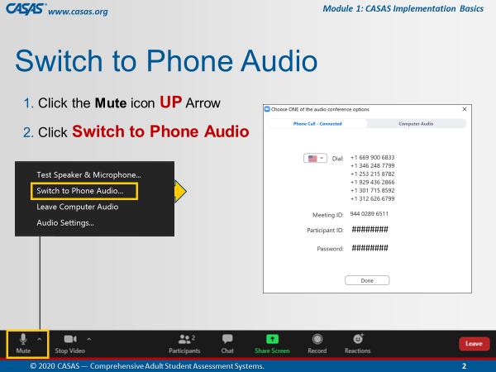 | This is an ANIMATED slide in PPT “slide show” mode.  Open Mic  Help participants switch audio if needed. | Some of you may be connected to the meeting using your computer audio. If you experience any trouble with your audio or Internet connectivity, we recommend switching to Phone Audio. To do that:  [Click 1] Click the UP arrow next to the Mute icon.  [Click 2] Select Switch to Phone Audio.  [Click 3] From the pop-up phone listing, dial a number, enter the Meeting ID and your Participant ID. You may also be prompted to enter the meeting Password.
 | Slide 3  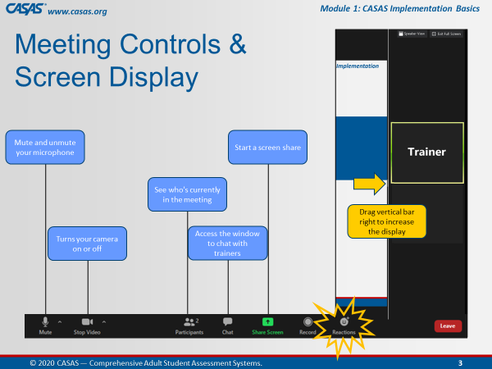 | This is an ANIMATED slide in PPT “slide show” mode.  Briefly review the web conference meeting controls. | Attendee controls appear at the bottom or top of your screen.  [Click 1] Mute/Unmute: You can mute and unmute your microphone.  [Click 2] Start Video/Stop Video: Use the video icon to turn your camera on or off.  [Click 3] Participants: See who's in the meeting with the participants icon.  [Click 4] Chat: Click the chat icon to access the window to communicate with each other.  [Click 5] Share Screen: The share screen icon lets you share your computer screen, which you will be doing in Breakout rooms.  [Click 7] Reactions: There is also a Reactions icon that you can give a clap or thumbs up at any time and we may ask you to acknowledge something during training with a thumbs up.  [Click 6] Display: And to increase the display on the left of your screen, click and drag the vertical bar on the RIGHT to minimize the video screens.
 | Slide 4  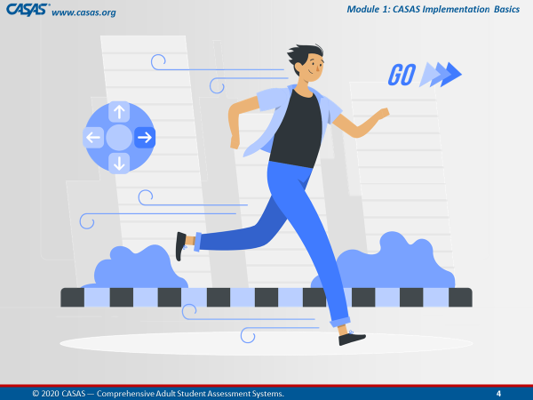 |  | We are going to get started…  Give a thumbs up from the Reactions icon if you are ready!
 |  | BEGIN TRAINING
10:00  4 min. | Slide 5  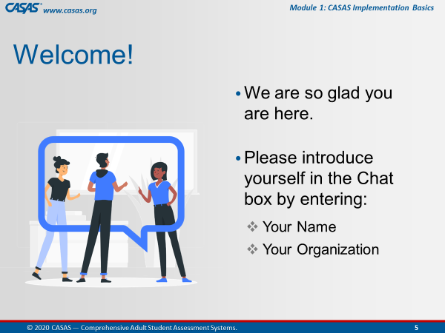 | Participant Introductions  Ask participants to introduce themselves in the Chatbox. | Hello everyone, let’s begin by introducing yourselves.  Please enter your name and [organization] in the Chatbox.  Alternates:  - Favorite hobby, color, etc.
 | Slide 6  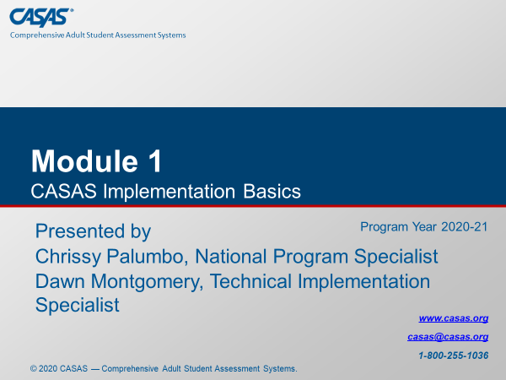 | Training Introduction | Today’s training covers Module 1: CASAS Implementation Basics.
 |  | Trainer Introduction(s)  Trainers introduce yourselves (each out loud). | Trainer 1: My name is [say your name], and I have been working in adult education for the past ## years and have [extensive] experience with [the CASAS assessment process].  Trainer 2: My name is [say your name], and I have been working in adult education for the past ## years and have [extensive] experience with [the CASAS assessment process].
 |  | Trainer 1:  Trainer 2: | STOP Screen Share.  START Screen Share.
10:04  1 min. | Slide 7  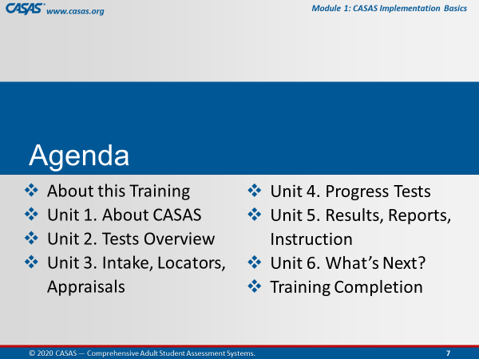 | Review meeting agenda.  - About this Training  - Unit 1. About CASAS  - Unit 2. Tests Overview  - Unit 3. Intake, Locators, Appraisals  - Unit 4. Progress Tests  - Unit 5. Results, Reports, Instruction  - Unit 6. Wrap Up  - Training Completion | Module 1 is an introduction to CASAS. It is overview of the components of the CASAS system, including how to administer and score tests and interpret results. The module covers the materials that agencies need to order to get started with CASAS.  After briefly reviewing a few more meeting controls, we will go online together and complete the About this Training content which will open the other 6 units.  [Trainer 1] and I will cover content and check your understanding of the content from each Unit…  …and then guide you through the Training Completion process to get your Certificate at the end of this training.
 | Slide 8  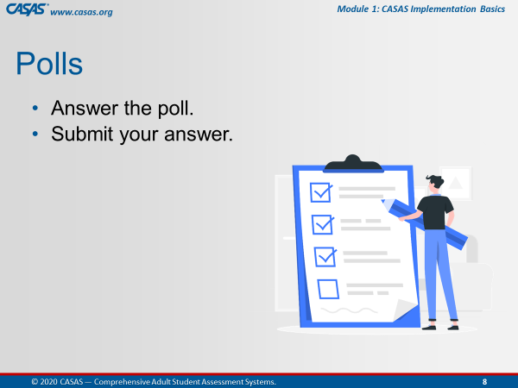 | Briefly review participating in Polls. | After we cover each unit, we will be answering checks for understanding either in the training Module, in Zoom Polls, through Chatbox responses, and together in Breakout rooms.  In Polls, you will answer the poll and then submit your answer.
 | Slide 9  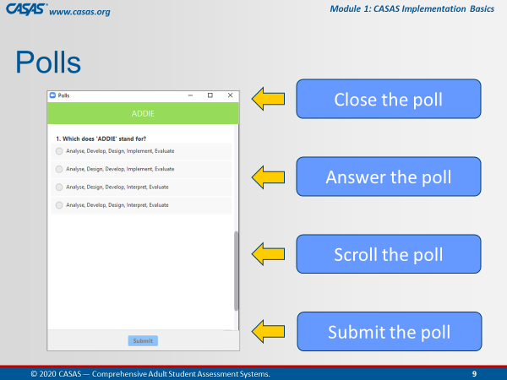 | This is an ANIMATED slide in PPT “slide show” mode.  Orient participants to polling. | This is what a Poll looks like in this web conference Meeting Room.  [Click 1] You will enter your responses directly on your screen.  [Click 2] In some polls, you will need to use the scroll bar to answer more questions in the poll.  [Click 3] Submit your answers. and then we will share your responses after closing the poll.  [Click 4] When done, you will want to close the Poll on your screen by clicking the X at the top RIGHT of the Poll window.
10:05  3 min. | Slide 10  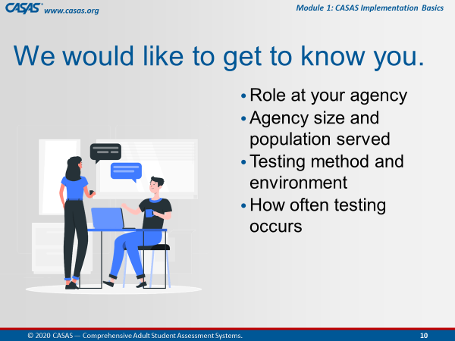 | Unit 1. Getting to Know You  Trainer: review info on slide. | Now, we would like to Get to Know You with a polling activity.  Such as your role, agency size and population, testing method and environment, and how often testing occurs.
 |  | LAUNCH POLLS:  - Respond to poll.  - Close the poll.  - Share the results. | - What is your role at your agency?  - What population does your agency serve?  - How long have you been using CASAS?
 |  | - Close the polls | Thank you for letting us get to know you!  Don’t forget to close the Poll screen.
10:08  5 min. | Slide 11  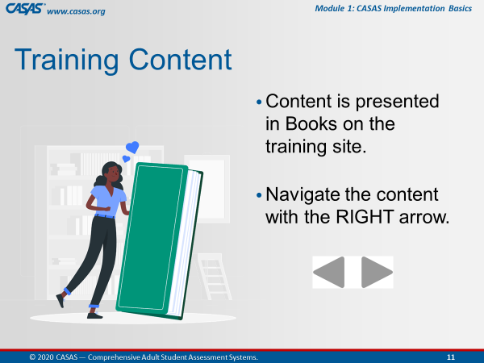 | This is an ANIMATED slide in PPT “slide show” mode. | We are going to go to the Training site together in a moment but first, I’d like to let you know what to expect.  You will see a green Book icon, which presents content in each unit.  We will review content in the first Book with you while you are in the module.  [Click 1] To navigate the pages in a book, click the RIGHT arrow at the top RIGHT or bottom RIGHT of your screen.
 | Slide 12  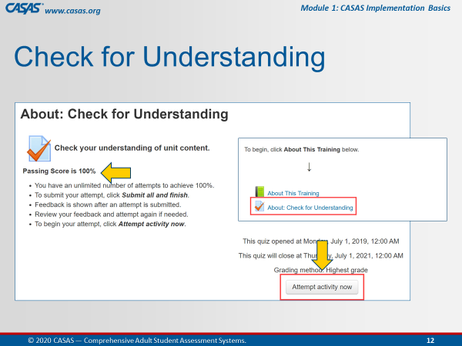 | This is an ANIMATED slide in PPT “slide show” mode. | We will be completing the first quiz together in the module so that the remainder of the module opens (Units 1 – 6) to access at different times during this training.  [Click 1] To begin the quiz, you will click the Attempt activity now button.  [Click 2] Our goal on this first quiz is to achieve 100%.  For the purpose of training together, you will get your certificate through your participation with us.  As a group, we will ensure we all get 100%.
 | Slide 13  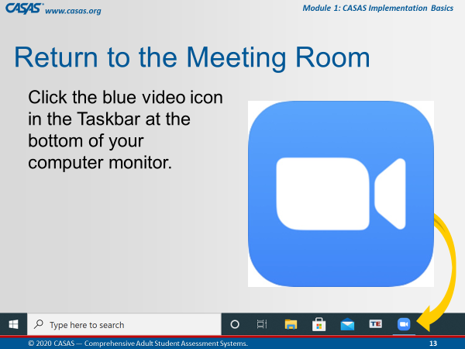 | This is an ANIMATED slide in PPT “slide show” mode.  (automated/no click).  Make sure participants know how to return to the Meeting Room. | When we are finished with the first Book and Quiz, we will ask you to return to the meeting room.  The way you will do that is click the Blue video icon at the bottom of your computer monitor.  Does everyone see this on your own computer?  Give me a “thumbs up” by clicking on the Reactions icon from your meeting controls.
 | Slide 14  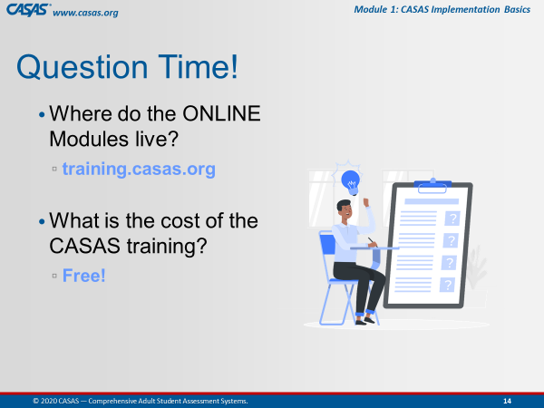 | This is an ANIMATED slide in PPT “slide show” mode. | [Click 1] Where does the ONLINE Training Modules live?  [Click 2] What is the cost of CASAS training?  [Click 3] ANSWER: Training.casas.org  [Click 4] ANSWER: Free!
 | Slide 15  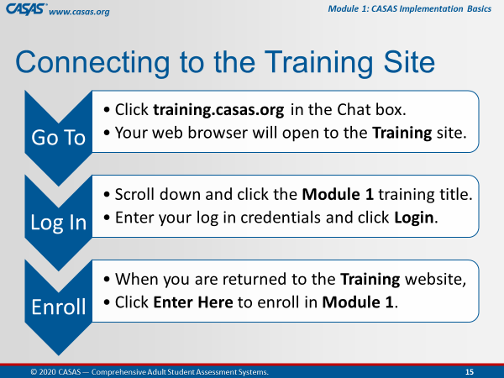 | This is an ANIMATED slide in PPT “slide show” mode. | We are about to go to the Training site together but first, I am going to describe the steps for us to get there.  [Click 1] Go To…  [Click 2] Log In…  [Click 3] Enroll…  Another purpose of this training is to help you understand the content in the online modules so you can RETURN to them to support you in your Adult Education position using CASSAS assessments.
 | Slide 16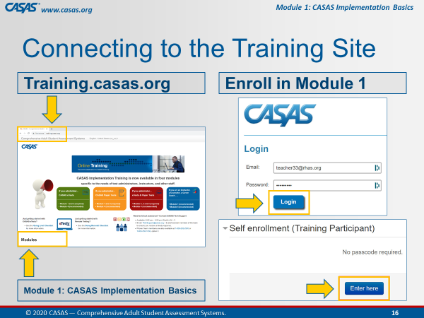 | This is an ANIMATED slide in PPT “slide show” mode. | Follow these 4 steps  Step 1. [Click 1] We will Go To the training site.  Step 2. [Click 2] And scroll down to click on Module 1.  Step 3. [Click 3] You will be automatically prompted to Log In with your CASAS website credentials.  Step 4. [Click 4] Then, you are automatically returned to the Training Site where you will click Enter here to open Module 1.
 |  | Prepare participants for logging on to the Training website.  http://training.casas.org/ | Please unmute your microphone so that we can continue to communicate when you are in your own module since the Training site will cover up the Meeting Room as soon as you click on the link that [Trainer 1] will put there  Ok, let’s go to the Training website.  [Trainer 1], please enter the training URL in the Chatbox.  Step 1. Ok Everyone, go to your Chatbox and click on the URL that [Trainer 1] just put in there.
 |  | Trainer 2:  Trainer 1: | STOP Screen Share.  START Screen Share.
10:13  5 min. | 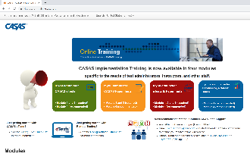 | OPEN the Training site.  Guide participants to logging on to the Training website and opening the module.  Demonstrate on your screen as you are talking the participants through each step.  Wait to proceed until everyone is looking at the module on their own screens. | Ok everyone, you should be looking at the Training website with the four colorful boxes.  Is everybody with me?  Step 2. Scroll down and click on the Module 1: CASAS Implementation Basics training title.  Step 3. Enter your CASAS website log in credentials and click Login.  Step 4. When you are returned to the Training website, click Enter Here to enroll in Module 1.
 | Module   | About This Training  Guide participants through information about the training as if they are viewing your screen. | Please click the About This Training link to open the green book, which contains the content for this part of the training.
 | 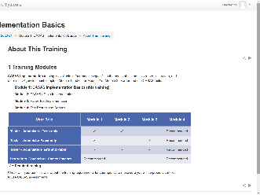 | 1 Training Modules  CFU 1, 2, 3 | The first page you should see in this book is Training Modules.  CASAS Implementation training is available in four modules specific to the needs of test administrators, instructors, and other staff.  [Q1] To use CASAS eTests, you are required to complete Modules 1 & 2.  [Q2] If you only plan to paper test, Modules 1 & 3 are required.  [Q3] Modules 1 & 4 are strongly recommended for all staff using CASAS.  How do we go to the next page?  Click the RIGHT arrow!
 | 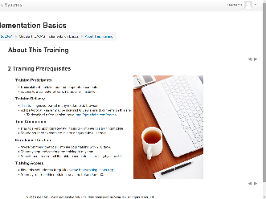 | 2 Training Prerequisites | The next page is about Training Prerequisites.  This is helpful information if you plan to complete another module on your own.  Now, click the arrow and go to the next page.
 | 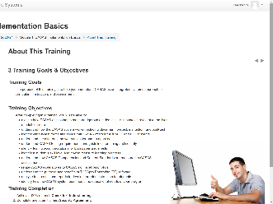 | 3 Training Goals & Objectives | You should see Training GOALS & Objectives.  This page describes the purpose of this training, which is to provide information and strategies to understand and interpret test results from CASAS assessments.  At the end of this training, we will guide you through the training completion process so that you can generate your certificate.  Let’s go to the next page.
 | 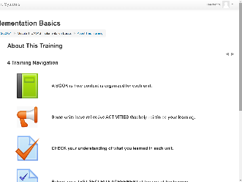 | 4 Training Navigation | You should now be on the Training Navigation page.  The navigation information will help you understand how to navigate a training module if you plan to complete a module on your own.  Since you are completing the training with us, we will guide you through this training.  What you need to know before we move on is how to return to the module HOME page from any training page when you are in the module on your own.  Look at the top of your module screen and you will see a Breadcrumb trail.  In that Breadcrumb trail is the Module Short Name, which in this case is M1 2020-21.  Let me know when you see the module Short Name in the Breadcrumb trail on your own computer screen.  Don’t click it now, but whenever you click the module Short Name from the Breadcrumb, this will return you to the module HOME page from wherever you are in the module.  So if you lose your place, just return Home and that will help you get back to where you need to be.  For now, we are going to SKIP the next three navigation pages and go to the last page in this book.  From the Table of Contents at the upper left of your screen, click Training & Technical Support.
 | 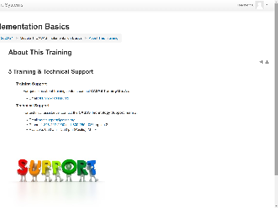 | 5 Training & Technical Support | You should be looking at the Training & Technical Support page now.  Whenever you have questions or need clarification about training content, don’t hesitate to contact training@casas.org.  And whenever you need technical assistance, you can reach out to the CASAS Technology Support Team with the contact information displayed on this page.
 |  | Guide participants back to the module HOME page. | Now we are going to leave this book.  Click the RIGHT arrow at the top RIGHT or bottom RIGHT of your screen.  This will return us to the module HOME page.
10:18  3 min. | 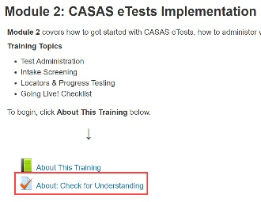 | About: Check for Understanding  MODULE – CFU Activity (3 Qs) | You should be back on the Home page and see the Module 1: CASAS Implementation Basics training title at the top.  Let me know that you are on the Home page.  Since we are in the module, we will answer Checks for Understanding for the About This Training unit.  Below the green Book icon, click on the About: Check for Understanding link.
 |  | Guide participants through completing the first quiz together. | You should see About: Check for Understanding at the top of your screen.  Click the Attempt activity now button at the bottom of your screen and let’s complete the first quiz together.
 |  | Participants must achieve 100% to unlock the rest of the module. | Now, click Submit all and finish.  Feedback at the top of the results page tells you your score.  Scroll the page to see how you did. You will see a green for correct answers. Answers that are not correct will show a red X beside them.  Click Finish Review at the bottom of the page.  If you did not get 100%, you can reattempt to correct any incorrect answers – until you get 100% correct – so please click Reattempt activity now if needed.
 | 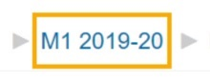 | Guide participants back to the module HOME page and proceed with the training. | When you see that you got 100%, click the module HOME link in the Breadcrumb trail at top of your screen and return to the module HOME page.  Take a look! The remainder of the module is now open for you to access at different times during this training. You should now see Units 1 – 6.  …and now that you have access to the training module, you can return to it at any time to review content through June 30, 2021.
 |  | Guide participants back to the web conference meeting room. | Ok, now let’s return to the Meeting Room.  Click the Blue video icon at the bottom of your computer monitor.
 | Slide 17  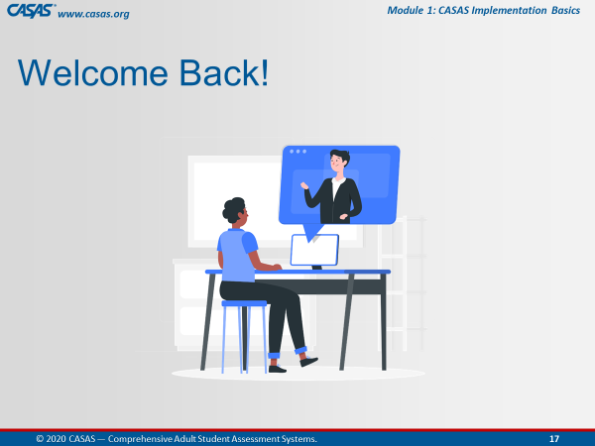 | Trainer: RETURN to PPT.  Welcome everyone back to the meeting room. | You will know when you are back in the meeting room when you see the Welcome back! slide.
10:21  3 min. | Slide 18  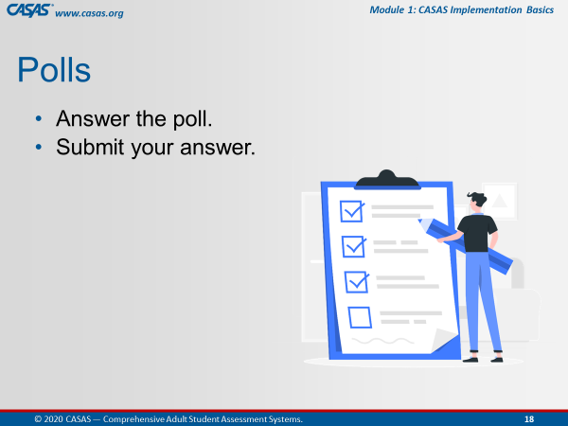 | Getting to Know You...Part 2  Trainer: review info on slide. | Now we’d like to know a little bit about testing at your organization.
 |  | LAUNCH POLLS:  - Respond to poll.  - Close the poll.  - Share the results. | - Testing method and environment.  - Do you use computer and /or paper testing?  - Where do you test?  - When does post-testing take place?  - What is the status of remote testing at your agency?
 |  | - Close the polls | Thank you for letting us get to know you!  Don’t forget to close the Poll screen.
 |  | Trainer 1:  Trainer 2: | STOP Screen Share.  START Screen Share.
10:24  5 min. | Module | Unit 1. About CASAS  Trainer 2: GO TO the Module.  Participants will view your screen. | Now, [Trainer 1] and I will continue to take you through the remaining content in this training.  Our next unit is a brief introduction to About CASAS.
 | 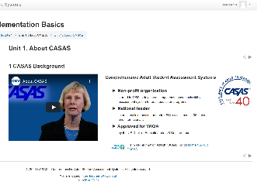 | 1 CASAS Background  CFU 1 | C-A-S-A-S stands for: Comprehensive Adult Student Assessment Systems  - CASAS is a non-profit organization that started in 1980 to develop a competency-based basic skills assessment system for adult education programs.  - [Q1] Since its inception, CASAS has become a leader in Adult Basic Education and Adult ESL assessment both nationally and internationally.  - CASAS assessments are approved for WIOA by the US Dept. of Education and US Dept. of Labor.
 | 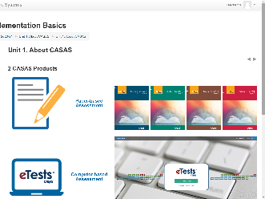 | 2 CASAS Products  CFU 2, 3 | CASAS Products are comprised of three main components:  - [Q2] Paper-based assessments  - [Q2] Computer-based assessments with the CASAS eTests application, and  - [Q3] Data Accountability Software with TOPSpro Enterprise.
 | 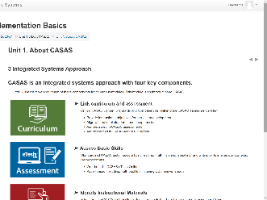 | 3 Integrated Systems Approach | CASAS is an integrated systems approach with four key components – Curriculum, Assessment, Instruction, and Accountability.  These components link curriculum and assessment, assess basic skills, identify instructional materials, and track student progress.  We will be covering these components in greater detail throughout this training.
 | 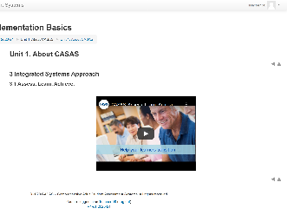 | 3.1 Assess. Learn. Achieve.  Time permitting: Play the first 59 seconds of the video. | This video – Assess. Learn. Achieve. – briefly shares how: CASAS is a quick introduction to CASAS.  [Trainer: invite participants to return to the module and view the remainder of the video.]
10:29  3 min. |  | Unit 1. Check for Understanding  MODULE – CFU Activity (3 Qs) | Since I am in the Module, I am going to display the Checks For Understanding from Unit 1 on my screen and we will go through them together.  Let’s get 100% everyone!
 |  | EXIT the CFU. | Great job everybody!
 |  | Return to the HOME page. | Now, I’m going to hand it over to [Trainer 2] to continue our training.
 |  | Trainer 2:  Trainer 1: | STOP Screen Share.  START Screen Share.
10:32  10 min. | Module | Unit 2. Tests Overview  Trainer 1: RETURN to Module.  Participants will view your screen. | Our next unit is an Overview about CASAS Tests.  This is the second unit out of 6 in this module.
 | 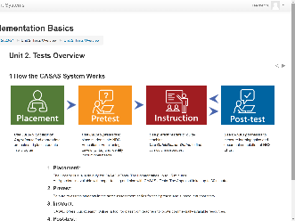 | 1 How the CASAS System Works | There are four components to How the CASAS System Works.  - You will use a Locator with eTests and an Appraisal with paper tests to initially assess a learner for Placement in an appropriate level.  - Then Pretest, and from the results,  - Provide Instruction based on the areas of need, and then  - Post-test after a period of instruction.
 | 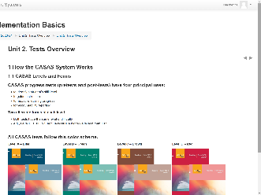 | 1.1 CASAS Levels and Forms  CFU 1 | [Q1] CASAS progress tests (pretests and post-tests) have four principal uses:  - To identify a student’s skill level  - To guide instruction  - To measure learning progress  - For accountability reporting
 | 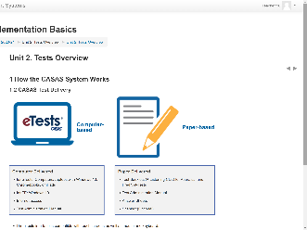 | 1.2 CASAS Test Delivery  CFU 4 | [Q4] CASAS eTests works with Chromebooks and iPads, and computers or laptops with Windows 10.  TOPSpro Enterprise is only available on Windows 10 computers  For former TABE testing sites: Scanners used with TABE 9/10 may be used to scan TOPSpro answer sheets into TOPSpro Enterprise.
 | 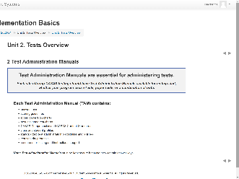 | 2 Test Administration Manuals  CFU 2, 3 | [Q2] All sites using CASAS eTests and / or Paper Tests should have a Test Administration Manual kept in a secure location.  [Q3] This is because they contain answers to CASAS test items in the form of Answer Keys.  TAMs also contain CASAS Competencies and CASAS Content Standards that apply to that test series, Standardized Test Administration Procedures and Policies, and Test Security Protocols…  Score Conversion Charts, Next Assigned Test Charts, and Class and Student Profile worksheets are included specifically for sites conducting paper testing.
 | 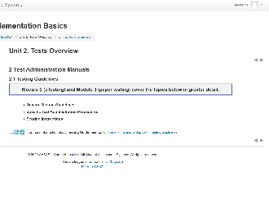 | 2.1 Testing Guidelines | Both Module 2 and Module 3 cover General Testing Guidelines, Specific Test Administration Procedures, and Scoring Instructions in greater detail.
 | 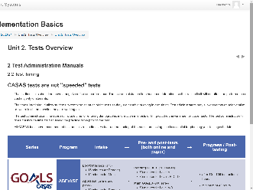 | 2.2 Test Timing  CFU 5 | About Test Timing.  All CASAS tests are timed. However, it is important to note that students should not feel as though they need to rush through the test.  They do not need to finish the test. They just need do the best they can - without guessing - in the allotted time.  Some students may not have finished when time is up. Reassure them that is OK.  Time limits should not have a negative effect on performance.  [Q5] A clear understanding of the maximum testing time is essential for planning your testing schedule.  With CASAS eTests, test timing is automatic however, it is good to know the amount of time it takes to complete pre- and post-tests.
 | 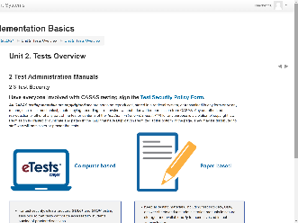 | 2.3 Test Security | Test Security is very important in order to maintain the integrity of CASAS assessments and to provide valid and reliable assessment results.  It is the responsibility of the agency and all persons involved with test administration to ensure the CASAS testing instruments and test items are kept secure.  Anyone involved with using CASAS should:  - read the Test Security Policy and  - sign the Agreement to certify that they will follow all test administration directions and  - agree to abide by all test security procedures.  CASAS eTests has built-in Test Security because:  - tests can only be administered on a computer registered for testing and  - tests cannot be administered unless a certified eTests Proctor is present to Start and Stop testing sessions.
 | 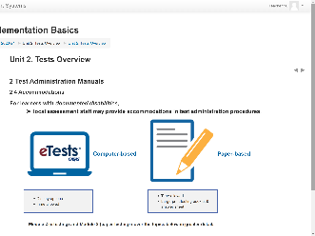 | 2.4 Accommodations | And now about Accommodations.  It is important that local assessment staff know they may provide accommodations during test administration procedures.  There is detailed information on Accommodations Guidelines posted on the CASAS website.  Both Module 2 and Module 3 cover Accommodations in greater detail.
 | 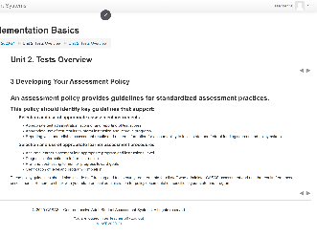 | 3 Developing Your Assessment Policy | All programs using CASAS should Develop an Assessment Policy outlining guidelines for appropriate assessment practices and procedures.  These policy guidelines should also include staff training and test security requirements for all staff who administer CASAS assessment and use the results from these assessments.  Be sure to check with your state or local administration for policy documentation specific to your state and program.  Your Local Assessment Policy should align with your State Assessment Policy.
 | 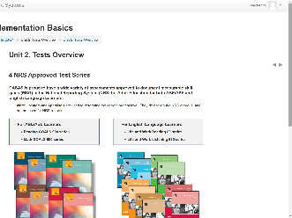 | 4 NRS Approved Test Series | The next few pages in this book cover NRS Approved Test Series.  NRS is the National Reporting System that Adult Ed programs report outcomes for Federal funding.
 | 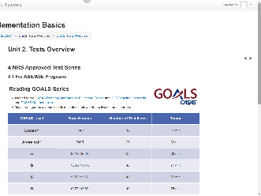 | 4.1 For ABE/ASE Programs | Here, you see that the new Reading GOALS and Math GOALS series is approved for ABE and ASE programs.  These tables identify the CASAS Level, Form Number, Number of Test Items and Timing per level.
 | 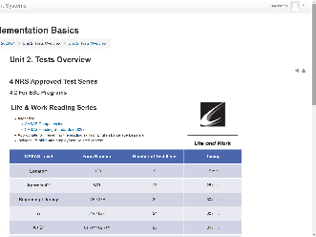 | 4.2 For ESL Programs | The next page shows the Life and Work Reading and Listening 980 series that are NRS approved for ESL programs.  Again, these tables detail the Number of Test Items and Timing per CASAS Level and Form Number.
 | Slide 19  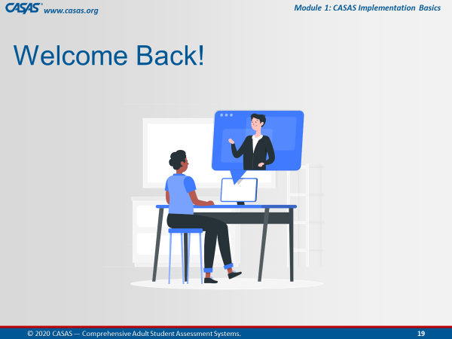 | Trainer: 1 | Return to the PPT.
10:42  5 min. | Slide 20  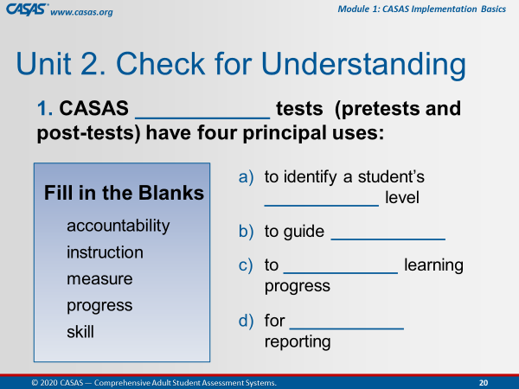 | Unit 2. Check for Understanding  This is an ANIMATED slide in PPT “slide show” mode.  CHATBOX – CFU Activity (4 Qs)  Ask participants to enter their answers in the Chatbox.  Click to reveal each answer. | - CASAS progress tests (pretests and post-tests) have four principal uses:  - to identify a student’s skill level  - to guide instruction  - to measure learning progress  - for accountability reporting
 | Slide 21  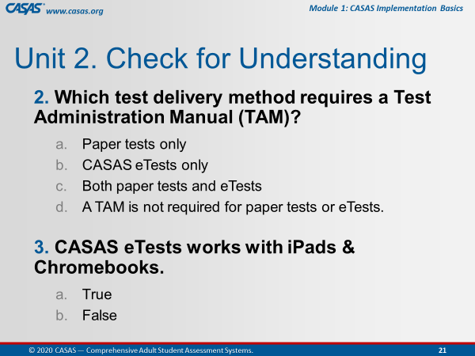 | This is an ANIMATED slide in PPT “slide show” mode.  Click to reveal each answer. | - Which test delivery method requires a Test Administration Manual (TAM)?  - Paper tests only CASAS eTests only  - Both paper tests and eTests  - A TAM is not required for paper tests or eTests.  - CASAS eTests works with iPads and Chromebooks.  - True  - False
 | Slide 22  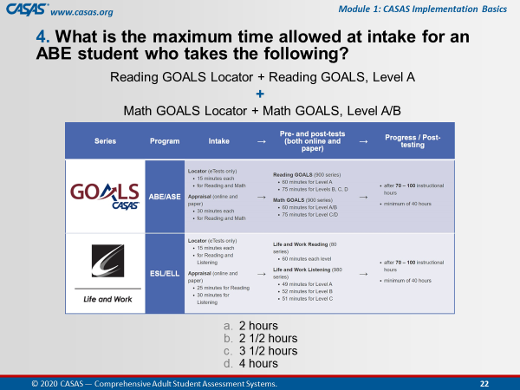 | This is an ANIMATED slide in PPT “slide show” mode.  No Chatbox, answer together out loud.  Click to reveal the answer. | - What is the maximum time allowed at intake for an ABE student who takes the following?  Reading GOALS Locator + Reading GOALS, Level A  AND  Math GOALS Locator + Math GOALS, Level A/B  - 2 hours  - 2 1/2 hours  - 3 1/2 hours  - 4 hours
 |  | Trainer 1:  Trainer 2: | STOP Screen Share.  START Screen Share.
10:47  10 min. | Module | Unit 3. Intake, Locators & Appraisals  Trainer 2: RETURN to Module.  Participants will view your screen. | Our next unit will cover Intake, Locators & Appraisals
 | 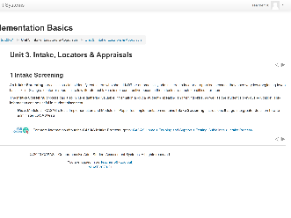 | 1 Intake Screening  CFU 5 | Module 2 - CASAS eTests Implementation and Module 3 - Paper Test Implementation will cover Intake Screening in greater detail.  What you need to know at this time is that Intake screening is crucial to identify test takers who should NOT be automatically administered a locator with eTests or an appraisal with paper tests.  Giving a locator or appraisal to all students is not constructive as these assessments are much too difficult for them.  So essentially, you are screening out students who should not take a locator or appraisal.  [Q5] Following the CASAS recommended Intake Process will help to:  - determine if a locator or appraisal is suitable for a student.  - determine which pretest to give a student with beginning level skills.  - provide valuable information about a student’s speaking and writing skills and previous education.
 | 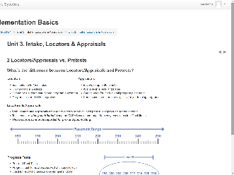 | 2 Locators/Appraisals vs. Pretests  CFU 1, 2, 3, 6, 7 | Locators and Appraisals are different assessments with different purposes and here’s why:  [Q3] They are different in the amount of time each take to administer – 15 minutes for Locators and 30 minutes for Appraisals.  [Q3] Locators are only available with eTests, while Appraisals are available with both eTests and paper.  [Q3] Locators cannot be used for instructional program placement while Appraisals can.  [Q3] Locators can only be administered together with the pretest while Appraisals can be administered independent of the pretest when determining eligibility for job training programs  While Locators and Appraisals are different, they function the same:  [Q1] Both are used to determine an appropriate level pretest.  [Q6] Both present test items widely distributed along the CASAS scale and  [Q2] Neither can be reported for pre- and post-testing, or progress testing.  [Q7] Progress Tests, pre- and post-tests, present test items clustered at a specific level and results are used for reporting measurable skill gains, or MSGs.
 | 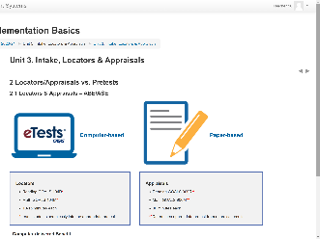 | 2.1 Locators & Appraisals – ABE/ASE  CFU 4 | Here is a side-by-side comparison for administering computer-based Locators and paper-based Appraisals for ABE/ASE programs.  Each side lists the assessment series, form numbers, and the amount of time it takes to administer each assessment.  As you can see, [Q4] Testing new students is usually faster with eTests because the locator takes less time than the appraisal. Also, the locator and pretest is combined into one test event saving time for both the student and the test administrator.  Testing students with the appraisal and then the pretest is two separate testing events. You can administer both in the same sitting or separately at different times depending on your Intake process.
 | 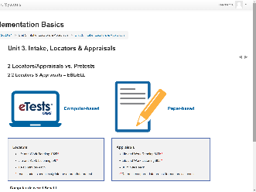 | 2.2 Locators & Appraisals – ESL/ELL  CFU 4 | Here is a similar side-by-side comparison for ESL programs.  Again, you can see that [Q4] Testing new students is usually faster with eTests.
 | 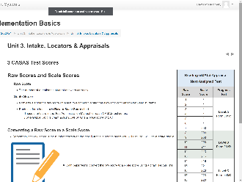 | 3 CASAS Test Scores  CFU 9 | Each test form has its own Raw to Scale Score conversion in a Next Assigned Test chart.  These charts are in the Test Administration Manual for each CASAS test series.  Here is an example from the Reading GOALS Appraisal.  The first column shows the Raw Score, which is the number of questions a student answers correctly.  The second column shows the Scale Score, which converts a student's raw score on a test to a common scale for measuring gains and for comparison between students.  eTests automatically scores each test and calculates the raw and scale score.  Here’s a Pop-Quiz for you!  [Q9] Based on this Next Assigned Test chart...  1. What is the scale score of a student with a raw score of 7 on the Reading GOALS Appraisal? A scale score of 200
 | 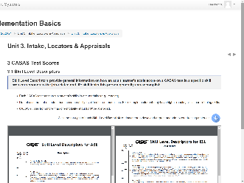 | 3.1 Skill Level Descriptors  CFU 8 | [Q8] CASAS Skill Level Descriptors provide general information about what a scale score means in terms of job and life skills functioning.  The CASAS Skill Level Descriptors show a continuum of skills from beginning through advanced adult secondary and explain in general terms what most learners can accomplish at the CASAS scale score level in a specific skill area.  Note that CASAS levels go from:  - A (lowest level) to  - E (highest level).  Each test modality (e.g., reading, listening) measures the ability of a student for the skill tested.  A student’s listening skills may not be the same as their reading skills. So the descriptors help to understand their educational functioning level.  CASAS scores from more than one modality should not be averaged.  If you are only testing reading skills, then only the reading descriptors apply. The same holds true for math and listening.  You will find more Skill Level Descriptors on the CASAS website.
 | 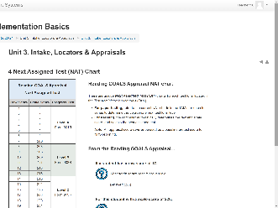 | 4 Next Assigned Test (NAT) Chart  CFU 9 | The Next‐Assigned Test CHARTS are important to use for paper testing to identify the appropriate next test form and level to administer, which is displayed in the third column.  This chart standardizes the Next Assigned Test administration for all students.  This chart is designed to take the legwork out of deciding which test to administer next to individual students.  For example:  - A student with a raw score of 17 converts to a scale score of 226.  - The pretest form he should take is LeveL C, Form 905R.  Here’s another Pop-Quiz for you!  [Q9] Based on this Next Assigned Test chart...  2. What Reading GOALS level test should you give a student with a scale score of 228? Level C  3. What Reading GOALS pretest form should you administer to a student with a raw score of 11? Form 903R  For agencies using eTests, TOPSpro Enterprise automatically assigns the next test form in each modality.  If your site is scanning paper test results into TOPSpro Enterprise, you will be able to easily generate Next‐Assigned Test REPORTs.  The reports will show which tests students should take next based on the last test a student took. This report is not necessary for those agencies that are only eTesting.
 | Slide 23  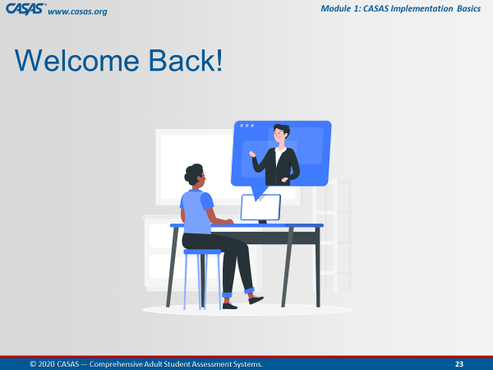 | Trainer 2: | RETURN to PPT.
10:57  10 min. | Slide 24  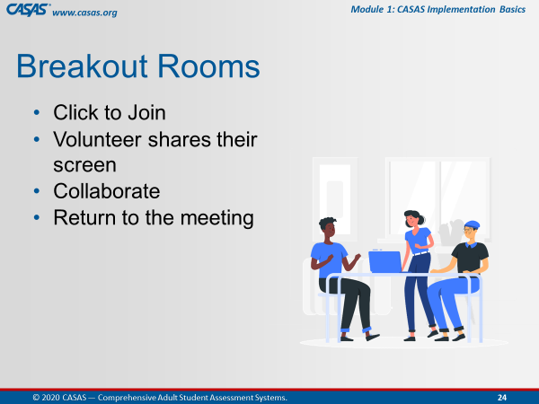 | Briefly review collaborating in Breakout Rooms. | We will be sending you to Breakout Rooms now.  A volunteer in your breakout room will share their screen so that everyone in the Breakout Room can collaborate on the checks for understanding in the unit we just covered.  When your group finishes you will return to the Meeting Room.
 | Slide 25  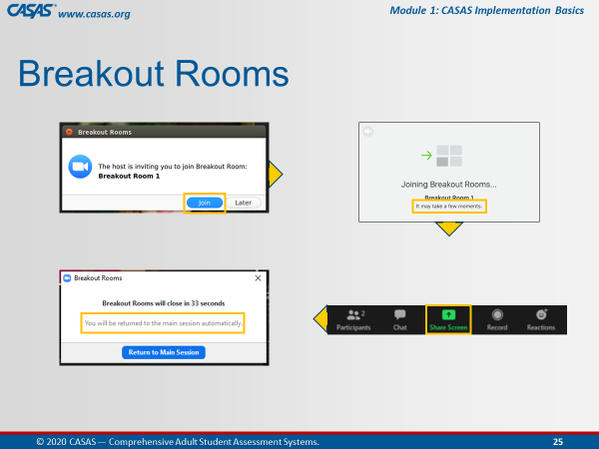 | This is an ANIMATED slide in PPT “slide show” mode. | When the pop-up appears on your screen,  [Click 1] Click Join.  Wait a few minutes…and when everyone is together in the Breakout Room,  [Click 2] Choose a volunteer who will share their screen.  [Click 3] A pop-up will appear just before you are automatically returned to the Meeting Room.  You will not need to return to the main room when you see this pop-up.  Just relax and continue your discussion until the application brings you back to the main room automatically.
 | Slide 26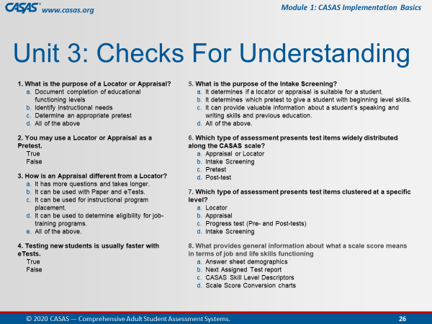 | Unit 3. Check for Understanding  BREAKOUT – CFU Activity (9 Qs)  One participant shares their screen and opens the Unit CFU.  Add Unit CFU Link and Task to Chatbox.  UNIT 3. CHECK FOR UNDERSTANDING  http://training.casas.org/mod/quiz/view.php?id=2798 | Ok, now we are going to send you to the Breakout Rooms.  [Trainer 1] will put the link to Unit 1. Check for Understanding link in the Chatbox.  When you are in the Breakout Room, the volunteer will:  - Share their screen and  - Click on the link from the Chatbox.  The checks for understanding will open automatically.  Please work together as a group to answer each question.  You will be automatically brought back to the Meeting Room when time is up.
 |  | - Send to BOR.  - Broadcast task.  - Close BOR when 1 min. remains. | Ok, click Join.  [Trainer: Broadcast task to BORs, e.g., “Please skip any questions if needed and go back to answer if time permits.”]
 | Slide 27  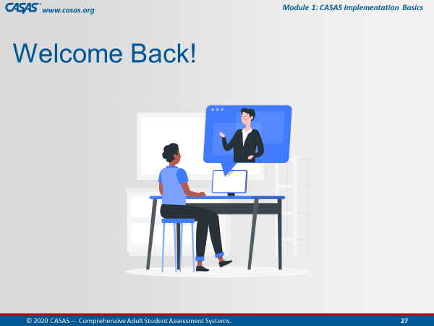 | Upon return, ask if anyone has questions about any CFU. | Welcome Back! Everyone.  Is there a CFU any of you had trouble answering?  We can take about [#] minute(s) to review the questions.
 | Slide 28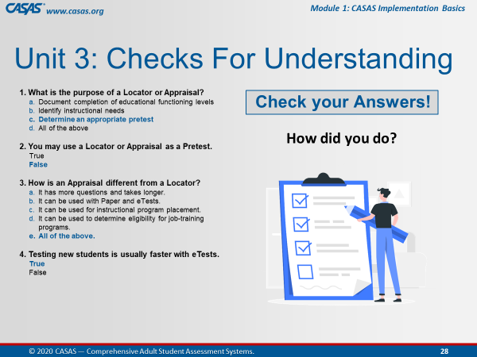 | Slide 29  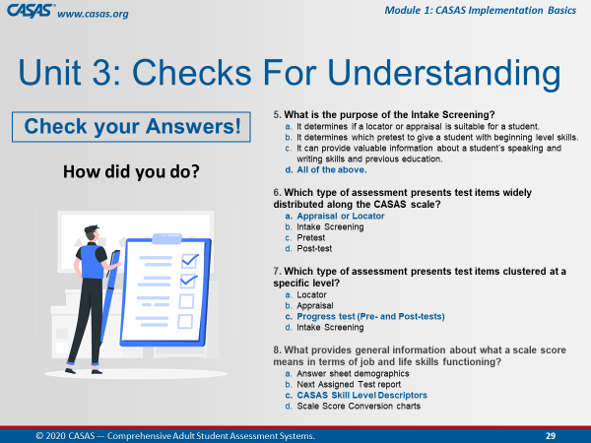 | Let’s review some of the answers together.  Feel free to point out any question you might need clarification.
 |  | Trainer 2:  Trainer 1: | STOP Screen Share.  START Screen Share.
11:07  10 min. | Module | Unit 4. Progress Tests (Pre- and Post)  Trainer 1: RETURN to Module.  Participants will view your screen. | Our next unit will cover Progress Testing.  This is the fourth out of 5 content units.
 | 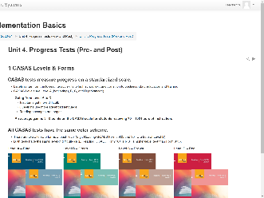 | 1 CASAS Levels & Forms  CFU 2, 3 | In all test series, paper booklets are color-coded to differentiate between levels.  CASAS assessments cover Beginning Literacy, Level A, to Post-secondary levels. Test items get more difficult from Level A, Easy, to Level D that is the most advanced level.  Each CASAS level has two alternate forms.  - For example, Reading GOALS Forms 903 and 904 are both at Level B.  [Q2] You must use the same assessment series when progress testing a student in the same test modality.  [Q3] You must also the same assessment series you used for the pretest but not the same form.  The alternate form in each CASAS level (i.e., Level A, B, C, D) is not more difficult than the first form.  - For example, 904R in CASAS Level B is not more difficult than 903R..
 | 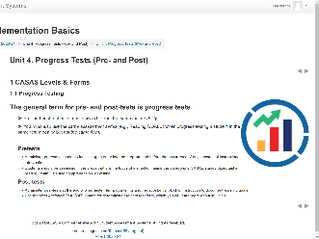 | 1.1 Progress Testing  CFU 1 | [Q1] The general term for pre- and post-tests is progress testing.  Administer pretests as soon as feasible upon entry into the program.  Administer post-tests at the end of a semester, term, quarter, or another substantial block of instruction to document learning gains.
 | 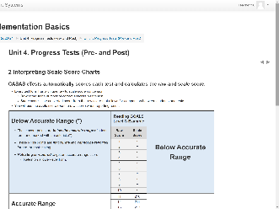 | 2 Interpreting Scale Score Charts  CFU 4 | All CASAS test forms have three score ranges – below accurate, accurate, and conservative estimate range.  Here is an example from the Reading GOALS series for Level C.  [Q4.1] The Raw score indicates the number of correct answers.  [Q4] The Raw Score must be converted to provide a standard score for reporting purposes.  [Q4.3] The Scale score indicates a score used for measuring progress.  [Q4.2] The Asterisk score (*) indicates a score below the accurate range. These scores are invalid and retesting with a lower-level form is required.  [Q4.4] The Diamond score (♦) indicates a conservative estimate score (above the accurate range). These scores are valid but CASAS recommends retesting for pretests.
 | 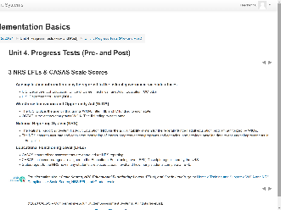 | 3 NRS EFLs & CASAS Scale Scores | You will hear many acronyms in Adult Ed.  In a nutshell, CASAS assessments are approved by the Office of Career, Technical, and Adult Education (OCTAE) for reporting in the National Reporting System (NRS).  CASAS scale score ranges align to the Educational Functioning Level (EFL) descriptors published by the NRS.  States funded by the Workforce Innovation Opportunity Act (WIOA) report to the NRS how many students are placed at each level and how many students complete an EFL.
 | 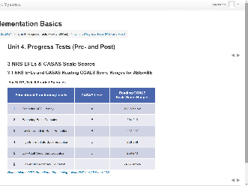 | 3.1 NRS EFLs and CASAS Reading GOALS Score Ranges for ABE/ASE | The CASAS scale scores cover all six Educational Functioning Levels (EFLs).  This chart shows the relationship between Educational Functioning Levels (EFLs) and Reading GOALS scale scores for ABE/ASE learners.
 | 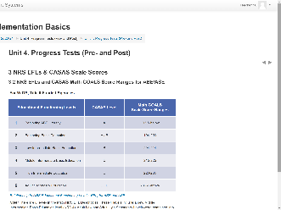 | 3.2 NRS EFLs and CASAS Math GOALS Score Ranges for ABE/ASE | This is the same information but for CASAS Math GOALS.  Note: There are 6 levels in the Math NRS EFL Descriptors.  - These 6 levels include a new Middle Intermediate Basic Education level (NRS 4).  - Adult Low and Adult High Secondary Levels were combined into one level (NRS 6).  - There are no longer Low Adult Secondary and High Adult Secondary levels.
 | 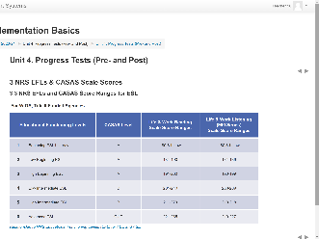 | 3.3 NRS EFLs and CASAS Score Ranges for ESL | This chart shows the relationship between Educational Functioning Levels (EFLs) and CASAS Life and Work Reading and Life and Work Listening test series for ESL Leaners.
 | 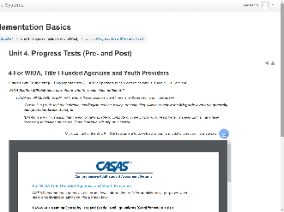 | 4 For WIOA, Title I Funded Agencies and Youth Providers | The CASAS scale covers all six Educational Functioning Levels (EFLs) for both ABE/ASE and ESL.  The top chart shows the relationship between Educational Functioning Levels (EFLs) and Reading GOALS scale scores for ABE/ASE learners.  The second chart is the same information but for Math GOALS.  Note: There are 6 levels in the Math NRS EFL Descriptors. These 6 levels include a new Middle Intermediate Basic Education level (NRS 4). Adult Low and Adult High Secondary Levels were combined into one level (NRS 6). There are no longer Low Adult Secondary and High Adult Secondary levels.  The last chart shows the relationship between Educational Functioning Levels (EFLs) and CASAS Life and Work Reading and Life and Work Listening test series for ESL Leaners.
11:17  5 min. |  | 1 Sample Test Items  CFU U5. Q1 | Sample Test Items are available in both eTests and paper-test formats.  These are not actual tests and cannot be used to determine basic skills or for placing students in a program, however,  Using sample test items will help to:  - Familiarize students with the format of CASAS test items  - Make testing go more smoothly  - Help reduce test anxiety  [U5.Q1] Using CASAS Sample Test Items are appropriate to prepare students for testing!
 |  | 1.1 CASAS eTests Sampler  1.2 Reading GOALS Level A  1.3 Reading GOALS Level B  1.4 Reading GOALS Level C  1.5 Reading GOALS Level D | Test items get more difficult going from Level A to D.  [Trainer: If time is running short, encourage participants to return to the module later to peruse these SAMPLE TEST ITEMS for their reference.]
 | Slide 30  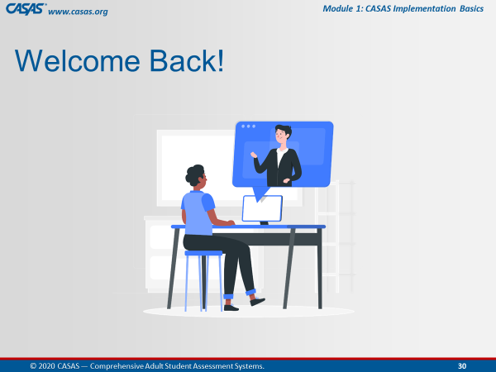 | Trainer 1: | RETURN to PPT.
11:22  3 min. | Slide 31  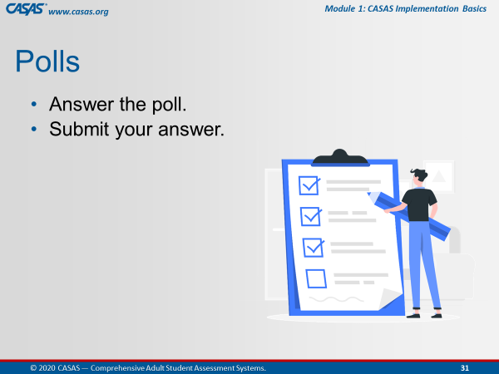 | Unit 4. Check for Understanding  POLL – CFU Activity (7 Qs)  - Launch the poll.  - Respond to the poll.  - Close the poll.  - Share the results.  Confirm correct responses and provide clarification if needed. | I am going to launch a Poll for you to answer checks for understanding the content we just covered in this unit.  There are 7 questions.  I’ll give you a [#] minute(s) to go through them and then close the poll.  Ok, everyone is doing a great job. I’m going to close the poll in about 5 seconds.  [Trainer: comment on participant responses.]
 |  | Remind participants how to close the poll on their screen. | Ok, go ahead and Close the poll window on your screen.
 |  | Trainer 1:  Trainer 2: | STOP Screen Share.  START Screen Share.
11:25  10 min. | Module | Unit 5. Results, Reports & Instruction  Trainer 2: RETURN to Module.  Participants will view your screen. | Unit 5 covers Test Results, Reports, and Instruction.
 | 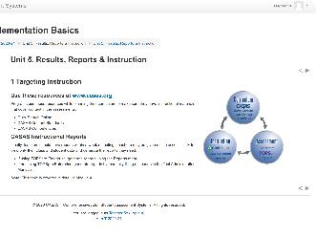 | 1 Targeting Instruction  CFU 1, 3 | [Q1,3] Programs use these resources while planning their curriculum to make sure they have instructional materials that cover content in the assessments.  - QuickSearch Online  - CASAS Content Standards  - CASAS Competencies
 | 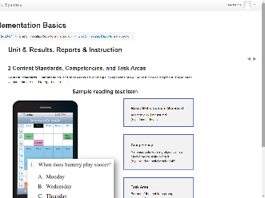 | 2 Content Standards, Competencies, and Task Areas  CFU 4 | CASAS test items measure basic language and math skills in realistic, everyday life and workplace contexts.  [Q4] All CASAS test items incorporate 3 Key elements:  - Content Standards, which are measurable academic skills. For example, locating detail in this Sample Reading Test Item.  - Competencies, which are measurable learning objectives in a functional life skills context like reading an activity schedule in this sample test item.  - Task Areas, which is the format or display of the test item prompt. In this case, the prompt a chart on a cell phone.  So in this Sample Test Item, the student must understand how to read a schedule displayed in a calendar format to find out when Sammy will play soccer.
 | 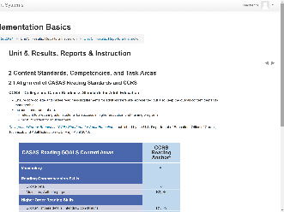 | 2.1 Alignment of CASAS Reading Standards and CCRS | CCRS = College and Career Readiness Standards for Adult Education  Here is an example of CASAS Reading GOALS Reading Standards aligned with CCR Standards relevant to preparing adult students for success in higher education and training programs.
 | 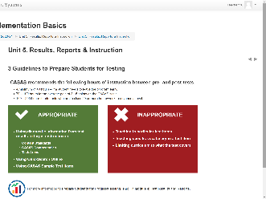 | 3 Guidelines to Prepare Students for Testing  CFU 2 | Here are some guidelines to consider when preparing students for testing.  [Q2] CASAS recommends:  A minimum of 40 hours of instruction between pre- and post-tests – if a student needs to leave the program early.  Preferrable, 70 – 100 hours for students to demonstrate an average gain of 3 - 5 points on the CASAS scale.  And 100 – 200 hours between pre- and post-tests for students who are in class 20 or more hours/week.

[Q1] Guidelines appropriate to prepare students for testing

Teaching using instructional material suggestions from QuickSearch.

Targeting instruction using diagnostic information from test results.

[Q1] Using CASAS Sample Test Items.
 | 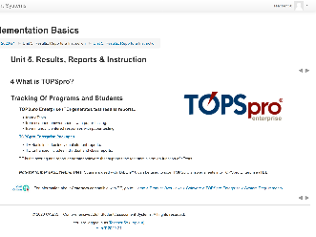 | 4 What is TOPSpro? | TOPSpro stands for Tracking Of Programs and Students.  TOPSpro Enterprise is also referred to as ‘TE’.  TE generates test results reports...  - from eTests.  - from scanned answer sheets with paper testing.  - from manually entered responses with paper testing.  TE is the scoring and report generating software that supports the test administration function of eTests.
 | 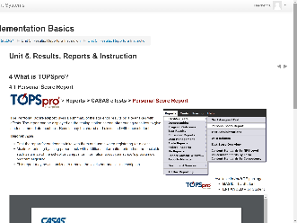 | 4.1 Personal Score Report | The Personal Score Report…is a student-based report…  …and provides students with immediate feedback after taking a test on eTests by giving them a summary of their test results at the end of the test taken.  The report can be displayed on the testing station screen after ending each test to give students immediate feedback.  The report may also be reproduced in TE.  Results may be shared and discussed with each student.
 | 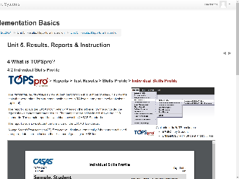 | - Individual Skills Profile | The Individual Skills Profile report…is a student-based report.  Skills Profiles show student performance in several areas.  Across the top, the report shows,  - tests that were taken  - form numbers  - scale scores  - NRS levels  At the top far right is an optional setting that you may add to the report to indicate Grade Level Equivalency.  The left side on both reports displays the CASAS Competency areas addressed on the tests taken.  This report also shows the Task Areas per skill, which in these examples is reading and math.  The Standards are displayed on the right side of this report by test modality. Here,  - the top report is by CCR Standards, and  - the report on the bottom displays the same test results by CASAS Standards.  The HSE Predictor is included in the report when a test modality score is appropriate to indicate the likelihood of the student passing a High School Equivalency Exam, either the GED or the HiSET exams.
 | 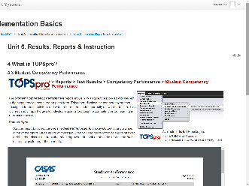 | 4.3 Student Competency Performance | The Student Competency Performance report…is a student-based report.  This report indicates the students’ performance in each competency by showing the percentage of correct responses to items that relate to each competency description.  When teachers sort this report by correct answers in descending order to display the strength areas at the top of the report, students are encouraged to celebrate their strength areas before discussing areas that need improvement.
 | 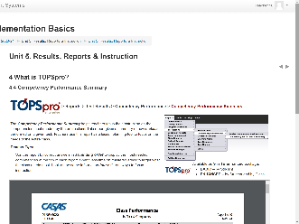 | 4.4 Competency Performance Summary | The Class Performance by Test and Competency Summary…is a class-based report…  …that identifies the competencies assessed on each test form students took in the class.  When teachers sort this report by correct answers in ascending order, this will display the most needed competencies at the top of each report.  The report helps teachers target appropriate instruction based on these skills and spend less time on mastered areas.
 | 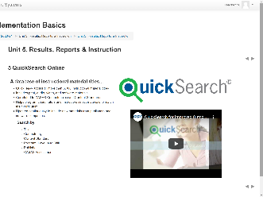 | 5 QuickSearch Online  CFU 3 | [Q3] CASAS assists with curriculum support by providing QuickSearch Online, which is a searchable database of instructional materials
 | Slide 32  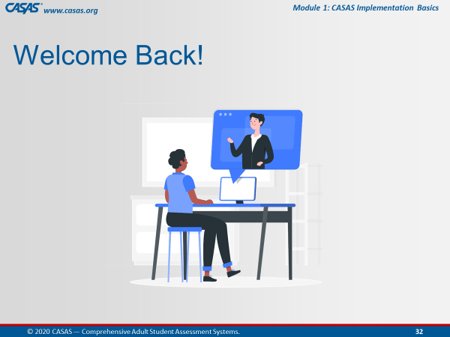 | Trainer 2: | RETURN to PPT.
11:35  8 min. | Slide 33  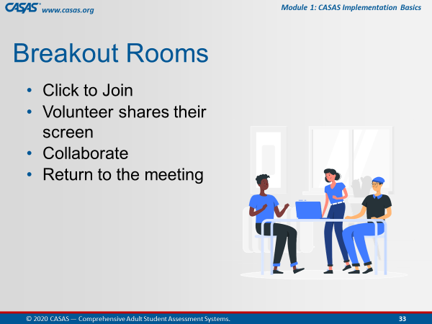 | Unit 5. Check for Understanding  BREAKOUT – CFU Activity (5 Qs)  One participant shares their screen and opens the Unit CFU.  Add Unit CFU Link and Task to Chatbox.  UNIT 5: CHECK FOR UNDERSTANDING  http://training.casas.org/mod/quiz/view.php?id=2800 | Ok, now we are going to send you to Breakout Rooms again.  [Trainer 2] will put the link to Unit 5. Check for Understanding in the Chatbox.  When you are in the Breakout Room, the volunteer will:  - Share their screen and  - Click on the link from the Chatbox.  The checks for understanding for Unit 5 will open automatically.  Please work together as a group to answer each question.  You will be automatically brought back to the Meeting Room when time is up.
 |  | - Send to BOR.  - Broadcast task.  - Close BOR when 1 min. remains. | Ok, click Join.  [Trainer: Broadcast task to BORs, e.g., “Please skip any questions if needed and go back to answer if time permits.”]
 | Slide 34  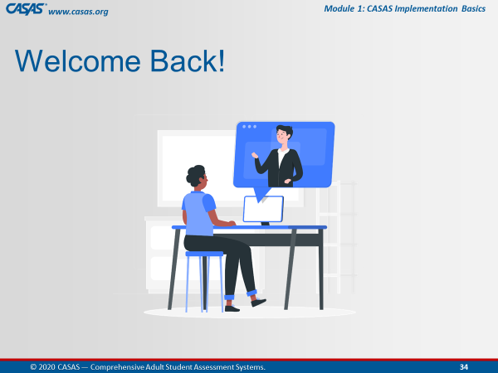 | Upon return, ask if anyone has questions about any CFU. | Welcome Back! Everyone.  Is there a CFU any of you had trouble answering?  We can take about [#] minute(s) to review the questions.
 |  | Trainer 2:  Trainer 1: | STOP Screen Share.  START Screen Share.
11:43  2 min. | Module | Unit 6. Wrap Up! What's Next?  Trainer 1: RETURN to Module.  Participants will view your screen. | Congratulations!  Our last unit wraps up this training with the steps you need to take to implement CASAS.
 | 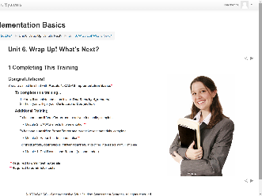 | 1 Completing This Training | You are almost finished with Module 1: CASAS Implementation Basics, which will allow you to order test materials  In a moment, we will walk you through the process to complete your training.  To administer CASAS eTests, you will also need to complete Module 2.  To administer Paper Tests, you will also need to complete Module 3.  And don’t forget Module 4, which will help you with interpreting test results and reports.
 | 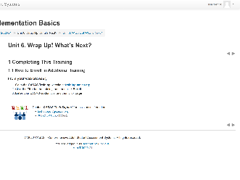 | 1.1 How to Enroll in Additional Training | Just like we did today, you will follow the same steps to enroll in additional training.
 | 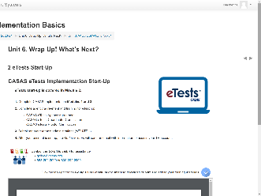 | 2 eTests Start-Up  CHATBOX URL:  GOING LIVE! CHECKLIST  https://www.casas.org/product-overviews/software/casas-etests/-going-live-checklist | So at this point, you only need to focus on completing the first four steps in the Going Live! process to have access to an eTests account.  You can download or print the Going Live!! Checklist from the module or the URL [Trainer 1] just put in the Chatbox.
 | 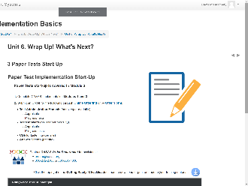 | 3 Paper Tests Start-Up  CHATBOX URL:  GETTING READY! CHECKLIST  http://training.casas.org/mod/book/view.php?id=2840&chapterid=4116 | Also, for paper assessments,  You can download or print the Getting Ready! Checklist from the module or URL [Trainer 1] just put in the Chat box.
 | 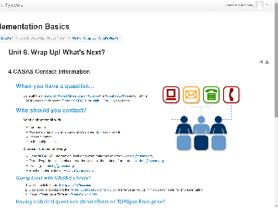 | 4 CASAS Contact Information | And finally, here is helpful information for who to contact at CASAS if you have a question.  Office hours are Monday through Friday, 8:30 am to 5:00 pm Pacific Time.
 |  | Trainer 1: | STOP Screen Share.
 | Slide 34 | Trainer 2: | START Screen Share.
11:45  10 min. | Slide 35  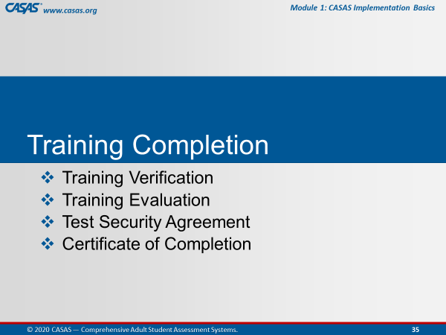 | TRAINING COMPLETION | To complete your training today, you will:  Submit a Training Verification and Evaluation with your Test Security Agreement, and then get your Certificate
 | Slide 36  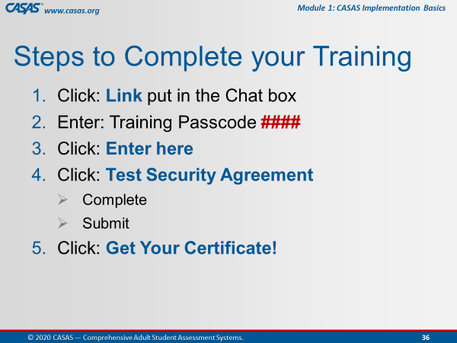 | This is an ANIMATED slide in PPT “slide show” mode.  Note: Click 4 has 2 additional automated text. | The steps you will complete are the following:  [Click 1] Click the Link that will be put in the CHATBOX after we review these steps.  [Click 2] You will be prompted to enter a Passcode, which is <Trainer: insert own passcode>.  [Click 3] After entering the passcode, click the Enter here button.  [Click 4] You will see the Test Security Agreement link, which you will click to complete and submit.  [Click 5] And last, click the Get your Certificate! Link.
 | Slide 37  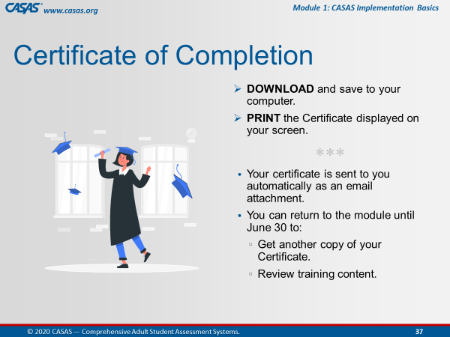 |  | You can download or print the certificate directly from your computer.  Your certificate will also be sent to you as an email attachment.  You can always return to the module to get another copy of your certificate and review training content.
 |  | TRAINING COMPLETION:  http://training.casas.org/course/view.php?id=423 | Ok everyone, go to your CHATBOX and click on the URL that [Trainer 1] just put in there.
 |  |  | Return to the Meeting Room when you are finished.  Remember how do we do that?  Click the Blue video icon at the bottom of your computer monitor.
 |  | Trainer 2: | STOP Screen Share.
 | Slide 38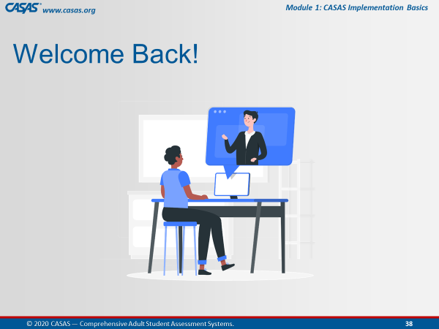 | Trainer 1: | START Screen Share.
11:55  3 min. | Slide 39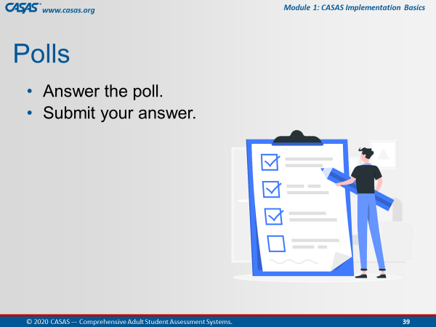 | CLOSING Polls  LAUNCH POLLS:  - Respond to poll.  - Close the poll.  - Share the results. | - Did you get your certificate?  - After this training do you feel more confident in returning to the online modules?  - After this training do you feel more confident that the content learned will support you in using CASAS?
 |  | - Close the polls | Congratulations everyone! You did a great job!  Don’t forget to close the Poll screen.
11:58  2 min. | Slide 40  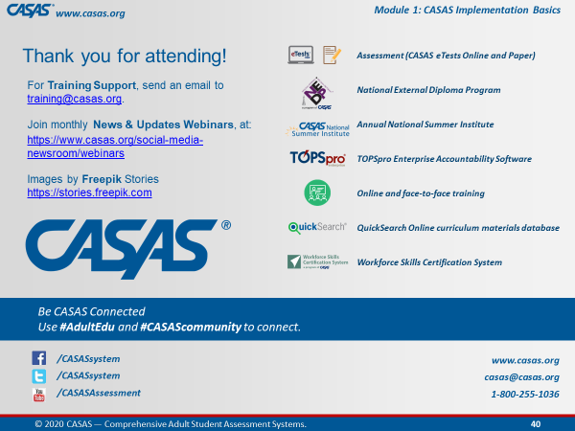 | Wrap Up!  CASAS Contact Info | Thank you for attending today’s training.  If you have any questions about Training, email the Training Desk at training@casas.org.
 |  | Webinars | Join us for monthly webinars to learn about the latest CASAS News & Updates.  Check the Social Media web page on the CASAS website for information about the next webinar.
 |  | Online Training | We hope you feel more confident in not only going in and out of the modules, but also knowing where a lot of rich information lives!  Don’t forget that you can review content in the online training modules and enroll in additional training at http://training.casas.org/
12:00  End Time |  | Stay “live” for any questions.  End meeting for all when finished. | We will stay on if anyone has questions otherwise, you are dismissed.  Thank you again for participating in this training.
120 min. |  | END TRAINING

