Checks for Understanding

About: Check for Understanding
Use this table to answer the following questions:
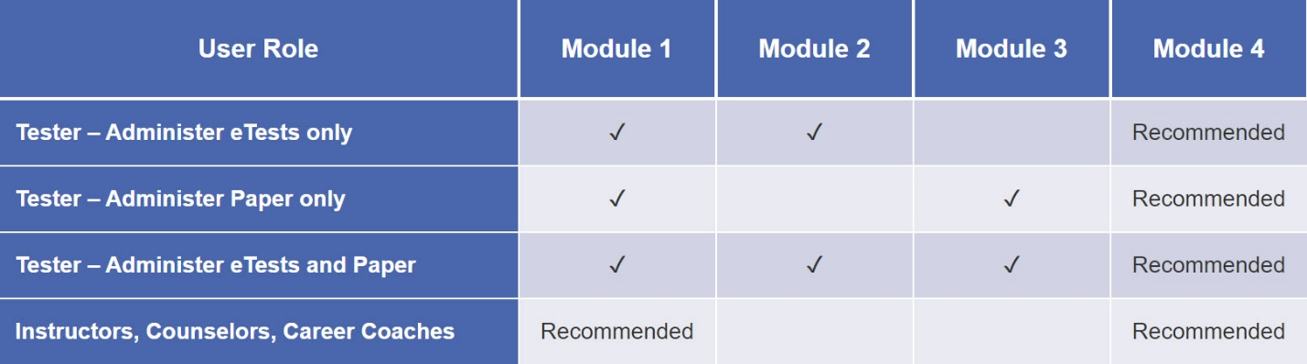
✓ = Required training

Question 1
If you plan to use CASAS eTests, you are required to complete which two training modules…
Please choose two answers
Module 1: CASAS Implementation Basic
Module 2: CASAS eTests Implementation
Module 3: Paper Test Implementation
Module 4: Test Results and Reports
Feedback: Module 1 and 2 are required for implementing CASAS eTests.

Question 2
Which two training modules are recommended for instructors, counselors, career coaches, and other interested staff?
Please choose two answers
Module 1: CASAS Implementation Basic
Module 2: CASAS eTests Implementation
Module 3: Paper Test Implementation
Module 4: Test Results and Reports

Unit 1. Check for Understanding

Question 1
Which test delivery method requires a Test Administration Manual (TAM)?
Select one:
Paper tests only
CASAS eTests only
Both paper tests and eTests
A TAM is not required for paper tests or eTests.

Question 2
A Test Administration Manual (TAM) contains:
- Answer Keys
- Score Conversion Charts
- Next Assigned Test Charts
- CASAS Competencies and CASAS Content Standards
- Class and Student Profiles
- Standardized Test Administration Procedures and Policies
- Test Security Protocols

Question 3
Local agencies are responsible for providing accommodations for learners who have documented disabilities. This applies to both eTesting and paper testing.
Indicate whether or not each accommodation below is allowed for students with special needs.
1. Allowing a student extended time for the test Allowed
2. Giving the student a supervised break Allowed
3. Using a sign language interpreter for test directions Allowed
4. Allowing a student to take the test in an alternate room Allowed
5. Leaving a student alone to take a test Not Allowed
6. Translating unfamiliar words in test items Not Allowed

Question 4
A proctor should instruct students to skip a test item if they do not know the answer.
Select one:
True
False

Question 5
Why should a proctor tell students that they should not guess on CASAS eTests?
Select one:
Students may guess correctly even though they have not mastered the content.
Students may be placed in a level that is too difficult for them.
Students' test results may not accurately reflect their skills and abilities.
All of the above.

Question 6
Students are allowed to stop testing at anytime and finish the test at another time or day.
Select one:
True
False

Question 7
All eTests proctors must adhere to test security guidelines.
After testing a student, the proctor is responsible for:
Select one:
Making sure students click LOGOUT from eTests when they are finished.
Clicking EXIT to close eTests on all testing stations.
Clicking STOP for all active testing sessions on the eTests management console.
Clicking LOGOUT on the eTests management console.
Clicking EXIT to close the eTests application.
All of the above.

Unit 2. Check for Understanding

Question 1
What is the purpose of the Intake Screening?
Select one:
It determines if a locator or appraisal is suitable for a student.
It determines which pretest to give a student with beginning level skills.
It can provide valuable information about a student’s speaking and writing skills and previous education.
All of the above.

Question 2
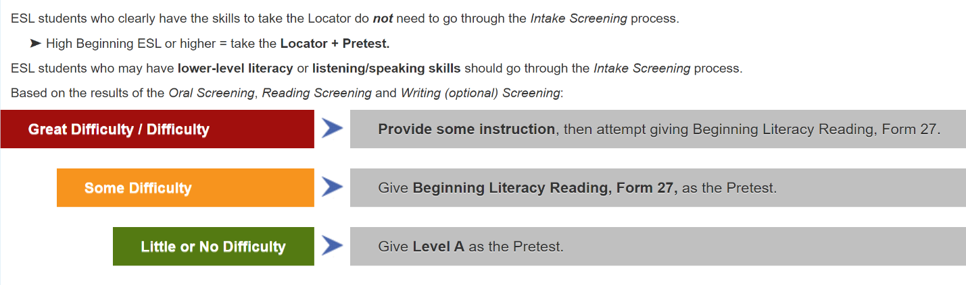

Answer the following questions.

1 .If an ESL student scores 6 or more on the Oral Screening or has little or no difficulty on the other Intake Screenings, then…give the Locator followed by the Pretest.

2. If an ESL student has lower level literacy skills and scores less than 6 on the Oral Screening, then…skip the Locator and give the Reading and Writing (optional) Screenings.

3. If an ESL student has some difficulty with the Reading or Writing Screening, then… administer a Level A form as the Pretest.

4. If an ESL student has great difficulty or difficulty on the Reading Screening, then…give the Beginning Literacy, Form 27 as the Pretest.

Unit 3. Check for Understanding

Question 1
Teachers may provide help with practice items.
Select one:
True
False

Question 2
A Locator is used to determine an appropriate pretest.
Select one:
True
False

Question 3
Select the correct term for each score description.
1. Raw score indicates the number of correct answers.
2. Asterisk score (*) indicates a score below the accurate range.
3. Scale score indicates a score used for measuring progress.
4. Diamond score (♦) indicates a conservative estimate score (above the accurate range).

Question 4
Students may use calculators when taking CASAS Math GOALS tests.
Select one:
True
False
Feedback: Students may use the basic calculator included with eTests, while programs that use paper tests should provide students with a basic calculator (not a graphing calculator).

Question 5
Students need to memorize formulas for CASAS Math GOALS tests.
Select one:
True
False
Feedback: Students may use the basic calculator included with eTests, while programs that use paper tests should provide students with a basic calculator (not a graphing calculator).

Unit 4. Check for Understanding

Question 1
CASAS eTests is primarily used…
Select one:
To create user accounts for staff members.
To report outcomes for local, state, and federal accountability.
To administer computer-delivered tests.
All of the above.

Question 2
You can only use computers with a Windows operating system to run TOPSpro Enterprise (TE).
Select one:
True
False

Question 3
Which electronic devices can you use with CASAS eTests?
Select one:
Chromebook
iPad
Laptops or desktop computers with Windows 10
All of the above

Question 4
The Agency Agreement provides critical information to set up your online account.
- Who is the recommended person to be the Main Point-of-Contact (MPOC) for your agency?
Select one:
Program Administrator
Testing Coordinator
Proctor

Question 5
In Step 4 of the Going Live! Checklist, after CASAS sets up your agency’s online account, an email will be sent to which two individuals?
Select one or more:
The Main Point of Contact (MPOC).
The certified eTests Coordinator.
The TE Data Manager (DM).
The certified eTests Proctor.

Question 6
The Data Manager's responsibilities include….
Select one:
Managing your online account data
Adding users, sites, teachers and classes to TOPSpro Enterprise
Managing user access to TOPSpro Enterprise and/or eTests
All of the above

Question 7
Each test site that administers CASAS eTests Online must have at least one Certified Coordinator and one Certified Proctor.
Your agency is implementing CASAS eTests Online and you have been asked to fulfill one or both of these roles.
- What is the first step you should take?
Select one:
Replicate sessions
Register computers
Complete certification
Place an order

Question 8
Registering computers is a one-time task.
Only one certified eTests user is needed to register a testing station.
- Who may register devices?
Select one:
Coordinators
Proctors
Either of the above

Question 9
Certified coordinators and proctors each perform different duties and yet have similar responsibilities.
- Identify the primary duties of coordinators and proctors.
Replicating sessions Coordinator
Administering tests Proctor
Managing sessions Proctor

Question 10
Coordinators must replicate a testing session every time testing is needed.
Select one:
True
False
Feedback: After a coordinator replicates sessions, proctors then start and stop these sessions throughout the program year whenever testing is needed.

Question 11
Any staff member who will be administering eTests must complete…
Select one:
CASAS Implementation Agreement.
Coordinator Certification.
Proctor Certification.
All of the above

Unit 5. Check for Understanding

Question 1
TE Client should be downloaded on which of the following:
Select one:
Computers that will be used for student testing
Computers that will be used by staff members who need to access student test data
Chromebooks that will be used for student testing
All of the above.
Feedback: TE Client does not need to be downloaded on computers that will only be used for student testing.

Question 2
Once access is granted by the Data Manager, each staff member will have one set of log-in credentials to access TE and /or eTests as appropriate.
Select one:
True
False

Question 3
There is a limit to the number of sites and users the Data Manager may add to an online account.
Select one:
True
False

Question 4
Registering computers requires two certified eTests users.
Select one:
True
False

Question 5
Devices must be registered every time you test.
Select one:
True
False
Feedback: Station registration is a one-time event!

Question 6
TOPSpro Enterprise vs. eTests Access
- Based on staff roles, responsibilities and certifications, the Data Manager may grant users...
Select one:
Access to TE without access to eTests.
Access to eTests without access to TE.
Access to both TE and eTests.
All of the above.

Question 7
CASAS eTests User Access Rights
- Based on staff roles, responsibilities and certifications, the Data Manager may grant users...
Select one:
Coordinator only access to eTests without Proctor access.
Proctor only access to eTests without Coordinator access.
Coordinator and Proctor access rights to eTests.
All of the above.

Question 8
Testing sessions must be replicated every time you test.
Select one:
True
False
Feedback: After replicating, sessions are ready to use and re-use whenever you need to test.

