Module 2 covers how to get started with CASAS eTests, how to administer web-based tests, and the benefits of computerized testing.
Time / Min. | Module / Slide | Content / Notes | Talking Points
 |  | Trainer 1:  START Screen Share. | Module 2: CASAS eTests Implementation
9:50  10 min. | Slide 1  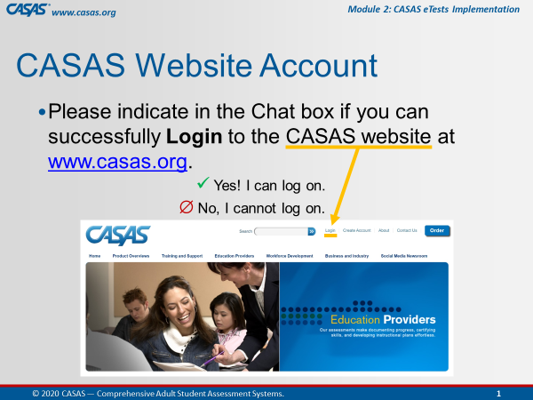 | Participant Arrivals:  Host admits participants into the web conference meeting from the waiting room.  Welcome participants as they arrive in the meeting room.  Confirm CASAS website logins. | Hi [participant name] and welcome to the training.  Please use the Chatbox to let us know if you can successfully log on to the CASAS website.  [Trainer 1: send anyone to the Tech Breakout Room (BOR) with Trainer 2 to assist with logins if needed.]
 | Slide 2  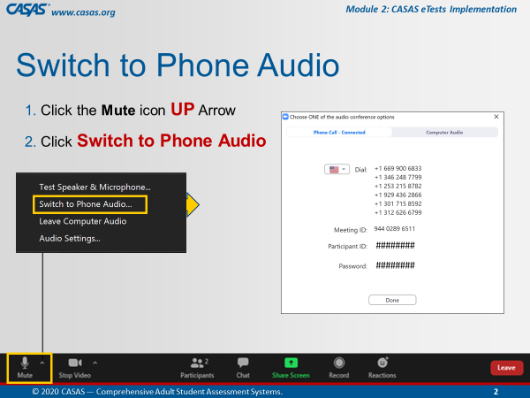 | This is an ANIMATED slide in PPT “slide show” mode.  Open Mic  Help participants switch audio if needed. | Some of you may be connected to the meeting using your computer audio. If you experience any trouble with your audio or Internet connectivity, we recommend switching to Phone Audio. To do that:  [Click 1] Click the UP arrow next to the Mute icon.  [Click 2] Select Switch to Phone Audio.  [Click 3] From the pop-up phone listing, dial a number, enter the Meeting ID and your Participant ID. You may also be prompted to enter the meeting Password.
 | Slide 3  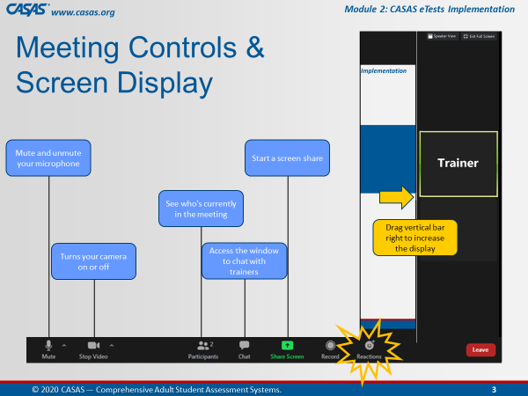 | This is an ANIMATED slide in PPT “slide show” mode.  Briefly review the web conference meeting controls. | Attendee controls appear at the bottom or top of your screen.  [Click 1] Mute/Unmute: You can mute and unmute your microphone.  [Click 2] Start Video/Stop Video: Use the video icon to turn your camera on or off.  [Click 3] Participants: See who's in the meeting with the participants icon.  [Click 4] Chat: Click the chat icon to access the window to communicate with each other.  [Click 5] Share Screen: The share screen icon lets you share your computer screen, which you will be doing in Breakout rooms.  [Click 7] Reactions: There is also a Reactions icon that you can give a clap or thumbs up at any time and we may ask you to acknowledge something during training with a thumbs up.  [Click 6] Display: And to increase the display on the left of your screen, click and drag the vertical bar on the RIGHT to minimize the video screens.
 | Slide 4  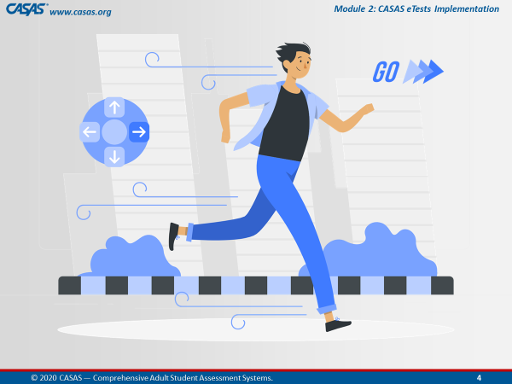 |  | We are going to get started…  Give a thumbs up from the Reactions icon if you are ready!
 |  | BEGIN TRAINING
10:00  3 min. | Slide 5  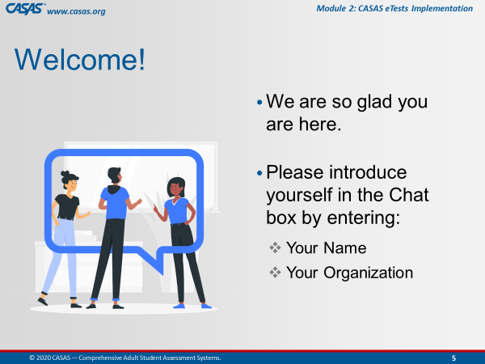 | Participant Introductions  Ask participants to introduce themselves in the Chatbox. | Hello everyone, let’s begin by introducing yourselves.  Please enter your name and [organization] in the Chatbox.  Alternates:  - Favorite hobby, color, etc.
 | Slide 6  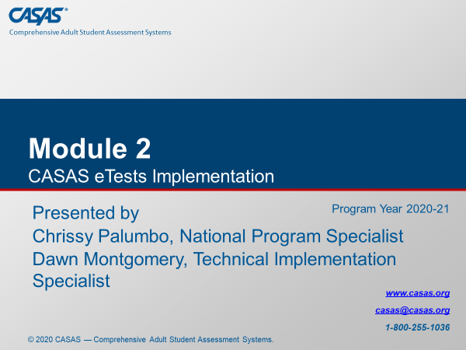 | Training Introduction | Today’s training covers Module 2: CASAS eTests Implementation.
 |  | Trainer Introduction(s)  Trainers introduce yourselves (each out loud). | Trainer 1: My name is [say your name], and I have been working in adult education for the past ## years and have [extensive] experience with [the CASAS assessment process].
 |  |  | Trainer 2: My name is [say your name], and I have been working in adult education for the past ## years and have [extensive] experience with [the CASAS assessment process].
 |  | Trainer 1:  Trainer 2: | STOP Screen Share.  START Screen Share.
10:03  1 min. | Slide 7  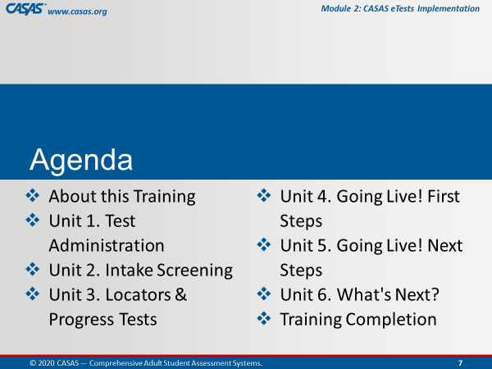 | Review training agenda  - About this Training  - Unit 1. Test Administration  - Unit 2. Intake Screening  - Unit 3. Locators & Progress Tests  - Unit 4. Going Live! First Steps  - Unit 5. Going Live! Next Steps  - Unit 6. What's Next?  - Training Completion | Module 2 covers how to get started with CASAS eTests, how to administer web-based tests, and the benefits of computerized testing.  After briefly reviewing a few more meeting controls, we will go online together and complete the About this Training content which will open the other 6 units.  [Trainer 1] and I will cover content and check your understanding of the content from each Unit…  …and then guide you through the Training Completion process to get your Certificate at the end of this training.
 | Slide 8  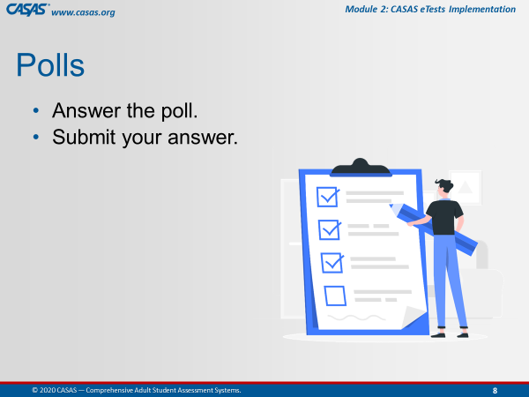 | Briefly review participating in Polls. | After we cover each unit, we will be answering checks for understanding either in the training Module, in Zoom Polls, through Chatbox responses, and together in Breakout rooms.  In Polls, you will answer the poll and then submit your answer.
 | Slide 9  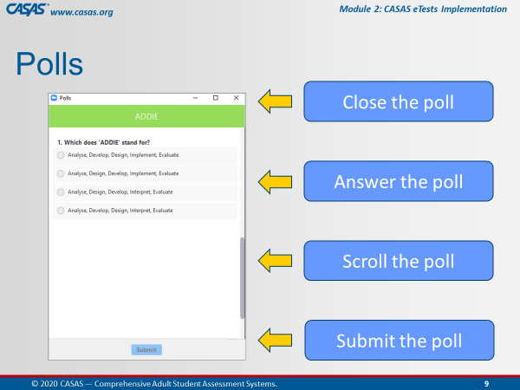 | This is an ANIMATED slide in PPT “slide show” mode.  Orient participants to polling. | This is what a Poll looks like in this web conference Meeting Room.  [Click 1] You will enter your responses directly on your screen.  [Click 2] In some polls, you will need to use the scroll bar to answer more questions in the poll.  [Click 3] Submit your answers. and then we will share your responses after closing the poll.  [Click 4] When done, you will want to close the Poll on your screen by clicking the X at the top RIGHT of the Poll window.
10:04  2 min. | Slide 10  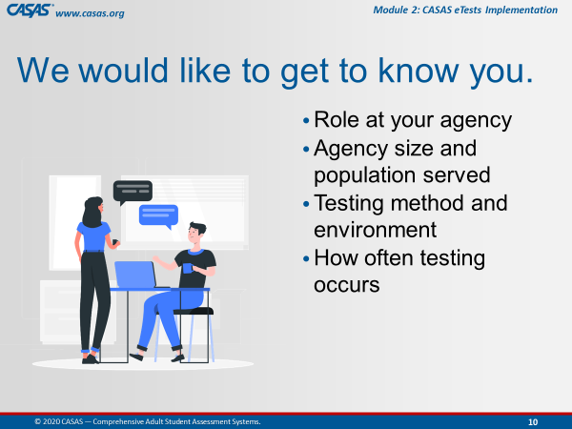 | Getting to Know You  Trainer: review info on slide. | Now, we would like to Get to Know You with a polling activity.  Such as your role, agency size and population, testing method and environment, and how often testing occurs.
 |  | LAUNCH POLLS:  - Respond to the poll.  - Close the poll.  - Share the results. | - What is your role at your agency?  - What is your agency size? / What population does your agency serve?  - What is your testing method? / What is your testing environment?  - How often does testing occur at your agency?
 |  | - Close the polls | Thank you for letting us get to know you!  Don’t forget to close the Poll screen.
10:06  4 min. | Slide 11  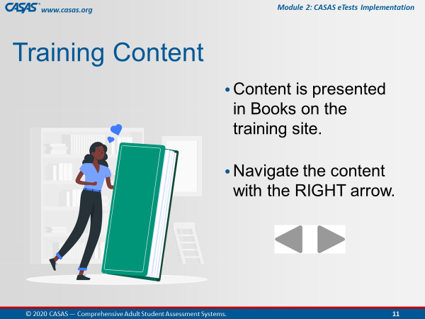 | This is an ANIMATED slide in PPT “slide show” mode. | We are going to go to the Training site together in a moment but first, I’d like to let you know what to expect.  You will see a green Book icon, which presents content in each unit.  We will review content in the first Book with you while you are in the module.  [Click 1] To navigate the pages in a book, click the RIGHT arrow at the top RIGHT or bottom RIGHT of your screen.
 | Slide 12  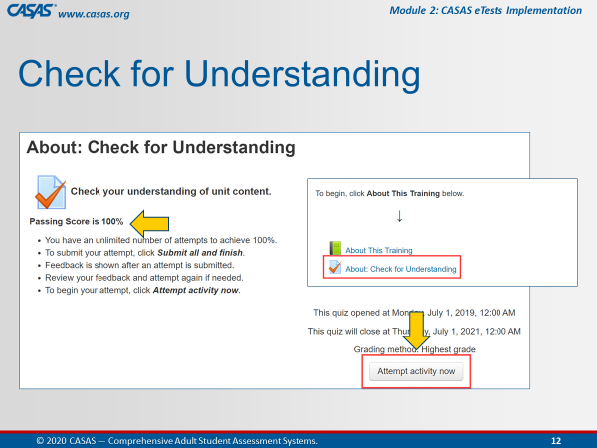 | This is an ANIMATED slide in PPT “slide show” mode. | We will be completing the first quiz together in the module so that the remainder of the module opens (Units 1 – 6) to access at different times during this training.  [Click 1] To begin the quiz, you will click the Attempt activity now button.  [Click 2] Our goal on this first quiz is to achieve 100%.  For the purpose of training together, you will get your certificate through your participation with us.  As a group, we will ensure we all get 100%.
 | Slide 13  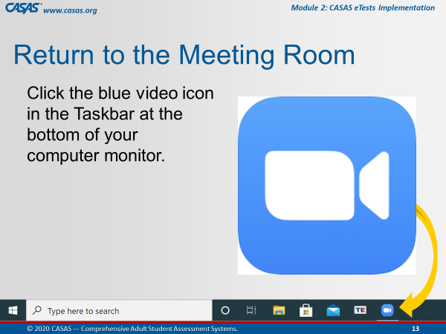 | This is an ANIMATED slide in PPT “slide show” mode (automated/no click).  Make sure participants know how to return to the Meeting Room. | When we are finished with the first Book and Quiz, we will ask you to return to the meeting room.  The way you will do that is click the Blue video icon at the bottom of your computer monitor.  Does everyone see this on your own computer?  Give me a “thumbs up” by clicking on the Reactions icon from your meeting controls.
 | Slide 14  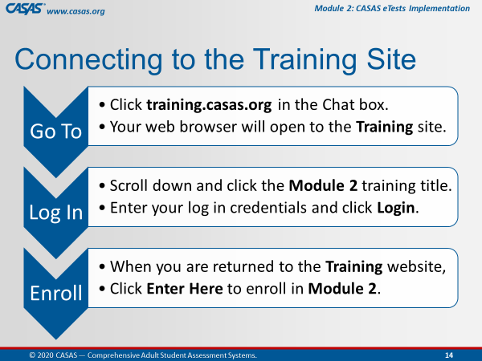 | This is an ANIMATED slide in PPT “slide show” mode. | We are about to go to the Training site together but first, I am going to describe the steps for us to get there.  [Click 1] Go To…  [Click 2] Log In…  [Click 3] Enroll…  Another purpose of this training is to help you understand the content in the online modules so you can RETURN to them to support you in your Adult Education position using CASSAS assessments.
 | Slide 15  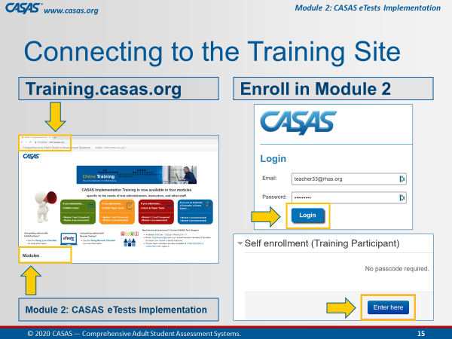 | This is an ANIMATED slide in PPT “slide show” mode. | Follow these 4 steps  Step 1. [Click 1] We will Go To the training site.  Step 2. [Click 2] And scroll down to click on Module 2.  Step 3. [Click 3] You will be automatically prompted to Log In with your CASAS website credentials.  Step 4. [Click 4] Then, you are automatically returned to the Training Site where you will click Enter here to open Module 2.
 |  | Prepare participants for logging on to the Training website.  http://training.casas.org/ | Please unmute your microphone so that we can continue to communicate when you are in your own module since the Training site will cover up the Meeting Room as soon as you click on the link that [Trainer 1] will put there  Ok, let’s go to the Training website.  [Trainer 1], please enter the training URL in the Chatbox.  Step 1. Ok Everyone, go to your Chatbox and click on the URL that [Trainer 1] just put in there.
 |  | Trainer 2:  Trainer 1: | STOP Screen Share.  START Screen Share.
10:10  5 min. | Training Site  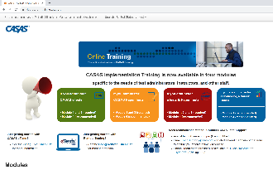 | OPEN the Training site.  Guide participants to logging on to the Training website and opening the module.  Demonstrate on your screen as you are talking the participants through each step.  Wait to proceed until everyone is looking at the module on their own screens. | Ok everyone, you should be looking at the Training website with the four colorful boxes.  Is everybody with me?  Step 2. Scroll down and click on the Module 2: CASAS eTests Implementation training title.  Step 3. Enter your CASAS website log in credentials and click Login.  Step 4. When you are returned to the Training website, click Enter Here to enroll in Module 2.
 | Module   | About This Training  Guide participants through information about the training as if they are viewing your screen. | Please click the About This Training link to open the green book, which contains the content for this part of the training.
 | 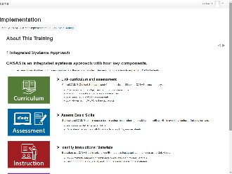 | 1 Integrated Systems Approach | The first page you should see in this book is Integrated Systems Approach.  CASAS is an integrated systems approach with four key components – Curriculum, Assessment, Instruction, and Accountability.  These components link curriculum and assessment, assess basic skills, identify instructional materials, and track student progress.  We will be covering these components in greater detail throughout this training.  To navigate to the next page, click the RIGHT arrow at the top RIGHT or bottom RIGHT of your screen.  This will take you to the next page in this book.
 | 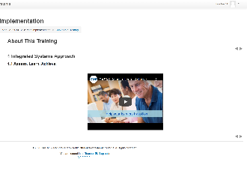 | 1.1 Assess. Learn. Achieve. (Video)  Time permitting: Play the first 59 seconds of the video. | On the next page, you should see the Assess. Learn. Achieve. video, which is a quick introduction to CASAS.  If you haven’t seen this video in Module 1, we encourage you to return later to this page to watch.  Remember those arrows?... click the RIGHT arrow and go to the next page.
 | 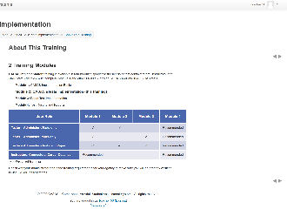 | 2 Training Modules  CFU 1, 2 | The next page is about the Training Modules.  CASAS Implementation training is available in four modules specific to the needs of test administrators, instructors, and other staff.  (Q1) To use CASAS eTests, you are required to complete Modules 1 & 2.  (Q2) Modules 1 & 4 are strongly recommended for instructors, counselors, career coaches, and other interested staff.  How do we go to the next page?  Click the RIGHT arrow!
 | 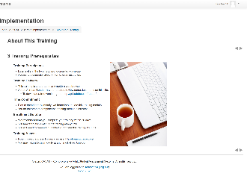 | 3 Training Prerequisites | The next page is about Training Prerequisites.  This is helpful information if you plan to complete another module on your own.  Now, click the arrow and go to the next page.
 | 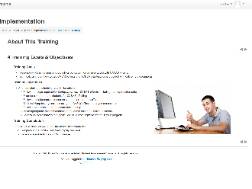 | 4 Training Goals & Objectives | You should see Training Goals and Objectives.  This page describes the purpose of this training, which is to provide a foundation for getting started with CASAS eTests.  This is not a proctor or technical training. This training is an overview of the steps necessary to implement CASAS eTests.  Technical training on how to use CASAS eTests and TOPSpro Enterprise is provided with online help documents and videos available on the CASAS website.  At the end of this training, we will guide you through the training completion process so that you can generate your certificate.  Let’s go to the next page.
 | 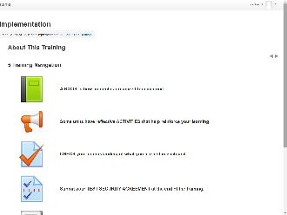 | 5 Training Navigation | You should now be on the Training Navigation page.  The navigation information will help you understand how to navigate a training module if you plan to complete a module on your own.  Since you are completing the training with us, we will guide you through this training.  What you need to know before we move on is how to return to the module HOME page from any training page when you are in the module on your own.  Look at the top of your module screen and you will see a Breadcrumb trail.  In that Breadcrumb trail is the Module Short Name, which in this case is M2 2020-21.  Let me know when you see the module Short Name in the Breadcrumb trail on your own computer screen.  Don’t click it now, but whenever you click the module Short Name from the Breadcrumb, this will return you to the module HOME page from wherever you are in the module.  So if you lose your place, just return Home and that will help you get back to where you need to be.  For now, we are going to SKIP the next three navigation pages and go to the last page in this book.  From the Table of Contents at the upper left of your screen, click Training & Technical Support.
 | 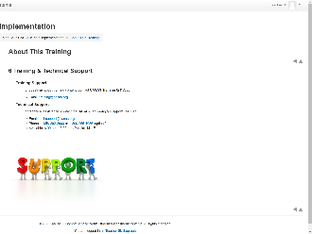 | 6 Training & Technical Support | You should be looking at the Training & Technical Support page now.  Whenever you have questions or need clarification about training content, don’t hesitate to contact training@casas.org.  And whenever you need technical assistance, you can reach out to the CASAS Technology Support Team with the contact information displayed on this page.
 |  | Guide participants back to the module HOME page. | Now we are going to leave this book.  Click the RIGHT arrow at the top RIGHT or bottom RIGHT of your screen.  This will return us to the module HOME page.
10:15  2 min. | 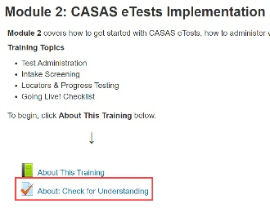 | About: Check for Understanding  MODULE – CFU Activity (2 Qs) | You should be back on the Home page and see the Module 2: CASAS eTests Implementation training title at the top.  Let me know that you are on the Home page.  Since we are in the module, we will answer Checks for Understanding for the About This Training unit.  Below the green Book icon, click on the About: Check for Understanding link.
 |  | Guide participants through completing the first quiz together. | You should see About: Check for Understanding at the top of your screen.  Click the Attempt activity now button at the bottom of your screen and let’s complete the first quiz together.
 |  | Participants must achieve 100% to unlock the rest of the module. | Now, click Submit all and finish.  Feedback at the top of the results page tells you your score.  Scroll the page to see how you did. You will see a green for correct answers. Answers that are not correct will show a red X beside them.  Click Finish Review at the bottom of the page.  If you did not get 100%, you can reattempt to correct any incorrect answers – until you get 100% correct – so please click Reattempt activity now if needed.
 | 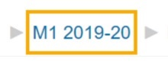 | Guide participants back to the module HOME page and proceed with the training. | When you see that you got 100%, click the module HOME link in the Breadcrumb trail at top of your screen and return to the module HOME page.  Take a look! The remainder of the module is now open for you to access at different times during this training. You should now see Units 1 – 6.  …and now that you have access to the training module, you can return to it at any time to review content through June 30, 2021.
 |  | Guide participants back to the web conference meeting room. | Ok, now let’s return to the Meeting Room.  Click the Blue video icon at the bottom of your computer monitor.
 |  | Trainer 1:  Trainer 2: | STOP Screen Share.  START Screen Share.
 | Slide 16  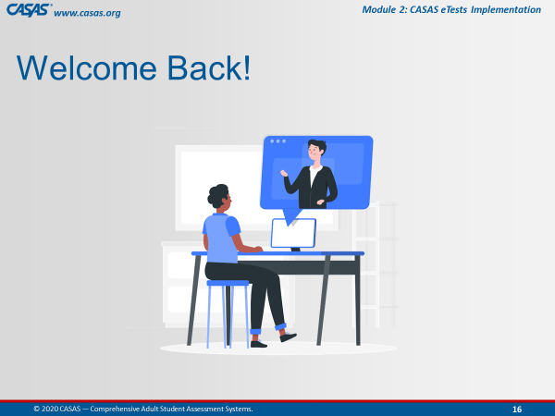 | Trainer: RETURN to PPT.  Welcome everyone back and remind participants… | Welcome back everybody!  You will know when you are back in the Meeting Room when you see this slide.
10:17  10 min. | Module | Unit 1. Test Administration  Trainer 2: GO TO the Module.  Participants will view your screen. | Now, [Trainer 1] and I will continue to take you through the remaining content in this training.  Our next unit will talk about Test Administration.
 | 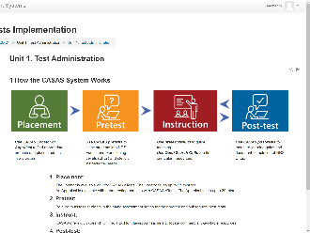 | 1 How the CASAS System Works | There are four components to How the CASAS System Works.  - You will use an eTests Locator to initially assess a learner for Placement in an appropriate level  - Then Pretest, and from the results,  - Provide Instruction based on the areas of need, and then  - Post-test after a period of instruction.
 | 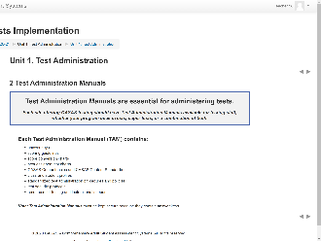 | 2 Test Administration Manuals  CFU 1, 2  (Content & CFUs also covered in M1)  Emphasize for those who already completed M1 | [Q1] All sites using CASAS eTests and / or Paper Tests should have a Test Administration Manual kept in a secure location.  [Q2] This is because they contain answers to CASAS test items in the form of Answer Keys.  TAMs also contain CASAS Competencies and CASAS Content Standards that apply to that test series, Standardized Test Administration Procedures and Policies, and Test Security Protocols…  Score Conversion Charts, Next Assigned Test Charts, and Class and Student Profile worksheets are included specifically for sites conducting paper testing.
 | 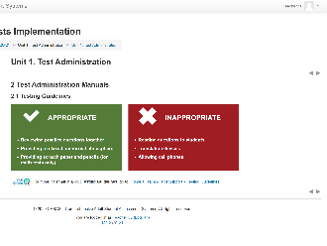 | 2.1 Testing Guidelines | Some Appropriate testing guidelines include:  - Helping students with practice questions.  - Making sure that you have an appropriate testing environment that allows students to perform to the best of their ability.  - And remembering to provide scratch paper and pencils for students taking math tests, which are collected when testing ends and the scratch paper is shredded.  Also, keep in mind the testing guidelines that are Inappropriate such as:  - Reading test questions to the students.  - Allowing translation devices and cell phones in the testing room.  Students should be given a secure place to store their personal belongings before testing begins.
 |  | 2.2 Test Timing  (Content also covered in M1)  Emphasize for those who already completed M1 | About Test Timing.  All CASAS tests are timed. However, it is important to note that students should not feel as though they need to rush through the test.  They do not need to finish the test. They just need do the best they can - without guessing - in the allotted time.  Some students may not have finished when time is up. Reassure them that is OK.  A clear understanding of the maximum testing time is essential for planning your testing schedule.  With CASAS eTests, test timing is automatic however, it is good to know the amount of time it takes to complete pre- and post-tests.
 | 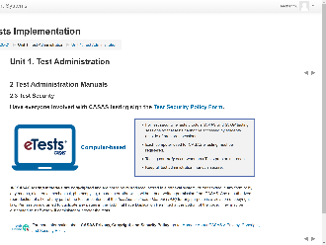 | 2.3 Test Security  (Content also covered in M1)  Emphasize for those who already completed M1 | Test Security is very important in order to maintain the integrity of CASAS assessments and to provide valid and reliable assessment results.  It is the responsibility of the agency and all persons involved with test administration to ensure the CASAS testing instruments and test items are kept secure.  Anyone involved with using CASAS should:  - read the Test Security Policy and  - sign the Agreement to certify that they will follow all test administration directions and  - agree to abide by all test security procedures.  CASAS eTests has built-in Test Security because:  - tests can only be administered on a computer registered for testing and  - tests cannot be administered unless a certified eTests Proctor is present to Start and Stop testing sessions.
 | 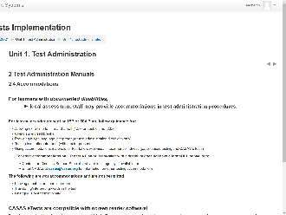 | 2.4 Accommodations  CFU 3 | And now about Accommodations.  [Q3] Local assessment staff may provide accommodations in test administration procedures for learners with documented disabilities, such as  - Allowing a student extended time for the test.  - Giving the student a supervised break.  - Using a sign language interpreter for test directions.  - Allowing a student to take the test in an alternate room.  What is not an accommodation and therefore not permitted is:  - Leaving a student alone to take a test.  - Translating unfamiliar words in test items.
 | 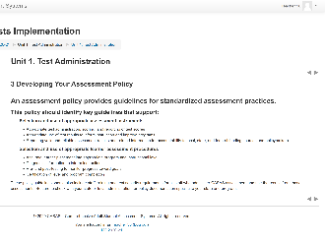 | 3 Developing Your Assessment Policy  (Content also covered in M1)  Emphasize for those who already completed M1 | All programs using CASAS should Develop an Assessment Policy outlining guidelines for appropriate assessment practices and procedures.  These policy guidelines should also include staff training and test security requirements for all staff who administer CASAS assessment and use the results from these assessments.  Be sure to check with your state or local administration for policy documentation specific to your state and program.  Your Local Assessment Policy should align with your State Assessment Policy.
 | 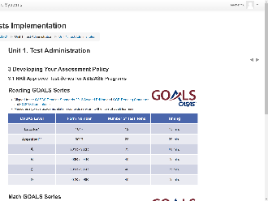 | 3.1 NRS Approved Test Series for ABE/ASE Programs  (Content also covered in M1)  Emphasize for those who already completed M1 | The next few pages in this book cover NRS Approved Test Series.  NRS is the National Reporting System that Adult Ed programs report outcomes for Federal funding.  Here, you see that the new Reading GOALS and Math GOALS series is approved for ABE and ASE programs.  These tables identify the CASAS Level, Form Number, Number of Test Items and Timing per level.
 | 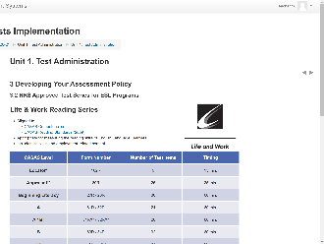 | 3.2 NRS Approved Test Series for ESL Programs  (Content also covered in M1)  Emphasize for those who already completed M1 | The next page shows the Life and Work Reading and Listening 980 series that are NRS approved for ESL programs.  Again, these tables detail the Number of Test Items and Timing per CASAS Level and Form Number.
 | 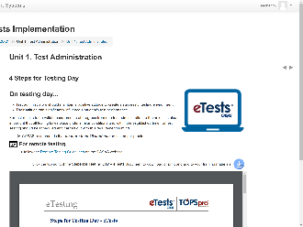 | 4 Steps for Testing Day | The role of an eTests proctor on Testing Day is very important.  Proctors follow the same procedures before, during, and after testing to ensure the validity of test results and reduce the likelihood of confusion or error during test administration.  This Steps for Testing Day with eTests document can be downloaded and printed from the module and is also available from the eTests Help page on the CASAS website.
 | 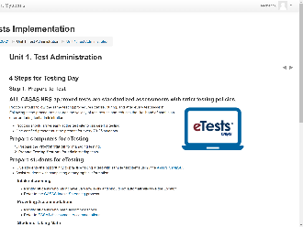 | Step 1. Prepare to Test | The first step on Testing Day involves:  - preparing computers and  - preparing students for eTesting.  Preparing computers involves:  - preparing the Proctor Station for managing testing, and  - preparing Testing Stations for administering tests.  Preparing students involves:  - Intake Screening,  - Providing Accommodations, and  - Handing out scratch paper and pencils to students taking math tests.
 | 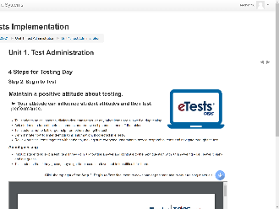 | Step 2. Begin to Test  CFU 4, 5 | As you help students Begin to Test, your attitude about testing is important and can influence student attitudes.  So, stay positive and that can help students perform their best while testing.  Here are some general guidelines to follow as you begin to test.  [Q4] A proctor should instruct students to skip a test item if they do not know the answer.  [Q5] Why? Because…  - Students may guess correctly even though they have not mastered the content.  - Their test results may not accurately reflect their skills and abilities.  - Students may be placed in a level that is too difficult for them.
 | 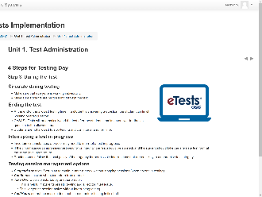 | Step 3. During the Test  CFU 6 | Proctors should quietly circulate around the room During Testing to make sure everyone is working individually and progressing through the test.  Some students may finish before time is up and that is OK.  CASAS eTests will alert the student when the test is about to end.  [Q6] Students are not allowed to stop testing at any time and finish the test on another time or day.  Here are options that proctors should understand how to use when managing sessions during testing.  - Suspend a session if you plan to continue after a break without stopping sessions when no one is testing.  - Continue a session when you return from a break.  - Take Over a session started by another proctor. This is helpful if students are still testing and a proctor must leave. This keeps the session active without interrupting testing.  - Add Hours so that the session does not time out before testing is finished.
 | 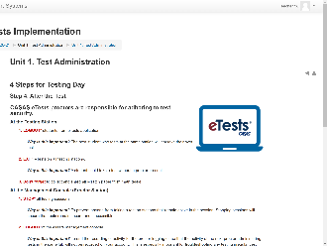 | Step 4. After the Test  CFU 7 | The last step for testing day is all about test security.  [Q7] After testing students, the proctor is responsible for:  [Q7] Making sure each student LOGs OUT from eTests when they are finished with their tests.  [Q7] When all testing is finished, the proctor EXITs and closes eTests on all testing stations.  [Q7] The proctor STOPs all active testing sessions and LOGs OUT of the eTests management console, and then  [Q7] EXITs to close the eTests application on the proctor station.
10:27  3 min. | Module | Unit 1. Sample Test Items  Trainer: click the Sample Test Items link on your screen. | This next Book in Unit 1, introduces you to Sample Test Items.
 |  | 1 Sample Test Items  (Content also covered in M1)  Emphasize for those who already completed M1 | Sample test items are a great way for teachers to provide student practice.  They:  - Familiarize students with the format of CASAS test items  - Make testing go more smoothly  - Help reduce test anxiety  These are not actual tests and cannot be used to determine basic skills or for placing students in a program.
 | SAMPLER  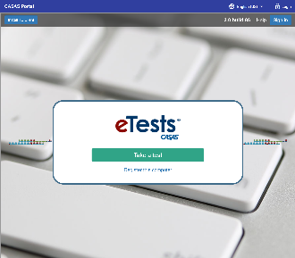 | 1.1 CASAS eTests Sampler  https://casasportal.org/eTests | [Trainer: SKIP if short on time.]  The CASAS eTests Sampler is a great way to give students practice with eTests and navigating through a test.  We have about [#] minute(s) for you to explore these items and then we will ask you to return to the Meeting Room.  You don’t need to actually test yourself, just explore the eTests application interface and how it functions.  Click on any of the URL that [Trainer 1] just entered in the Chatbox.
 |  | Guide participants back to the web conference Meeting Room. | Ok, now let’s have everyone return to the Meeting Room.  Click the Blue video icon at the bottom of your computer monitor.
 | Slide 16 | Trainer 2: RETURN to PPT
10:30  10 min. | Slide 17  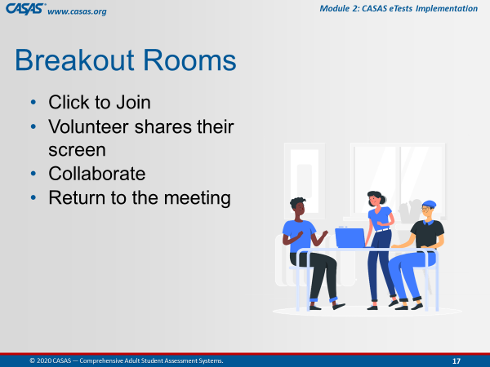 | Briefly review collaborating in Breakout Rooms. | We will be sending you to Breakout Rooms now.  A volunteer in your breakout room will share their screen so that everyone in the Breakout Room can collaborate on the checks for understanding in the unit we just covered.  When your group finishes you will return to the Meeting Room.
 | Slide 18  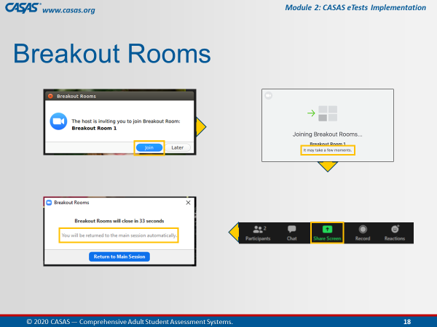 | This is an ANIMATED slide in PPT “slide show” mode. | When the pop-up appears on your screen,  [Click 1] Click Join.  Wait a few minutes…and when everyone is together in the Breakout Room,  [Click 2] Choose a volunteer who will share their screen.  [Click 3] A pop-up will appear just before you are automatically returned to the Meeting Room.  You will not need to return to the main room when you see this pop-up.  Just relax and continue your discussion until the application brings you back to the main room automatically.
 |  | Unit 1. Check for Understanding  BREAKOUT – CFU Activity (7 Qs)  One participant shares their screen and opens the Unit CFU.  Add Unit CFU Link and Task to Chatbox.  UNIT 1. CHECK FOR UNDERSTANDING  http://training.casas.org/mod/quiz/view.php?id=2688 | Ok, now we are going to send you to the Breakout Rooms.  [Trainer 1] will put the link to Unit 1. Check for Understanding link in the Chatbox.  When you are in the Breakout Room, the volunteer will:  - Share their screen and  - Click on the link from the Chatbox.  The checks for understanding will open automatically.  Please work together as a group to answer each question.  You will be automatically brought back to the Meeting Room when time is up.
 |  | - Send to BOR.  - Broadcast task.  - Close BOR when 1 min. remains. | Ok, click Join.  [Trainer: Broadcast task to BORs, e.g., “Please skip any questions if needed and go back to answer if time permits.”]
 | Slide 19  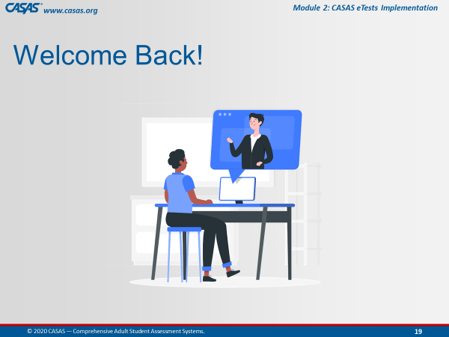 | Upon return, ask if anyone has questions about any CFU. | Welcome Back! Everyone.  Is there a CFU any of you had trouble answering?  We can take about [#] minute(s) to review the questions.
 |  | Trainer 2:  Trainer 1: | STOP Screen Share.  START Screen Share.
10:40  10 min. | Module | Unit 2. Intake Screening  Trainer 1: RETURN to Module.  Participants will view your screen. | Our next unit covers the importance of Intake Screening and what to observe and consider.  This unit will describe the oral, writing and reading tools used as part of the screening process.  This is the second of six units in this module.
 | 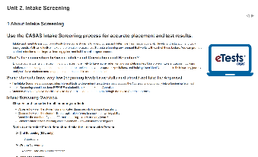 | 1 About Intake Screening  CFU 1 | The CASAS Intake Process is recommended for accurate test results and placement.  [Q1] The purpose of the Intake Screening is to determine if a locator (or appraisal) is suitable for a student.  [Q1] It also determines which pretest to give a student with beginning level skills.  [Q1] It can provide valuable information about a student’s speaking and writing skills and previous education.
 | 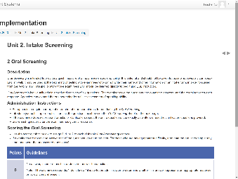 | 2 Oral Screening | Oral Screening is for non-native speakers of English and is intended to provide a quick measure of their speaking ability.  The Oral Screening is scored using the scoring rubric shown here to assign 0, 1, or 2 to each of the six Oral Screening questions.  If examinees are not able to answer one of the questions, go on to the next.  For those who are having apparent difficulty, terminate the oral screening at any time, and score the unanswered questions 0.
 | 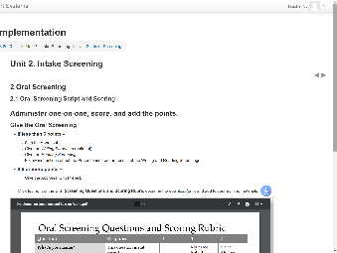 | 2.1 Oral Screening Script and Scoring | Here is the Oral Screening Script and some examples of scoring the Oral Screening questions.
 | 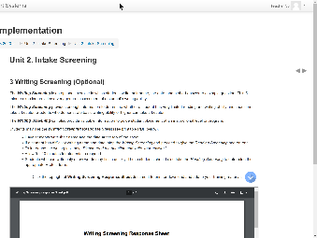 | 3 Writing Screening (Optional) | There is also an optional Writing Screening to determine  - if a student has very limited reading and writing ability,  - or a student demonstrates basic writing ability or higher.  This information is helpful in knowing the appropriate testing process for a student and for guiding student placement at an instructional level.
 | 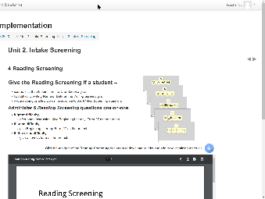 | 4 Reading Screening | The Reading Screening is for students  - scoring less than 6 points on the Oral Screening,  - or for students who had difficulty writing their Name or Date,  - or wrote nothing or just a few words on the Writing Screening.  The Reading Screening is administered one-on-one with the proctor observing the student’s level of difficulty.
 | 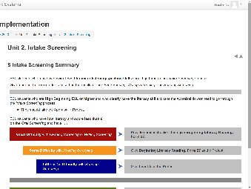 | 5 Intake Screening Summary  CFU 2 (4 parts) | Here is a summary of the Intake Screening process.  Give a pretest to ESL students based on the results of the Oral Screening, Writing Screening, and Reading Screening.  [Q2.1] If an ESL student scores 6 or more on the Oral Screening or has little or no difficulty on the other Intake Screenings, then…give the Locator followed by the Pretest.  [Q2.2] If an ESL student has lower level literacy skills and scores less than 6 on the Oral Screening, then…skip the Locator and give the Reading and Writing (optional) Screenings.  [Q2.3] If an ESL student has some difficulty with the Reading or Writing Screening, then… administer a Level A form as the Pretest.  [Q2.4] If an ESL student has great difficulty or difficulty on the Reading Screening, then…give the Beginning Literacy, Form 27 (or 28) as the Pretest.
 | 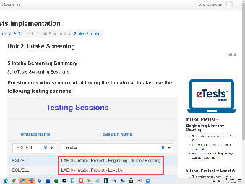 | 5.1 eTests Screening Sessions | CASAS adds a default set of Intake sessions to your eTests online account.  The first two sessions are for students who screen out of taking the Locator.  - So you would give the 1st Intake session to Beginning Literacy students with Form 27.  - and you would give the 2nd Intake session to Low Literacy students with Level A forms.  - The 3rd Intake session is for students who clearly have the literacy skills to take the Locator followed with the pretest.
 | Slide 19 | Trainer 1: | RETURN to the PPT.
10:50  5 min. | Slide 20  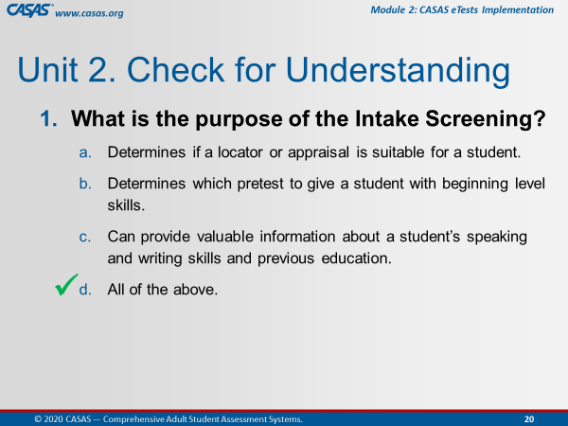 | Unit 2. Check for Understanding  CHATBOX – CFU Activity (2 Qs)  This is an ANIMATED slide in PPT “slide show” mode.  Participants enter their responses in the Chatbox. | I am going to display the next checks for understanding on my screen.  Please enter your answers in the Chatbox.  - What is the purpose of the Intake Screening?  - Determines if a locator or appraisal is suitable for a student.  - Determines which pretest to give a student with beginning level skills.  - Can provide valuable information about a student’s speaking and writing skills and previous education.  - [Click 1] All of the above.
 | Slide 21  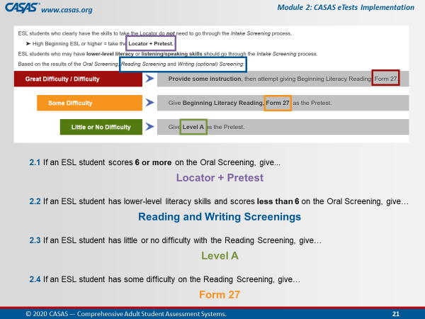 | Trainer: review answers in Chatbox and use them to respond to the CFUs.  [Click] Let’s check our answers.  CFU 2 | The next check for understanding is to determine what Intake Screening, or what test you should give a new student at Intake.  Choose your answer from the text in colorful boxes.  - Locator + Pretest  - Reading/Writing Screening  - Form 27  - Level A  2.1 If an ESL student scores 6 or more on the Oral Screening or has little or no difficulty on the other Intake Screenings, then…  [Click 1] ANSWER: give the Locator followed by the Pretest.  2.2 If an ESL student has lower level literacy skills and scores less than 6 on the Oral Screening, then…  [Click 2] ANSWER: skip the Locator and give the Reading and Writing (optional) Screenings.  2.3 If an ESL student has some difficulty with the Reading or Writing Screening, then…  [Click 3] ANSWER: administer a Level A form as the Pretest.  2.4 If an ESL student has great difficulty or difficulty on the Reading Screening, then…  [Click 4] ANSWER: give the Beginning Literacy, Form 27 as the Pretest.
 |  | Trainer 1:  Trainer 2: | STOP Screen Share.  START Screen Share.
10:55  10 min. | Module | Unit 3. Locators & Progress Tests (Pre- and Post)  Trainer 2: RETURN to Module.  Participants will view your screen. | Our next unit, Unit 3, is about Locators and Pre- and Post-Tests, which are referred to as Progress Tests because gains are measured between the pretest and the post-test.  [Trainer: click the Unit 3. link on your screen.]
 | 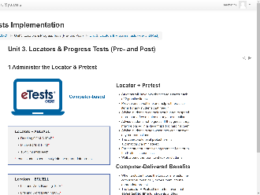 | 1 Administer the Locator & Pretest  CFU 1, 2 | [Q2] When a student takes the Locator in eTests, the computer automatically moves them into the appropriate pretest level and form.  The Locator + Pretest is one test event that saves testing time for students and test administrators.  [Q1] You may provide additional time and help with practice items for any students that need it.  Advise students to do their best and not to guess.  Assure students that they may stop when they can’t answer any more questions.  Don’t forget to walk around the room to check on students.
 | 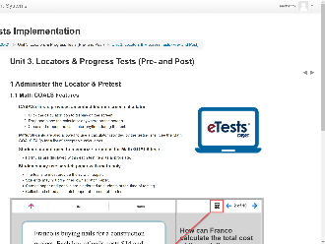 | 1.1 Math GOALS Features  CFU 4, 5 | [Q4] Students may use calculators when taking CASAS Math GOALS tests.  [Q5] Students do not need to memorize formulas for CASAS Math GOALS tests.  Programs that use paper tests should provide students with a basic calculator (not a graphing calculator) with taking Math GOALS tests.  Scratch paper may also be provided to students taking Math tests but the paper must be collected and destroyed after testing.
 | 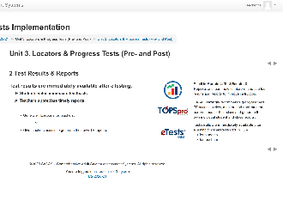 | 2 Test Results & Reports | - Students value immediate feedback, and  - Teachers appreciate timely reports.  Because test results are immediately available after eTesting, teachers can generate their own reports in TOPSpro Enterprise immediately after testing.
 | 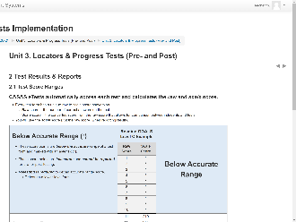 | 2.1 Test Score Ranges  CFU 3  (Content also covered in M1)  Emphasize for those who already completed M1. | All CASAS test forms have three score ranges – below accurate, accurate, and conservative estimate range.  Here is an example from the Reading GOALS series for Level C.  We learned in Module 1 that…  [Q3.1] The Raw score indicates the number of correct answers and that these scores must be converted to a scale score to measure gains.  And that the…  [Q3.3] The Scale score indicates a score used for measuring progress and reporting outcomes.  [Q3.2] The Asterisk score (*) indicates a score below the accurate range. These scores are invalid and retesting with a lower-level form is required.  [Q4.4] The Diamond score (♦) indicates a conservative estimate score (above the accurate range). These scores are valid but CASAS recommends retesting for pretests.
 | 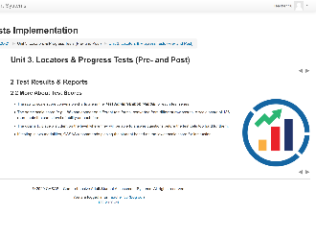 | 2.2 More About Test Scores | CASAS eTests automatically scores each test and calculates the raw and scale score.  Score conversion charts are in the Test Administration Manual for each test series.  CASAS scale scores appear on different test forms and represent the same level of ability on each form.  If you test in two modalities, place students at the lower scale score for placement.  The test Form Level a student took is not as important as placing students based on their Scale Score.
 | 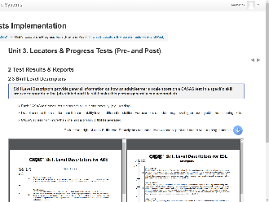 | 2.3 Skill Level Descriptors  (Content also covered in M1)  Emphasize for those who already completed M1. | The CASAS Skill Level Descriptors show a continuum of skills from beginning through advanced adult secondary and explain in general terms what most learners can accomplish at the CASAS scale score level in a specific skill area.  Note that CASAS levels go from:  - A (lowest level) to  - E (highest level).  Each test modality (e.g., reading, listening) measures the ability of a student for the skill tested.  A student’s listening skills may not be the same as their reading skills. So the descriptors help to understand their educational functioning level.  CASAS scores from more than one modality should not be averaged.  If you are only testing reading skills, then only the reading descriptors apply. The same holds true for math and listening.  You will find more Skill Level Descriptors on the CASAS website.
 | 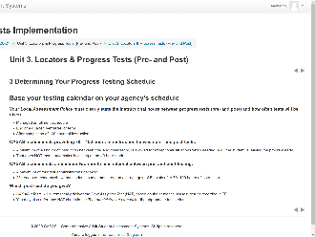 | 3 Determining Your Progress Testing Schedule | How will you determine a progress testing schedule?  Base it on your agency’s calendar for instructional terms such as quarterly or by semester or when a student completes 100 hours of instruction.  Every agency should have a written Local Assessment Policy that clearly states the instructional hours between pre- and post-tests and how often testing will occur.  25+ years of research show that students demonstrate an average gain of 5 points after 70-100 hours of instruction.  You are permitted to test after a minimum of 40 hours.  However, this should only be the exception, and not the norm, and only if a student is leaving the program early.  CASAS also recommends a minimum of two-month intervals between pre- and post-testing with a maximum of four test administrations per year.
 | 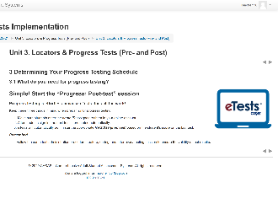 | 3.1 What do you need for progress testing? | What do you need for progress testing?  Not much! That’s because eTests automatically administers the appropriate “Next Assigned Test” based on the student’s score on the last test in the same modality.  Simply start the Progress: Post-test session and make sure students enter the same ID that already exists in your TOPSpro Enterprise online account.
 | 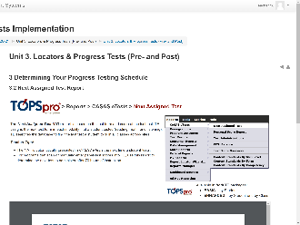 | 3.2 Next Assigned Test Report  Review the report with participants | The Next‐Assigned Test report is useful if your agency uses both eTests and paper tests.  This report is designed to take the legwork out of deciding which paper test to administer an individual student who previously took an eTests.  This report standardizes test administration for all students – regardless if the next test is taken with eTests or with paper tests.  The take-away from this report is that eTests is fully automated to present the next appropriate level tests at any time.
 | Slide 22  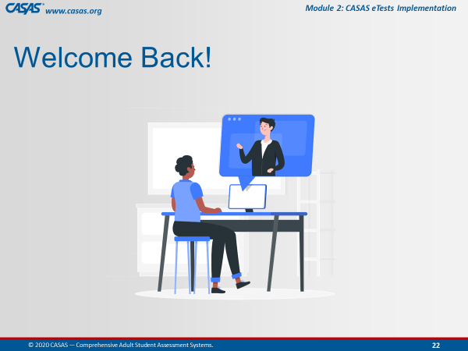 | Trainer 2: RETURN to PPT.
11:05  5 min. | Slide 23  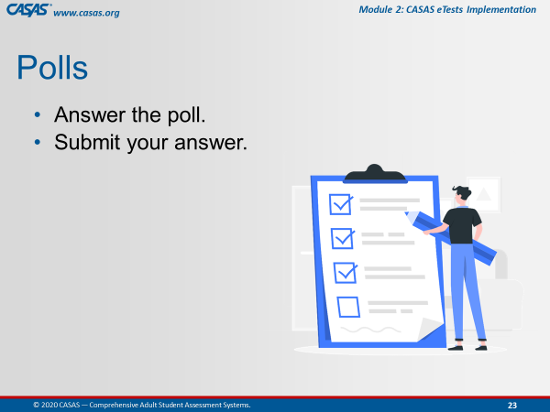 | Unit 3. Check for Understanding  POLL – CFU Activity (8Qs)  - Launch the poll.  - Respond to the poll.  - Close the poll.  - Share the results.  Confirm correct responses and provide clarification if needed. | I am going to launch a Poll for you to answer checks for understanding the content we just covered in this unit.  There are 8 questions.  I’ll give you a [#] minute(s) to go through them and then close the poll.  Ok, everyone is doing a great job. I’m going to close the poll in about 5 seconds.  [Trainer: comment on participant responses.].
 |  | Remind participants to close the poll on their screen. | Ok, go ahead and Close the poll window on your screen.
 |  | Trainer 2:  Trainer 1: | STOP Screen Share.  START Screen Share.
11:10  8 min. | Module | Unit 4. Going Live! Checklist - First Steps  Trainer 1: RETURN to Module.  Participants will view your screen. | Our next unit will cover the CASAS eTests Implementation process and the FIRST set of STEPS to complete before accessing your online account.  This is the fourth unit out of six in this module.  [Trainer: click the Unit 4. link on your screen.]
 | 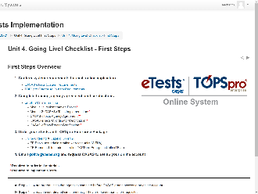 | First Steps Overview  [Trainer: point to each step as you describe the following.] | The First Steps to Going Live! are to:  - Confirm system requirements for each online application – eTests and TOPSpro Enterprise.  - Complete training, submit an agency agreement, and complete eTests certification.  - Order your online package, and we’ll talk a little more about that in a minute.  - Email the Go Live! Team after completing Steps 1-3 and let them know you are ready for CASAS to set up your online account.  Steps 1 through 4 are prerequisites that agencies complete before access can be granted to an online account.  Steps 1 through 3 may be coordinated simultaneously. They are not sequential prerequisites.  Step 4 is what alerts CASAS that your agency is ready to access an online account and complete the second set of steps before Going Live! with eTests Online.
 | 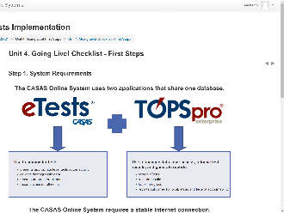 | Step 1. System Requirements  CFU 1, 2, 3 | The CASAS Online System uses two applications sharing the same database.  You will be using both online applications.  [Q1] CASAS eTests is primarily used to administer computer-delivered tests, with the option to collect demographic information.  TOPSpro Enterprise, commonly referred to as TE, scores eTests, records results, tracks progress, and reports outcomes for accountability.  Both applications require a stable Internet connection.  [Q3] eTests can be delivered on multiple devices, such as Chromebooks, iPads, and PCs with Windows 10;  [Q2] whereas TE only runs on Windows-based machines.  TE is a cloud-based application that staff access through installation of the TE Client.  - If TE will be accessed on computers that are also registered for eTesting, TE Client must be installed.  - If computers are only used for eTesting, installation of the TE Client is not required.
 | 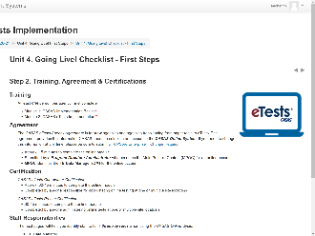 | Step 2. Training, Agreement & Certifications  CFU 4, 7, 11 | The CASAS eTests Agency Agreement is for New Agencies and current agencies transitioning from CASAS paper tests to CASAS eTests.  [Q4] The Agency Agreement provides critical information to set up your online account. We ask for this agreement to be submitted only once by the Program Director or Administrator, who will be your online account’s Main Point-of-Contact.  [Q7] Each test site that administers CASAS eTests must have at least one Certified Coordinator and one Certified Proctor. So if you are asked by your agency to fulfill one or both of these roles, the first step you should take is to complete certification.  [Q11] Any staff who will administer eTests must complete proctor certification.
 | 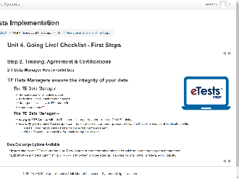 | 2.1 Data Manager Responsibilities  CFU 6 | [Q6] The TE Data Manager is responsible for:  - Managing your online account data  - Adding users, sites, teachers and classes to TE, which can also be imported from an external database for quick setup and ongoing data management, and  - Managing user access to TE and / or eTests.  The Data Manager is also generally responsible for reporting outcomes for accountability. This can be done by exporting data in different formats, which can also be imported to an external database.
 | 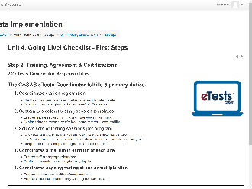 | 2.2 eTests Coordinator Responsibilities  CFU 8, 9, 10 | eTests Coordinators have 5 primary duties to fulfill. Among these duties are to:  - Coordinate the registration of testing stations.  [Q8] Registering computers is a one-time task. Only one certified eTests user is needed to register a testing station, which can be either coordinators or proctors.  - Selects sets of testing sessions per program.  [Q9] The coordinator selects sets the sessions that are appropriate for their program based on the testing purpose. After selecting these sessions, eTests coordinators replicate them to each testing lab at each site for standardized testing at all site locations.  [Q10] After an eTests coordinator replicates sessions, proctors then start and stop these sessions throughout the program year whenever testing is needed.
 | 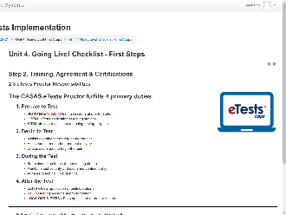 | 2.3 eTests Proctor Responsibilities  CFU 9 | eTests Proctors have 4 primary duties to fulfill. Among these duties are  1. Prepare to Test  [Q9] Proctors manage the same testing sessions throughout the program year.  [Q9] They simply START testing sessions to administer tests, and  4. After the Test  [Q9] STOP testing sessions when they are finished with testing.
 | 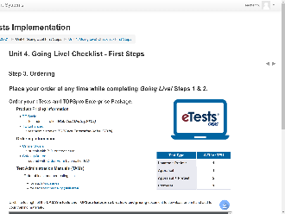 | Step 3. Ordering | You can place an order for your TOPSpro Enterprise Package at any time while you are completing the First Steps in the Going Live! process.  Here is a product brochure that you can download or print from the module to help you determine which package works best for you.  Essentially, you will be ordering electronic test administrations, or virtual answer sheets.  Here is a simple table to help you determine how many test units to order.
 | 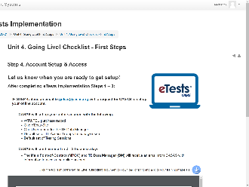 | Step 4. Account Setup & Access  CFU 5 | After you’ve completed Steps 1 to 3 on the Going Live! Checklist, then complete Step 4 by sending an email to CASAS and request the set-up of your online account.  Your account is set up in about 1 to 2 business days.  [Q5] When set up, CASAS will send an email to the Main Point of Contact and TE Data Manager with information to access your account.
 | Slide 24  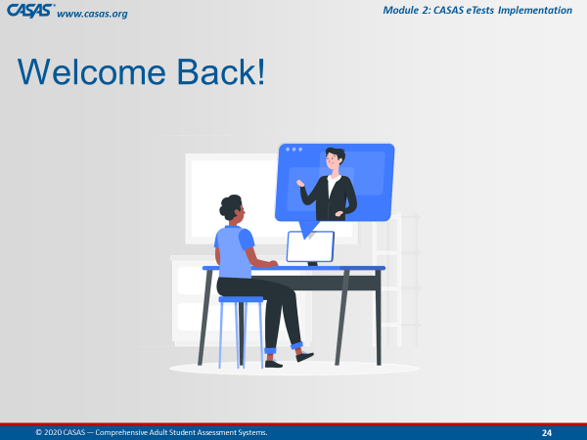 | Trainer 1: | RETURN to the PPT.
11:18  10 min. | Slide 25  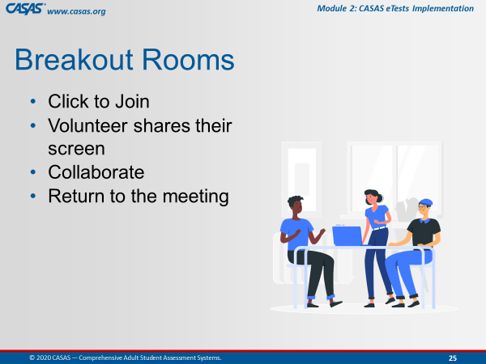 | Unit 4. Check for Understanding  BREAKOUT – CFU Activity (11 Qs)  One participant shares their screen and opens the Unit CFU.  Add Unit CFU Link and Task to Chatbox.  UNIT 4. CHECK FOR UNDERSTANDING  http://training.casas.org/mod/quiz/view.php?id=2802 | Ok, now we are going to send you to Breakout Rooms again.  [Trainer 1] will put the link to Unit 4. Check for Understanding in the Chatbox.  When you are in the Breakout Room, the volunteer will:  - Share their screen and  - Click on the link from the Chatbox.  The checks for understanding for Unit 4 will open automatically.  Please work together as a group to answer each question.  You will be automatically brought back to the Meeting Room when time is up.
 |  | - Send to BOR.  - Broadcast task.  - Close BOR when 1 min. remains. | Ok, click Join.  [Trainer: Broadcast task to BORs, e.g., “Please skip any questions if needed and go back to answer if time permits.”]
 | Slide 26  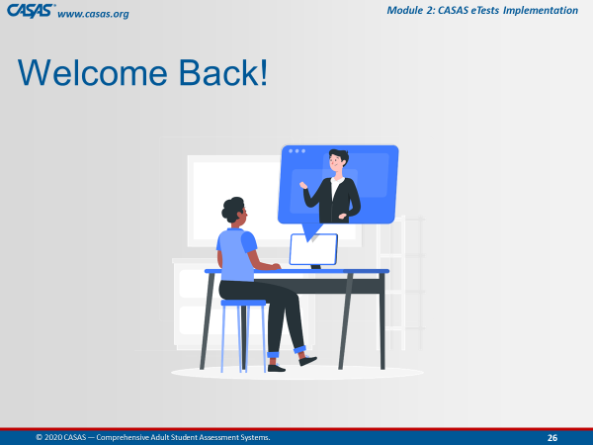 | Upon return, ask if anyone has questions about any CFU. | Welcome Back! Everyone.  Is there a CFU any of you had trouble answering?  We can take about [#] minute(s) to review the questions.
 |  | Trainer 1:  Trainer 2: | STOP Screen Share.  START Screen Share.
11:28  10 min. | Module | Unit 5. Going Live! Checklist - Next Steps  Trainer 2: RETURN to Module.  Participants will view your screen. | Our next unit will continue the Going Live! discussion by presenting the Next Steps in the process, Steps 5 through 12.  [Trainer: click the Unit 5. link on your screen.]
 | 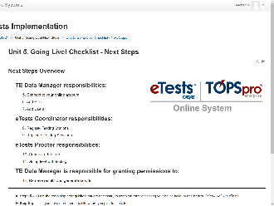 | Next Steps Overview | These steps are necessary to ensure your implementation process goes smoothly and you get off to a good start.  [Trainer: Review each step and then sum it up with …]  Steps 5 – 10 are remaining prerequisites necessary to complete after initially accessing to your online account and before Going Live! with eTests.  Step 6 applies if you have more than one site where you plan to use eTests.  Step 7 is necessary to add certified eTests users who will assist with Step 8 and also participate in Steps 10 & 11.  Steps 8 & 9 may be completed in any order.  Step 10 is strongly recommended prior to going live in Step 11.  Step 12 applies any time after Going Live!
 | 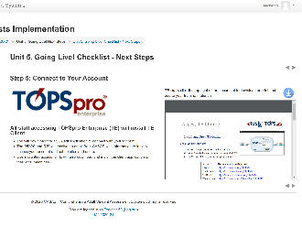 | Step 5: Connect to Your Account  CFU 1 | To access your account for the first time, you will simply open your web browser and download the TE Client application to connect to your account.  CASAS will provide you will your initial log in credentials to connect.  This document gives you step-by-step directions how to connect to your account as well as the recommended steps for exiting TE to ensure that your data is kept secure.  [Q1] The TE Client application should be downloaded on Computers that will be used by staff who need to access student test data.
 | 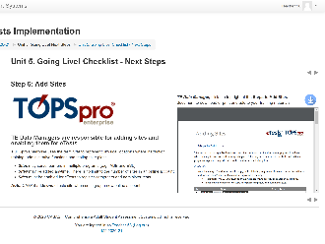 | Step 6: Add Sites  CFU 3 | When setting up a new online account, CASAS adds one Site enabled for eTests.  [Q3] The TE Data Manager adds additional Sites in TE as needed and enables the Sites that will use eTests.  If a testing site is not enabled for eTests, the Site will not be available in the eTests application, which is necessary to register testing stations.  If the mobile devices (such as Chrome books) are used at multiple testing sites, they can be registered as a site named “Mobile Lab”.  There is no limit to the number of sites that the Data Manager may add to the online account.
 | 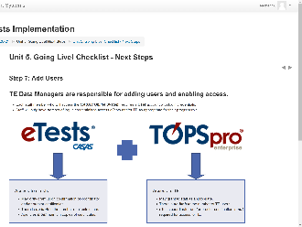 | Step 7: Add Users  CFU 2 | When setting up a new online account, CASAS also adds one User account for the Data Manager who then adds additional User accounts for other staff.  [Q2] Once access is granted by the TE Data Manager, each staff member will have one set of log-in credentials to access TE and /or eTests as appropriate.  Access to eTests –  - May only be granted upon confirmation of coordinator and/or proctor certification.  - [Q3] There is no limit to the number of eTests users.  - Agencies must maintain copies of certificates.  Access to TE –  - May be granted to staff as appropriate.  - [Q3] There is no limit to the number of TE users.  - eTests coordinator and/or proctor certification is not required for access to TE.
 | 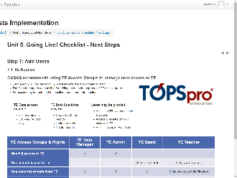 | 7.1 TE Access  CFU 6 | CASAS recommends using TE Access groups to manage users at all sites.  [Q6] Based on staff roles, responsibilities and certifications, the TE Data Manager may grant users...  - Access to TE without access to eTests.  - Access to eTests without access to TE.  - Access to both TE and eTests.  This table shows the Default set of Access Groups that CASAS adds to online accounts and the basic access RIGHTs granted to TE users in each group.
 | 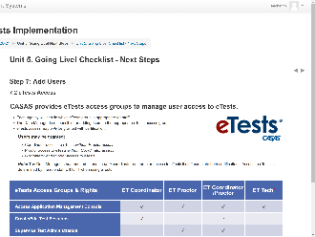 | 7.2 eTests Access  CFU 7 | The TE Data Manager is not required to enable both Coordinator and Proctor access to eTests if staff complete both certifications.  eTests access may only be granted upon confirmation of coordinator and/or proctor certification.  Agencies must maintain copies of certificates on file.  This table defines the access RIGHTs granted to coordinators and proctors.  [Q7] Based on staff roles, responsibilities and certifications, the Data Manager may grant users...  - Coordinator only access to eTests without Proctor access.  - Proctor only access to eTests without Coordinator access.  - Coordinator and Proctor access RIGHTs to eTests.
 | 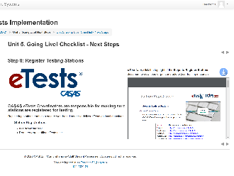 | Step 8: Register Testing Stations  CFU 4, 5 | Registering testing stations enables a web-secure server to deliver eTests on the local machine.  [Q4] Remember, station registration is a one-time event!  [Q5] And registering stations only requires one certified eTests user, which may be an eTests Coordinator or an eTests Proctor  It is the responsibility of a certified eTests Coordinator to identify and authorize the registration of testing stations.
 | 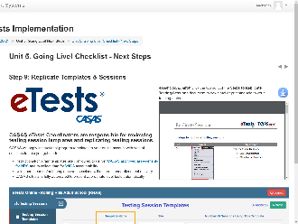 | Step 9: Replicate Templates & Sessions | CASAS will add a default set of Instructional-program templates and sessions to your online account as pictured here.  These are configured to deliver CASAS approved assessments for NRS and to collect demographic data for WIOA accountability.  Using use these default templates and sessions will  - ensure standardized test delivery, and  - present appropriate level tests automatically.  CASAS eTests Coordinators are responsible for reviewing these testing session templates and making any changes needed to meet their program’s assessment and accountability needs.
 | 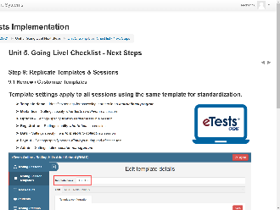 | 9.1 Review / Customize Templates | Testing Session Templates define the following:  Template Name – Identifies settings for assessing learners in an instructional program.  - Template Name – Identifies settings for assessing learners in an instructional program  - Modalities – Settings specify what tests to deliver in a session  - Options – Settings specify how to deliver tests in a session  - Registration – Settings identify who to test in a session  - Data – Settings specify the information to collect in a session  - Layout – Settings specify screen displays during and after the test  - Admin – Settings define session management
 | 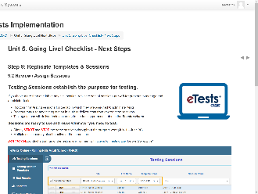 | 9.2 Review / Assign Sessions  CFU 8 | Testing Sessions establish the purpose for testing.  CASAS eTests Coordinators are also responsible for replicating testing sessions to each lab at each test site.  Sets of testing sessions are required per lab for proctors to manage and administer tests.  One certified proctor per 20-25 students is required per lab.  [Q8] After replicating, sessions are ready to use and re-use whenever you need to test.  Simply START and STOP the same sessions throughout the program year (July 1 – June 30).  Multiple sessions may also be active at the same time.  The CASAS Online System is fully automated to present appropriate-level tests with these standardized sessions.  Proctors may use any testing station in a lab to deliver tests from any of these sessions.  Testing stations will deliver tests according to the testing session purpose stated in the session name.
 | 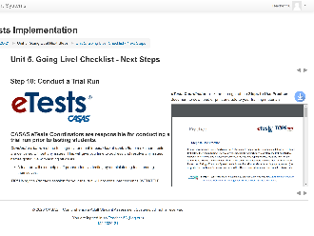 | Step 10: Conduct a Trial Run | CASAS eTests Coordinators are also responsible for conducting a trial run prior to testing students.  Conducting a trial run will help staff prepare for live testing.  Role-play the steps for testing day and administer eTests Practice tests with staff.  Here is a step-by-step document to help you do that.  The Practice tests in eTests are the same as in the eTests Sampler.  There is no cost to using Practice.
 | 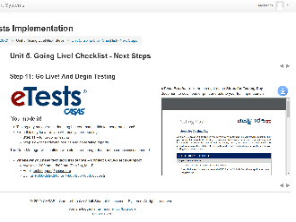 | Step 11: Go Live! And Begin Testing | When you Go Live! Use the Steps for Testing Day document to guide you.  And if you ever need technical assistance – CASAS Tech Support Team Members are there to help.
 | 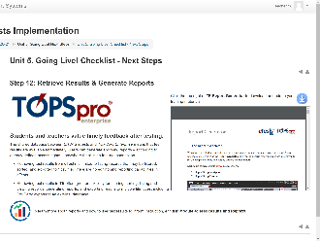 | Step 12: Retrieve Results & Generate Reports | Because eTests and TE share the same database, test results are immediately available in TE to generate reports.  There is no reporting capability in eTests other than exporting a list of test results.  Retrieving test results in TE offers greater flexibility for filtering, sorting, listing and viewing records, generating reports, and exporting results to multiple file types,
 | Slide 26 | Trainer 2: | RETURN to the PPT.
11:38  5 min. | Slide 27  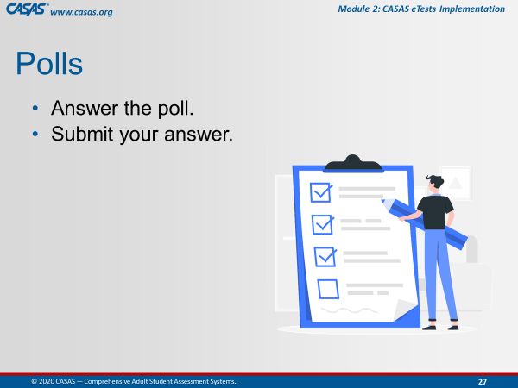 | Unit 5. Check for Understanding  POLL – CFU Activity (8 Qs)  - Launch the poll.  - Respond to the poll.  - Close the poll.  - Share the results.  Confirm correct responses and provide clarification if needed. | The checks for understanding the content in Unit 5 are in one Poll.  There are 8 questions.  I’ll give you a [#] minute(s) to go through them and then close the poll.  Ok, everyone is doing a great job. I’m going to close the poll in about 5 seconds.  [Trainer: comment on participant responses.]
 |  | Remind participants to close the poll on their screen. | Ok, go ahead and Close the poll window on your screen.
 |  | Trainer 2:  Trainer 1: | STOP Screen Share.  START Screen Share.
11:43  2 min. | Module | Unit 6. Wrap-up! What's Next?  Trainer 1: RETURN to Module.  Participants will view your screen. | Congratulations! You are almost finished with Module 2.  [Trainer: click the Unit 6. link on your screen.]
 | 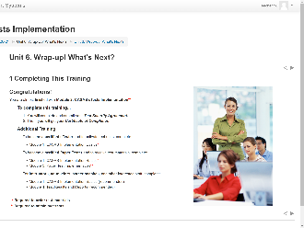 | 1 Completing This Training | You are almost finished with Module 2: CASAS eTests Implementation, which will allow you to implement eTests.  In a moment, we will walk you through the process to complete your training.  To order CASAS eTests and any other test materials, you will also need to complete Module 1.  To administer Paper Tests, you will also need to complete Module 3.  And don’t forget Module 4, which will help you with interpreting test results and reports.
 | 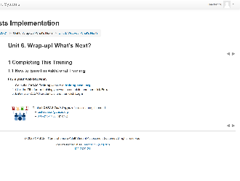 | 1.1 How to Enroll in Additional Training | Just like we did today, you will follow the same steps to enroll in additional training.
 | 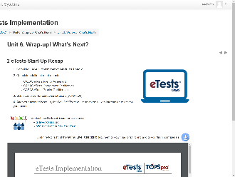 | 2 eTests Start-Up Recap  GOING LIVE! CHECKLIST  https://www.casas.org/product-overviews/software/casas-etests/-going-live-checklist | So at this point, you only need to focus on completing the first four steps in the Going Live! process to have access to an eTests account.  You can download or print the Going Live!! Checklist from the module or the URL [Trainer 1] just put in the Chatbox.
 | 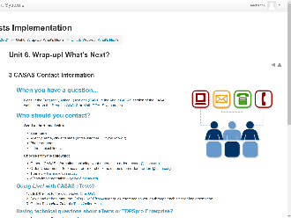 | 3 CASAS Contact Information | And finally, here is helpful information for who to contact at CASAS if you have a question.  Office hours are Monday through Friday, 8:30 am to 5:00 pm Pacific Time.
 |  | Trainer 1: | STOP Screen Share.
 | Slide 28  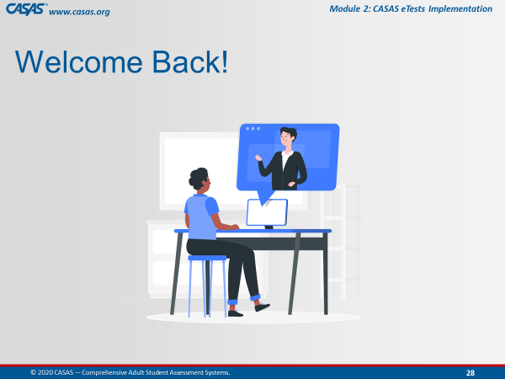 | Trainer 2: | START Screen Share.
11:45  10 min. | Slide 29  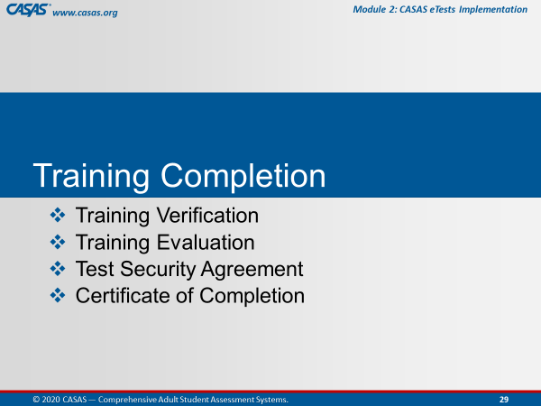 | TRAINING COMPLETION | To complete your training today, you will:  Submit a Training Verification and Evaluation with your Test Security Agreement, and then get your Certificate.
 | Slide 30  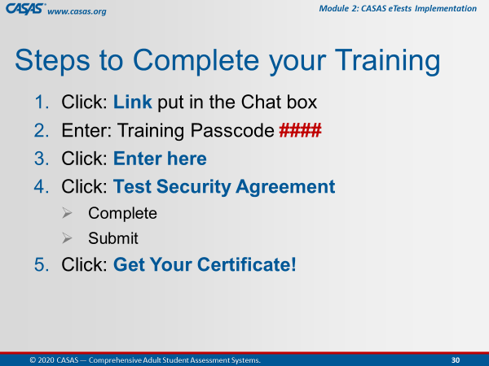 | This is an ANIMATED slide with 5 clicks for each highlighted text.  Note: Click 4 has 2 additional automated text. | The steps you will complete are the following:  [Click 1] Click the Link that will be put in the CHATBOX after we review these steps.  [Click 2] You will be prompted to enter a Passcode, which is <Trainer: insert own passcode>.  [Click 3] After entering the passcode, click the Enter here button.  [Click 4] You will see the Test Security Agreement link, which you will click to complete and submit.  [Click 5] And last, click the Get your Certificate! Link.
 | Slide 31  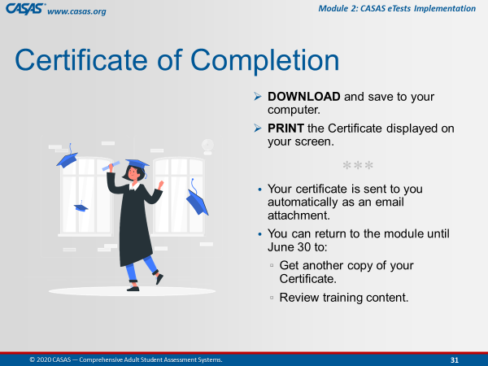 |  | You can download or print the certificate directly from your computer.  Your certificate will also be sent to you as an email attachment.  You can always return to the module to get another copy of your certificate and review training content.
 |  | TRAINING COMPLETION:  http://training.casas.org/course/view.php?id=424 | Ok everyone, go to your CHATBOX and click on the URL that [Trainer 1] just put in there.
 |  |  | Return to the Meeting Room when you are finished.  Remember how do we do that?  Click the Blue video icon at the bottom of your computer monitor.
 |  | Trainer 2: | STOP Screen Share.
 | Slide 32  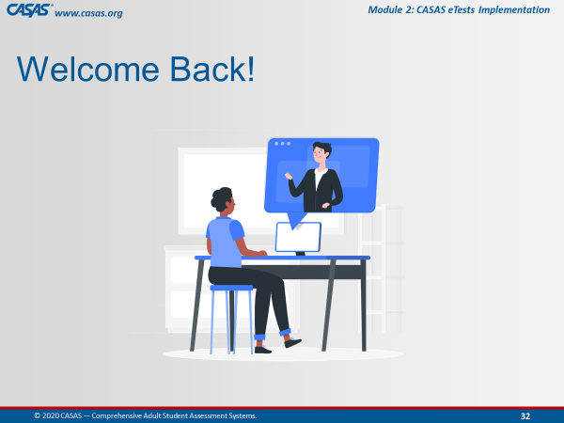 | Trainer 1: | START Screen Share.
11:55  3 min. | Slide 32  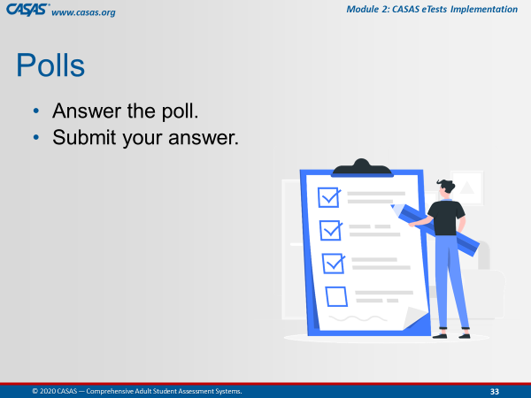 | CLOSING Polls  LAUNCH POLLS:  - Respond to poll.  - Close the poll.  - Share the results. | - Did you get your certificate?  - After this training do you feel more confident in returning to the online modules?  - After this training do you feel more confident that the content learned will support you in using CASAS?
 |  | - Close the polls | Congratulations everyone! You did a great job!  Don’t forget to close the Poll screen.
 |  | Trainer 1:  Trainer 2: | STOP Screen Share.  START Screen Share.
11:58  2 min. | Slide 33  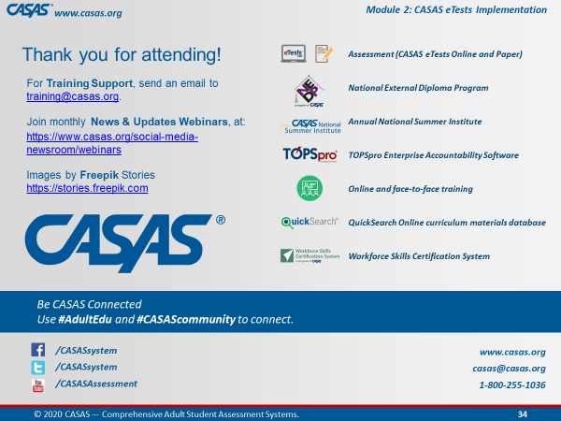 | Wrap Up!  CASAS Contact Info | Thank you for attending today’s training.  If you have any questions about Training, email the Training Desk at training@casas.org.
 |  | Webinars | Join us for monthly webinars to learn about the latest CASAS News & Updates.  Check the Social Media web page on the CASAS website for information about the next webinar.
 |  | Online Training | We hope you feel more confident in not only going in and out of the modules, but also knowing where a lot of rich information lives!  Don’t forget that you can review content in the online training modules and enroll in additional training at http://training.casas.org/
12:00  End Time |  | Stay “live” for any questions.  End meeting for all when finished. | We will stay on if anyone has questions otherwise, you are dismissed.  Thank you again for participating in this training.
120 min. |  | END TRAINING

