Checks for Understanding

About: Check for Understanding
Use this table to answer the following questions:
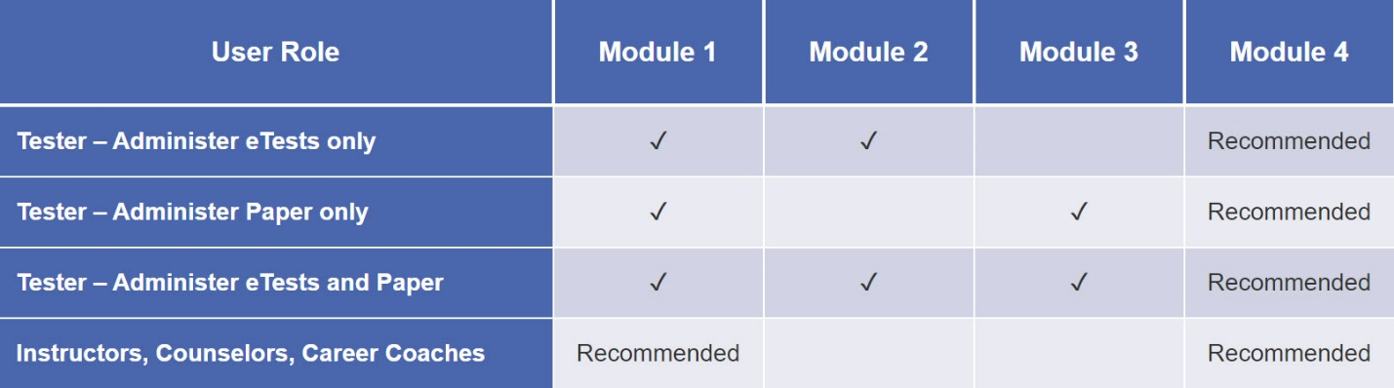
✓ = Required training

Question 1
If you only plan to paper test, which two training modules are required?
Please choose two answers
Module 1: CASAS Implementation Basics
Module 2: CASAS eTests Implementation
Module 3: Paper Test Implementation
Module 4: Test Results and Reports

Question 2
Which two training modules are recommended for instructors, counselors, career coaches, and other interested staff?
Please choose two answers
Module 1: CASAS Implementation Basics
Module 2: CASAS eTests Implementation
Module 3: Paper Test Implementation
Module 4: Test Results and Reports

Unit 1. Check for Understanding

Question 1
Which test delivery method requires a Test Administration Manual (TAM)?
Select one:
Paper tests only
CASAS eTests only
Both paper tests and eTests
A TAM is not required for paper tests or eTests.

Question 2
A Test Administration Manual (TAM) contains:
- Answer Keys
- Score Conversion Charts
- Next Assigned Test Charts
- CASAS Competencies and CASAS Content Standards
- Class and Student Profiles
- Standardized Test Administration Procedures and Policies
- Test Security Protocols

Question 3
A scanner is required to correct paper answer sheets.
Select one:
True
False

Question 4
Where can you find the answers to CASAS test items?
Select one:
On the CASAS website
In the Test Administration Manual (TAM)
All of the above

Question 5
Local agencies are responsible for providing accommodations for learners who have documented disabilities. This applies to both eTesting and paper testing.
Indicate whether or not each accommodation below is allowed for students with special needs.
1. Allowing a student extended time for the test Allowed
2. Giving the student a supervised break Allowed
3. Using a sign language interpreter for test directions Allowed
4. Allowing a student to take the test in an alternate room Allowed
5. Leaving a student alone to take a test Not Allowed
6. Translating unfamiliar words in test items Not Allowed

Question 6
Teachers may provide help with practice items.
Select one:
True
False

Unit 2. Check for Understanding

Question 1
What is the purpose of the Intake Screening?
Select one:
It determines if a locator or appraisal is suitable for a student.
It determines which pretest to give a student with beginning level skills.
It can provide valuable information about a student’s speaking and writing skills and previous education.
All of the above.

Question 2
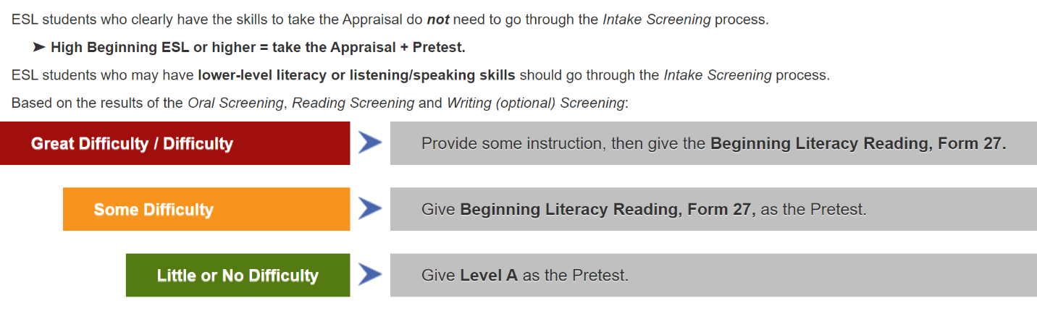
Answer the following questions.
1. If an ESL student scores 6 or more on the Oral Screening, then… give the Appraisal followed by the Pretest.

2. If an ESL student has lower-level literacy skills and scores less than 6 on the Oral Screening, then… skip the Appraisal and give the Reading and Writing (optional) Screenings.

3. If an ESL student has little or no difficulty with the Reading Screening, then… administer a Level A form as the Pretest.

4. If an ESL student has some difficulty on the Reading Screening, then… give the Beginning Literacy, Form 27, as the Pretest.

Unit 3. Check for Understanding

Question 1
An appraisal may be used to determine an appropriate pretest.
Select one:
True
False

Question 2
An appraisal may be used as a baseline to measure learning gains.
Select one:
True
False

Question 3
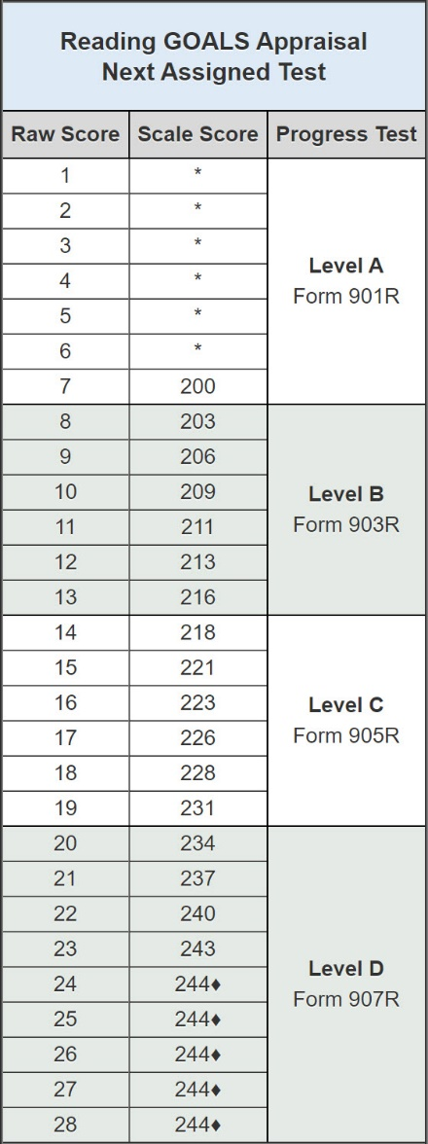
An appraisal may not be used for...
Select one:
placing students in an appropriate program.
measuring learning gains.
identifying instructional needs.
determining an appropriate pretest.

Question 4
Based on the Next Assigned Test chart...
1. What is the scale score of a student with a raw score of 7 on the Reading GOALS Appraisal? A scale score of 200
2. What Reading GOALS level test should you give a student with a scale score of 228? Level C
3. What Reading GOALS pretest form should you administer to a student with a raw score of 11? Form 903R

Question 5
What provides general information about what a scale score means in terms of job and life skills functioning?
Select one:
Answer sheet demographics
Next Assigned Test report
CASAS Skill Level Descriptors
Scale Score Conversion charts

Unit 4. Check for Understanding

Question 1
What is the general term for pre- or post-tests?
Select one:
Appraisals
Equivalency tests
Intake screenings
Progress tests

Question 2
Which assessment should you use for post-testing?
Select one:
A locator or appraisal from the same series as the pretest.
Any CASAS series at the same level of difficulty as the pretest.
The same series and form number used in the pretest.
The same series you used for the pretest but not the same form.

Question 3
You must use the same assessment series (e.g., Reading GOALS) when progress testing a student in the same test modality.
Select one:
True
False

Question 4
Students need to memorize formulas for CASAS Math GOALS tests.
Select one:
True
False

Question 5
Students may use calculators when taking CASAS Math GOALS tests.
Select one:
True
False

Question 6
Select the correct term for each score description.
1. Raw score indicates the number of correct answers.
2. Asterisk score (*) indicates a score below the accurate range.
3. Scale score indicates a score used for measuring progress.
4. Diamond score (♦) indicates a conservative estimate score (above the accurate range).

Question 7
Which score must be converted to provide a standard score for reporting purposes?
Select one:
Raw Score
Asterisk
Diamond
Scale Score

Question 8
How many hours of instruction does CASAS recommend between pre- and post-tests?
Select one:
A minimum of 40 hours – if a student needs to leave the program early
70 – 100 hours
100 - 200 hours for students who are in class 20 or more hours/week
All of the above

Unit 5. Check for Understanding

Question 1
A program can use both CASAS eTests and paper tests.
Select one:
True
False

Question 2
Any staff member who will be administering CASAS paper tests must complete the following for certification(s):
Select one or more:
Module 1: CASAS Implementation Basics
Module 2: eTests Implementation
Module 3: Paper Tests Implementation
Module 4: Test Results and Reports

Question 3
TOPSpro Enterprise (TE), a software program, is required to implement CASAS paper tests.
Select one:
True
False

Question 4
Which of the following are advantages of choosing to use TOPSpro Enterprise (TE) with CASAS paper tests? (check all that apply)
Select one or more:
Scanned answer sheets are automatically scored.
Raw scores are automatically converted to scale scores.
Test results are immediately available to generate reports.

Question 5
Your agency may place an order while your staff completes training.
Select one:
True
False

Question 6
Adult Basic Education (ABE) and Adult Secondary Education (ASE) programs should order…
Select one:
Reading GOALS and Math GOALS
Beginning Literacy Reading
Life and Work Reading
Life and Work Listening 980 Series

Question 7
The test series most appropriate for English as a Second Language (ESL) and English Language Learners (ELL) programs are:
Select one or more:
Reading GOALS and Math GOALS
Beginning Literacy Reading
Life and Work Reading
Life and Work Listening 980 Series

