Module 3 covers how to get started with paper-based testing, how to administer tests, and how to use paper testing to its full advantage.
Time / Min. | Module / Slide | Content / Notes |  | Talking Points
 |  | Trainer 1:  START Screen Share. |  | Module 3: Paper Test Implementation
9:50  10 min | Slide 1  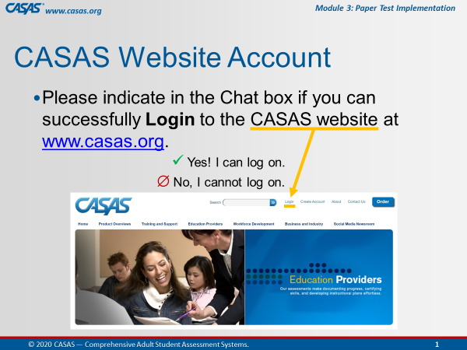 | Participant Arrivals:  Host admits participants into the web conference meeting from the waiting room.  Welcome participants as they arrive in the meeting room.  Confirm CASAS website logins. |  | Hi [participant name] and welcome to the training.  Please use the Chatbox to let us know if you can successfully log on to the CASAS website.  [Trainer 1: send anyone to the Tech Breakout Room (BOR) with Trainer 2 to assist with logins if needed.]
 | Slide 2  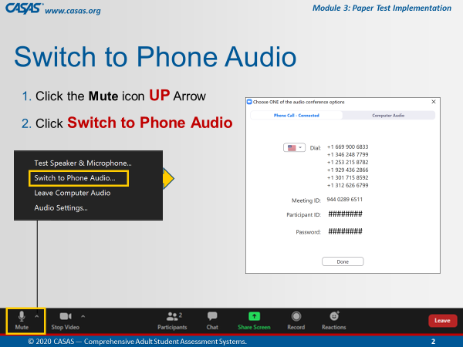 | This is an ANIMATED slide in PPT “slide show” mode.  Open Mic  Help participants switch audio if needed. |  | Some of you may be connected to the meeting using your computer audio. If you experience any trouble with your audio or Internet connectivity, we recommend switching to Phone Audio. To do that:  [Click 1] Click the UP arrow next to the Mute icon.  [Click 2] Select Switch to Phone Audio.  [Click 3] From the pop-up phone listing, dial a number, enter the Meeting ID and your Participant ID. You may also be prompted to enter the meeting Password.
 | Slide 3  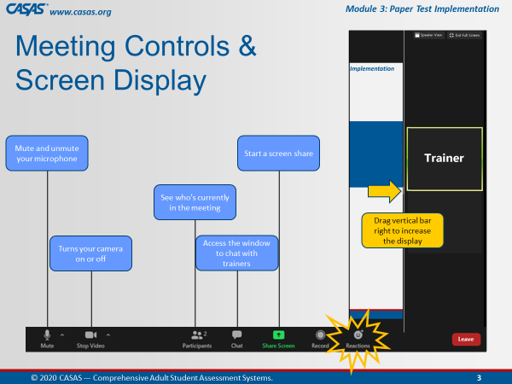 | This is an ANIMATED slide in PPT “slide show” mode.  Briefly review the web conference meeting controls. |  | Attendee controls appear at the bottom or top of your screen.  [Click 1] Mute/Unmute: You can mute and unmute your microphone.  [Click 2] Start Video/Stop Video: Use the video icon to turn your camera on or off.  [Click 3] Participants: See who's in the meeting with the participants icon.  [Click 4] Chat: Click the chat icon to access the window to communicate with each other.  [Click 5] Share Screen: The share screen icon lets you share your computer screen, which you will be doing in Breakout rooms.  [Click 7] Reactions: There is also a Reactions icon that you can give a clap or thumbs up at any time and we may ask you to acknowledge something during training with a thumbs up.  [Click 6] Display: And to increase the display on the left of your screen, click and drag the vertical bar on the RIGHT to minimize the video screens.
 | Slide 4  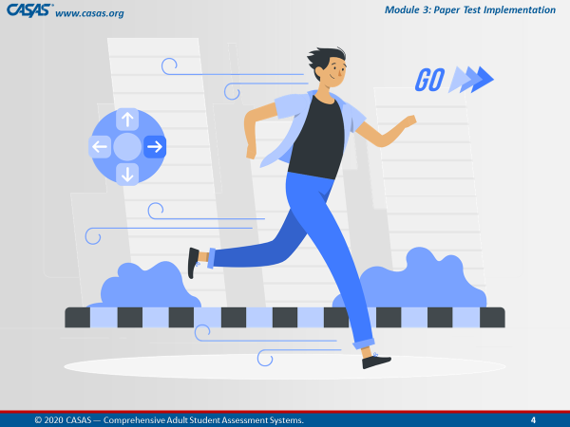 |  |  | We are going to get started…  Give a thumbs up from the Reactions icon if you are ready!
 |  | BEGIN TRAINING
10:00  4 min | Slide 5  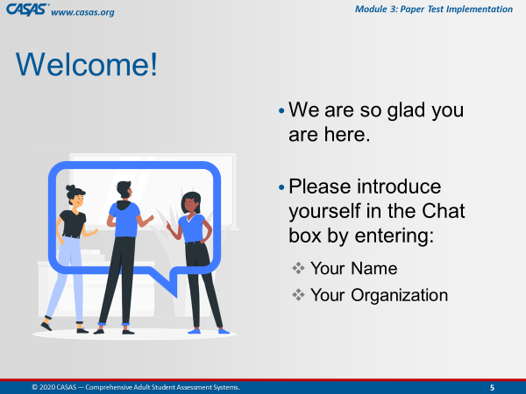 | Participant Introductions  Ask participants to introduce themselves in the Chatbox. |  | Hello everyone, let’s begin by introducing yourselves.  Please enter your name and [organization] in the Chatbox.  Alternates:  - Favorite hobby, color, etc.
 | Slide 6  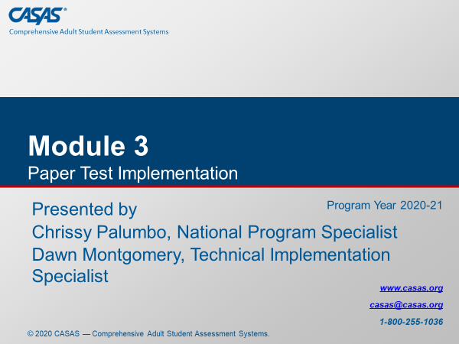 | Training Introduction |  | Today’s training covers Module 3: Paper Test Implementation.
 |  | Trainer Introduction(s)  Trainers introduce yourselves (each out loud). |  | Trainer 1: My name is [say your name], and I have been working in adult education for the past ## years and have [extensive] experience with [the CASAS assessment process].  Trainer 2: My name is [say your name], and I have been working in adult education for the past ## years and have [extensive] experience with [the CASAS assessment process].
 |  | Trainer 1:  Trainer 2: |  | STOP Screen Share.  START Screen Share.
10:03  2 min. | Slide 7  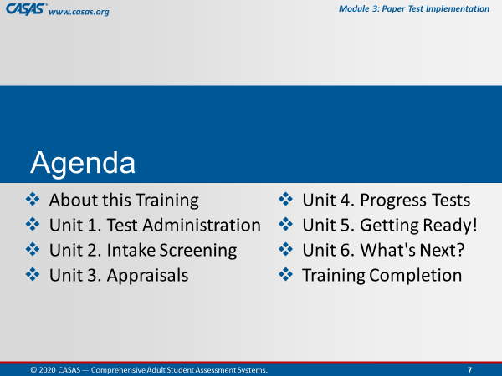 | Review meeting agenda.  - About this Training  - Unit 1. Test Administration  - Unit 2. Intake Screening  - Unit 3. Appraisals  - Unit 4. Progress Tests  - Unit 5. Getting Ready!  - Unit 6. What's Next?  - Training Completion |  | Module 3 covers how to get started with paper-based testing, how to administer tests, and how to use paper testing to its full advantage.  After briefly reviewing a few more meeting controls, we will go online together and complete the About this Training content which will open the other 6 units.  [Trainer 1] and I will cover content and check your understanding of the content from each Unit…  …and then guide you through the Training Completion process to get your Certificate at the end of this training.
 | Slide 8  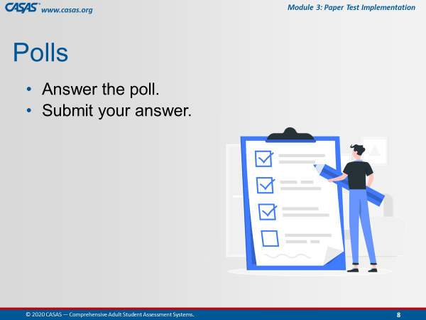 | Briefly review participating in Polls. |  | After we cover each unit, we will be answering checks for understanding either in the training Module, in Zoom Polls, through Chatbox responses, and together in Breakout rooms.  In Polls, you will answer the poll and then submit your answer.
 | Slide 9  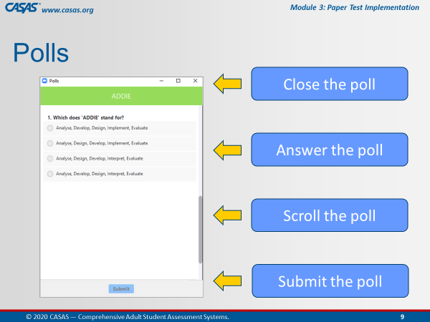 | This is an ANIMATED slide in PPT “slide show” mode.  Orient participants to polling. |  | This is what a Poll looks like in this web conference Meeting Room.  [Click 1] You will enter your responses directly on your screen.  [Click 2] In some polls, you will need to use the scroll bar to answer more questions in the poll.  [Click 3] Submit your answers. and then we will share your responses after closing the poll.  [Click 4] When done, you will want to close the Poll on your screen by clicking the X at the top RIGHT of the Poll window.
10:05  3 min. | Slide 10  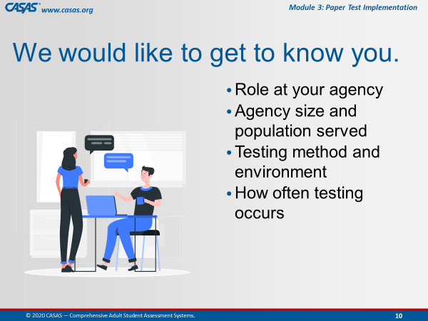 | Getting to Know You  Trainer: review info on slide. |  | Now, we would like to Get to Know You with a polling activity.  Such as your role, agency size and population, testing method and environment, and how often testing occurs.
 |  | LAUNCH POLLS:  - Respond to the poll.  - Close the poll.  - Share the results. |  | - What is your role at your agency?  - What is your agency size? / What population does your agency serve?  - What is your testing method? / What is your testing environment?  - How often does testing occur at your agency?
 |  | - Close the polls |  | Thank you for letting us get to know you!  Don’t forget to close the Poll screen.
10:08  5 min. | Slide 11  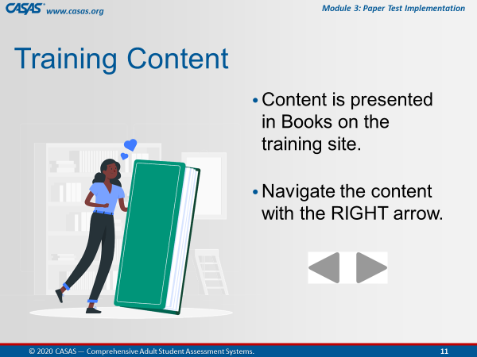 | This is an ANIMATED slide in PPT “slide show” mode. |  | We are going to go to the Training site together in a moment but first, I’d like to let you know what to expect.  You will see a green Book icon, which presents content in each unit.  We will review content in the first Book with you while you are in the module.  [Click 1] To navigate the pages in a book, click the RIGHT arrow at the top RIGHT or bottom RIGHT of your screen.
 | Slide 12  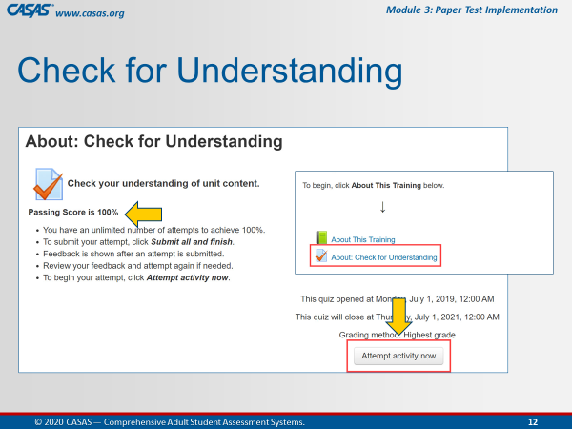 | This is an ANIMATED slide in PPT “slide show” mode. |  | We will be completing the first quiz together in the module so that the remainder of the module opens (Units 1 – 6) to access at different times during this training.  [Click 1] To begin the quiz, you will click the Attempt activity now button.  [Click 2] Our goal on this first quiz is to achieve 100%.  For the purpose of training together, you will get your certificate through your participation with us.  As a group, we will ensure we all get 100%.
 | Slide 13  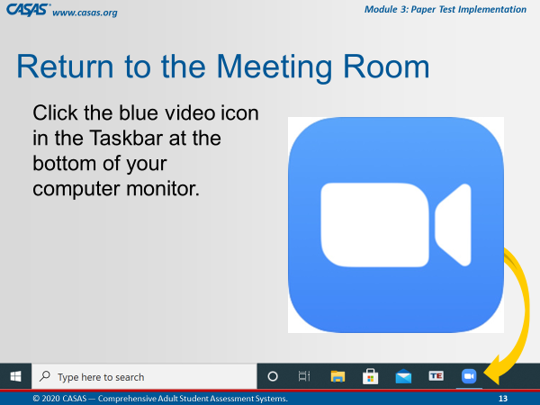 | This is an ANIMATED slide in PPT “slide show” mode (automated/no click).  Make sure participants know how to return to the Meeting Room. |  | When we are finished with the first Book and Quiz, we will ask you to return to the meeting room.  The way you will do that is click the Blue video icon at the bottom of your computer monitor.  Does everyone see this on your own computer?  Give me a “thumbs up” by clicking on the Reactions icon from your meeting controls.
 | Slide 14  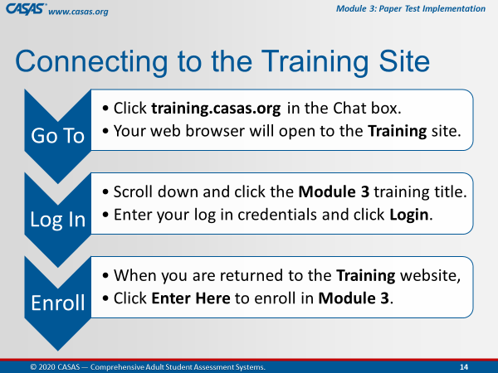 | This is an ANIMATED slide in PPT “slide show” mode. |  | We are about to go to the Training site together but first, I am going to describe the steps for us to get there.  [Click 1] Go To…  [Click 2] Log In…  [Click 3] Enroll…  Another purpose of this training is to help you understand the content in the online modules so you can RETURN to them to support you in your Adult Education position using CASSAS assessments.
 | Slide 15  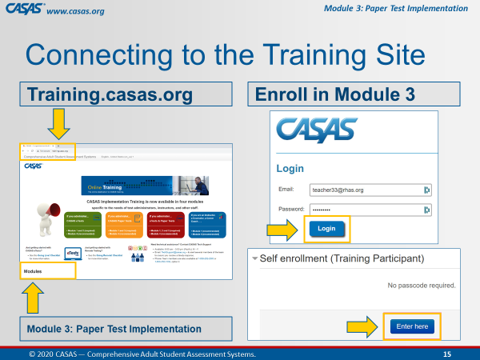 | This is an ANIMATED slide in PPT “slide show” mode. |  | Follow these 4 steps  Step 1. [Click 1] We will Go To the training site.  Step 2. [Click 2] And scroll down to click on Module 1.  Step 3. [Click 3] You will be automatically prompted to Log In with your CASAS website credentials.  Step 4. [Click 4] Then, you are automatically returned to the Training Site where you will click Enter here to open Module 1.
 |  | Prepare participants for logging on to the Training website.  http://training.casas.org/ |  | Please unmute your microphone so that we can continue to communicate when you are in your own module since the Training site will cover up the Meeting Room as soon as you click on the link that [Trainer 1] will put there  Ok, let’s go to the Training website.  [Trainer 1], please enter the training URL in the Chatbox.  Step 1. Ok Everyone, go to your Chatbox and click on the URL that [Trainer 1] just put in there.
 |  | Trainer 2:  Trainer 1: |  | STOP Screen Share.  START Screen Share.
10:13  5 min. | Training Site  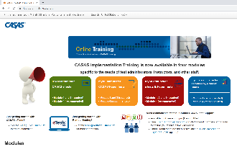 | OPEN the Training site.  Guide participants to logging on to the Training website and opening the module.  Demonstrate on your screen as you are talking the participants through each step.  Wait to proceed until everyone is looking at the module on their own screens. |  | Ok everyone, you should be looking at the Training website with the four colorful boxes.  Is everybody with me?  Step 2. Scroll down and click on the Module 3: Paper Test Implementation training title.  Step 3. Enter your CASAS website log in credentials and click Login.  Step 4. When you are returned to the Training website, click Enter Here to enroll in Module 3.
 | Module   | About This Training  Guide participants through information about the training as if they are viewing your screen. |  | Please click the About This Training link to open the green book, which contains the content for this part of the training.
 | 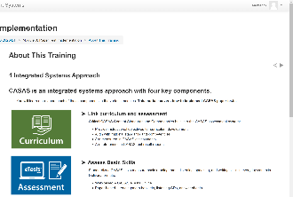 | 1 Integrated Systems Approach |  | The first page you should see in this book is Integrated Systems Approach.  CASAS is an integrated systems approach with four key components – Curriculum, Assessment, Instruction, and Accountability.  These components link curriculum and assessment, assess basic skills, identify instructional materials, and track student progress.  We will be covering these components in greater detail throughout this training.  To navigate to the next page, click the RIGHT arrow at the top RIGHT or bottom RIGHT of your screen.  This will take you to the next page in this book.
 | 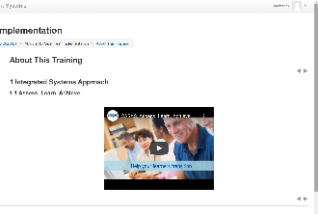 | 1.1 Assess. Learn. Achieve. (video)  Time permitting: Play the first 59 seconds of the video. |  | On the next page, you should see the Assess. Learn. Achieve. video, which is a quick introduction to CASAS.  If you haven’t seen this video in Module 1, we encourage you to return later to this page to watch.  Remember those arrows?... click the RIGHT arrow and go to the next page.
 | 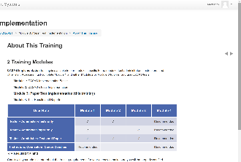 | 2 Training Modules  CFU 1,2 |  | The next page is about the Training Modules.  CASAS Implementation training is available in four modules specific to the needs of test administrators, instructors, and other staff.  [Q1] To use CASAS paper tests, you are required to complete Modules 1 & 3.  [Q2] Modules 1 & 4 are strongly recommended for all staff using CASAS.  How do we go to the next page?  Click the RIGHT arrow!
 | 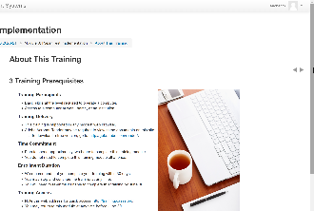 | 3 Training Prerequisites |  | The next page is about Training Prerequisites.  This is helpful information if you plan to complete another module on your own.  Now, click the arrow and go to the next page.
 | 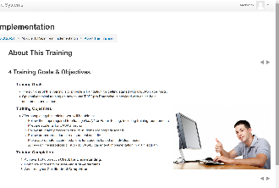 | 4 Training Goals & Objectives |  | You should see Training Goals and Objectives.  This page describes the purpose of this training, which is to provide a foundation for getting started with CASAS paper tests.  Optional technical training on how to use TOPSpro Enterprise is provided with online help documentation and videos available on the CASAS website.  At the end of this training, we will guide you through the training completion process so that you can generate your certificate.  Let’s go to the next page.
 | 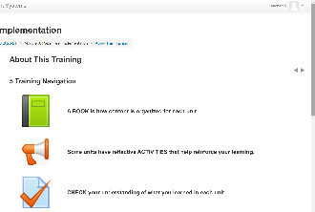 | 5 Training Navigation |  | You should now be on the Training Navigation page.  The navigation information will help you understand how to navigate a training module if you plan to complete a module on your own.  Since you are completing the training with us, we will guide you through this training.  What you need to know before we move on is how to return to the module HOME page from any training page when you are in the module on your own.  Look at the top of your module screen and you will see a Breadcrumb trail.  In that Breadcrumb trail is the Module Short Name, which in this case is M3 2020-21.  Let me know when you see the module Short Name in the Breadcrumb trail on your own computer screen.  Don’t click it now, but whenever you click the module Short Name from the Breadcrumb, this will return you to the module HOME page from wherever you are in the module.  So if you lose your place, just return Home and that will help you get back to where you need to be.  For now, we are going to SKIP the next three navigation pages and go to the last page in this book.  From the Table of Contents at the upper left of your screen, click Training & Technical Support.
 | 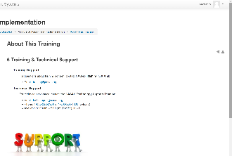 | 6 Training & Technical Support |  | You should be looking at the Training & Technical Support page now.  Whenever you have questions or need clarification about training content, don’t hesitate to contact training@casas.org.  And whenever you need technical assistance, you can reach out to the CASAS Technology Support Team with the contact information displayed on this page.
 |  | Guide participants back to the module HOME page. |  | Now we are going to leave this book.  Click the RIGHT arrow at the top RIGHT or bottom RIGHT of your screen.  This will return us to the module HOME page.
10:18  2 min. | 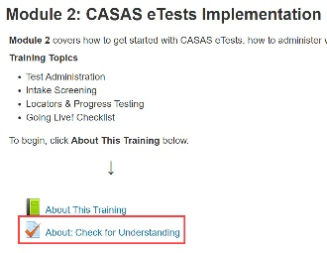 | About: Check for Understanding  MODULE – CFU Activity (2 Qs) |  | You should be back on the Home page and see the Module 3: Paper Test Implementation training title at the top.  Let me know that you are on the Home page.  Since we are in the module, we will answer Checks for Understanding for the About This Training unit.  Below the green Book icon, click on the About: Check for Understanding link.
 |  | Guide participants through completing the first quiz together. |  | You should see About: Check for Understanding at the top of your screen.  Click the Attempt activity now button at the bottom of your screen and let’s complete the first quiz together.
 |  | Participants must achieve 100% to unlock the rest of the module. |  | Now, click Submit all and finish.  Feedback at the top of the results page tells you your score.  Scroll the page to see how you did. You will see a green for correct answers. Answers that are not correct will show a red X beside them.  Click Finish Review at the bottom of the page.  If you did not get 100%, you can reattempt to correct any incorrect answers – until you get 100% correct – so please click Reattempt activity now if needed.
 | 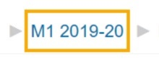 | Guide participants back to the module HOME page and proceed with the training. |  | When you see that you got 100%, click the module HOME link in the Breadcrumb trail at top of your screen and return to the module HOME page.  Take a look! The remainder of the module is now open for you to access at different times during this training. You should now see Units 1 - 6  …and now that you have access to the training module, you can return to it at any time to review content through June 30, 2021.
 |  | Guide participants back to the web conference meeting room. |  | Ok, now let’s return to the Meeting Room.  Click the Blue video icon at the bottom of your computer monitor.
 |  | Trainer 1:  Trainer 2: |  | STOP Screen Share.  START Screen Share.
 | Slide 16  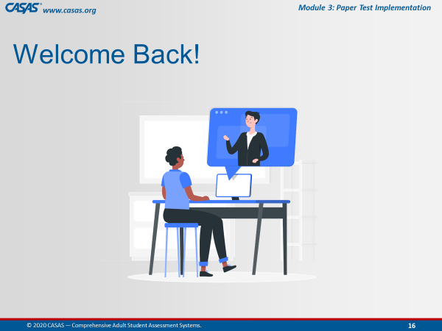 | Welcome everyone back and remind participants… |  | Welcome back everybody!  You will know when you are back in the Meeting Room when you see this slide.
 | Module | Unit 1. Test Administration  Trainer 2: GO TO the Module  Participants will view your screen. |  | Now, [Trainer 1] and I will continue to take you through the remaining content in this training.  Our next unit will talk about Test Administration.
10:20  10 min. | 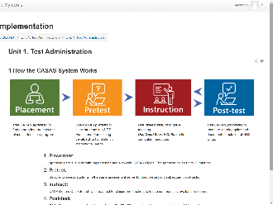 | 1 How the CASAS System Works |  | There are four components to How the CASAS System Works.  - You will use a CASAS Appraisal to initially assess a learner for Placement in an appropriate level  - Then Pretest, and from the results,  - Provide Instruction based on the areas of need, and then  - Post-test after a period of instruction.
 | 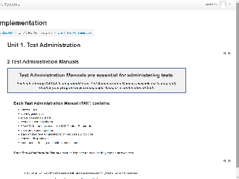 | 2 Test Administration Manuals  CFU 1,2,4  (Content & CFUs also covered in M1)  Emphasize for those who already completed M1 |  | [Q1] All sites using CASAS eTests and / or Paper Tests should have a Test Administration Manual kept in a secure location.  [Q4] This is because they contain answers to CASAS test items in the form of Answer Keys.  [Q2] TAMs also contain CASAS Competencies and CASAS Content Standards that apply to that test series, Standardized Test Administration Procedures and Policies, and Test Security Protocols…  Score Conversion Charts, Next Assigned Test Charts, and Class and Student Profile worksheets are included specifically for sites conducting paper testing.
 | 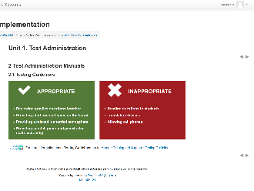 | 2.1 Testing Guidelines |  | Some Appropriate testing guidelines include:  - Helping students with practice questions.  - Making sure that you have an appropriate testing environment that allows students to perform to the best of their ability.  - And remembering to provide scratch paper and pencils for students taking math tests, which are collected when testing ends and the scratch paper is shredded.  Also, keep in mind the testing guidelines that are Inappropriate such as:  - Reading test questions to the students.  - Allowing translation devices and cell phones in the testing room.  Students should be given a secure place to store their personal belongings before testing begins.
 | 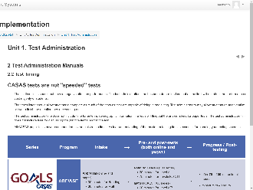 | 2.2 Test Timing  (Content also covered in M1)  Emphasize for those who already completed M1 |  | About Test Timing.  All CASAS tests are timed. However, it is important to note that students should not feel as though they need to rush through the test.  They do not need to finish the test. They just need do the best they can - without guessing - in the allotted time.  Some students may not have finished when time is up. Reassure them that is OK.  A clear understanding of the maximum testing time is essential for planning your testing schedule.
 | 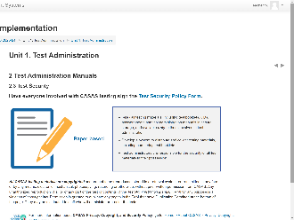 | 2.3 Test Security  (Content also covered in M1)  Emphasize for those who already completed M1 |  | Test Security is very important in order to maintain the integrity of CASAS assessments and to provide valid and reliable assessment results.  It is the responsibility of the agency and all persons involved with test administration to ensure the CASAS testing instruments and test items are kept secure.  Anyone involved with using CASAS should:  - read the Test Security Policy and  - sign the Agreement to certify that they will follow all test administration directions and  - agree to abide by all test security procedures.
 | 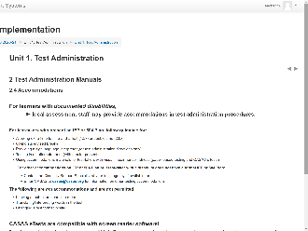 | 2.4 Accommodations  CFU 5 |  | And now about Accommodations.  [Q3] Local assessment staff may provide accommodations in test administration procedures for learners with documented disabilities, such as  - Allowing a student extended time for the test.  - Giving the student a supervised break.  - Using a sign language interpreter for test directions.  - Allowing a student to take the test in an alternate room.  What is not an accommodation and therefore not permitted is:  - Leaving a student alone to take a test.  - Translating unfamiliar words in test items.
 | 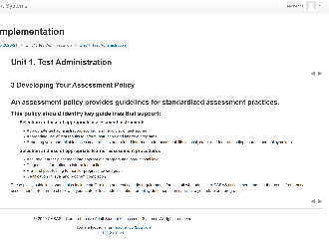 | 3 Developing Your Assessment Policy  (Content also covered in M1)  Emphasize for those who already completed M1 |  | All programs using CASAS should Develop an Assessment Policy outlining guidelines for appropriate assessment practices and procedures.  These policy guidelines should also include staff training and test security requirements for all staff who administer CASAS assessment and use the results from these assessments.  Be sure to check with your state or local administration for policy documentation specific to your state and program.  Your Local Assessment Policy should align with your State Assessment Policy.
 | 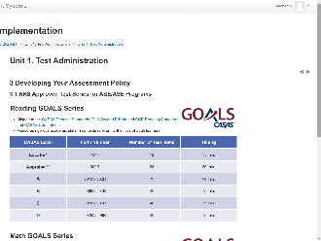 | 3.1 NRS Approved Test Series for ABE/ASE Programs  (Content also covered in M1)  Emphasize for those who already completed M1 |  | The next few pages in this book cover NRS Approved Test Series.  NRS is the National Reporting System that Adult Ed programs report outcomes for Federal funding.  Here, you see that the Reading GOALS and Math GOALS series is approved for ABE and ASE programs.  These tables identify the CASAS Level, Form Number, Number of Test Items and Timing per level.
 | 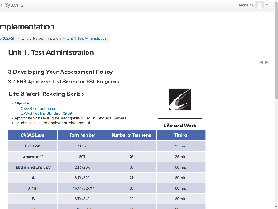 | 3.2 NRS Approved Test Series for ESL Programs  (Content also covered in M1)  Emphasize for those who already completed M1 |  | The next page shows the Life and Work Reading and Listening 980 series that are NRS approved for ESL programs.  Again, these tables detail the Number of Test Items and Timing per CASAS Level and Form Number.
 | 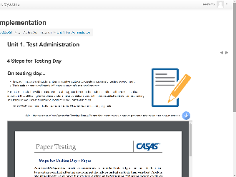 | 4 Steps for Testing Day |  | The role of paper test proctor on Testing Day is very important.  Proctors follow the same procedures before, during, and after testing to ensure the validity of test results and reduce the likelihood of confusion or error during test administration.  CASAS recommends that no more than 25 students be tested per proctor.  This Steps for Testing Day with Paper Tests document can be downloaded and printed from the module to provide proctors on testing day.
 | 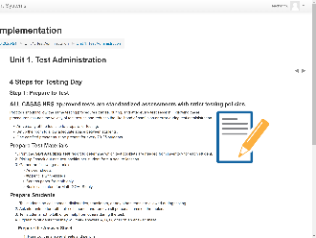 | Step 1: Prepare to Test |  | The first step on Testing Day involves:  - preparing test materials and  - preparing students for paper testing.  Preparing test materials includes:  - Answer sheets and test booklets  - #2 pencils with erasers  - Scratch paper for math only  - Basic calculators for Math GOALS only  Preparing students involves:  - Helping students prepare their answer sheets,  - Passing out test booklets, and  - Handing out scratch paper, pencils and basic calculators to students taking Math GOALS tests.  Preparing students also involves:  - Intake Screening, and  - Providing Accommodations
 | 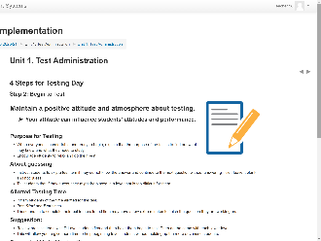 | Step 2: Begin to Test |  | As you help students Begin to Test, your attitude about testing is important and can influence student attitudes.  So, stay positive and that can help students perform their best while testing.  Here are some general guidelines to follow as you begin to test.  - Explain the purpose for testing, encourage students to relax and do their best.  - Instruct students to skip a test item if they do not know the answer  Why? Because…  - Students may guess correctly even though they have not mastered the content.  - Their test results may not accurately reflect their skills and abilities.  - Students may be placed in a level that is too difficult for them.  - Inform students about the amount of time they are allowed to take the test and write the Start and End times on the board.  - Assure students that if they are unable to complete their test in the allotted time, they will have a few extra minutes to finish the question they are working on.  If you are testing students at multiple levels, here’s a suggestion:  - Review practice items with D Level students first and then have them begin to test.  - Then do the same with each lower level.  - This will allow you to give more time to help beginning level students without holding up the more advanced students.  Here are Suggested Verbal Instructions to help you through the Beginning to Test process.
 | 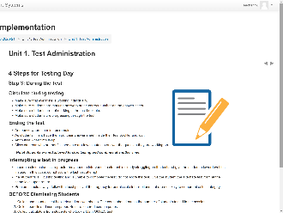 | Step 3: During the Test |  | Proctors should quietly circulate around the room During Testing to make sure everyone is working individually and progressing through the test.  Also, to make sure students are not marking in the test booklet.  Some students may finish before time is up and that is OK.  Students are not allowed to stop testing at any time and finish the test on another time or day.  Proctors should be fully aware of their agency’s local assessment policy for when to intervene a test in progress and how to handle test interruptions.  For example, if a student is struggling on the test, given the student a lower-level test and don’t score the last attempt.  If a student falls ill or for any other reason why the student cannot finish the test, do not score the test and instead, give the student the alternate test form at the same level upon return.
 | 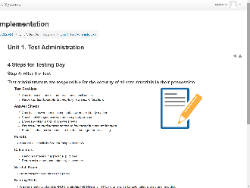 | Step 4: After the Test  CFU 3 |  | After testing students, the proctor is responsible for:  - Checking all answer sheets to see that answers are clearly marked and changed answers are erased. This will make scoring go more smoothly.  - Returning all test booklets and unused answer sheets to inventory in a secure location.  - Sharpening pencils, removing batteries from calculators.  - Shredding all scratch paper.  Scoring Tests:  - Answer sheets can be scanned or manually entered into TOPSpro Enterprise for automatic scoring OR  - Answer sheets can be hand-scored using answer keys in the TAM.  [Q3] A scanner is NOT required to correct paper-test answer sheets.
10:30  5 min. | Module | Unit 1. Sample Test Items  Trainer: click the Sample Test Items link on your screen. |  | This next Book in Unit 1, introduces you to Sample Test Items.
 | 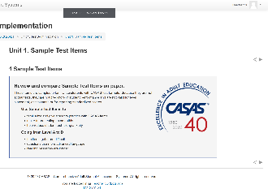 | 1 Sample Test Items  CFU 6  (Content also covered in M1)  Emphasize for those who already completed M1 |  | [Q-6] Sample test items are a great way for teachers to provide student practice.  They:  - Familiarize students with the format of CASAS test items  - Make testing go more smoothly  - Help reduce test anxiety  These are not actual tests and cannot be used to determine basic skills or for placing students in a program.
 | 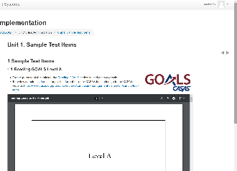 | 1.1 Reading GOALS Level A  1.2 Reading GOALS Level B  1.3 Reading GOALS Level C  1.4 Reading GOALS Level D |  | [Trainer: SKIP if short on time.]  Test items get more difficult going from Level A to D.  We have about [#] minute(s) for you to explore these items and then we will ask you to return to the Meeting Room.  You don’t need to actually test yourself, just explore the eTests application interface and how it functions.  Click on any of the URLs that [Trainer 1] just entered in the Chatbox.
Ok, now let’s have everyone return to the Meeting Room.
Click the Blue video icon at the bottom of your computer monitor.
 | Slide 16 | Trainer 2: |  | RETURN to PPT
10:35  5 min. | Slide 17  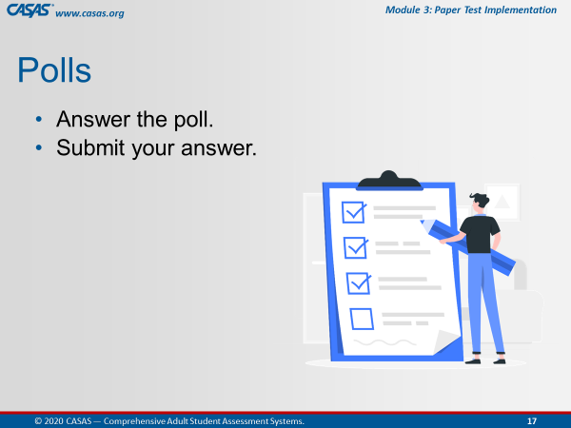 | Unit 1. Check for Understanding  POLL – CFU Activity (6 Qs)  - Launch the poll.  - Respond to the poll.  - Close the poll.  - Share the results.  - Confirm correct responses and provide clarification if needed. |  | I am going to launch a Poll for you to answer checks for understanding the content we just covered in this unit.  There are 6 questions.  I’ll give you a [#] minute(s) to go through them and then close the poll.  Ok, everyone is doing a great job. I’m going to close the poll in about 5 seconds.  [Trainer: comment on participant responses.].
 |  | - Remind participants to close the poll on their screen. |  | Ok, go ahead and Close the poll window on your screen.
 |  | Trainer 2:  Trainer 1: |  | STOP Screen Share.  START Screen Share.
10:40  10 min. | Module | Unit 2. Intake Screening  Trainer: RETURN to Module.  Participants will view your screen. |  | Our next unit covers the importance of Intake Screening and what to observe and consider.  This unit will describe the oral, writing and reading tools used as part of the screening process.  This is the second of six units in this module.
 | 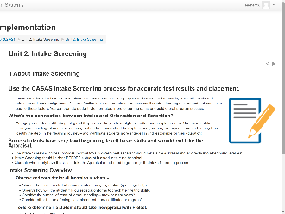 | 1 About Intake Screening  CFU 1 |  | The CASAS Intake Process is recommended for accurate test results and placement.  [Q1] The purpose of the Intake Screening is to determine if a locator or appraisal is suitable for a student.  [Q1] It also determines which pretest to give a student with beginning level skills.  [Q1] It can provide valuable information about a student’s speaking and writing skills and previous education.
 | 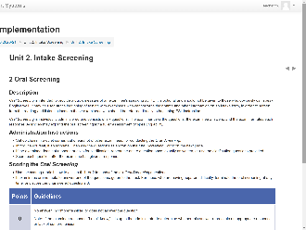 | 2 Oral Screening |  | Oral Screening is for non-native speakers of English and is intended to provide a quick measure of their speaking ability.  The Oral Screening is scored using the scoring rubric shown here to assign 0, 1, or 2 to each of the six Oral Screening questions.  If examinees are not able to answer one of the questions, go on to the next.  For those who are having apparent difficulty, terminate the oral screening at any time, and score the unanswered questions 0.
 | 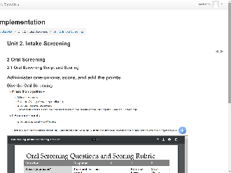 | 2.1 Oral Screening Script and Scoring |  | Here is the Oral Screening Script and some examples of scoring the Oral Screening questions.
 | 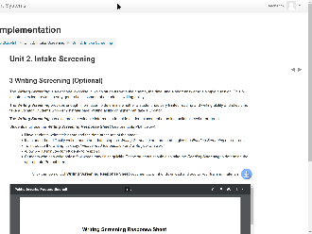 | 3 Writing Screening (Optional) |  | There is also an optional Writing Screening to determine  - if a student has very limited reading and writing ability,  - or a student demonstrates basic writing ability or higher.  This information is helpful in knowing the appropriate testing process for a student and for guiding student placement at an instructional level.
 | 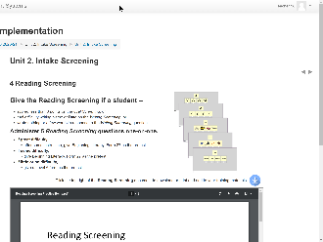 | 4 Reading Screening |  | The Reading Screening is for students  - scoring less than 6 points on the Oral Screening,  - or for students who had difficulty writing their Name or Date,  - or wrote nothing or just a few words on the Writing Screening.  The Reading Screening is administered one-on-one with the proctor observing the student’s level of difficulty.
 | 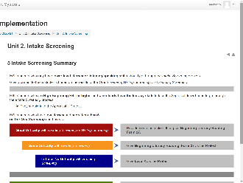 | 5 Intake Screening Summary  CFU 2 (4 parts) |  | Here is a summary of the Intake Screening process.  Give a pretest to ESL students based on the results of the Oral Screening, Writing Screening, and Reading Screening.  [Q2.1] If an ESL student scores 6 or more on the Oral Screening or has little or no difficulty on the other Intake Screenings, then…give the Appraisal followed by the Pretest.  [Q2.2] If an ESL student has lower level literacy skills and scores less than 6 on the Oral Screening, then…skip the Appraisal and give the Reading and Writing (optional) Screenings.  [Q2.3] If an ESL student has some difficulty with the Reading or Writing Screening, then… administer a Level A form as the Pretest.  [Q2.4] If an ESL student has great difficulty or difficulty on the Reading Screening, then…give the Beginning Literacy, Form 27 (or 28) as the Pretest.
 | Slide 18  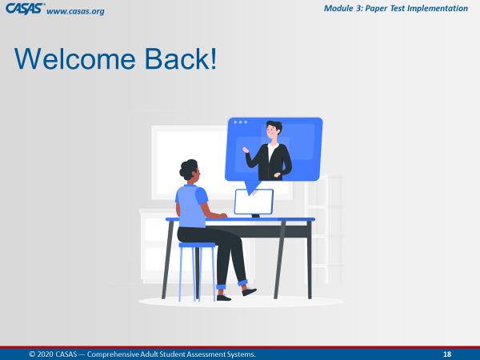 | Trainer 1: |  | RETURN to the PPT.
10:50  5 min. | Slide 19  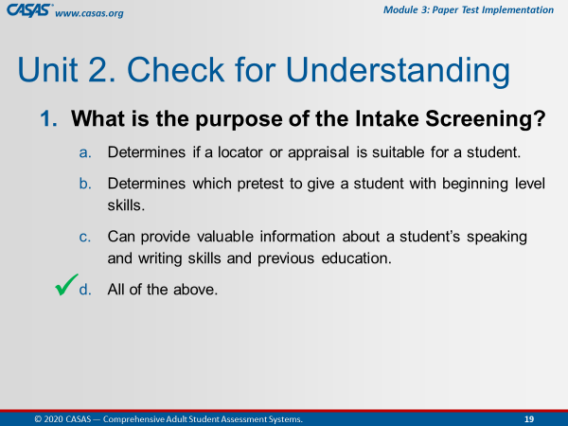 | Unit 2. Check for Understanding  CHATBOX – CFU Activity (2 Qs)  This is an ANIMATED slide in PPT “slide show” mode.  Participants enter their responses in the Chatbox. |  | I am going to display the next checks for understanding on my screen.  Please enter your answers in the Chatbox.  - What is the purpose of the Intake Screening?  - Determines if a locator or appraisal is suitable for a student.  - Determines which pretest to give a student with beginning level skills.  - Can provide valuable information about a student’s speaking and writing skills and previous education.  - [Click 1] All of the above.
 | Slide 20  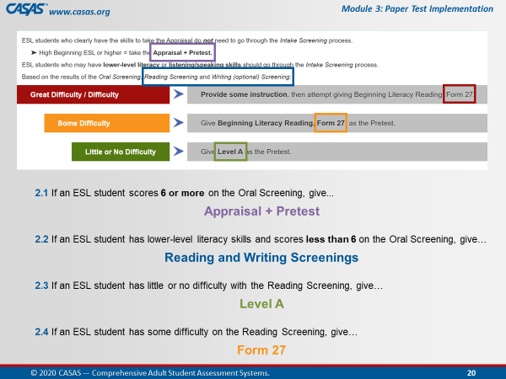 | Trainer: review answers in Chatbox and use them to respond to the CFUs.  [Click] Let’s check our answers. |  | The next check for understanding is to determine what Intake Screening, or what test you should give a new student at Intake.  Choose your answer from the text in colorful boxes.  - Appraisal + Pretest  - Reading/Writing Screening  - Form 27  - Level A  2.1 If an ESL student scores 6 or more on the Oral Screening or has little or no difficulty on the other Intake Screenings, then…  [Click 1] ANSWER: give the Appraisal followed by the Pretest.  2.2 If an ESL student has lower level literacy skills and scores less than 6 on the Oral Screening, then…  [Click 2] ANSWER: skip the Appraisal and give the Reading and Writing (optional) Screenings.  2.3 If an ESL student has some difficulty with the Reading or Writing Screening, then…  [Click 3] ANSWER: administer a Level A form as the Pretest.  2.4 If an ESL student has great difficulty or difficulty on the Reading Screening, then…  [Click 4] ANSWER: give the Beginning Literacy, Form 27 as the Pretest.
 |  | Trainer 1:  Trainer 2: |  | STOP Screen Share.  START Screen Share.
10:55  10 min. | Module | Unit 3. Appraisals  Trainer 2: RETURN to the Module.  Participants will view your screen. |  | Our next unit is about Appraisals.  This is the 3rd out of 6 units in this module.  [Trainer: click the Unit 3. link on your screen.]
 | 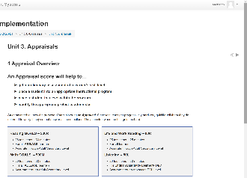 | 1 Appraisal Overview  CFU 1,2,3 |  | [Q2] Appraisals provide a preliminary assessment or baseline score for placing students at an appropriate level within an instructional program.  [Q1] Appraisal scores will also determine an appropriate pretest to administer.  [Q3] Appraisals may not be used for measuring learning gains.  Appraisal test items get progressively hard very quickly, so it is important to let students know they do not need to worry if they cannot answer all the questions and that they can stop when the test gets too difficult.  This will give you the most accurate results for placement or for identifying the appropriate pretest.
 | 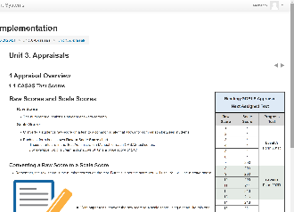 | 1.1 CASAS Test Scores  CFU 4 |  | Each test form has its own Raw to Scale Score conversion in a Next Assigned Test chart.  These charts are in the Test Administration Manual for each CASAS test series.  Here is an example from the Reading GOALS Appraisal.  The first column shows the Raw Score, which is the number of questions a student answers correctly.  The second column shows the Scale Score, which converts a student's raw score on a test to a common scale for measuring gains and for comparison between students.  eTests automatically scores each test and calculates the raw and scale score.  Here’s a Pop-Quiz for you!  [Q4] Based on this Next Assigned Test chart...  1. What is the scale score of a student with a raw score of 7 on the Reading GOALS Appraisal? A scale score of 200
 | 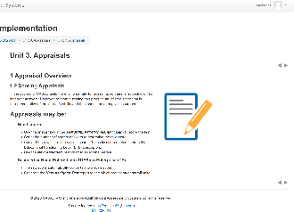 | 1.2 Scoring Appraisals |  | When scoring Appraisals, or any other CASAS tests, there is no deduction for incorrect answers.  When hand scoring Appraisals…  - Use the Answer Key in the TAM to score the test.  - Count the number of correct answers to determine the raw score.  - Convert the raw score into a scale score.  - Use the Next Assigned Test Chart to determine the pretest to administer.  Appraisal may also be scanned or hand-entered into TOPSpro Enterprise.  - TE will automatically convert the Raw score into a Scale score and automatically assign the next test.  - Generate the Next Assigned Test report to see which pretest to administer.
 | 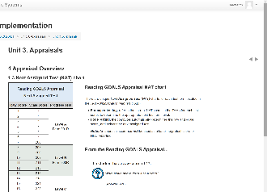 | 1.3 Next Assigned Test (NAT) chart |  | The Next‐Assigned Test CHARTS are important to use for paper testing to identify the appropriate next test form and level to administer, which is displayed in the third column.  This chart standardizes the Next Assigned Test administration for all students.  This chart is designed to take the legwork out of deciding which test to administer next to individual students.  For example:  - A student with a raw score of 17 converts to a scale score of 226.  - The pretest form he should take is LeveL C, Form 905R.  Here’s another Pop-Quiz for you!  [Q9] Based on this Next Assigned Test chart...  2. What Reading GOALS level test should you give a student with a scale score of 228? Level C  3. What Reading GOALS pretest form should you administer to a student with a raw score of 11? Form 903R  If your site is scanning paper test results into TOPSpro Enterprise, you will be able to easily generate Next‐Assigned Test REPORTs.
 | 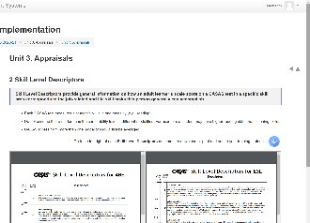 | 2 Skill Level Descriptors  CFU 5  (Content also covered in M1)  Emphasize for those who already completed M1 |  | [Q5] CASAS Skill Level Descriptors provide general information about what a scale score means in terms of job and life skills functioning.  The CASAS Skill Level Descriptors show a continuum of skills from beginning through advanced adult secondary and explain in general terms what most learners can accomplish at the CASAS scale score level in a specific skill area.  Note that CASAS levels go from:  - A (lowest level) to  - E (highest level).  Each test modality (e.g., reading, listening) measures the ability of a student for the skill tested.  A student’s listening skills may not be the same as their reading skills. So the descriptors help to understand their educational functioning level.  CASAS scores from more than one modality should not be averaged.  If you are only testing reading skills, then only the reading descriptors apply. The same holds true for math and listening.  You will find more Skill Level Descriptors on the CASAS website.
 | Slide 21  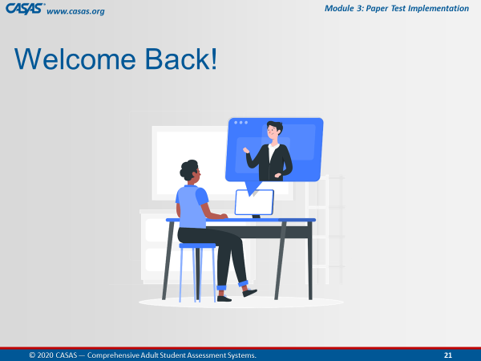 | Trainer 2: |  | RETURN to PPT.
11:05  5 min. | Slide 22  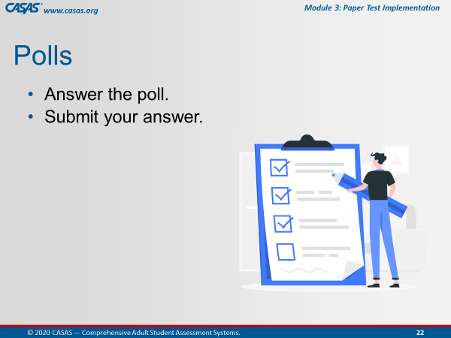 | Unit 3. Check for Understanding  POLL – CFU Activity (5Qs)  Note: Q4 used in content.  - Launch the poll.  - Respond to the poll.  - Close the poll.  - Share the results.  Confirm correct responses and provide clarification if needed. |  | I am going to launch a Poll for you to answer checks for understanding the content we just covered in this unit.  There are 4 questions.  I’ll give you a [#] minute(s) to go through them and then close the poll.  Ok, everyone is doing a great job. I’m going to close the poll in about 5 seconds.  [Trainer: comment on participant responses.].
 |  | Remind participants how to close the poll on their screen. |  | Ok, go ahead and Close the poll window on your screen.
 |  | Trainer 2:  Trainer 1: |  | STOP Screen Share.  START Screen Share.
11:10  8 min. | Module | Unit 4. Progress Tests (Pre- and Post)  CFU 1  Trainer 1: RETURN to the Module.  Participants will view your screen. |  | [Q1] Our next unit is about Pre- and Post-Tests, which are referred to as Progress Tests because gains are measured between the pretest and the post-test.  This is the fourth unit out of six in this module.  [Trainer: click the Unit 4. link on your screen.]
 | 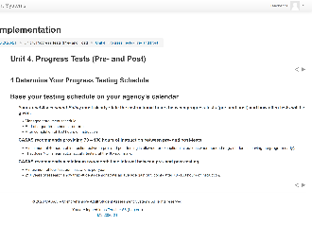 | 1 Determine Your Progress Testing Schedule  CFU 8 |  | How will you determine a progress testing schedule?  Base it on your agency’s calendar for instructional terms such as quarterly or by semester or when a student completes 100 hours of instruction.  Every agency should have a written Local Assessment Policy that clearly states the instructional hours between pre- and post-tests and how often testing will occur.  [Q8] As mentioned earlier, CASAS recommends 70 – 100 hours of instruction between pre- and post-tests.  [Q8] 25+ years of research show that students demonstrate an average gain of 5 points after 70-100 hours of instruction.  [Q8] You are permitted to test after a minimum of 40 hours.  However, this should only be the exception, and not the norm, and only if a student is leaving the program early.  CASAS also recommends a minimum of two-month intervals between pre- and post-testing with a maximum of four test administrations per year.
 | 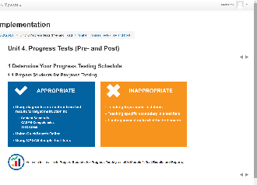 | 1.1 Prepare Students for Progress Testing |  | Here are some Appropriate testing guidelines to keep in mind when preparing students for progress testing:  Use the information from the most recent test results to focus on instruction in the content standards, competencies, and task areas students need help on so that when they test again, students answering questions they received instruction in will feel more confident.  Use QuickSearch Online to help locate instructional materials to address the areas of need when preparing students for progress testing.  And use the Sample Test Items to help students practice with answering test items at their current skill level.  Also, keep in mind the testing guidelines that are Inappropriate such as:  Teaching to the test. Instead, instructors should be addressing the underlying Content Standards, Competencies, and Task Areas addressed in the test items.  Teaching vocabulary specific to a particular test item or in a test forms is very inappropriate and not allowed.  Also, limiting instruction to only what a test covers is not appropriate either.
 | 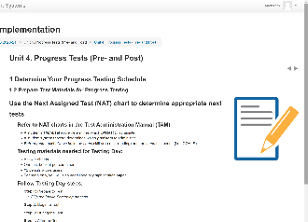 | 1.2 Prepare Test Materials for Progress Testing  CFU 2, 4, 5 |  | You will want to allow time ahead of progress testing to gather your testing materials.  This includes using the Next-Assigned Test charts included in TAMS, to determine the appropriate next test per individual student.  It is not appropriate to give all students the same test form.  The next test for each student should be solely…  - Based on the…Appraisal score to determine which pretest to administer,  - Based on the…Pretest score to determine which post-test, or progress test to administer, and  - Based on the…Most recent progress test to administer another progress test.  [Q2] Keep in mind that all paired tests must always be in the same test modality, or skill area such a reading, math or listening as well in the same test series but NOT the same FORM.  In addition to checking out test booklets from a secure inventory location, gather enough answer sheets and #2 sharpened pencils with erasers.  Provide scratch paper for students taking math tests.  [Q4] Students do not need to memorize math formulas.  [Q5] Provide basic calculators to students taking CASAS Math GOALS tests.  You must collect calculators and shred scratch paper after testing.  Use the Steps for Testing Day with paper tests as a Quick Reference guide to help you follow the same procedures before, during, and after testing to ensure the validity of test results and reduce the likelihood of confusion or error during test administration.
 | 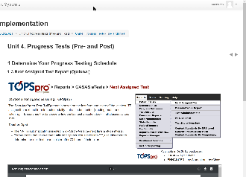 | 1.3 Next Assigned Test Report (Optional)  CFU 3 |  | The Next Assigned Test report from TOPSpro Enterprise can also be used to select the correct test booklets for each individual student when preparing for progress testing.  The NAT report standardizes the selection of the next test for both paper testing and eTesting, which is automatic!  The NAT report will identify the same assessment series, such as Reading GOALS, when progress testing a student in the same modality.  [Q3] You must use the same assessment series when progress testing a student in the same modality.
 | 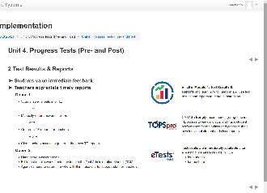 | 2 Test Results & Reports |  | - Students value immediate feedback, and  - Teachers appreciate timely reports.  If your program optionally implements TOPSpro Enterprise, you will have the ability to scan or manually enter paper test answers in to TE. The benefit of using TE, especially if teachers are given access to TE, is generating timely reports based on test results.  Paper test results can also be hand scored if you choose not to implement TOPSpro Enterprise. The TAMS provide you with fillable worksheets to record test results.
 | 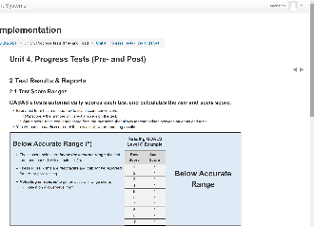 | 2.1 Test Score Ranges  CFU 6,7  (Content also covered in M1)  Emphasize for those who already completed M1. |  | All CASAS test forms have three score ranges – below accurate, accurate, and conservative estimate range.  Here is an example from the Reading GOALS series for Level C.  We learned in Module 1 that…  [Q6] The Raw score indicates the number of correct answers.  [Q7] The Raw Score must be converted to provide a standard score for reporting purposes.  And that…  [Q6] The Scale score indicates a score used for measuring progress.  [Q6] The Asterisk score (*) indicates a score below the accurate range. These scores are invalid and retesting with a lower-level form is required.  [Q6] The Diamond score (♦) indicates a conservative estimate score (above the accurate range). These scores are valid but CASAS recommends retesting for pretests.
 | 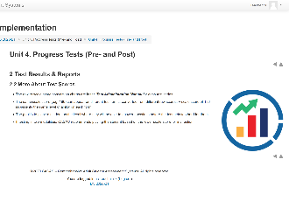 | 2.2 More About Test Scores |  | Score conversion charts are in the Test Administration Manual for each test series.  CASAS scale scores appear on different test forms and represent the same level of ability on each form.  If you test in two modalities, place students at the lower scale score for placement.  The test Form Level a student took is not as important as placing students based on their Scale Score.
 | Slide 23  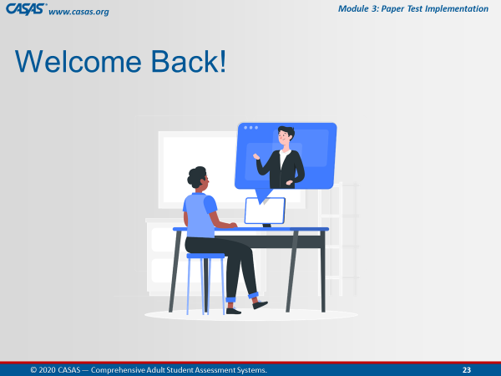 | Trainer 2 |  | RETURN to PPT.
11:18  10 min. | Slide 24  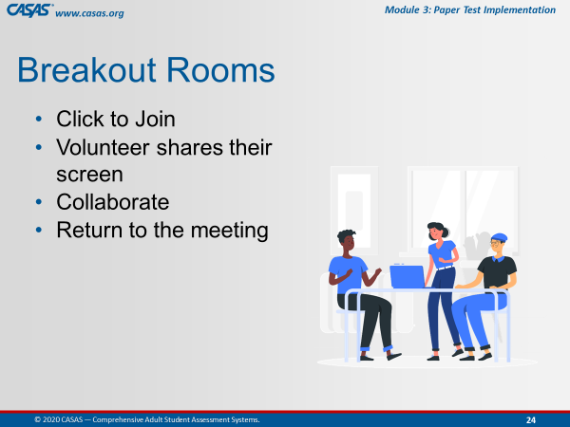 | Briefly review collaborating in Breakout Rooms. |  | We will be sending you to Breakout Rooms now.  A volunteer in your breakout room will share their screen so that everyone in the Breakout Room can collaborate on the checks for understanding in the unit we just covered.  When your group finishes you will return to the Meeting Room.
 | Slide 25  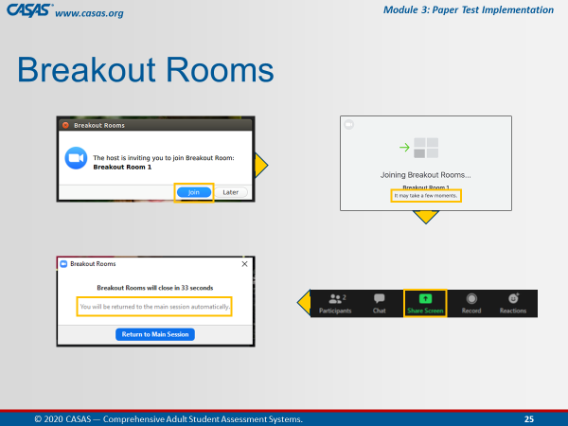 | This is an ANIMATED slide in PPT “slide show” mode. |  | When the pop-up appears on your screen,  [Click 1] Click Join.  Wait a few minutes…and when everyone is together in the Breakout Room,  [Click 2] Choose a volunteer who will share their screen.  [Click 3] A pop-up will appear just before you are automatically returned to the Meeting Room.  You will not need to return to the main room when you see this pop-up.  Just relax and continue your discussion until the application brings you back to the main room automatically.
 |  | Unit 4. Check for Understanding  BREAKOUT – CFU Activity (8 Qs)  One participant shares their screen and opens the Unit CFU.  Add Unit CFU Link and Task to Chatbox.  UNIT 4. CHECK FOR UNDERSTANDING  http://training.casas.org/mod/quiz/view.php?id=2598 |  | Ok, now we are going to send you to the Breakout Rooms.  [Trainer 1] will put the link to Unit 1. Check for Understanding link in the Chatbox.  When you are in the Breakout Room, the volunteer will:  - Share their screen and  - Click on the link from the Chatbox.  The checks for understanding will open automatically.  Please work together as a group to answer each question.  You will be automatically brought back to the Meeting Room when time is up.
 |  | - Send to BOR.  - Broadcast task.  - Close BOR when 1 min. remains. |  | Ok, click Join.  [Trainer: Broadcast task to BORs, e.g., “Please skip any questions if needed and go back to answer if time permits.”]
 | Slide 26  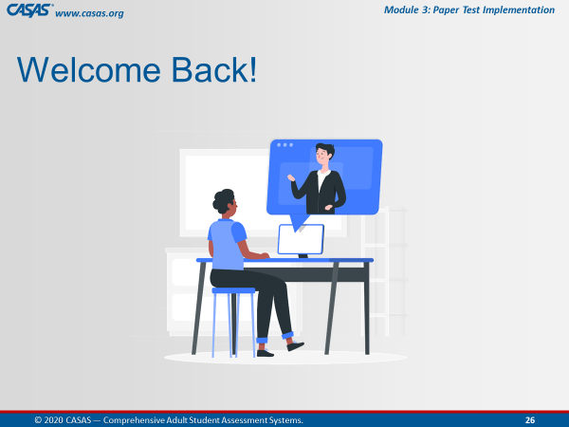 | Upon return, ask if anyone has questions about any CFU. |  | Welcome Back! Everyone.  Is there a CFU any of you had trouble answering?  We can take about [#] minute(s) to review the questions.
 | Slide 27  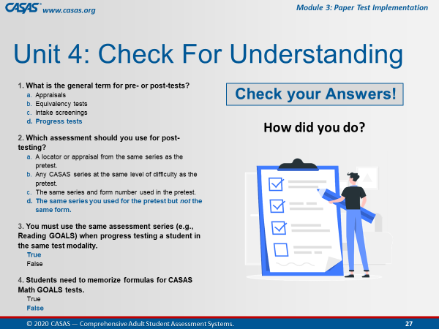 | Slide 28  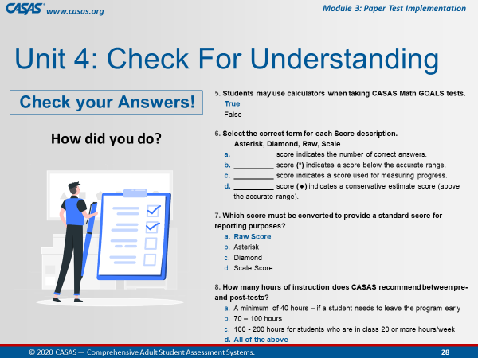 |  | Let’s review some of the answers together.  Feel free to point out any question you might need clarification.
 |  | Trainer 2:  Trainer 1: |  | STOP Screen Share.  START Screen Share.
11:28  10 min. | Module | Unit 5. Getting Ready! Checklist  CFU 2  Trainer: RETURN to Module.  Participants will view your screen. |  | Our next unit will talk about the Paper Test Implementation process and the steps to get ready for testing.  [Trainer: click the Unit 5. link on your screen.]  [Q2] Any staff member who will be administering CASAS paper tests must complete Modules 1 and 3.
 | 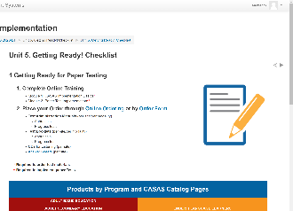 | 1 Getting Ready for Paper Testing  CFU 5,6,7 |  | [Q5] Your agency may place an order while your staff completes training. True  [Q6] ABE and ASE programs should order Reading Goals and Math Goals  [Q7] ESL programs should order: Beginning Literacy Reading, Life and Work Reading and Life and Work Listening 980 Series
 | 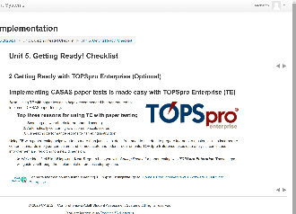 | 2 Getting Ready with TOPSpro Enterprise (Optional)  CFU 1,3,4 |  | [Q3] TE is NOT required to implement CASAS paper tests.  [Q4] Top 3 reasons to use TE with paper:  - Scanning answer sheets for automated scoring  - Automatically converting raw scores to scale scores, and  - Generating performance reports for targeting instruction.  [Q1] A program can use both paper tests and CASAS eTests with TE.
 | 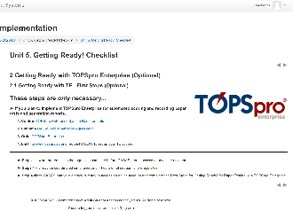 | 2.1 Getting Ready with TE - First Steps (Optional) |  | Steps 1-4 are prerequisites that agencies complete before CASAS grants access to an online account.  Steps 1-3 can be done simultaneously.  Step 4 alerts CASAS that your agency is ready to access an online account and complete the next steps for GettingReady!
 | 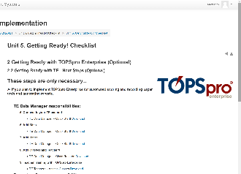 | 2.2 Getting Ready with TE - Next Steps (Optional) |  | The next steps 5 – 9 are only necessary IF you plan to implement TOPSpro Enterprise for automated scoring and recording paper tests and generating reports.  Steps 6-9 are the remaining prerequisites that are necessary to complete after accessing your account and before scanning tests.
 | Slide 29  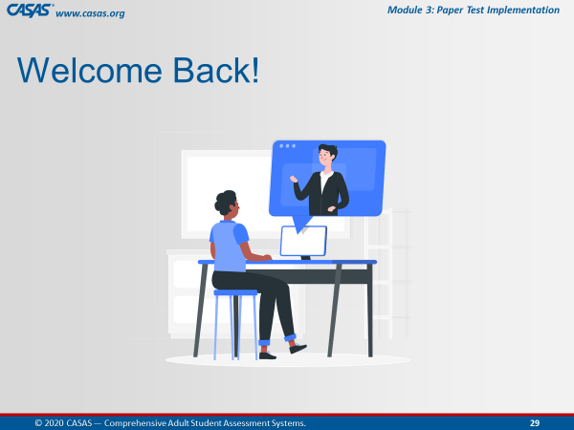 | Trainer 2: |  | RETURN to the PPT.
11:38  5 min. | Slide 30  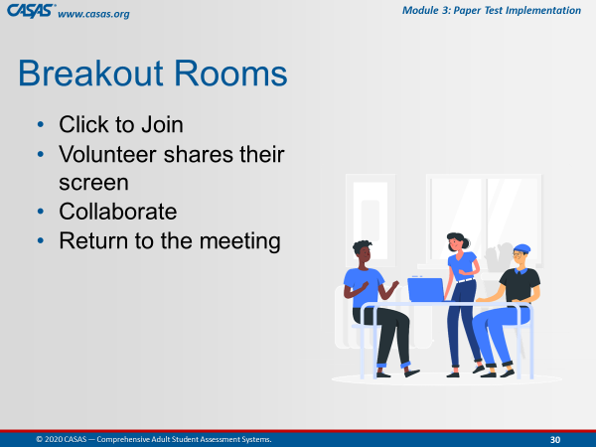 | Unit 5. Check for Understanding  BREAKOUT – CFU Activity (7 Qs)  One participant shares their screen and opens the Unit CFU.  Add Unit CFU Link and Task to Chatbox.  UNIT 5: CHECK FOR UNDERSTANDING  http://training.casas.org/mod/quiz/view.php?id=2727 |  | Ok, now we are going to send you to Breakout Rooms again.  [Trainer 1] will put the link to Unit 4. Check for Understanding in the Chatbox.  When you are in the Breakout Room, the volunteer will:  - Share their screen and  - Click on the link from the Chatbox.  The checks for understanding for Unit 4 will open automatically.  Please work together as a group to answer each question.  You will be automatically brought back to the Meeting Room when time is up.
 |  | - Send to BOR.  - Broadcast task.  - Close BOR when 1 min. remains. |  | Ok, click Join.  [Trainer: Broadcast task to BORs, e.g., “Please skip any questions if needed and go back to answer if time permits.”]
 | Slide 31  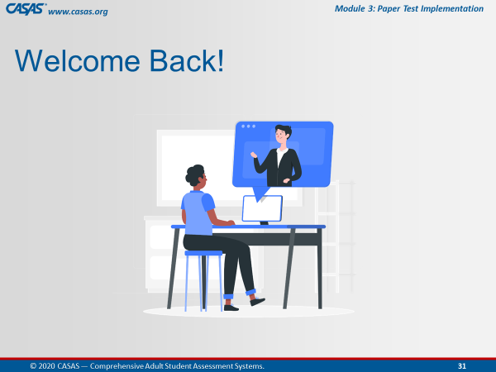 | Upon return, ask if anyone has questions about any CFU. |  | Welcome Back! Everyone.  Is there a CFU any of you had trouble answering?  We can take about [#] minute(s) to review the questions.
 |  | Trainer 1:  Trainer 2: |  | STOP Screen Share.  START Screen Share.
11:43  2 min. | Module | Unit 6. Wrap-up! What's Next?  Trainer: RETURN to Module.  Participants will view your screen. |  | Congratulations! You are almost finished with Module 3.  [Trainer: click the Unit 6. link on your screen.]
 | 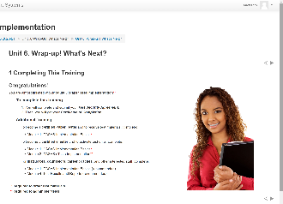 | 1 Completing This Training |  | In a moment, we will walk you through the process to complete your training.  If you haven’t completed Module 1, you will want to enroll in that module to complete the training requirements for implementing paper tests.  If you also plan to administer eTests, you will need to complete Module 2.  And don’t forget Module 4, which will help you with interpreting test results and reports.
 | 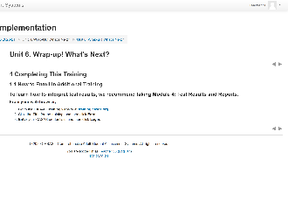 | 1.1 How to Enroll in Additional Training |  | Just like we did today, you will follow the same steps to enroll in additional training.
 | 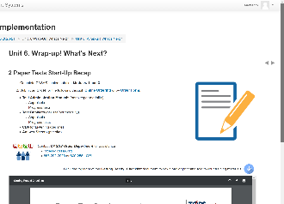 | 2 Paper Tests Start-Up Recap  GETTING READY! CHECKLIST  http://training.casas.org/mod/book/view.php?id=2840&chapterid=4116 |  | So at this point,  You can download or print the Getting Ready! Checklist from the module or the URL [Trainer 1] just put in the Chatbox.
 | 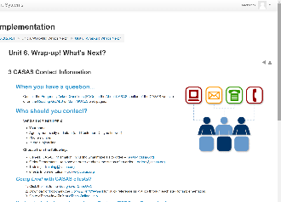 | 3 CASAS Contact Information |  | And finally, here is helpful information for who to contact at CASAS if you have a question.  Office hours are Monday through Friday, 8:30 am to 5:00 pm Pacific Time.
 |  | Trainer 1: |  | STOP Screen Share.
 | Slide 31 | Trainer 2: |  | START Screen Share.
11:45  10 min. | Slide 32  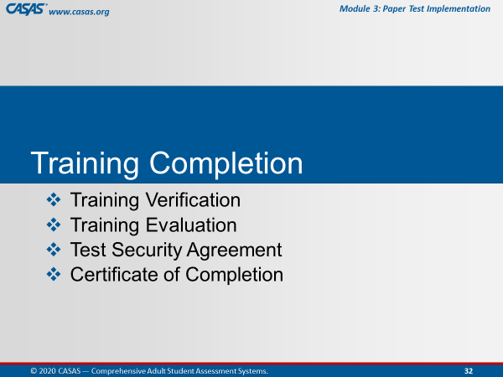 | TRAINING COMPLETION |  | To complete your training today, you will:  Submit a Training Verification and Evaluation with your Test Security Agreement, and then get your Certificate.
 | Slide 33  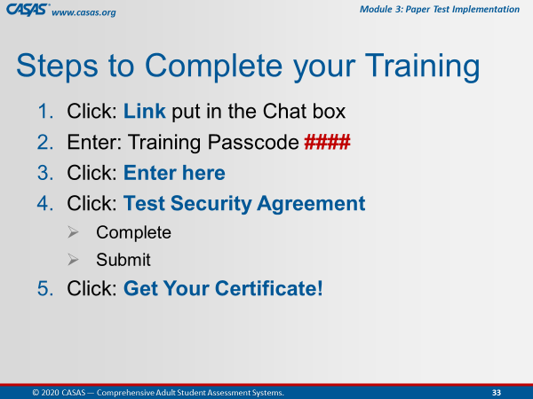 | This is an ANIMATED slide with 5 clicks for each highlighted text.  Note: Click 4 has 2 additional automated text. |  | The steps you will complete are the following:  [Click 1] Click the Link that will be put in the CHATBOX after we review these steps.  [Click 2] You will be prompted to enter a Passcode, which is <Trainer: insert own passcode>.  [Click 3] After entering the passcode, click the Enter here button.  [Click 4] You will see the Test Security Agreement link, which you will click to complete and submit.  [Click 5] And last, click the Get your Certificate! Link.
 | Slide 34  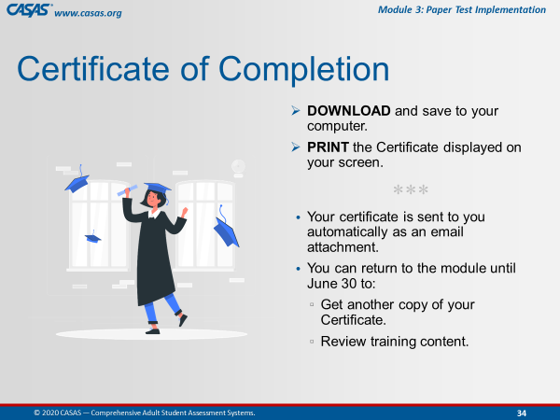 |  |  | You can download or print the certificate directly from your computer.  Your certificate will also be sent to you as an email attachment.  You can always return to the module to get another copy of your certificate and review training content.
 |  | TRAINING COMPLETION:  http://training.casas.org/course/view.php?id=425 |  | Ok everyone, go to your CHATBOX and click on the URL that [Trainer 1] just put in there.
 |  |  |  | Return to the Meeting Room when you are finished.  Remember how do we do that?  Click the Blue video icon at the bottom of your computer monitor.
 |  | Trainer 1: |  | STOP Screen Share.
 | Slide 35  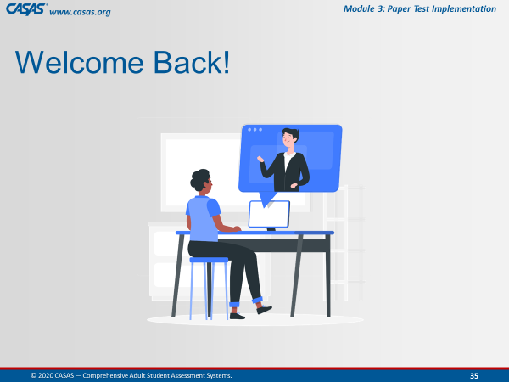 | Trainer 2: |  | START Screen Share.
11:55  3 min. | Slide 36  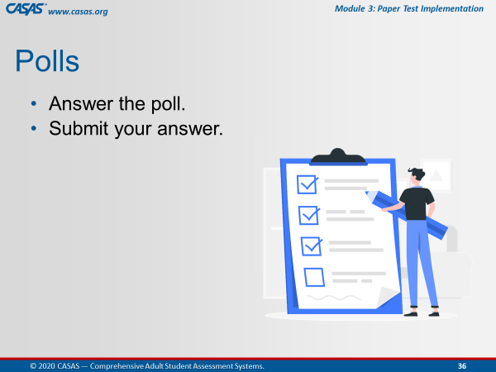 | CLOSING Polls  LAUNCH POLLS:  - Respond to poll.  - Close the poll.  - Share the results. |  | - Did you get your certificate?  - After this training do you feel more confident in returning to the online modules?  - After this training do you feel more confident that the content learned will support you in using CASAS?
 |  | - Close the polls |  | Congratulations everyone! You did a great job!  Don’t forget to close the Poll screen.
 |  | Trainer 1:  Trainer 2: | STOP Screen Share.  START Screen Share.
11:58  2 min. | Slide 37  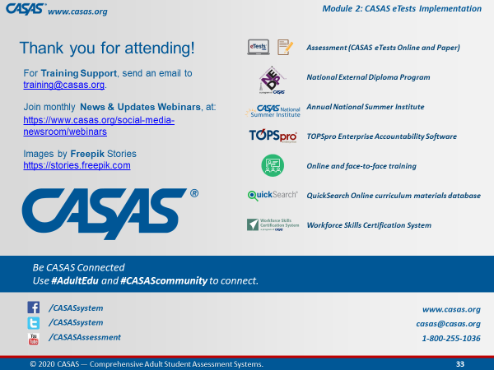 | Wrap Up!  CASAS Contact Info |  | Thank you for attending today’s training.  If you have any questions about Training, email the Training Desk at training@casas.org.
 |  | Webinars |  | Join us for monthly webinars to learn about the latest CASAS News & Updates.  Check the Social Media web page on the CASAS website for information about the next webinar.
 |  | Online Training |  | We hope you feel more confident in not only going in and out of the modules, but also knowing where a lot of rich information lives!  Don’t forget that you can review content in the online training modules and enroll in additional training at http://training.casas.org/
12:00  End Time |  | Stay “live” for any questions.  End meeting for all when finished. |  | We will stay on if anyone has questions otherwise, you are dismissed.  Thank you again for participating in this training.
120 min. |  | END TRAINING

