Checks for Understanding

About: Check for Understanding
Use this table to answer the following questions:
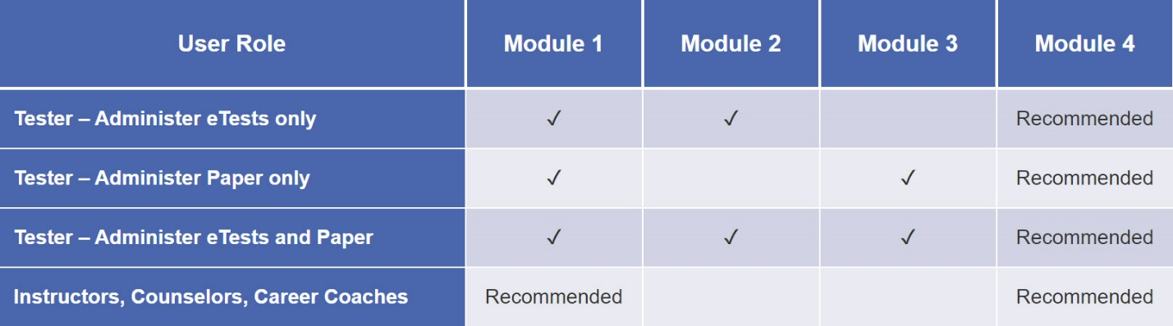
✓ = Required training

Question 1
If you plan to use CASAS eTests, you are required to complete which two training modules…
Please choose two answers
- Module 1: CASAS Implementation Basic
- Module 2: CASAS eTests Implementation
- Module 3: Paper Test Implementation
- Module 4: Test Results and Reports
Feedback: Module 1 and 2 are required for implementing CASAS eTests.

Question 2
If you only plan to paper test, which two training modules are required?
Please choose two answers
- Module 1: CASAS Implementation Basic
- Module 2: CASAS eTests Implementation
- Module 3: Paper Test Implementation
- Module 4: Test Results and Reports
Feedback: Module 1 and 3 are required for paper test implementation.

Question 3
Which two training modules are recommended for instructors, counselors, career coaches, and other interested staff?
Please choose two answers
- Module 1: CASAS Implementation Basic
- Module 2: CASAS eTests Implementation
- Module 3: Paper Test Implementation
- Module 4: Test Results and Reports
Feedback: Module 1 and 2 are required for implementing CASAS eTests.

Unit 1. Check for Understanding

Question 1
CASAS test items incorporate which of the following elements?
Select one:
- Competencies
- Content Standards
- Task Areas
- All of the above

Question 2
The CASAS scale covers all six Educational Functioning Levels (EFLs) for both ESL and ABE/ASE.
Select one:
True
False

Question 3
In all test series, paper booklets are color-coded to differentiate between levels.
Select one:
True
False

Question 4
CASAS assessments cover Beginning Literacy to Post-secondary levels.
Select one:
True
False

Question 5
Each CASAS level has two alternate forms.
For example, Reading GOALS, Level C, 905R and 906R.
Select one:
True
False

Question 6
The alternate form in each CASAS level (i.e., Level A, B, C, D) is more difficult than the first form.
For example, 904R in CASAS Level B is more difficult than 903R.
Select one:
True
False

Question 7
Which of the statements below is a proper use of sample test items?
Select one:
- Familiarize students with the format of CASAS test items
- Help reduce test anxiety
- Make testing go more smoothly
- All of the above
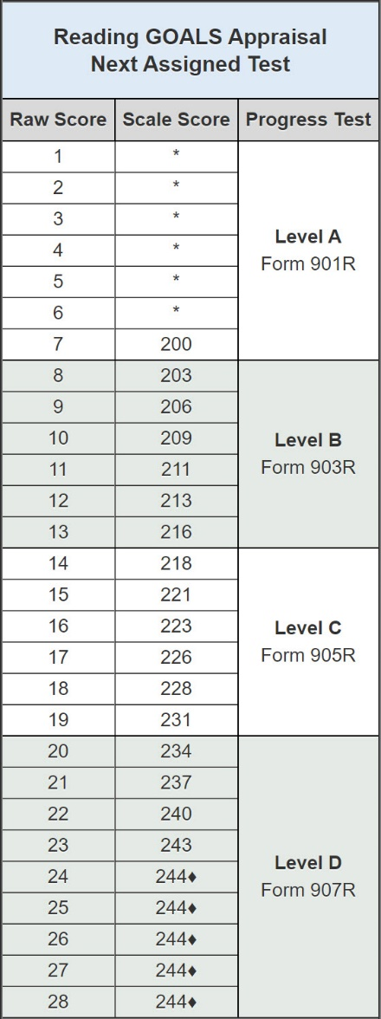

Question 8
Based on the Next Assigned Test chart...
1. What is the scale score of a student with a raw score of 7 on the Reading GOALS Appraisal? A scale score of 200
2. What Reading GOALS level test should you give a student with a scale score of 228? Level C
3. What Reading GOALS pretest form should you administer to a student with a raw score of 11? Form 903R

Unit 2. Check for Understanding

Question 1

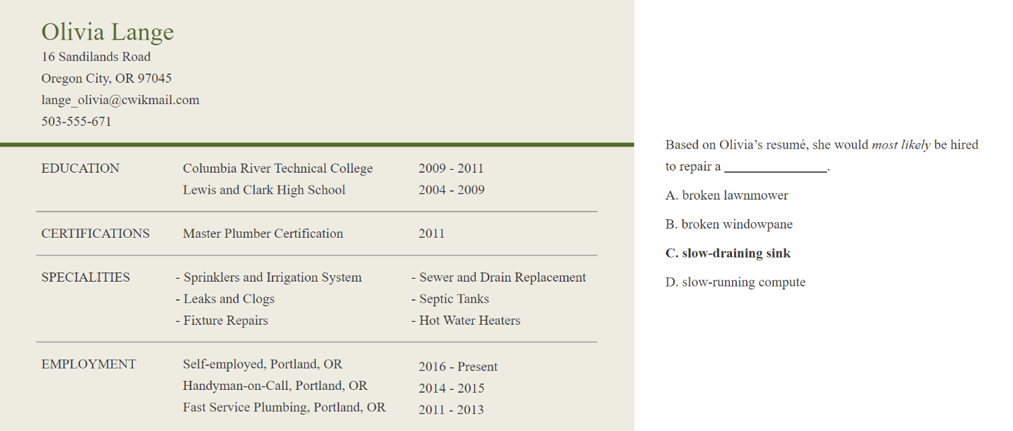

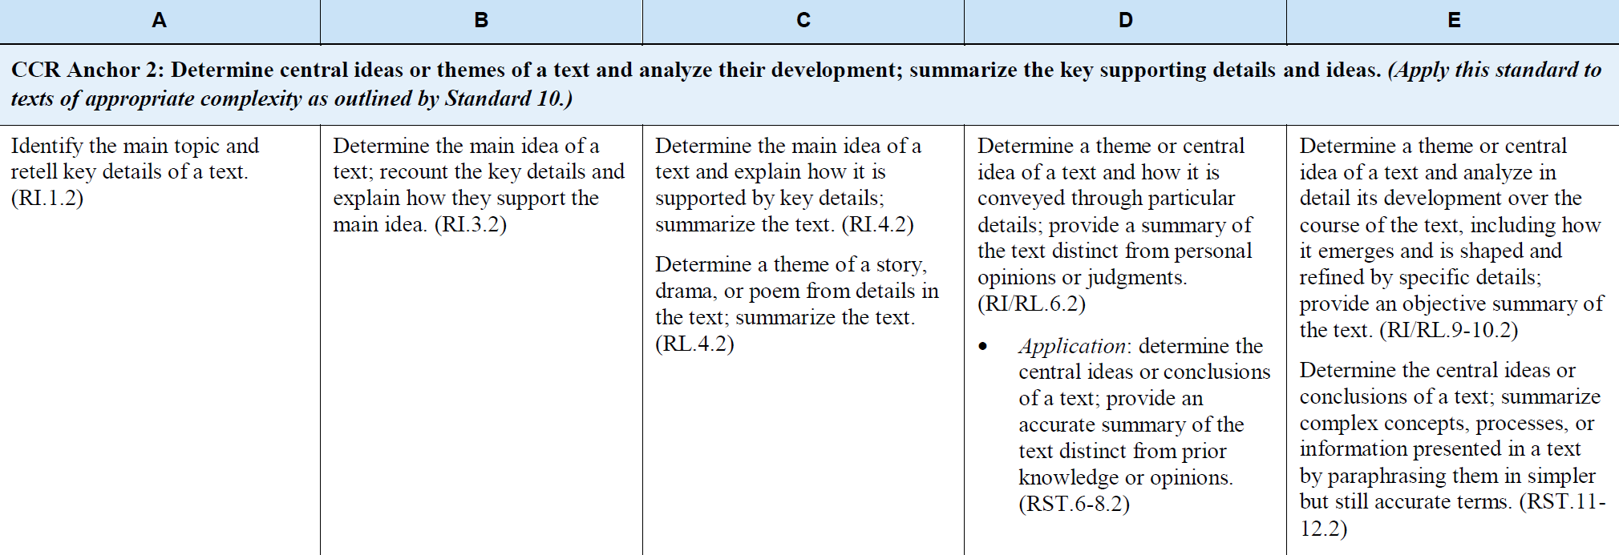

CASAS Reading Standards have references to the College and Career Readiness Standards for Adult Education (2013).
The standards are referenced as follows – CCR: R2. C, D, E; CASAS: RDG 4.1

1.1 This test item measures if a student can draw an inference from the details and specific examples in Olivia’s resume.
True
False

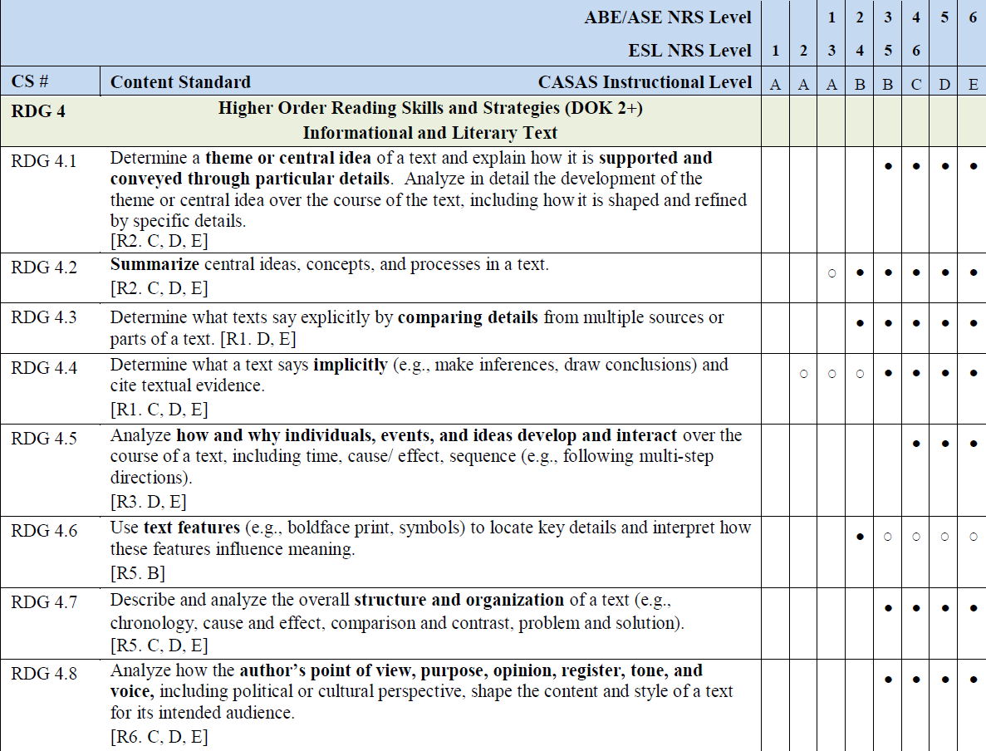

1.2 RDG 4.4 – Determine what a text says implicitly (e.g., make inferences, draw conclusions) and cite textual evidence is a that is measured in this test item.
- CASAS Competency
- CASAS Reading Standard
- CCR Reading Standard
- All of the above

1.3 CASAS test items align with CASAS Content Standards and correlate to CCR Standards. Select the CCR Reading Standard and levels that most closely correlate with CASAS Reading Standard RDG 4.4.
- R1. C, D, E
- R1. D, E
- R2, C, D, E

1.4 Students who answered this test item incorrectly could be grouped together for instruction.
True
False

Question 2
CASAS Reading Standards…
Select one:
- help instructors understand what basic reading skills a student need.
- contain clear statements of reading skills that are leveled according to the National Reporting System (NRS).
- align with the College and Career Readiness Standards for Adult Education for both ABE and ESL.
- All of the above.

Unit 3. Check for Understanding

Question 1

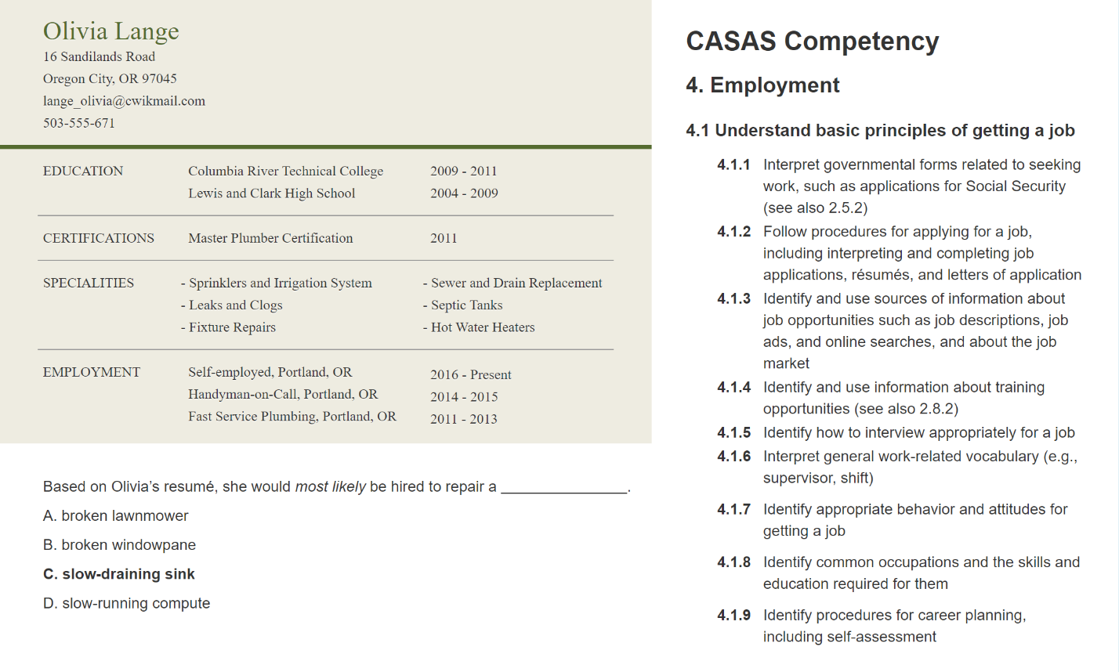

This test item aligns with CASAS Competency...

- 4.1.2 Follow procedures for applying for a job, including interpreting and completing job applications, résumés, and letters of application
- 4.1.3 Identify and use sources of information about job opportunities such as job descriptions, job ads, and online searches, and about the job market
- 4.1.4 Identify and use information about training opportunities (see also 2.8.2)
- 4.1.5 Identify how to interview appropriately for a job

Question 2
Which description best describes a CASAS competency?
Select one:
- An academic skill in language and math
- The format of a test item
- A functional life skill
- All of the above

Question 3
The CASAS Competencies...
Select one or more:
- apply only to beginning literacy levels.
- cover broad content areas that are ranked in order of difficulty from 0 – 8.
- provide instructional objectives for curriculum.
- are an organizational system that can help teachers determine which instructional materials to use for specific students.
- are all addressed in one test at each instructional level.
- are identified by a three-digit number that refers to content area, competency area, and competency statement (Example: 4.6.1).
- are based on field research which began in 1980.

Question 4
María just had a baby. She has been reading information and discussing "baby-proofing" ideas with her husband.
What competency is this?
Select one:
- 1.9.6 Interpret information related to automobile maintenance
- 2.3.2 Identify the months of the year and the days of the week
- 3.4.2 Identify safety measures that can prevent accidents and injuries

Question 5
Your boss asked you to write a memo about the new procedure for switching schedules. You've never written a memo before.
What competency is required to write the memo?
Select one:
- 2.8.4 Interpret policies and procedures of educational institutions regarding attendance, grades, conduct, student rights, etc.
- 4.6.2 Interpret and write work-related correspondence, including notes, memos, letters, and e-mail
- 5.1.7 Identify how to contact public officials about issues and concerns

Question 6
Mohamed has a new wristwatch. While standing in line at the supermarket, someone asks him the time.
What competency is required here?
Select one:
- 2.3.1 Interpret clock time
- 2.8.4 Interpret policies and procedures of educational institutions regarding attendance, grades, conduct, student rights, etc.
- 3.1.2 Identify information necessary to make or keep medical and dental appointments

Unit 4. Check for Understanding

Question 1

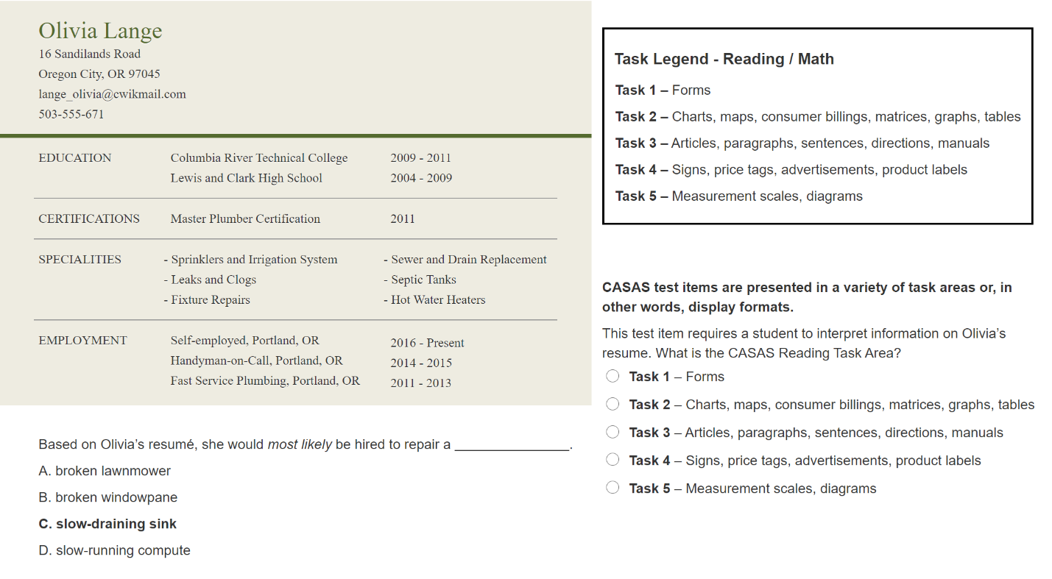

CASAS test items are presented in a variety of task areas or, in other words, display formats. This test item requires a student to interpret information on Olivia’s resume.
What is the CASAS Reading Task Area?
Select one:
- Task 1 – Forms
- Task 2 – Charts, maps, consumer billings, matrices, graphs, tables
- Task 3 – Articles, paragraphs, sentences, directions, manuals
- Task 4 – Signs, price tags, advertisements, product labels
- Task 5 – Measurement scales, diagrams

Question 2
Understanding student performance on Task Areas can help a teacher develop lesson plans that include a specific task type.
This can be accomplished by using authentic materials in the classroom to reinforce learning.
Select the correct authentic material for each Task Area.
Task 1 – Forms / Insurance claim form
Task 2 – Charts, maps, consumer billings, matrices, graphs, tables / Park trail map
Task 3 – Articles, paragraphs, sentences, directions, manuals / Sanitizing procedure from a daycare manual
Task 4 – Signs, price tags, advertisements, product labels / Cough syrup label
Task 5 – Measurement scales, diagrams / Onboarding flow chart

Question 3
Understanding student performance on Item Types helps teachers guide students' listening practice.
Authentic audio media such as songs, news broadcasts, sports events and airport announcements are useful tools for teachers to give students practice with Item Types.
Select one:
True
False

Question 4
A CASAS test item calls for a student to interpret a budget pie chart.
What is the Reading Task Area?
Select one:
- Task 1 – Forms
- Task 2 – Charts, maps, consumer billings, matrices, graphs, tables
- Task 3 – Articles, paragraphs, sentences, directions, manuals
- Task 4 – Signs, price tags, advertisements, product labels
- Task 5 – Measurement scales, diagrams

Unit 5. Check for Understanding

Question 1
Which of the following are incorporated in all CASAS test items? Check all that apply.
Select one or more:
- Competencies
- Content Standards
- Curriculum development
- Task Areas

Question 2
Understanding the relationship between CASAS test items and CASAS Content Standards, Competencies and Task Areas or Item Types helps instructors target instruction to an individual’s needs based on test results.
Select one:
True
False

Question 3
Use the resources to answer the questions.
Select the term that best fits the following descriptions.
- CASAS Content Standard – Identify the author’s point or purpose including what the author wants to answer, explain or describe.
- Task Area – Use an illustration of a floor plan to answer questions on measurement.
- CASAS Competency – Identify job training needs and set learning goals.

Question 4
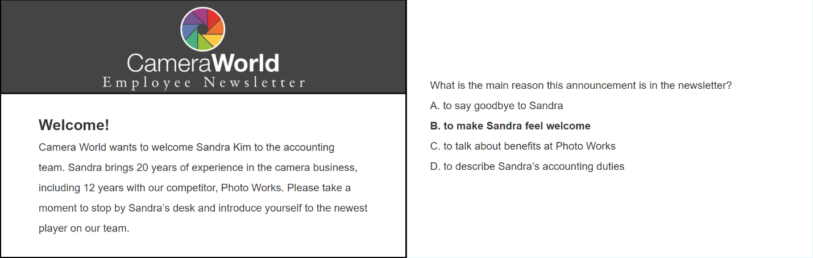

CASAS Reading Standards have references to the College and Career Readiness Standards for Adult Education (2013).
The standards are referenced as follows – CCRS: R2. C, D, E; CASAS: RDG 4.1

RDG 3.11 – Identify the main idea of a simple text or the central ideas or themes of a complex text, is measured in this test item. RDG: 3.11 is a...
Select one:
- CASAS Competency
- CASAS Reading Standard
- CCR Reading Standard
- All of the above

Because this test item aligns with CASAS Reading Standard RDG 3.11, it also aligns with which CCR Standard?
Select one:
a. CCR Anchor 2: A, B, C [R2.A,B,C]
b. CCR Anchor 3: A, B, C [R3.A,B,C]
c. Both a and b

This test item requires reading a newsletter, a type of informational text. Students who answered this test item correctly can determine the central idea of an informational text.
True
False

Would you group together students who answered this test item incorrectly for instruction on the main idea, central idea, and themes of simple or complex texts?
Yes
No

Question 5

This test item includes which CASAS Competency?
Select one:
a. 4.6.2 Interpret and write work-related correspondence
b. 4.6.3 Interpret written workplace announcements and notices
c. Both a and b

What type of instruction might you provide a student who misses this test item?
Select one:
a. Reading a variety of company newsletters to determine the main idea.
b. Reading company notices to determine the central idea of the text.
c. Both a and b.

Question 6
Which is an example of a measurable competency?
Select one:
- Complete a job application
- Read library materials
- Understand life concepts
- Learn about presidents

Question 7
Mr. Kim sent a package to his mother in Seattle. She never received the package. Mr. Kim needs to go to the post office and find out what happened.
Which competency will he need to use?
Select one:
- 5.3.6 Interpret information or identify requirements for establishing residency and/or obtaining citizenship
- 2.4.5 Interpret procedures for tracking shipments
- 7.6.3 Distinguish fact from opinion, fiction from non-fiction, and point of view in media messages and presentations

Question 8

This test item includes which CASAS Reading Task?
Select one:
- Task 1 – Forms
- Task 2 – Charts, maps, consumer billings, matrices, graphs, tables
- Task 3 – Articles, paragraphs, sentences, directions, manuals
- Task 4 – Signs, price tags, advertisements, product labels
- Task 5 – Measurement scales, diagrams

Unit 6. Check for Understanding

Question 1
Why is it important for teachers to access TOPSpro Enterprise?
Select one:
- For reports to help them understand and interpret test results.
- For reports that suggest how they can better focus their teaching.
- For reports that show how well students are meeting recognized standards.
- All of the above.

Question 2
Summary reports may be used to inform class instruction while Individual Student reports provide information to guide individual student instruction.
Select one:
True
False

Question 3
Many reports in TOPSpro Enterprise can be generated for an individual student and an entire class.
Indicate whether each of the following is a student-based or class-based report.
Choose student-based or class-based for each of the following reports.
Student Content Standard Performance = Student-based
Individual Skills Profile = Student-based
Competency Performance Summary = Class-based
Student Competency Performance = Student-based
Learning Gains Summary = Class-based
Content Standard Performance Summary = Class-based
Personal Score Report = Student-based

Question 4
Use these Score Reports to answer the questions below.
Answer the following questions about Score Reports.

4.1 These Score Reports can only be accessed if you use CASAS eTests.
True
False

4.2 The Student Test Summary and Learning Gains Summary reports provide valuable information for teachers to review after progress testing.
True
False

4.3 Which report gives the student immediate feedback after taking a test on eTests?
- Personal Score Report
- Next Assigned Test
- Student Test Summary
- Learning Gains Summary

Question 5
Use these Skill Reports to answer the questions below.
Answer the following questions about Skill Reports
5.1 How can teachers benefit from sorting student performance reports by correct answers in descending order when reviewing the report with a student?
The student is encouraged as their attention is first drawn to areas of strength at the top of the report.
- The teacher can reinforce student achievement.
- The teacher can easily help the student identify specific areas that need improvement displayed at the end of the report.
- All of the above.

5.2 How can teachers benefit from sorting class reports by correct answers in ascending order when planning lessons for class instruction?
- The teacher can readily identify the specific skills needed most by the entire class displayed at the top of the report.
- The teacher can focus their instruction on areas of greatest need spending less class time on mastered skills.
- The teacher can track progress in previously targeted areas of instruction.
- All of the above.

Question 6
This Individual Skills Profile shows a student's performance in basic reading and math skills from their most recent assessments.
The report displays the Competency areas and CCR Content Standards for each assessment with the percentage of correct answers.

Teachers should consider the number of items in each content area and not solely the percentage to determine instructional needs.
For example, it would be wiser to focus on an area indicating 15% correct with 20 items than an area indicating 1% percent correct with only 2 items.

Based on the statements above, in which Math Task Area does this student most need instruction?
- Charts, maps, consumer billings, matrices, graphs, tables
- Articles, paragraphs, sentences, directions, manuals
- Signs, price tags, advertisements, product labels
- Measurement scales, diagrams

Question 7
Use this Individual Skills Profile to answer the question below.
When reviewing the Individual Skills profile with a student...
Which of the following CCR Standards Reading Content Areas would you highlight as strengths to encourage the student?
Hint: There are four correct answers.
Select one or more:
- Reading Comprehension Skills: Locate details
- Reading Comprehension Skills: Identify main idea, Author’s purpose
- Higher Order Reading Skills: Locate/Compare details, Infer/Draw conclusions
- Higher Order Reading Skills: Text structure
- Higher Order Reading Skills: Author’s point of view
- Higher Order Reading Skills: Analyze claim

Question 8
The Content Standard Performance Summary (or Class Performance by Test & Content Standard) is a class report that helps teachers target instruction by identifying...
- the content standards covered on this test form,
- the number of test items addressing each content standard, and
- the percentage of students who answered the items correctly.
When planning instruction, teachers should take note that class reports have multiple pages showing student performance on a range of test form levels.
NOTE: Teachers may use these reports to inform class instruction by identifying the content standards with low percentages (50% and below).
For example: Refer to pages 2 and 5 in this sample report to answer the following questions.

9.1 A teacher should target instruction on CASAS Standard RDG 4.4 in small groups because:
- The reports show a high number of test items and low performance for RDG 4.4 on Form 905R - Level C and Form 908R - Level D.
- Only 48% of the Level C students and 46% of the Level D students answered questions covering RDG 4.4 correctly.
- Less than 50% of students at Level C and D demonstrated mastery of this standard.
- All of the above.

9.2 According to these reports, which CASAS Reading Standard should not initially be the focus of whole-class instruction because the majority of students on Test Forms 905R and 908R correctly answered the items for which standard?
- RDG 2.3 – Interpret accurately a range of general academic, and domain-specific words and phrases in context.
- RDG 3.12 – Identify the key details and cite evidence from a text.
- RDG 3.14 – Identify the author’s point of purpose including what the author wants to answer, explain or describe.
- RDG 4.4 – Determine what a text says implicitly (e.g. make inferences, draw conclusions) and cite textual evidence.

Question 9
The Test Score Overview is a new class report that allows you to select which of the following options to display in a single report?
Select one:
- CASAS Scale Score
- National Reporting System (NRS) Educational Functioning Level (EFL)
- Grade Level Equivalent (GLE)
- All of the above.

Unit 7. Check for Understanding

Question 1
CASAS assists with curriculum support by providing...
Select one:
- Publications that teach basic skills to adult students
- Free online classes in reading and math geared to adult students
- A searchable database of instructional resources
- A recommended curriculum for classes at all levels

Question 2
With QuickSearch Online, you can search for instructional materials by:
Select one:
- Publisher or Title
- Competency or Content Standard
- Program, Level or Skill
- CASAS Assessment
- All of the above

Question 3
Do you need a paid subscription to access QuickSearch Online and the Low-Level Literacy Curriculum Modules?
yes
no

