Module 4 covers how to interpret and use test results and reports to improve instruction.
Time / Min. | Module / Slide | Content / Notes | Talking Points
 |  | Trainer 1:  START Screen Share. | Module 4: Test Results and Reports
9:50  10 min | Slide 1  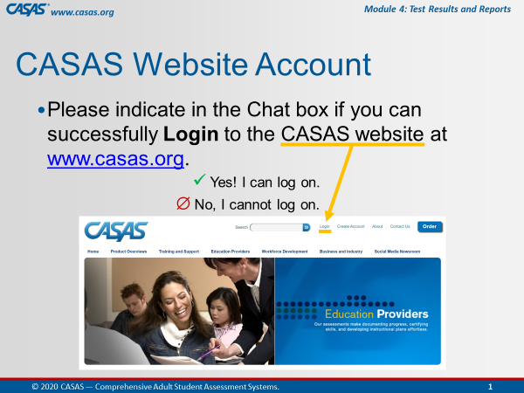 | Participant Arrivals:  Host admits participants into the web conference meeting from the waiting room.  Welcome participants as they arrive in the meeting room.  Confirm CASAS website logins. | Hi [participant name] and welcome to the training.  Please use the Chatbox to let us know if you can successfully log on to the CASAS website.  [Trainer 1: send anyone to the Tech Breakout Room (BOR) with Trainer 2 to assist with logins if needed.]
 | Slide 2  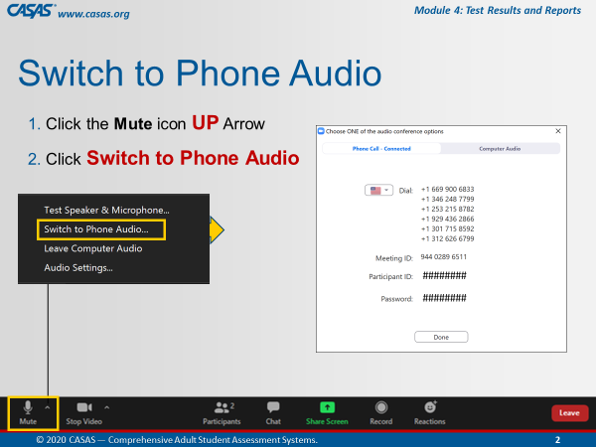 | This is an ANIMATED slide in PPT “slide show” mode.  Open Mic  Help participants switch audio if needed. | Some of you may be connected to the meeting using your computer audio. If you experience any trouble with your audio or Internet connectivity, we recommend switching to Phone Audio. To do that:  [Click 1] Click the UP arrow next to the Mute icon.  [Click 2] Select Switch to Phone Audio.  [Click 3] From the pop-up phone listing, dial a number, enter the Meeting ID and your Participant ID. You may also be prompted to enter the meeting Password.
 | Slide 3  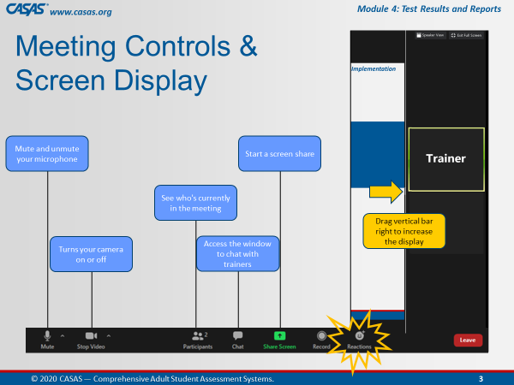 | This is an ANIMATED slide in PPT “slide show” mode.  Briefly review the web conference meeting controls. | Attendee controls appear at the bottom or top of your screen.  [Click 1] Mute/Unmute: You can mute and unmute your microphone.  [Click 2] Start Video/Stop Video: Use the video icon to turn your camera on or off.  [Click 3] Participants: See who's in the meeting with the participants icon.  [Click 4] Chat: Click the chat icon to access the window to communicate with each other.  [Click 5] Share Screen: The share screen icon lets you share your computer screen, which you will be doing in Breakout rooms.  [Click 7] Reactions: There is also a Reactions icon that you can give a clap or thumbs up at any time and we may ask you to acknowledge something during training with a thumbs up.  [Click 6] Display: And to increase the display on the left of your screen, click and drag the vertical bar on the RIGHT to minimize the video screens.
 | Slide 4  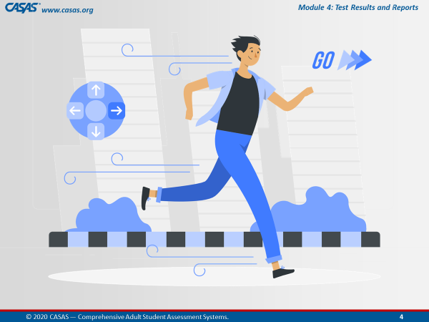 |  | We are going to get started…  Give a thumbs up from the Reactions icon if you are ready!
 |  | BEGIN TRAINING
10:00  3 min | Slide 5  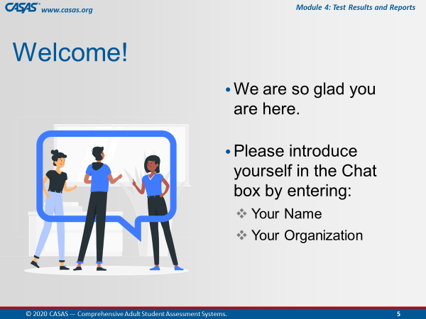 | Participant Introductions  Ask participants to introduce themselves in the Chatbox. | Hello everyone, let’s begin by introducing yourselves.  Please enter your name and [organization] in the Chatbox.  Alternates:  - Favorite hobby, color, etc.
 | Slide 6  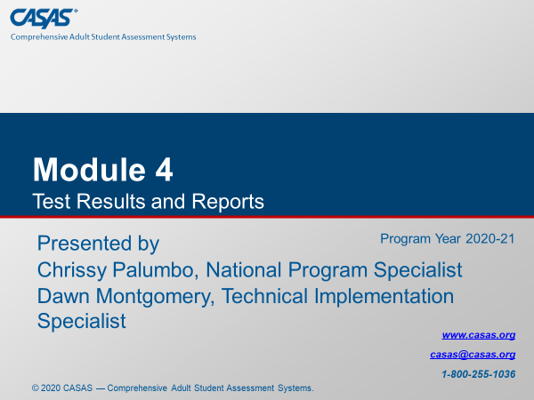 | Training Introduction | Today’s training covers Module 4: Test Results and Reports.
 |  | Trainer Introduction(s)  Trainers introduce yourselves (each out loud). | Trainer 1: My name is [say your name], and I have been working in adult education for the past ## years and have [extensive] experience with [the CASAS assessment process].  Trainer 2: My name is [say your name], and I have been working in adult education for the past ## years and have [extensive] experience with [the CASAS assessment process].
 |  | Trainer 1:  Trainer 2: | STOP Screen Share.  START Screen Share.
10:03  1 min | Slide 7  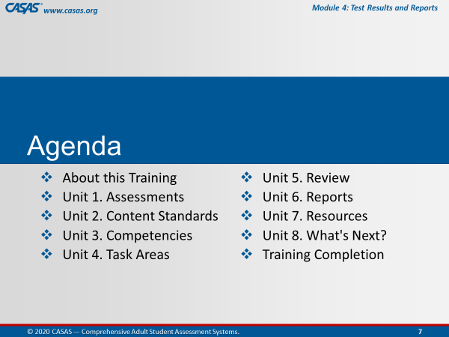 | Review meeting agenda.  - About this Training  - Unit 1. Assessments  - Unit 2. Content Standards  - Unit 3. Competencies  - Unit 4. Task Areas  - Unit 5. Review  - Unit 6. Reports  - Unit 7. Resources  - Unit 8. What's Next?  - Training Completion | Module 4 covers how to interpret and use test results and reports to improve instruction.  After briefly reviewing a few more meeting controls, we will go online together and complete the About this Training content which will open the other 8 units.  [Trainer 1] and I will cover content and check your understanding of the content from each Unit…  …and then guide you through the Training Completion process to get your Certificate at the end of this training.
 | Slide 8  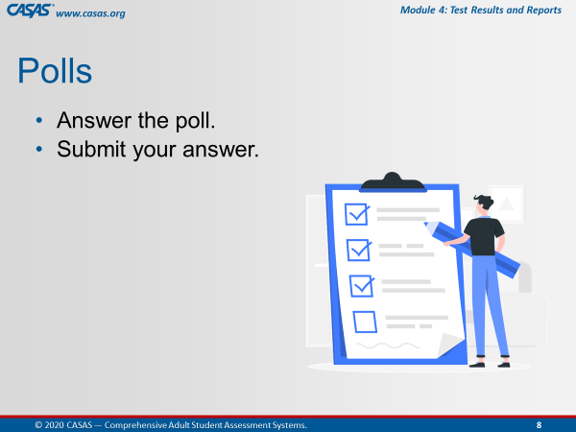 | Briefly review participating in Polls. | After we cover each unit, we will be answering checks for understanding either in the training Module, in Zoom Polls, through Chatbox responses, and together in Breakout rooms.  In Polls, you will answer the poll and then submit your answer.
 | Slide 9  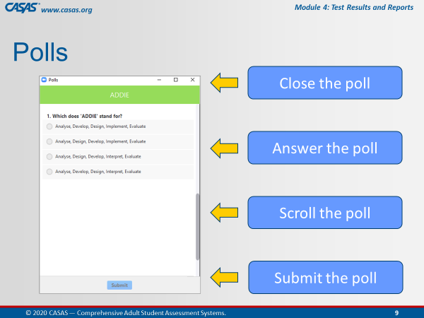 | This is an ANIMATED slide in PPT “slide show” mode.  Orient participants to polling. | This is what a Poll looks like in this web conference Meeting Room.  [Click 1] You will enter your responses directly on your screen.  [Click 2] In some polls, you will need to use the scroll bar to answer more questions in the poll.  [Click 3] Submit your answers. and then we will share your responses after closing the poll.  [Click 4] When done, you will want to close the Poll on your screen by clicking the X at the top RIGHT of the Poll window.
10:04  2 min | Slide 10  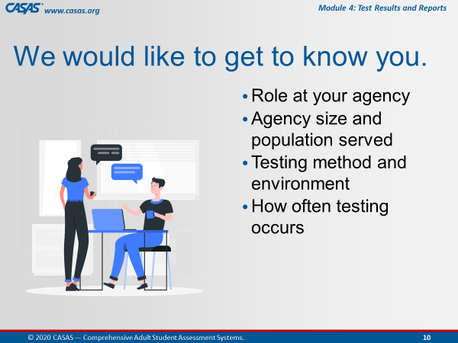 | Getting to Know You  Trainer: review info on slide. | Now, we would like to Get to Know You with a polling activity.  Such as your role, agency size and population, testing method and environment, and how often testing occurs.
 |  | LAUNCH POLLS:  - Respond to poll.  - Close the poll.  - Share the results. | - What is your role at your agency?  - What population does your agency serve?  - How long have you been using CASAS?
 |  | - Close the polls | Thank you for letting us get to know you!  Don’t forget to close the Poll screen.
10:06  1 min | Slide 11  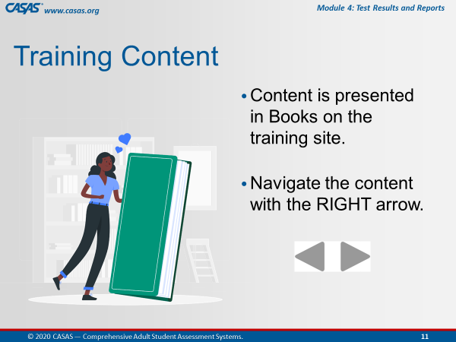 | This is an ANIMATED slide in PPT “slide show” mode. | We are going to go to the Training site together in a moment but first, I’d like to let you know what to expect.  You will see a green Book icon, which presents content in each unit.  We will review content in the first Book with you while you are in the module.  [Click 1] To navigate the pages in a book, click the RIGHT arrow at the top RIGHT or bottom RIGHT of your screen.
 | Slide 12  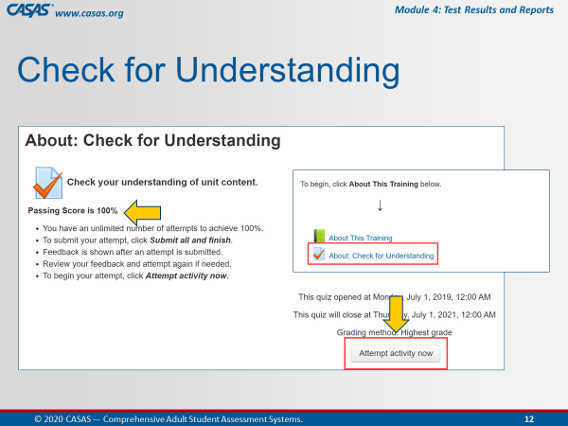 | This is an ANIMATED slide in PPT “slide show” mode. | We will be completing the first quiz together in the module so that the remainder of the module opens (Units 1 – 8) to access at different times during this training.  [Click 1] To begin the quiz, you will click the Attempt activity now button.  [Click 2] Our goal on this first quiz is to achieve 100%.  For the purpose of training together, you will get your certificate through your participation with us.  As a group, we will ensure we all get 100%.
 | Slide 13  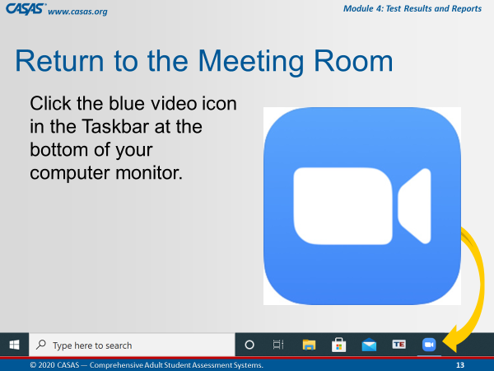 | This is an ANIMATED slide in PPT “slide show” mode.  (automated/no click).  Make sure participants know how to return to the Meeting Room. | When we are finished with the first Book and Quiz, we will ask you to return to the meeting room.  The way you will do that is click the Blue video icon at the bottom of your computer monitor.  Does everyone see this on your own computer?  Give me a “thumbs up” by clicking on the Reactions icon from your meeting controls.
 | Slide 14  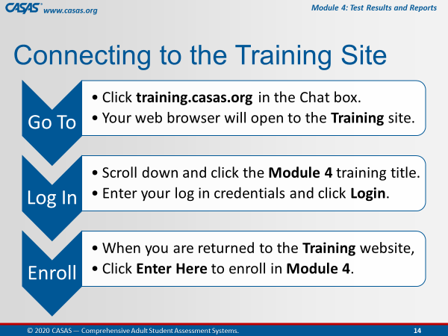 | This is an ANIMATED slide in PPT “slide show” mode. | We are about to go to the Training site together but first, I am going to describe the steps for us to get there.  [Click 1] Go To…  [Click 2] Log In…  [Click 3] Enroll…  Another purpose of this training is to help you understand the content in the online modules so you can RETURN to them to support you in your Adult Education position using CASSAS assessments.
 | Slide 15  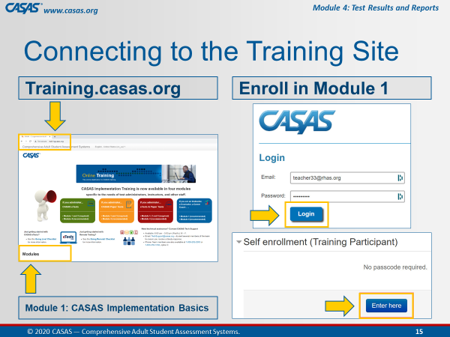 | This is an ANIMATED slide in PPT “slide show” mode. | Follow these 4 steps  Step 1. [Click 1] We will Go To the training site.  Step 2. [Click 2] And scroll down to click on Module 1.  Step 3. [Click 3] You will be automatically prompted to Log In with your CASAS website credentials.  Step 4. [Click 4] Then, you are automatically returned to the Training Site where you will click Enter here to open Module 1.
 |  | Prepare participants for logging on to the Training website.  http://training.casas.org/ | Please unmute your microphone so that we can continue to communicate when you are in your own module since the Training site will cover up the Meeting Room as soon as you click on the link that [Trainer 1] will put there  Ok, let’s go to the Training website.  [Trainer 1], please enter the training URL in the Chatbox.  Step 1. Ok Everyone, go to your Chatbox and click on the URL that [Trainer 1] just put in there.
 |  | Trainer 2:  Trainer 1: | STOP Screen Share.  START Screen Share.
10:07  5 min | 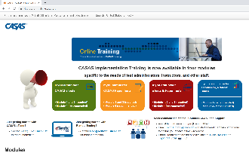 | OPEN the Training site.  Guide participants to logging on to the Training website and opening the module.  Demonstrate on your screen as you are talking the participants through each step.  Wait to proceed until everyone is looking at the module on their own screens. | Ok everyone, you should be looking at the Training website with the four colorful boxes.  Is everybody with me?  Step 2. Scroll down and click on the Module 4: Test Results and Reports training title.  Step 3. Enter your CASAS website log in credentials and click Login.  - Step 4. When you are returned to the Training website, click Enter Here to enroll in Module 4.
 | Module   | About This Training  Guide participants through information about the training as if they are viewing your screen. | Please click the About This Training link to open the green book, which contains the content for this part of the training.
 | 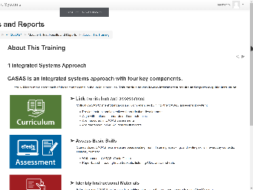 | 1 Integrated Systems Approach | The first page you should see in this book is Integrated Systems Approach.  CASAS is an integrated systems approach with four key components – Curriculum, Assessment, Instruction, and Accountability.  These components link curriculum and assessment, assess basic skills, identify instructional materials, and track student progress.  We will be covering these components in greater detail throughout this training.  To navigate to the next page, click the RIGHT arrow at the top RIGHT or bottom RIGHT of your screen.  This will take you to the next page in this book.
 | 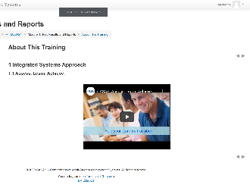 | 1.1 Assess. Learn. Achieve. (video)  Time permitting: Play the first 59 seconds of the video. | On the next page, you should see the Assess. Learn. Achieve. video, which is a quick introduction to CASAS.  If you haven’t seen this video in Module 1, we encourage you to return later to this page to watch.  Remember those arrows?... click the RIGHT arrow and go to the next page.
 |  | 2 Training Modules  CFU 1, 2, 3 | The first page you should see in this book is Training Modules.  CASAS Implementation training is available in four modules specific to the needs of test administrators, instructors, and other staff.  [Q1] To use CASAS eTests, you are required to complete Modules 1 & 2.  [Q2] If you only plan to paper test, Modules 1 & 3 are required.  [Q3] Modules 1 & 4 are strongly recommended for all staff using CASAS.  How do we go to the next page?  Click the RIGHT arrow!
 | 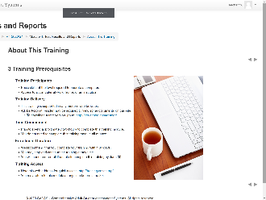 | 3 Training Prerequisites | The next page is about Training Prerequisites.  This is helpful information if you plan to complete another module on your own.  Now, click the arrow and go to the next page.
 | 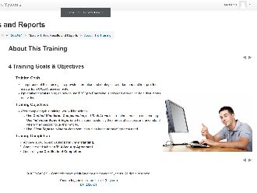 | 4 Training Goals & Objectives | You should see Training Goals and Objectives.  This page describes the purpose of this training, which is to provide information and strategies to understand and interpret test results from CASAS assessments.  Technical training on how to use TOPSpro Enterprise is provided with online help documents and videos available on the CASAS website.  At the end of this training, we will guide you through the training completion process so that you can generate your certificate.  Let’s go to the next page.
 | 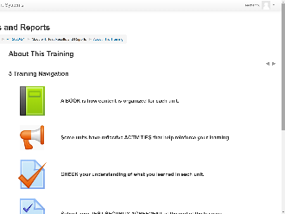 | 5 Training Navigation | You should now be on the Training Navigation page.  The navigation information will help you understand how to navigate a training module if you plan to complete a module on your own.  Since you are completing the training with us, we will guide you through this training.  What you need to know before we move on is how to return to the module HOME page from any training page when you are in the module on your own.  Look at the top of your module screen and you will see a Breadcrumb trail.  In that Breadcrumb trail is the Module Short Name, which in this case is M2 2020-21.  Let me know when you see the module Short Name in the Breadcrumb trail on your own computer screen.  Don’t click it now, but whenever you click the module Short Name from the Breadcrumb, this will return you to the module HOME page from wherever you are in the module.  So if you lose your place, just return Home and that will help you get back to where you need to be.  For now, we are going to SKIP the next three navigation pages and go to the last page in this book.  From the Table of Contents at the upper left of your screen, click Training & Technical Support.
 | 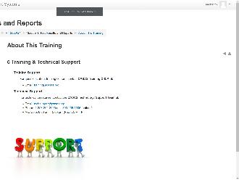 | 6 Training & Technical Support | You should be looking at the Training & Technical Support page now.  Whenever you have questions or need clarification about training content, don’t hesitate to contact training@casas.org.  And whenever you need technical assistance, you can reach out to the CASAS Technology Support Team with the contact information displayed on this page.
 |  | Guide participants back to the module HOME page. | Now we are going to leave this book.  Click the RIGHT arrow at the top RIGHT or bottom RIGHT of your screen.  This will return us to the module HOME page.
10:12  5 min | 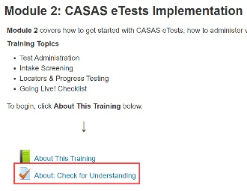 | About: Check for Understanding  MODULE – CFU Activity (3 Qs) | You should be back on the Home page and see the Module 4: Test Results and Reports training title at the top.  Let me know that you are on the Home page.  Since we are in the module, we will answer Checks for Understanding for the About This Training unit.  Below the green Book icon, click on the About: Check for Understanding link.
 |  | Guide participants through completing the first quiz together. | You should see About: Check for Understanding at the top of your screen.  Click the Attempt activity now button at the bottom of your screen and let’s complete the first quiz together.
 |  | Participants must achieve 100% to unlock the rest of the module. | Now, click Submit all and finish.  Feedback at the top of the results page tells you your score.  Scroll the page to see how you did. You will see a green for correct answers. Answers that are not correct will show a red X beside them.  Click Finish Review at the bottom of the page.  If you did not get 100%, you can reattempt to correct any incorrect answers – until you get 100% correct – so please click Reattempt activity now if needed.
 | 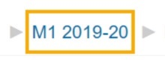 | Guide participants back to the module HOME page and proceed with the training. | When you see that you got 100%, click the module HOME link in the Breadcrumb trail at top of your screen and return to the module HOME page.  Take a look! The remainder of the module is now open for you to access at different times during this training. You should now see Units 1 – 8.  …and now that you have access to the training module, you can return to it at any time to review content through June 30, 2021.
 |  | Guide participants back to the web conference meeting room. | Ok, now let’s return to the Meeting Room.  Click the Blue video icon at the bottom of your computer monitor.
 |  | Trainer 1:  Trainer 2: | STOP Screen Share.  START Screen Share.
 | Slide 16  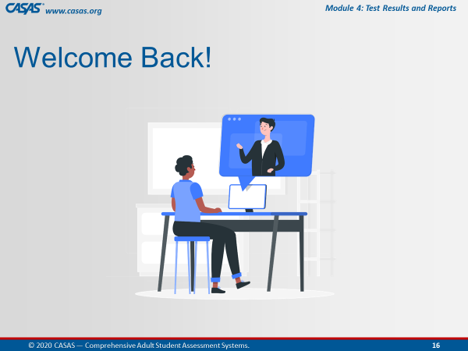 | Trainer: RETURN to PPT.  Welcome everyone back and remind participants… | Welcome back everybody!  You will know when you are back in the Meeting Room when you see this slide.
10:17  10 min | Module | Unit 1. Assessments  Trainer 2: RETURN to Module  Participants will view your screen. | Now, [Trainer 1] and I will now continue to take you through the remaining content in this training.  The first unit is a brief review about Test Administration.
 | 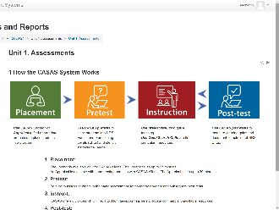 | 1 How the CASAS System Works | There are four components to How the CASAS System Works.  - You will use a CASAS Appraisal to initially assess a learner for Placement in an appropriate level  - Then Pretest, and from the results,  - Provide Instruction based on the areas of need, and then  - Post-test after a period of instruction.
 | 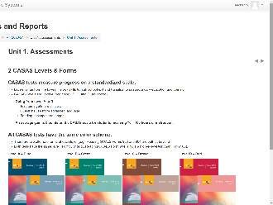 | 2 CASAS Levels & Forms  CFU 3, 4, 5, 6 | [Q3] In all test series, paper booklets are color-coded to differentiate between levels.  [Q4] CASAS assessments cover Beginning Literacy, Level A, to Post-secondary levels.  Test items get more difficult from Level A, Easy, to Level D that is the most advanced level.  [Q5] Each CASAS level has two alternate forms.  - For example, Reading GOALS Forms 903 and 904 are both at Level B.  [Q6] The alternate form in each CASAS level (i.e., Level A, B, C, D) is not more difficult than the first form.  - For example, 904R in CASAS Level B is not more difficult than 903R.
 | 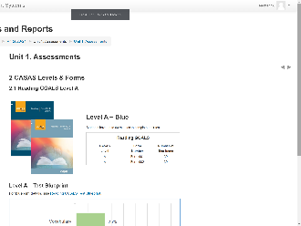 | 2.1 Reading GOALS Level A  [Trainer: Comment on percentages of content.] | Test content in Reading GOALS, Level A, includes:  - 25% Vocabulary  - 75% Reading Comprehension Skills
 | 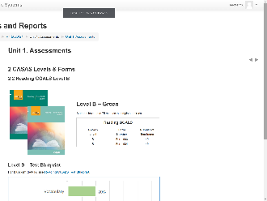 | 2.2 Reading GOALS Level B  [Trainer: Comment on percentages of content.] | Test content in Reading GOALS, Level A, includes:  - 20% Vocabulary  - 60% Reading Comprehension Skills  - 20% Higher Order Reading Skills
 | 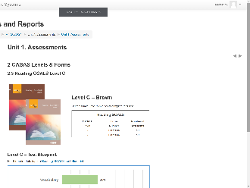 | 2.3 Reading GOALS Level C  [Trainer: Comment on percentages of content.] | Test content in Reading GOALS, Level A, includes:  - 20% Vocabulary  - 40% Reading Comprehension Skills  - 40% Higher Order Reading Skills
 | 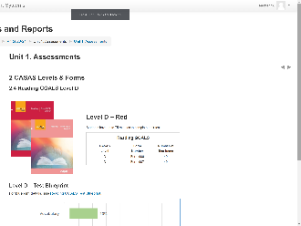 | 2.4 Reading GOALS Level D  [Trainer: Comment on percentages of content.] | Test content in Reading GOALS, Level A, includes:  - 20% Vocabulary  - 25% Reading Comprehension Skills  - 55% Higher Order Reading Skills
 | 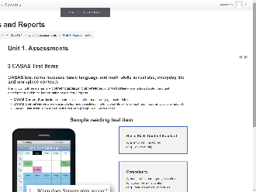 | 3 CASAS Test Items  CFU 1 | CASAS test items measure basic language and math skills in realistic, everyday life and workplace contexts.  [Q1] [U5Q1] All CASAS test items incorporate 3 Key elements:  - Content Standards, which are measurable academic skills. For example, locating detail in this Sample Reading Test Item.  - Competencies, which are measurable learning objectives in a functional life skills context like reading an activity schedule in this sample test item.  - Task Areas, which is the format or display of the test item prompt. In this case, the prompt a chart on a cell phone.  So in this Sample Test Item, the student must understand how to read a schedule displayed in a calendar format to find out when Sammy will play soccer.
 | 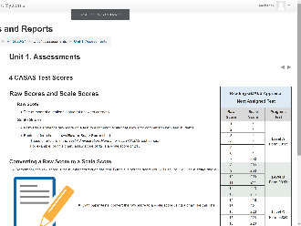 | 4 CASAS Test Scores  CFU 8 | Each test form has its own Raw to Scale Score conversion in a Next Assigned Test chart.  These charts are in the Test Administration Manual for each CASAS test series.  Here is an example from the Reading GOALS Appraisal.  The first column shows the Raw Score, which is the number of questions a student answers correctly.  The second column shows the Scale Score, which converts a student's raw score on a test to a common scale for measuring gains and for comparison between students.  eTests automatically scores each test and calculates the raw and scale score.  Here’s a Pop-Quiz for you!  [Q8] Based on this Next Assigned Test chart...  1. What is the scale score of a student with a raw score of 7 on the Reading GOALS Appraisal? A scale score of 200  2. What Reading GOALS level test should you give a student with a scale score of 228? Level C  3. What Reading GOALS pretest form should you administer to a student with a raw score of 11? Form 903R
 | 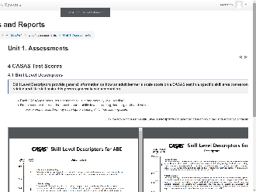 | 4.1 Skill Level Descriptors | Each test modality (e.g., reading, listening) measures the ability of a student for the skill tested.  The CASAS Skill Level Descriptors show a continuum of skills from beginning through advanced adult secondary and explain in general terms what most learners can accomplish at the CASAS scale score level in a specific skill area.  Note that CASAS levels go from:  - A (lowest level) to  - E (highest level).  Each test modality (e.g., reading, listening) measures the ability of a student for the skill tested.  A student’s listening skills may not be the same as their reading skills. So the descriptors help to understand their educational functioning level.  CASAS scores from more than one modality should not be averaged.  If you are only testing reading skills, then only the reading descriptors apply. The same holds true for math and listening.  You will find more Skill Level Descriptors on the CASAS website.
 | 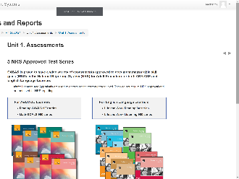 | 5 NRS Approved Test Series | The next few pages in this book cover NRS Approved Test Series.  NRS is the National Reporting System that Adult Ed programs report outcomes for Federal funding.
 | 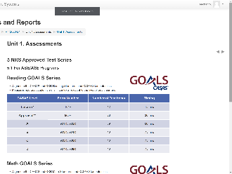 | 5.1 For ABE/ASE Programs | Here, you see that the new Reading GOALS and Math GOALS series is approved for ABE and ASE programs.  These tables identify the CASAS Level, Form Number, Number of Test Items and Timing per level.
 | 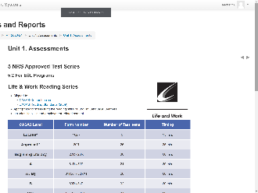 | 5.2 For ESL Programs | The next page shows the Life and Work Reading and Listening 980 series that are NRS approved for ESL programs.  Again, these tables detail the Number of Test Items and Timing per CASAS Level and Form Number.
 | 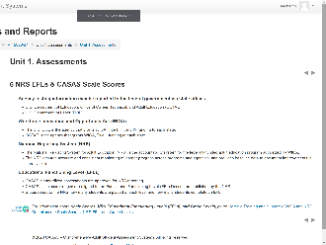 | 6 NRS EFLs & CASAS Scale Scores | You will hear many acronyms in Adult Ed.  In a nutshell, CASAS assessments are approved by the Office of Career, Technical, and Adult Education (OCTAE) for reporting in the National Reporting System (NRS).  CASAS scale score ranges align to the Educational Functioning Level (EFL) descriptors published by the NRS.  States funded by the Workforce Innovation Opportunity Act (WIOA) report to the NRS how many students are placed at each level and how many students complete an EFL.
 | 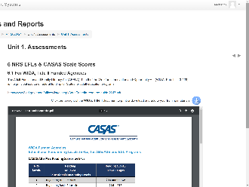 | 6.1 For WIOA, Title II Funded Agencies  CFU 2 | [Q2] The CASAS scale covers all six Educational Functioning Levels (EFLs) for both ABE/ASE and ESL.  The top chart shows the relationship between Educational Functioning Levels (EFLs) and Reading GOALS scale scores for ABE/ASE learners.  The second chart is the same information but for Math GOALS.  Note: There are 6 levels in the Math NRS EFL Descriptors. These 6 levels include a new Middle Intermediate Basic Education level (NRS 4). Adult Low and Adult High Secondary Levels were combined into one level (NRS 6). There are no longer Low Adult Secondary and High Adult Secondary levels.  The last chart shows the relationship between Educational Functioning Levels (EFLs) and CASAS Life and Work Reading and Life and Work Listening test series for ESL Leaners.
 | 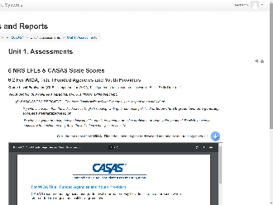 | 6.2 For WIOA, Title I Funded Agencies and Youth Providers | WIOA, Title I programs serving youth and adults for workforce readiness and job training programs use a similar chart with Grade Level Equivalents (GLEs).  This chart helps Title I programs determine if a student is basic skills deficient and needs to be referred to a WIOA, Title II Adult Ed program for instruction.  And students who are not basic skills deficient may be eligible for enrollment in workforce readiness and job training programs.
10:27  1 min | Module | Unit 1. Sample Test Items  Trainer: click the Sample Test Items link on your screen. | The next book in this unit will introduce you to Sample Test Items.
 | 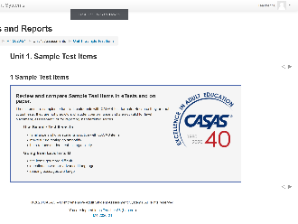 | 1 Sample Test Items  CFU 7 | Sample Test Items are available in both eTests and paper-test formats.  These are not actual tests and cannot be used to determine basic skills or for placing students in a program, however,  [Q7] Using sample test items will help to:  - Familiarize students with the format of CASAS test items  - Make testing go more smoothly  - Help reduce test anxiety
 | 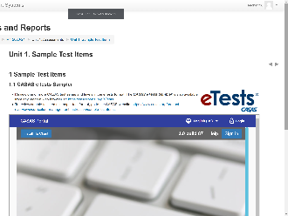 | 1.1 CASAS eTests Sampler  1.2 Reading GOALS Level A  1.3 Reading GOALS Level B  1.4 Reading GOALS Level C  1.5 Reading GOALS Level D | Test items get more difficult going from Level A to D.  [Trainer: If time is running short, encourage participants to return to the module later to peruse these SAMPLE TEST ITEMS for their reference.]
 | 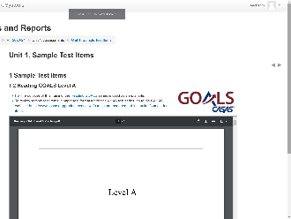 | OPTIONAL:  Trainer: Paste URLs for Sample Test Items in the CHATBOX. | We have about [#] minute(s) for you to explore these items and then we will ask you to return to the meeting room.  You don’t need to test yourself, just scroll through the samples to see items at that level.  Click on any of the URLs that [Trainer 1] just entered in the CHATBOX.
 | Slide 16 | Trainer: 1 | Return to PPT.
10:28  4 min | Slide 17  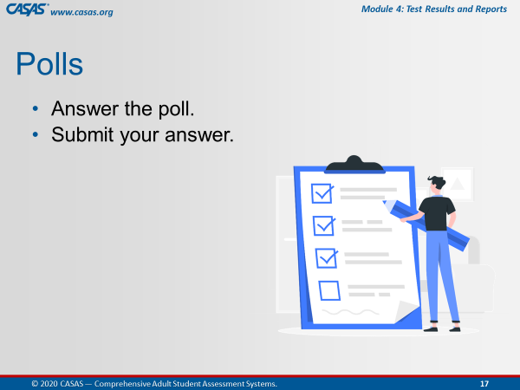 | Unit 1. Check for Understanding  POLL – CFU Activity (8 Qs)  Note: Q8 was used as a pop-quiz in U1:C4 content.  - Launch the poll.  - Respond to the poll.  - Close the poll.  - Share the results.  Confirm correct responses and provide clarification if needed. | I am going to launch a Poll for you to answer checks for understanding the content we just covered in this unit.  There are 7 questions.  I’ll give you a [#] minute(s) to go through them and then close the poll.  Ok, everyone is doing a great job. I’m going to close the poll in about 5 seconds.  [Trainer: comment on participant responses.]
 |  | Remind participants how to close the poll on their screen. | Ok, go ahead and Close the poll window on your screen.
 |  | Trainer 2:  Trainer 1: | STOP Screen Share.  START Screen Share.
10:32  8 min | Module | Unit 2. CCR & CASAS Content Standards  Trainer 1: RETURN to Module  Participants will view your screen. | Unit 2 covers College and Career Readiness & CASAS Content Standards.
 | 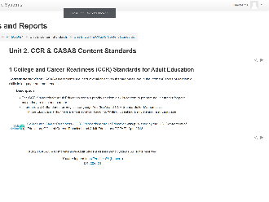 | 1 College and Career Readiness (CCR) Standards for Adult Education | CCR Standards on CASAS assessments are instructional objectives measured in the “content” areas of academic skills in language and mathematics.  These standards prepare adult learners for post-secondary training and careers.
 | 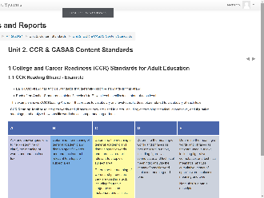 | 1.1 CCR Reading Strand - Example | Each CCR strand has Anchor Standards that describe standards in that strand.  Each Anchor Standard contains 5 levels (A to E) with descriptors specific to each level.  This example shows CCR Reading Anchor 4 that relates to vocabulary and level-specific descriptors related to vocabulary at each level.
 | 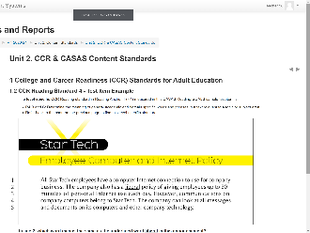 | 1.2 CCR Reading Standard 4 - Test Item Example | The level-specific CCR Reading standard measured in this CASAS Reading GOALS sample test item is:  - R4.B and C, which looking at the chart on the previous page is to:  - Determine the meaning of general academic and domain specific words and phrases in a text relevant to a topic or subject area.
 | 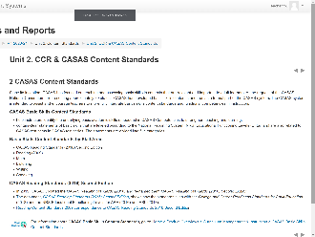 | 2 CASAS Content Standards  CFU 2, U5 CFU 2 | [Q2] [U5Q2] CASAS Basic Skills Reading Standards…  - help instructors understand what basic reading skills a student needs.  - contain clear statements of reading skills that are leveled according to the National Reporting System (NRS).
 | 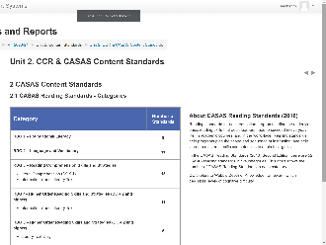 | 2.1 CASAS Reading Standards - Categories | There are 52 standards in five categories in the 2016 second edition of CASAS Reading Standards.  This chart shows the number of CASAS Reading Standards in each category.
 | 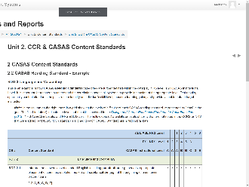 | 2.2 CASAS Reading Standard - Example  CFU 1.3, U5 CFU 4 | Understanding the correlations across all systems is important for teachers to provide instruction at the appropriate level.  Looking at this chart, note:  - In the column on the right, there is a grid showing the levels of difficulty of each CASAS reading standard, represented by “dots” in the grid.  - The filled-in dots (•) indicate the level that the skill is covered in the College and Career Readiness Standards for Adult Education (2013), NRS ABE/ASE Levels, and NRS ESL Levels.  - The hollow dots (○) are skills or levels of ability that are not noted in the CCRS or NRS that were added by CASAS.  - CCR standards aligned to each CASAS Standard are noted in brackets.  [Q1.3] [U5Q4] For example RDG 2.8 is:  - aligned to CCR standards L4. at CCR Levels A, B, C, D, E;  - and R4 at CCR Levels A, B, C, D, E  - as noted in brackets.
 | 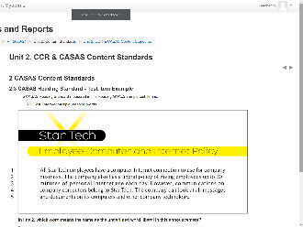 | 2.3 CASAS Reading Standard - Test Item Example  CFU 1.1, 1.4, U5 CFU 4 | [Q1.1] CASAS Reading Standards have references to the College and Career Readiness Standards.  We saw previously, the CCR Reading Standard referenced in this test item is Reading Anchor 4, B and C.  The CASAS Reading Standard measured in this Reading GOALS sample test item is:  - RDG 2.8: Interpret multiple-meaning words  [Q1.4] [U5Q4] Students who answered this test item incorrectly could be grouped together for instruction.
 | 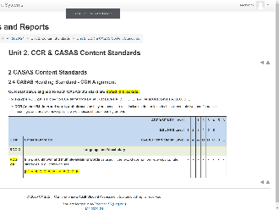 | 2.4 CASAS Reading Standard - CCR Alignment  CFU 2 | [Q2] CASAS Reading Standards…  - align with the College and Career Readiness Standards for Adult Education for both ABE and ESL.  - Noted in brackets on this chart.
 | Slide 18  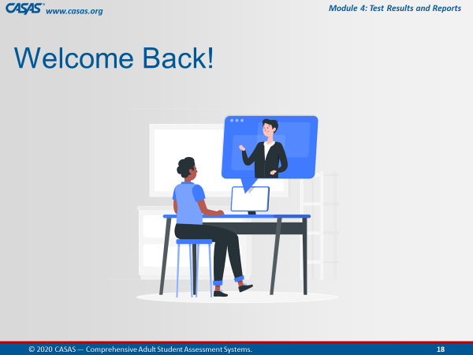 | Trainer 1: | RETURN to PPT.
10:40  2 min | Slide 19  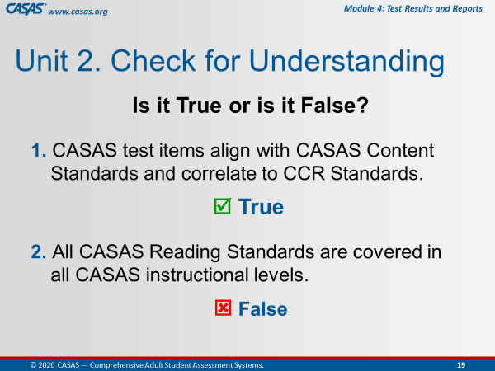 | Unit 2. Check for Understanding  CHATBOX – CFU Activity (2 Qs)  This is an ANIMATED slide in PPT “slide show” mode.  Participants enter their responses in the CHATBOX. | I am going to display the next checks for understanding on my screen.  Please enter your answers in the Chatbox.  Is it True or is it False?  [Click 1] CASAS test items align with CASAS Content Standards and correlate to CCR Standards.  [Click 2] CASAS Reading Standards are covered in all CASAS instructional levels.
 |  | Trainer: review answers in CHATBOX and use them to respond to the CFUs. | [Click 1] True  [Click 2] False
 |  | Trainer 1:  Trainer 2: | STOP Screen Share.  START Screen Share.
10:42  5 min | Module | Unit 3. CASAS Competencies  Trainer 2: RETURN to Module  Participants will view your screen. | Our next unit is about CASAS Competencies.  This is the 3rd unit out of 8 in this module.  [Trainer: click the Unit 3. link on your screen.]
 | 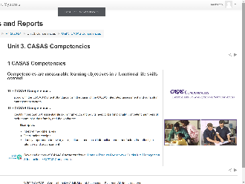 | 1 CASAS Competencies  CFU 2, U5 CFU 6 | [Q2] [U5Q6] CASAS Competencies are measurable learning objectives in a functional life skills context, and along with the CASAS Content Standards form the basis of the CASAS integrated assessment and curriculum management system.  CASAS Competencies identify more than 360 essential life skills.  [U5Q6] Examples of measurable competencies include:  - interpreting medicine labels, and  - checking sales receipts
 | 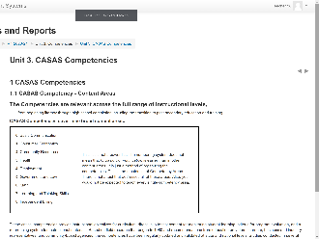 | 1.1 CASAS Competency - Content Areas  CFU 3, 4, 5, 6 | [Q4,5,6] CASAS Competencies are relevant across the full range of instructional levels and cover nine broad content areas shown here, such as:  [Q6] 2. Community Resources  [Q4] 3. Health  [Q5] 4. Employment  The numbering system does not mean that 0. Basic Communication is easier than in other content areas. It is just a method of organizing the competencies.  [Q3] These critical CASAS Competencies...  - provide instructional objectives for curriculum.  - are an organizational system that can help teachers determine which instructional materials to use for specific students.  - are based on field research which began in 1980.
 | 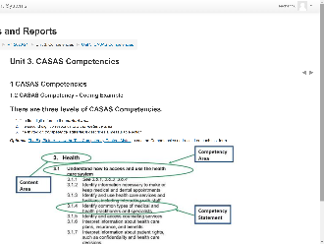 | 1.2 CASAS Competency - Coding Example  CFU 3 | [Q3] CASAS Competencies are also identified by a three-digit number that refers to content area, competency area, and competency statement.  For example, 3.1.4.  - The first digit refers to the content area.  - The second digit corresponds to a competency area.  - The third-digit competency statement describes a measurable action.
 | 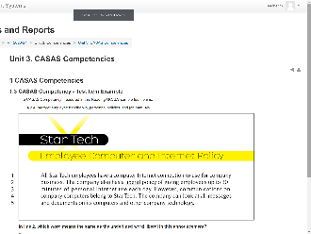 | 1.3 CASAS Competency - Test Item Example | Using the same Reading GOALS sample test item, the CASAS Competency measured is:  - 4.2.4 Interpret employee handbooks, personnel policies, and job manuals.
 | Slide 20  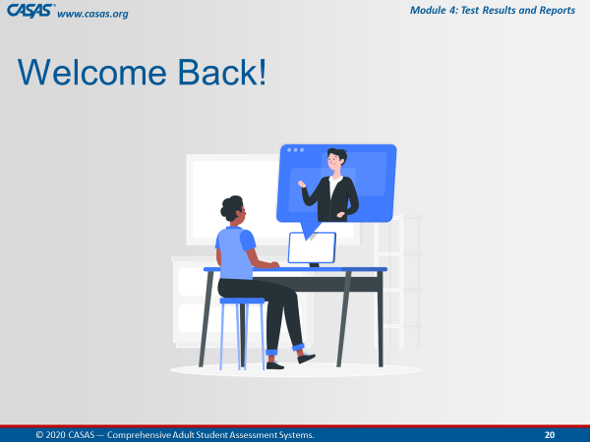 | Trainer 2: | RETURN to PPT.
10:47  3 min | Slide 21  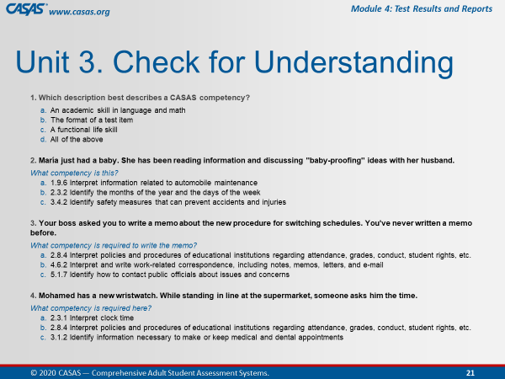 | Unit 3. Check for Understanding  CHATBOX – CFU Activity (4 Qs)  This is an ANIMATED slide in PPT “slide show” mode.  Participants enter their responses in the Chatbox. | I am going to display the next checks for understanding on my screen.  Please enter your answers in the Chatbox.
 |  | Trainer: review answers in Chatbox and use them to respond to the CFUs. | 1. Which description best describes a CASAS competency?  - A functional life skill  2. María just had a baby. She has been reading information and discussing "baby-proofing" ideas with her husband.  What competency is this?  - 3.4.2 Identify safety measures that can prevent accidents and injuries  3. Your boss asked you to write a memo about the new procedure for switching schedules. You've never written a memo before.  What competency is required to write the memo?  - 4.6.2 Interpret and write work-related correspondence, including notes, memos, letters, and e-mail  4. Mohamed has a new wristwatch. While standing in line at the supermarket, someone asks him the time.  What competency is required here?  - 2.3.1 Interpret clock time
 |  | Trainer 2:  Trainer 1: | STOP Screen Share.  START Screen Share.
11:50  3 min | Module | Unit 4. CASAS Task Areas  Trainer 1: RETURN to Module.  Participants will view your screen. | Our next unit is about the format of the test item prompt. This is Unit 4 out of 8 units for this training.  [Trainer 1: click the Unit 4. link on your screen.]
 | 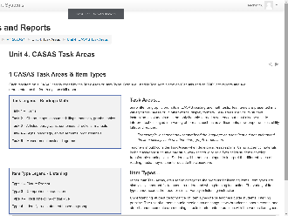 | 1 CASAS Task Areas & Item Types  CFU 1, 2, 3, 4 | [Q1] CASAS Reading and Math test items are presented in a variety of display formats referred to as Task Areas and Listening test items use Item Types.  A student may comprehend the language on a test item but not understand the item display, such as a bar chart, graph, or pie chart.  Task Areas and Item Types are represented as the fourth digit on skill reports.  [Q2] Understanding student performance on Task Areas can help a teacher develop lesson plans that include a specific task type.  This can be accomplished by using authentic materials in the classroom to reinforce learning.  For example, authentic material for:  Task 1 – could be an insurance claim form  Task 2 – a Park trail map  Task 3 – could be a workplace manual  Task 4 – a medicine label, and  Task 5 – could be a flow chart  [Q4] What would the Reading Task Area be on a CASAS test item that calls for a student to interpret a budget pie chart?  Yes! Task 2.  [Q3] Understanding student performance on Item Types helps teachers guide students' listening practice.
 | 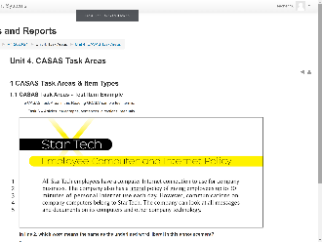 | 1.1 CASAS Task Areas - Test Item Example  CFU 4, U5 CFU 8 | [Q4] [U5Q8] The CASAS Task Area in this Reading GOALS sample test item is:  Task 3 because this item appears to be an excerpt from an employee manual.
 | Slide 22  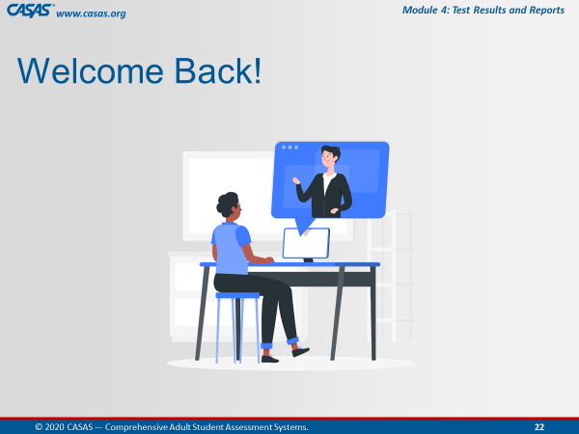 | Trainer 2: | RETURN to PPT.
10:53  2 min | Slide 23  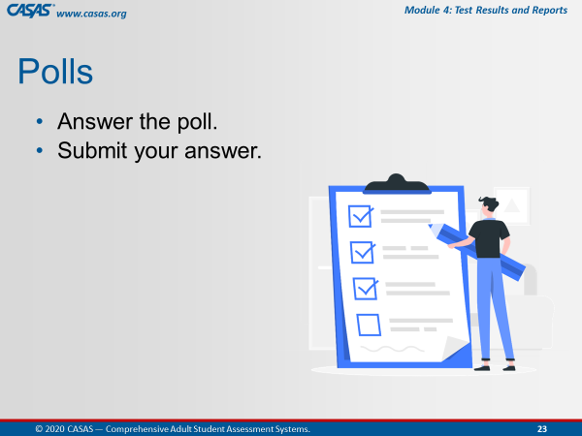 | Unit 4. Check for Understanding  POLL – CFU Activity (3 Qs)  Note: Q2 was used as examples in U4:C1 content.  - Launch the poll.  - Respond to poll.  - Close the poll. | The checks for understanding the content in Unit 4 are in a Poll.  There are 3 questions.  I’ll give you a couple of minutes to go through them and then close the poll.  Ok, everyone is doing a great job. I’m going to close the poll in about 5 seconds.
 |  | - Share the results.  Confirm correct responses. Provide clarification if needed. | [Trainer: comment on participant responses.]
 |  | Remind participants how to close the poll on their screen. | Ok, go ahead and Close the poll window on your screen.
 |  | Trainer 1:  Trainer 2: | STOP Screen Share.  START Screen Share.
10:55  1 min | Module | Unit 5. REVIEW: Content Standards, Competencies, and Task Areas  Trainer 2: RETURN to Module.  Participants will view your screen. | Unit 5 is a Review of the information we just covered on Content Standards, Competencies, and Task Areas.  [Trainer: click the Unit 5. link on your screen.]
 | 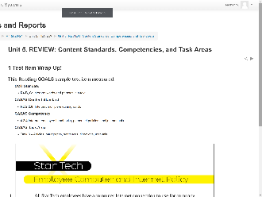 | 1 Test Item Wrap-Up! | Here is the same sample test item we’ve been using to identify the three elements -- Content Standards, Competencies, and Task Areas -- included in item and test development.
 | 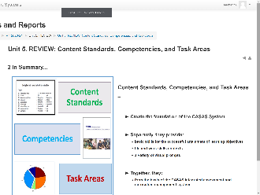 | 2 In Summary... | Content Standards, Competencies, and Task Areas –  - Create the foundation of the CASAS System  Separately, they provide:  - basic skills for the successful attainment of learning objectives  - life and work skills contexts  - a variety of visual prompts  Together, they:  - form the basis of the CASAS integrated assessment and curriculum management system.
 | Slide 24  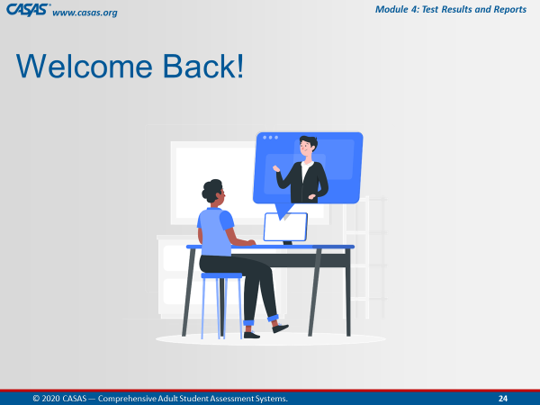 | Trainer 2: | RETURN to PPT.
10:56  9 min | Slide 25  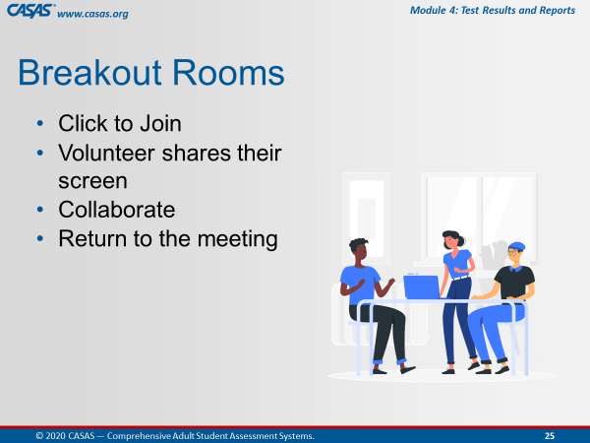 | Briefly review collaborating in Breakout Rooms. | We will be sending you to Breakout Rooms now.  A volunteer in your breakout room will share their screen so that everyone in the Breakout Room can collaborate on the checks for understanding in the unit we just covered.  When your group finishes you will return to the Meeting Room.
 | Slide 26  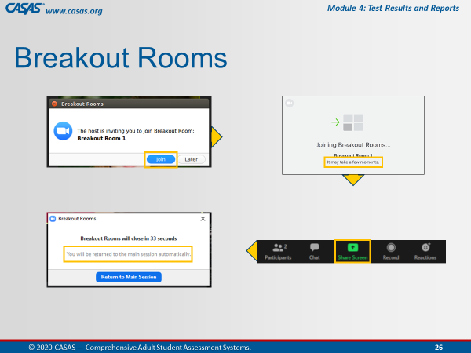 | This is an ANIMATED slide in PPT “slide show” mode. | When the pop-up appears on your screen,  [Click 1] Click Join.  Wait a few minutes…and when everyone is together in the Breakout Room,  [Click 2] Choose a volunteer who will share their screen.  [Click 3] A pop-up will appear just before you are automatically returned to the Meeting Room.  You will not need to return to the main room when you see this pop-up.  Just relax and continue your discussion until the application brings you back to the main room automatically.
 |  | Unit 5. Check for Understanding  BREAKOUT – CFU Activity (6 Qs)  One participant shares their screen and opens the Unit CFU.  Add Unit CFU Link and Task to Chatbox.  UNIT 5. CHECK FOR UNDERSTANDING | Ok, now we are going to send you to the Breakout Rooms.  [Trainer 1] will put the link to Unit 1. Check for Understanding link in the Chatbox.  When you are in the Breakout Room, the volunteer will:  - Share their screen and  - Click on the link from the Chatbox.  The checks for understanding will open automatically.  Please work together as a group to answer each question.  You will be automatically brought back to the Meeting Room when time is up.
 |  | - Send to BOR.  - Broadcast task.  - Close BOR when 1 min. remains. | Ok, click Join.  [Trainer: Broadcast task to BORs, e.g., “Please skip any questions if needed and go back to answer if time permits.”]
 | Slide 27  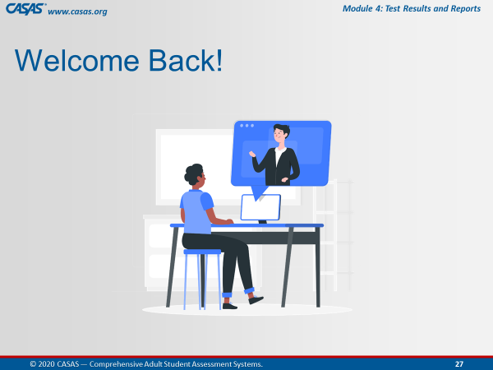 | Slide 28  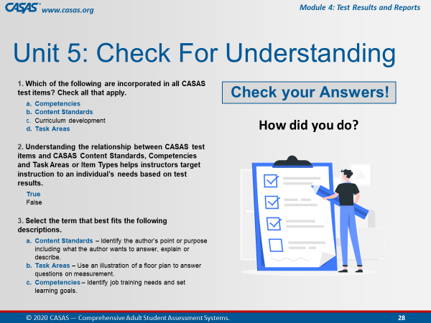 | Welcome Back! Everyone.  Let’s review some of the answers together.  Feel free to point out any question you might need clarification.
 | Slide 29  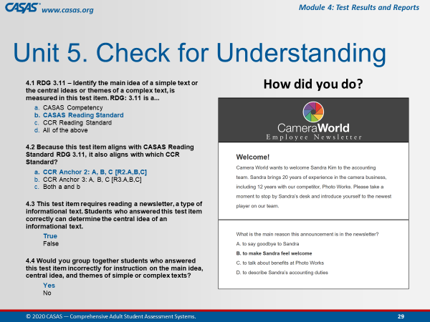 | Slide 30  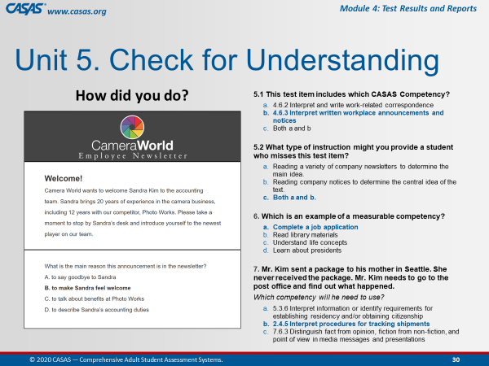 | Slide 31  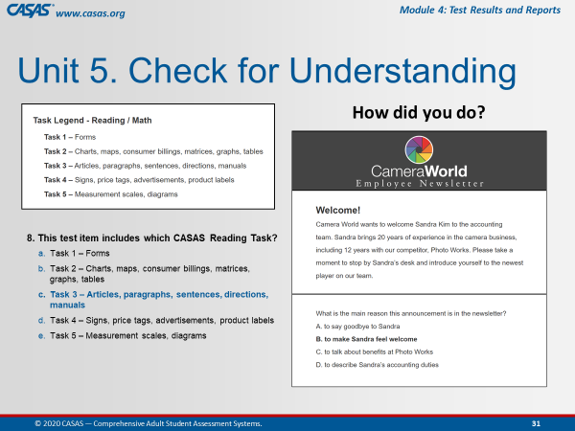
 |  | Trainer 2:  Trainer 1: | STOP Screen Share.  START Screen Share.
11:05  10 min | Module | Unit 6. Score Reports  CFU 3  Trainer 1: RETURN to Module.  Participants will view your screen. | [Q3] TOPSpro Enterprise (TE) reports are available for instructors to generate for individual students and for their class.  Unit 6 focuses on reports that instructors most commonly use.
 | 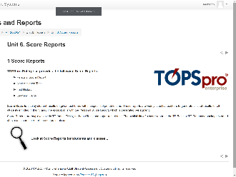 | 1 Score Reports  CFU 1, 4.1 | Score Reports display student results on given test forms within a specified period.  (Q4.1) Score Reports are only available in TE (not in TAMs) for both eTests and paper-test results.  These reports are widely used by teachers to generate a list of results for all students enrolled in their class.  [Q1] Why is it important for teachers to access TOPSpro Enterprise?  Select one:  For reports to help them understand and interpret test results.  For reports that suggest how they can better focus their teaching.  For reports that show how well students are meeting recognized standards.
 | 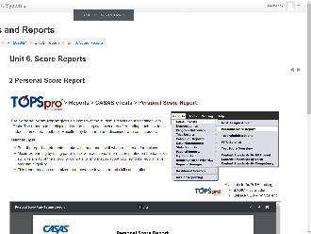 | 2 Personal Score Report  CFU 3, 4.3 | The Personal Score Report…  [Q3] is a student-based report…  [Q4.3] and provides students with immediate feedback after taking a test on eTests by giving them a summary of their test results at the end of the test taken.  The report can be displayed on the testing station screen after ending each test to give students immediate feedback.  The report may also be reproduced in TE.  Results may be shared and discussed with each student..
 | 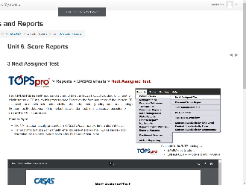 | 3 Next Assigned Test | This is the Next-Assigned Test report.  Based on the form and score of the last test, TE assigns the next test form in each modality that a student tested (reading, math, and listening).  TE searches the database to find the last test a student took across sites to display the NAT in this report.  The NAT is automatically presented in CASAS eTests the next time a student tests.  For programs that scan or manually enter paper-test scores into TE, use this report to determine the next test to administer.
 | 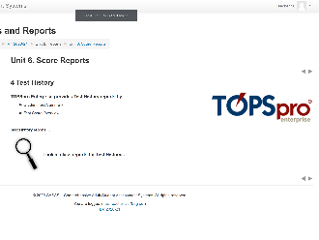 | 4 Test History | TOPSpro Enterprise provides Test History reports by:  - Student Test Summary  - Test Score Overview
 | 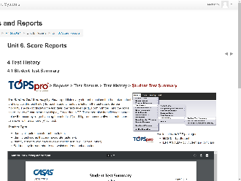 | 4.1 Student Test Summary  CFU 4.2 | [Q4.2] The Student Test Summary report provides valuable information for teachers to review after progress testing.  The report lists who have taken a test and displays the test history for each student.  Tests are listed in the test date order per modality.  The report displays the test date, the tests taken (e.g., Form number), and the scale score.  The report also identifies test scores below the accuracy range by using the asterisk (*) and high-end conservative estimate scores as shown with a diamond (♦) symbol.
 | 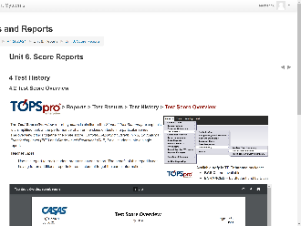 | 4.2 Test Score Overview  CFU 9 | [Q9] The Test Score Overview report is a new class report that brings together these 3 elements:  - Scale Score,  - National Reporting System (NRS) Educational Functioning Level (EFL), and  - Grade Level Equivalent (GLE) for all students into a single report.  Use this report to track student progress on one report. Use this report to track student progress on one report.
 | 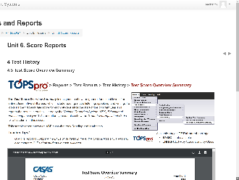 | 4.3 Test Score Overview Summary | The Test Score Overview Summary is designed to show the general functional level of an entire class in five skill areas, which include reading, math, listening, speaking, and writing.
 | 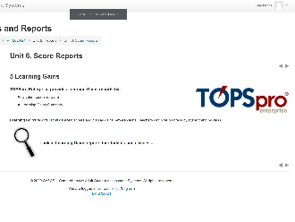 | 5 Learning Gains | TOPSpro Enterprise provides Learning Gains reports by:  - Student Learning Gains  - Learning Gains Summary
 | 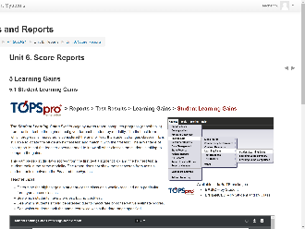 | 5.1 Student Learning Gains | The Learning Gains First to High report computes progress (or setbacks) from the first test to the highest test given.  The first test from which progress is measured is considered the anchor test.  TE matches tests by form type. For example, if a student takes reading, listening, and math test, the report generator will selectively match reading tests to reading tests, listening tests to listening tests, and math tests to math tests.  How to use:  - Use this report to determine the highest gain a student (or the class as a whole) received on a particular form type across classes.  - Use this report to see which students have a pretest, but no post-test.  - Use this report to see which students should be retested due to invalid test scores or high end conservative estimate scores.
 | 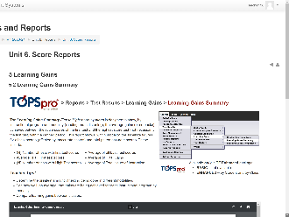 | 5.2 Learning Gains Summary  CFU 3, 4.2 | The Learning Gains Summary report…  [Q3] is a class-based report…  [Q4.2] and also provides valuable information for teachers to review after progress testing.  The Learning Gains Summary First to High report by class helps teachers to  - Determine the greatest amount of testing being done in different modalities.  - See how well, on average, that gains are being achieved for each instructional program by modality.  - Compare learning gains between classes.
 |  | Trainer 1:  Trainer 2: | STOP Screen Share.  START Screen Share.
11:15  10 min | Module | Unit 6. Skill Reports  Trainer 2: RETURN to Module  Participants will view your screen. | Skill Reports may be generated from TE or using templates in the Test Administration Manuals.
 | 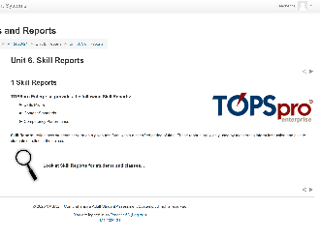 | 1 Skill Reports  CFU 2, 3 | TOPSpro Enterprise provides the following Skill Reports:  - Skills Profile  - Content Standards  - Competency Performance  [Q3] These reports can be generated for an individual student and an entire class.  [Q2] Summary reports may be used to inform class instruction while student reports provide information to guide individual student instruction.
 | 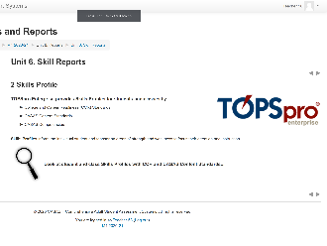 | 2 Skills Profile | Skills Profile reports inform the individual student and teacher on areas of strength and weakness to focus their attention and instruction.
 | 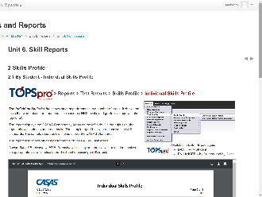 | 2.1 By Student - Individual Skills Profile  CFU 3 | The Individual Skills Profile report…  [Q3] is a student-based report.  Skills Profiles show student performance in several areas.  Across the top, the report shows,  - tests that were taken  - form numbers  - scale scores  - NRS levels  At the top far right is an optional setting that you may add to the report to indicate Grade Level Equivalency.  The left side on both reports displays the CASAS Competency areas addressed on the tests taken.  This report also shows the Task Areas per skill, which in these examples is reading and math.  The Standards are displayed on the right side of this report by test modality. Here,  - the top report is by CCR Standards, and  - the report on the bottom displays the same test results by CASAS Standards.  - The HSE Predictor is included in the report when a test modality score is appropriate to indicate the likelihood of the student passing a High School Equivalency Exam, either the GED or the HiSET exams.
 | 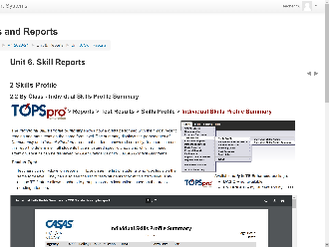 | 2.2 By Class - Individual Skills Profile Summary | The Individual Skills Profile Summary shows how a class performed with their most recent tests at the same FORM LEVEL.  The summary displays the PERCENTAGES of COMPETENCY and CONTENT STANDARD areas that students answered correctly.  Teachers can use this report to determine if all students have mastered specific areas and which still need attention.  Results can be displayed by:  - CCR STANDARDS shown in the top report, or by  - CASAS CONTENT STANDARDS as shown in the report at the bottom.  Teachers can drill-down on reports in TE and see the LIST OF STUDENTS who took tests on the same form level.  They can also see the LIST OF TESTS students took at this form level.  This unique TE feature allows teachers to group classroom instruction based on the areas needing attention.
 | 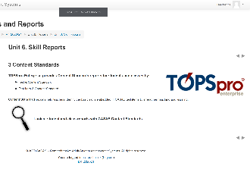 | 3 Content Standards | TOPSpro Enterprise provides Content Standards reports for students and classes by:  - Test & Content Standard  - Test Item & Content Standard
 | 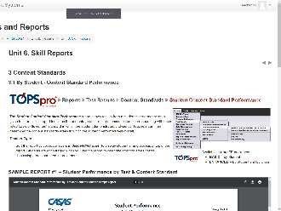 | 3.1 By Student - Content Standard Performance  CFU 3, 5.1 | The Student Content Standard Performance report…  [Q3] is a student-based report…  Content Standards reports have two layout options.  - By Test & Content Standard (default)  - By Test Item & Content Standard  The top Student Performance report is by Test & Content Standard.  This report indicates the students’ performance in each content standard by showing the percentage of correct responses to items that relate to each basic skills content standard.  [Q5.1] When teachers sort this report by correct answers in descending order to display strength areas at top of the report, students are encouraged when you use the report to celebrate their strength areas before discussing areas that need improvement.  The Student Performance report at the bottom shows the same test results except now by Test Item & Content Standard, which combines both competencies and associated basic skills content standards on the test in one report.  - Each row in this report contains a reading content standard.  - The columns contain a test item, corresponding competency number(s) and task area.  - Each check mark indicates the student’s correct response to the test item that relates to that particular content standard.  - Each red “X” indicates the student’s incorrect response to the item relating to the content standard.
 | 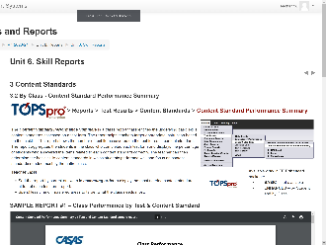 | 3.2 By Class - Content Standard Performance Summary  CFU 3, 5.2 | The Content Standard Performance Summary…  [Q3] is a class-based report…  …that identifies the underlying basic skills content standards assessed on each test form students took in the class.  [Q5.2] When teachers sort this report by correct answers in ascending order, this will display the most needed content standards at the top of each report.  The report helps teachers target appropriate instruction based on these skills and spend less time on mastered areas to target what the class needs most.
 | 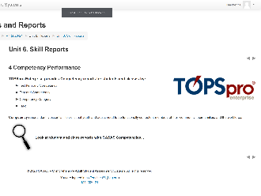 | 4 Competency Performance | TOPSpro Enterprise provides Competency reports for students and classes by:  - Test Item and Competency  - Test and Competency  - Competency Category  - Task
 | 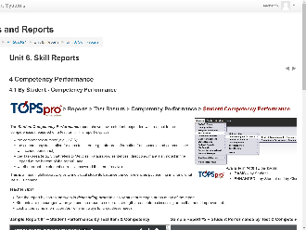 | 4.1 By Student - Competency Performance  CFU 3, 5.1 | The Student Competency Performance report…  [Q3] is a student-based report…  …and provide students with feedback for their performance on the test and the competencies they need to learn in a functional life skills context.  [Q5.1] Sort the report by correct answers in descending order to display student strength areas at top of the report.  Again, students are encouraged when you use the report to celebrate strength areas before discussing areas that need improvement.  Look at the same test results four different ways to target these needs.  SAMPLE 1: The Student Performance by Test Item & Competency report shows how an individual student responded on a given test form.  This report displays by test item the competency number and statement, the task area for how the item was presented, and if the student answered the item correct.  SAMPLE 2: This Competency Performance report shows the same test results but by Test & Competency.  The report displays by test the competency number and statement, the task area for how the item was presented, and the percentage the student answered the item correct.  SAMPLE 3: This is another Student Performance report but by Competency Category.  Notice now that the Competency Number and Description describes the competency area as compared to the previous competency performance report, which describes a measurable action.  SAMPLE 4: The fourth Student Performance report option is by Task.  Task areas are vital to student instruction, as students must not only be able to read a sentence but must also be able to interpret text displayed in a variety of formats.
 | 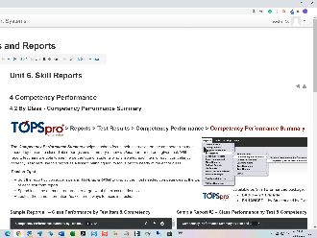 | 4.2 By Class - Competency Performance Summary  CFU 3, 5.2 | The Competency Performance Summary…  [Q3] is a class-based report…  …and helps teachers focus their instruction on the competencies most needed by the entire class.  The summary report can also be produced with the same four options as we saw with the individual student competency reports…  - By Test Item and Competency  - By Test and Competency  - By Competency Category  - By Task  [Q5.2] When teachers sort this report by correct answers in ascending order, this will display the most needed competencies at the top of each report.  Teachers can then target what the class needs most and spend less time on mastered areas.
 | Slide 32  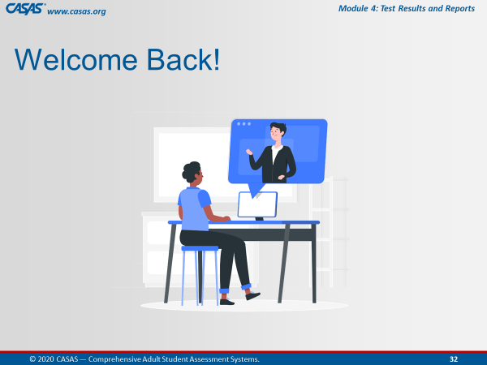 | Trainer 2: | RETURN to PPT.
11:25  10 min | Slide 33  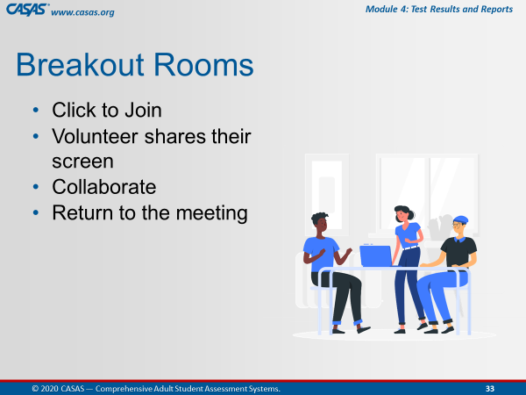 | Unit 6. Check for Understanding  BREAKOUT – CFU Activity (9 Qs)  One participant shares their screen and opens the Unit CFU.  Add Unit CFU Link and Task to Chatbox.  UNIT 6. CHECK FOR UNDERSTANDING  http://training.casas.org/mod/quiz/view.php?id=2603 | Ok, now we are going to send you to Breakout Rooms again.  [Trainer 2] will put the link to Unit 5. Check for Understanding in the Chatbox.  When you are in the Breakout Room, the volunteer will:  - Share their screen and  - Click on the link from the Chatbox.  The checks for understanding for Unit 6 will open automatically.  Please work together as a group to answer each question.  You will be automatically brought back to the Meeting Room when time is up.
 |  | - Send to BOR.  - Broadcast task.  - Close BOR when 1 min. remains. | Ok, click Join.  [Trainer: Broadcast task to BORs, e.g., “Please skip any questions if needed and go back to answer if time permits.”]
 | Slide 34  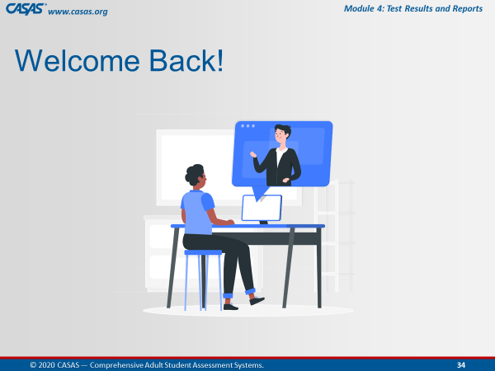 | - Upon return, ask if anyone has questions about any CFU. | Welcome Back! Everyone.  Is there a CFU any of you had trouble answering?  We can take about [#] minute(s) to review the questions.
 | Slide 35  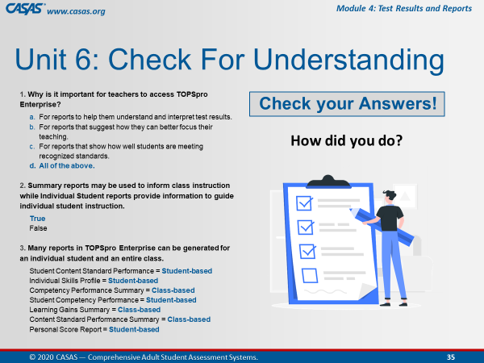 | Slide 36  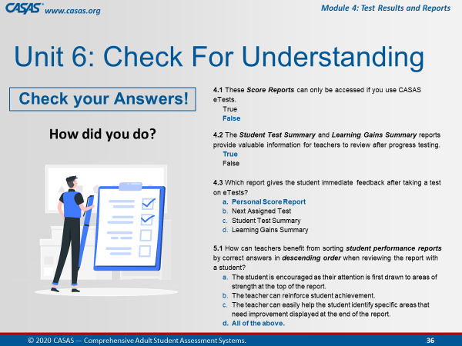 | Slide 37  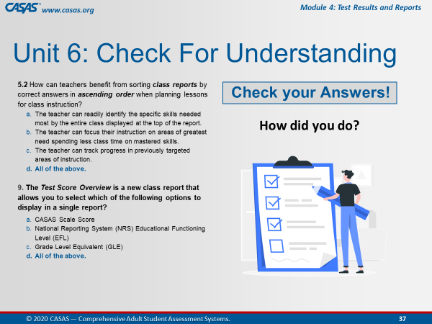
 |  | Trainer 2:  Trainer 1: | STOP Screen Share.  START Screen Share.
11:35  5 min | Module | Unit 7. Additional Resources  Trainer 1: RETURN to Module.  Participants will view your screen.
 | 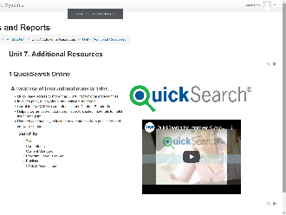 | 1 QuickSearch Online  CFU 1, 2, 3 | [Q1] CASAS assists with curriculum support by providing QuickSearch Online, which is a searchable database of instructional resources.  QuickSearch helps teachers select materials to match their curriculum.  [Q2] With QuickSearch Online, you can search for instructional materials by:  - Publisher or Title  - Competency or Content Standard  - Program, Level or Skill  - CASAS Assessment  [Q3] You do not need a paid subscription to access QuickSearch Online.
 | 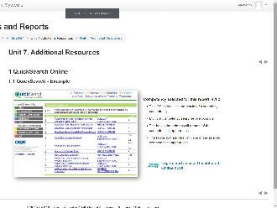 | 1.1 QuickSearch - Example | QuickSearch is available 24/7.  Here is an example of one of the screens when searching by competencies.
 | 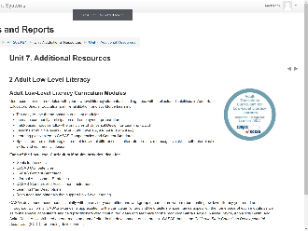 | 2 Adult Low-Level Literacy | [Q3] You also do not need a paid subscription to access the Low-Level Literacy Curriculum Modules, which are also available 24/7 from the CASAS website.  Use these curriculum modules with your low-level literacy students, including those with intellectual disabilities, in Adult Basic Education, Special Education and Rehabilitation, and Workforce Learning.
 | 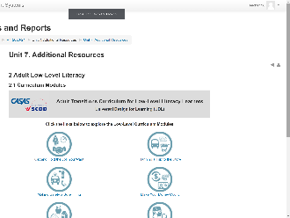 | 2.1 Curriculum Modules | CASAS developed these modules jointly with an advisory committee and workgroup of curriculum writers representing low-level literacy youth and adults throughout California.  We encourage you to explore these modules.
 | Slide 38  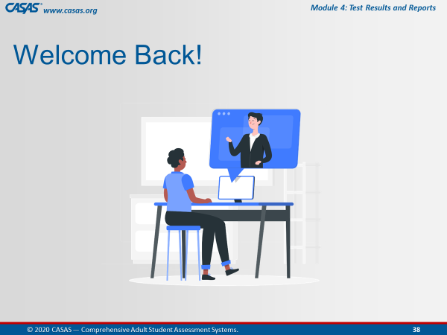 | Trainer 1: | RETURN to PPT.
11:40  2 min | MODULE | Unit 7. Check for Understanding  MODULE – CFU Activity (3 Qs)  - Open the CFU. | Since I am in the Module, I am going to display the checks for understanding the content from Unit 7 on my screen and we will go through them together.  Let’s get 100%!
 |  | - Exit the CFU. | Great job everyone!
 |  | - Return to the HOME page. | Now, I’m going to hand it over to [Trainer 2] to Wrap Up! our training.
 |  | Trainer 1:  Trainer 2: | STOP Screen Share.  START Screen Share.
11:42  3 min | Module | Unit 8. Wrap-up! What's Next?  Trainer 2: RETURN to Module.  Participants will view your screen. | Congratulations!  Our last unit wraps up this training with the steps you need to take to implement CASAS.
 | 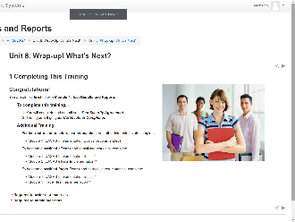 | 1 Completing This Training | You are almost finished with Module 4: Test Results and Reports.  In a moment, we will walk you through the process to complete your training.  To administer CASAS eTests, you will also need to complete Module 2.  To administer Paper Tests, you will also need to complete Module 3.  And to order test materials, you will also need to complete Module 1.
 | 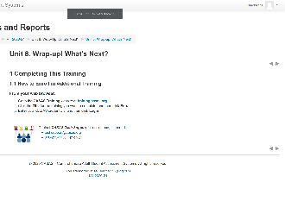 | 1.1 How to Enroll in Additional Training | Just like we did today, you will follow the same steps to enroll in additional training.
 | 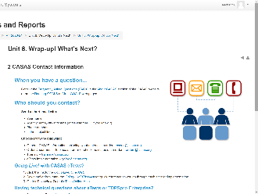 | 2 CASAS Contact Information | And finally, here is helpful information for who to contact at CASAS if you have a question.  Office hours are Monday through Friday, 8:30 am to 5:00 pm Pacific Time.
 | Slide 38 | Trainer 2: | RETURN to PPT.
11:45  10 min | Slide 39  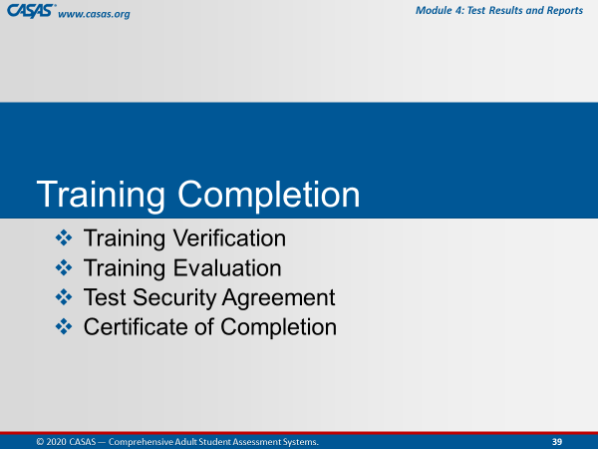 |  | To complete your training today, you will:  Submit a Training Verification and Evaluation with your Test Security Agreement, and then get your Certificate
 | Slide 40  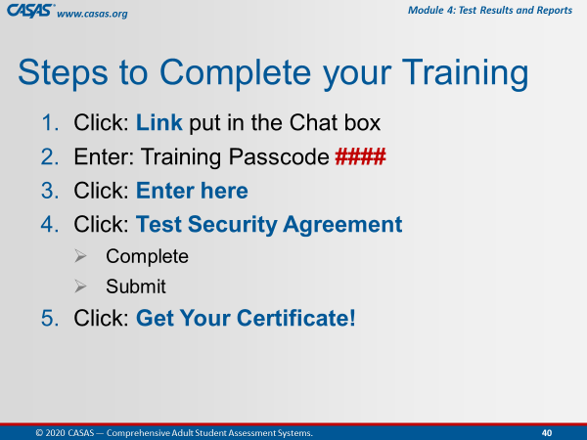 | This is an ANIMATED slide in PPT “slide show” mode.  Note: Click 4 has 2 additional automated text. | The steps you will complete are the following:  [Click 1] Click the Link that will be put in the CHATBOX after we review these steps.  [Click 2] You will be prompted to enter a Passcode, which is <Trainer: insert own passcode>.  [Click 3] After entering the passcode, click the Enter here button.  [Click 4] You will see the Test Security Agreement link, which you will click to complete and submit.  [Click 5] And last, click the Get your Certificate! Link.
 | Slide 41  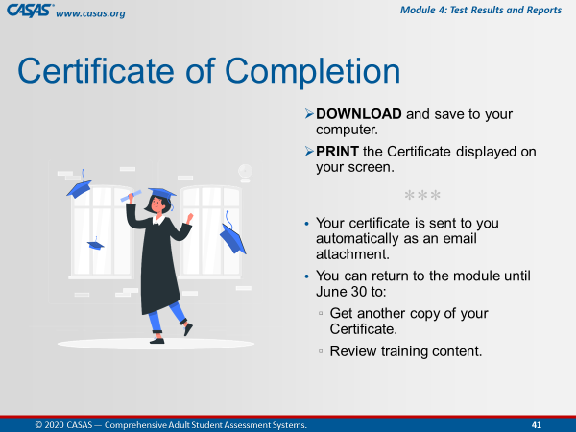 |  | You can download or print the certificate directly from your computer.  Your certificate will also be sent to you as an email attachment.  You can always return to the module to get another copy of your certificate and review training content.
 |  | TRAINING COMPLETION:  http://training.casas.org/course/view.php?id=426 | Ok everyone, go to your CHATBOX and click on the URL that [Trainer 1] just put in there.
 |  |  | Return to the Meeting Room when you are finished.  Remember how do we do that?  Click the Blue video icon at the bottom of your computer monitor.
 |  | Trainer 2: | STOP Screen Share.
 | Slide 42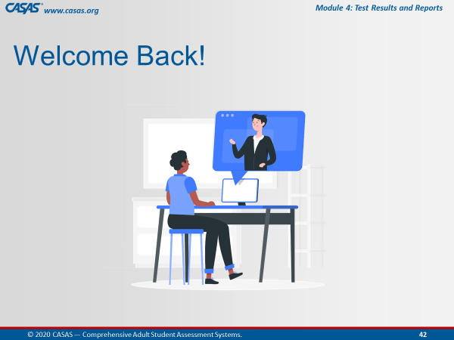 | Trainer 1: | START Screen Share.
11:55  3 min | Slide 43  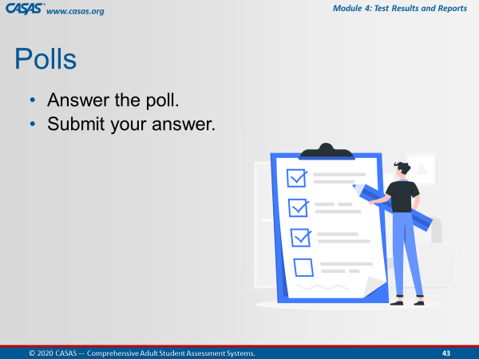 | CLOSING Polls  LAUNCH POLLS:  - Respond to poll.  - Close the poll.  - Share the results. | - Did you get your certificate?  - After this training do you feel more confident in returning to the online modules?  - After this training do you feel more confident that the content learned will support you in using CASAS?
 |  | Close the polls | Congratulations everyone! You did a great job!  Don’t forget to close the Poll screen.
 |  | Trainer 1:  Trainer 2: | STOP Screen Share.  START Screen Share.
11:58  2 min | Slide 44  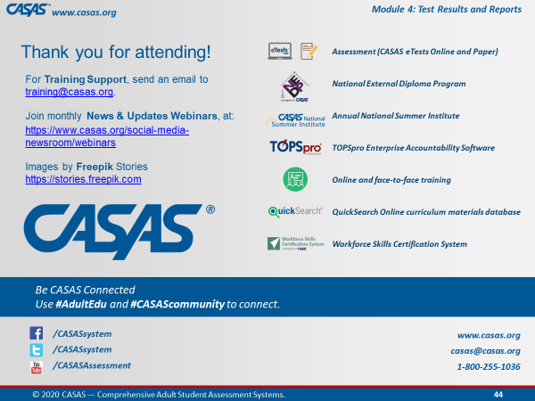 | Wrap Up!  CASAS Contact Info | Thank you for attending today’s training.  If you have any questions about Training, email the Training Desk at training@casas.org.
 |  | Webinars | Join us for monthly webinars to learn about the latest CASAS News & Updates.  Check the Social Media web page on the CASAS website for information about the next webinar.
 |  | Online Training | We hope you feel more confident in not only going in and out of the modules, but also knowing where a lot of rich information lives!  Don’t forget that you can review content in the online training modules and enroll in additional training at http://training.casas.org/
12:00  End Time |  | Stay “live” for any questions.  End meeting for all when finished. | We will stay on if anyone has questions otherwise, you are dismissed.  Thank you again for participating in this training.
120 min. |  | END TRAINING

