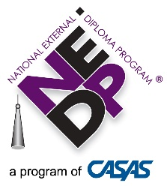
NEDP Implementation Training Components
Name, Agency
Pre-Training
CASAS Implementation Training | Written Prompt Certification  (required of 3 from each site)

Training
Mod 1  4/21/17 D/M/Y | Mod 2  D/M/Y | Mod 3  D/M/Y | Mod 4  D/M/Y | T Trainer Health Planning | T Trainer Legal System | T Trainer Consumer Loans | T Trainer Cover Letter | T Trainer  H’Hold  Budgets | T Trainer Scientific Method | Mod 5  D/M/Y | Added as Staff

Post-Training
The Advisor/Assessor trainee is eligible for certification when the following criteria have been met and verified by the State or National Trainer:
- All NEDP Implementation Training modules and T Trainer requirements are complete,
- The trainee is certified to administer CASAS tests through CASAS Implementation Training,
- The trainee has served at least one client through the Diagnostic Phase,
- The trainee has served one client through the Generalized Assessment Phase,
- The Portfolio Review for trainee’s first Generalized Assessment client is conducted by a State or National Trainer, and
- The State or National Trainer verifies that the first portfolio is satisfactory and recommends that the trainee be certified as an NEDP Advisor/Assessor.

