T Trainer Master Key

Financial Literacy | Household Budgets | Activity A and IOC | T Trainer Order: 1st (trainer models assessment)
Rationale: Mixture of auto-scored & Assessor-scored items, viewing evaluation criteria and an uploaded spreadsheet side by side, opportunity to see how Activity prepares client for IOC.
Training Issues Raised:
- Autoscored v/s Assessor scored; answers not identified as demonstrated by the algorithm will default to Assessor scoring- not marked ND.
- Activity Q2a – 2m: Even though the instructions say to use initials (P/V/F), both the client and the evaluation criteria use full words.
- Activity Q5: Although autoscored, the answer does not address whether this is a surplus or deficit.
- Activity Q7: spreadsheet not uploaded. This happens with actual clients. IOC upload shows trainee what it should look like when a doc has been uploaded (“view file” v. “upload file”)
- IOC Q3: Do category titles have to be complete? E.g. can the client say “food” when the category is “food (dining in/eating out)”? Yes, if category is clearly identified.
- Activity Q8: opportunity to see how client’s response reflects evaluation criteria, even though not in the same words.

# | Household Budgets Activity A  T Trainer Client Response | D/ND | Evaluation Guideline | Training Note
1a | $84.87 | D | $84.87 Autoscored | System recognized this answer as D
1b | $49.22 – 119.09 | D  35D:  4ND | $69.87 OR $49.22 - $119.09 | Not autoscored because of minus sign? Opportunity to discuss that an autoscored item left unscored does not necessarily mean that the item is ND. Rather, it means that the algorithm could not determine, without a doubt, that the answer demonstrated. In this case, assessment defaults to the Assessor.
2a-2m | Multiple answers | D  36D:  3ND | Multiple answers | Even though the instructions say to use initials (P/V/F), both the client and the eval. criteria use full words. Good example of focusing on what is being measured when assessing.
3 | $51 | D | $51; autoscored
4 | $25 | D | $25; autoscored
5 | $539 | D | $539; autoscored | Some trainees may notice that although autoscored, the answer does not address whether this is a surplus or deficit.
6a-6h | Multiple answers | D | Multiple answers; autoscored | This activity is similar to the one we’ll see in the IOC, focusing on transferrable math competency of finding the percentage.
7 | No Pie Chart Uploaded | ND  2D:  37ND | Pie chart in evaluation criteria | Pie chart was not uploaded. Notes to client should indicate this, not just mark ND/incomplete.
8a | Use coupons | D  39D:  0ND | “clip coupons” is one option | Use coupons = clip coupons
8b | Compare prices | D  38D:  1ND | “comparison shop” is one option | Compare prices = comparison shop
8c | Record how much they spend | D  37D:  2ND | “continue to keep track of spending” is one option | Record how much they spend = continue to keep track of spending

# | Household Budgets In-Office Check  T Trainer Client Response | D/ND | Evaluation Guideline | Training Note
1a- 1h | Multiple answers | D | Multiple answers- autoscored | Overview says “In the In Office Check, you will examine a family’s annual budget and expenses, analyze the results and represent them graphically.” The activity did not explicitly prepare the client for the IOC by providing a duplicate of the skill that must be demonstrated in the IOC; however, the transferrable math skill of finding the percent of a whole was practiced in the activity.
2 | See Excel spreadsheet | D  38D:  1ND | 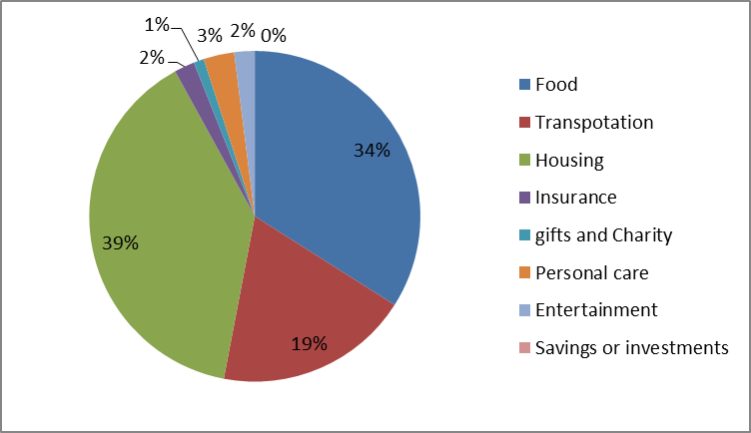 | Model opening evaluation criteria and uploaded spreadsheet and evaluating side-by-side.
3 | Food- dine in more | D  37D:  2 ND | Food (groceries and dining out) | Although T Trainer client answer doesn’t mention groceries, the category of food was clearly identified and indicates an understanding of how to reduce expenses.

Consumer Awareness | Consumer Loans | IOC | T Trainer Order: 2nd
Rationale: Mixture of auto-scored & Assessor-scored items, plus opening windows with evaluation criteria and an uploaded spreadsheet.
Trainees Assess before Module 4 in web delivery, during Module 4 in face-to-face delivery
Training Issues Raised:
- Times when simply marking ND and checking “incorrect” or “incomplete” is enough
- Q3a: Bar chart abbreviates bank names- is competency still demonstrated?
- Q3b: Pie charts are not formatted to currency; therefore, system will leave off zero in cents place even if client put that in the spreadsheet. Does this keep the competency from demonstrating?
- In questions 3a and 3b, consider what is being evaluated.

# | Consumer Loans In-Office Check  T Trainer Client Response | D/ND | Evaluation Guideline | Training Note
1 | Take the monthly payment amount times the number of months, then subtract the loan amount from that. What’s left is your interest paid over the whole loan. | D  36D:  3ND | 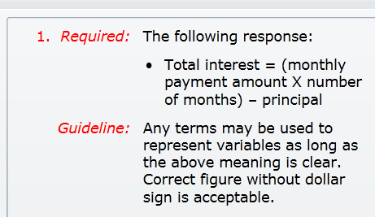 | Originally included in T Trainer because of the oral IOC- now a written IOC.  T Trainer client answer uses the same process as evaluation criteria to arrive at the answer.
2a | National Bank of Orangeville | D  39D:  0ND | 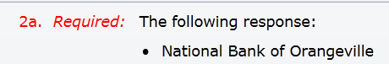
2b | 6218.44 | ND  2D:  37ND | 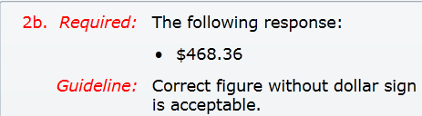 | Amount incorrect. Just marking ND and checking “incorrect” should be enough here.
3a |  | D  24D:  15ND | 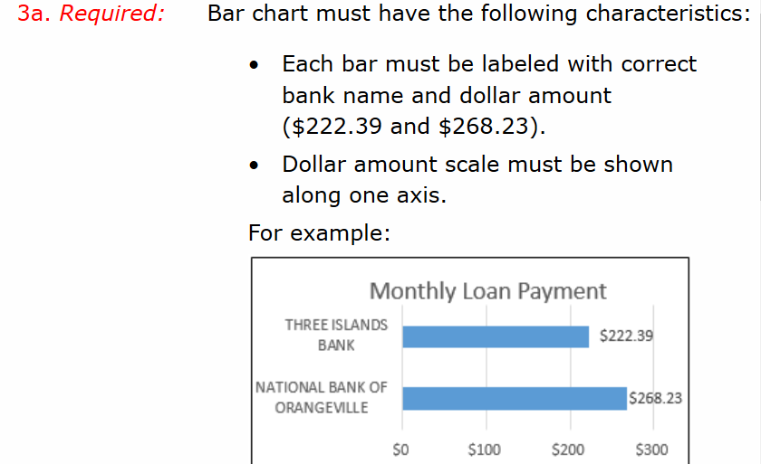 | Some Assessors marked ND because  - bank names are incomplete,  - no dollar signs  Dollar signs are not in instructions or in evaluation criteria.  Bank names must be “correct” – e.g. the bank name must correspond to the correct amount of monthly payment. Shorthand appears to be appropriate. Allow differences of opinion on this. Discuss consensus and item suggestion form.
3b |  | D  21D:  17ND | 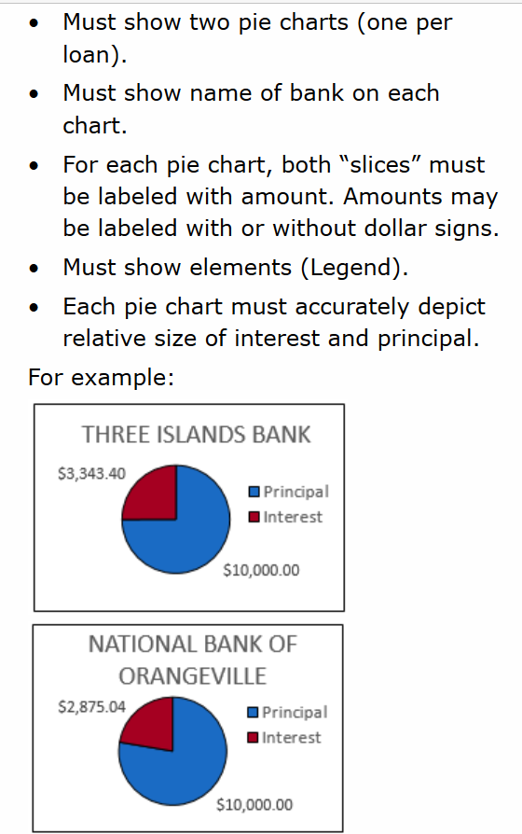 | Assessors evaluating this as ND almost entirely because client didn’t format this as currency, so there’s a .4 instead of .40 on both pie charts.  Other Assessors felt that this additional formatting step was not addressed in the tutorial or instructions, and that the skills being measured were demonstrated even if the currency formatting was not present.

Science | Scientific Method | Activity A | T Trainer Order: 3rd
Rationale: Higher Depth of Knowledge (DOK) questions mixed with easy-to-score, type 1 items. Higher DOK items will not exactly match evaluation criteria.
Trainees Assess before Module 4 in web delivery, during Module 4 in face-to-face delivery
Training Issues Raised:
- Assessing higher DOK items in which the client response must contain the information in the evaluation criteria but will not match word-for-word.
- Q3c: assessing and leaving notes when multi-part question when part of the answer demonstrates but another part is incorrect or incomplete.
- Q3c: assessing “dependent” answers, in which the answer refers to a prior answer (happens a lot in Cultural Literacy). If prior answer is ND, it is unlikely that the “dependent” answer can be D, and this should be mentioned in “notes to client.”

# | Scientific Method- Activity A  T Trainer Client Response | D/ND | Evaluation Guideline | Training Note
1a | Student B | D  39D:  0ND | 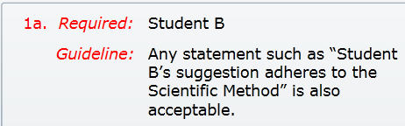 | Clearly demonstrates
1b | Student B ask a question that can be answered by testing | D  36D:  3ND | 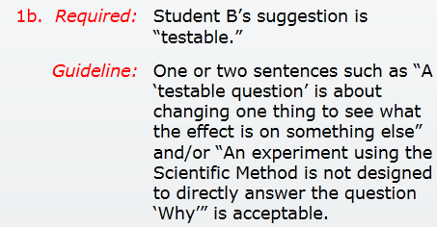 | Question asks for “one or more sentences.” The lack of end punctuation and the sub/verb agreement error do not keep this from demonstrating. However, an answer of “testable” alone would not demonstrate, since this one word doesn’t approximate a sentence.
2a | Student A | D  38D:  1ND | 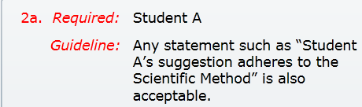 | Clearly D
2b | Student a follows the sequence. Background research sets you up to develop a hypothesis. | D  36D:  3ND | 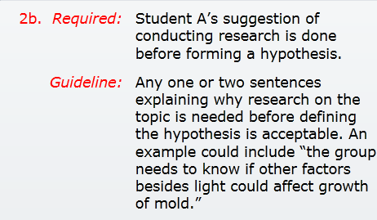 | Although it does not match the evaluation criteria word-for-word, the T trainer response addresses all parts of the question correctly.
3a | The color of the paper | D  39D:  0ND | 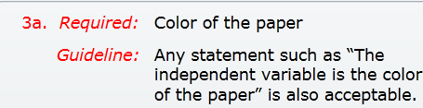 | Clearly demonstrates
3b | The 20 minutes that the paper soaked up the sunlight | ND  0D:  39ND | 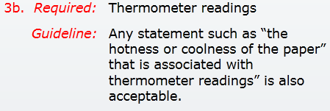 | Discuss sample note to client: something like “please review the dependent variable description in the resource” would be appropriate.
3c | I chose the color of the sheets as the independent because it was the one thing that changed. I chose the amount of time the paper sat in the sunlight because it was measured exactly. | ND  31ND:  8D | 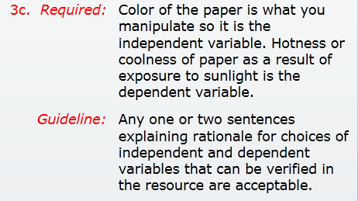 | The first part of the answer is correct. The second sentence is incorrect; it refers to question 3b, which is ND, so stands to reason that this dependent answer would also be ND. The entire question must be marked ND, but it is important to leave the client a note that clearly expresses that this answer is partly correct. Something like “The first sentence is correct; please make sure you repeat it in PTA. The second sentence is incorrect; please review the dependent variable description in the resource and consider your reattempted answer for 3b when you redo this part of 3c” would be appropriate because it provides procedural guidance.

Health Literacy | Health Planning | Activity A | 4th
Rationale: Short-answer, opportunities to assess when client paraphrase, multiple steps, need to review resource as back-up. Illustrates clients selecting options appropriate to their lives.
Trainees Assess before Module 4 in web delivery, during Module 4 in face-to-face delivery
Training Issues Raised:
- This activity gives trainees the opportunity to see an example of how clients will select two of five possible health planning issues that are most relevant to their lives
- Opportunity to discuss NEDP evaluation caveat: any answer that is verifiable in the resource and answers the question demonstrates
- Have to get deep into resources for #2a; click on R2 and then on 2nd page of resource, click “Find out which shots your child still needs”, then click “Current Childhood and Adolescent Immunization Schedule,” then “Children- Birth through 6 Years.”
- Although the above is a lot of digging, clients often know list the immunizations with which they’re familiar, so Assessors have to be diligent with investigating within the resource.
- Discuss that when the client provides a demonstrating answer and additional information that was not asked for in a response, the additional information does not prevent the correct & complete answer from demonstrating, even if incorrect, unless the additional information is dangerous or negates the correct information.

# | Health Planning- Activity A  T Trainer Client Response | D/ND | Evaluation Guideline | Training Note
2a1 | Hepatitis A and B | D  39D:  0ND | Hepatitis A and B
2a2 | DTAP | D  27D:  12ND | Diptheria, Tetanus, and Pertussis are all listed in the evaluation criteria. DTAP is listed in the resource | Answer demonstrates both because it’s found in the resource and because the components of DTAP are all listed in the evaluation criteria.
2a3 | Polio | D  39D:  0ND | Polio
2a4 | HiB | D  22D:  17ND | Not listed in evaluation criteria, but in resource. | In resource, so it demonstrates
2b1 | Stay calm | D  35D:  4ND | Stay calm
2b2 | Distract your child during the shot | D  35D:  4ND | Distract and comfort the child during the shot | Does it demonstrate without the “and comfort”? Ask yourself, is distracting a child during the shot a way to make shots easier? If so, it demonstrates.
2b3 | Praise child when shot is over | D  38D:  1ND | Praise the child after the shot is over.
2c1 | Use a cool, wet cloth to reduce redness, soreness, and swelling in the place where she got the shot. | D  38D:  0ND | Use a cool, wet cloth to reduce redness, soreness and swelling in the place where the shot was given
2c2 | Reduce any fever with a cool sponge bath. If your doctor approves, give non-aspirin pain reliever. | D  37D:  1ND | Reduce any fever with a cool sponge bath | More information than necessary is not dangerous and does not negate the correct answer, so it demonstrates
2c3 | Give your child lots of liquid. It’s normal for some children to eat less during the 24 hours after getting vaccines. | D  37D:  1ND | Give your child lots of liquids | Additional information does not keep the answer from demonstrating.
2c4 | Review any information your doctor gives you about the shots, especially the vaccine information statements | D  34D:  4ND | Review any information your doctor gives you about the shots on expected side effects | Additional information does not keep the answer from demonstrating.
2c5 | Pay extra attention to your child for a few days. If you see something that concerns you, call your doctor. | D  38D:  0ND | Pay extra attention to your child for a few days and call your doctor if you have any concerns
5a1 | Know your family health history | D  38D:  0ND | Know your family health history
5a2 | Keep track of important health information | D  38D:  0ND | Keep track of important health information
5a3 | See a doctor regularly for routine checkups | D  38D:  0ND | See a doctor for regular checkups
5b1 | Name, birthdate, and blood type | D  38 D:  0ND | Name, birthdate, and blood type
5b2 | Vaccination record | D  35D:  3ND | List of shots and dates you got them | Vaccination record would be the list of shots and dates you got them
5b3 | Current health conditions, including allergies | D  38D:  0ND | Health conditions you have and allergies
5b4 | Name and phone number of emergency contact | D  38D:  0ND | Emergency name and phone number of a relative or friend
5b5 | Dates and results of screening tests | D  25D:  13ND | Dates and results of screening tests and checkups | Screening test and checkups are two different items and could be listed separately. One of them alone satisfies the requirement of an “important thing to include in one’s personal health record.”
5b6 | Info about medicines you take | D  24D:  14ND | Medicines, how much you take, and why you take them | Although consensus is that this answer demonstrates, many Assessors do not feel that “info” tells enough about what the health record should include. Allow disagreement on this or trainee consensus of ND
5b7 | Family health history | D  38D:  0ND | Know your family health history
5c1 | New medicines you are taking, including vitamins | D  23D:  15ND | New medicines you are taking, including over-the-counter medicines, herbs, or home remedies and vitamins | Not necessary to list all of the “included” sub-categories as long as general category is listed.
5c2 | Recent illnesses or surgeries | D  38D:  0ND | Recent illnesses or surgery
5c3 | Health concerns | D  37D:  1ND | Health concerns or issues | Health concerns alone demonstrates; most Assessors consider “issues” to be another word for “concerns” in this context. If a patient were going to talk to her doctor about her concerns, it would be unreasonable to think she is leaving something important out because she wasn’t also talking about “issues”.
5c4 | Any important changes in your life | D  35D:  3ND | Any important changes in your life, like becoming unemployed or a death in the family | Not necessary to list examples as long as category is listed.

21st Century Workplace | Cover Letter | In-Office Check | 5th
Rationale: Good example of a writing evaluation that has to be without errors, but with easier formatting that resume.
Training Issues Raised:
- Assessors and clients might need to check resource or NEDP Writing Guide.
- Illustrates how the entire item must be redone if ND, but only ND parts are reassessed
- This is a 21st Century Workplace Skill with an embedded foundational ICT skill- not a formal cover letter, but a less formal email cover to be sent along with a resume.
- Client knows exactly on which nine criteria the cover letter will be assessed.
- Client has access to job ad and resume in the IOC, but is not allowed to bring notes or access resource.

Subject: Fabrication and Welding Position  To Whom it May Concern,  I am contacting you in reference to the recent job opening the Fabricator Welder position. I’m very interested in the position. I have all the certifications required for the job. I also can be very flexible in my hours. I have attached my resume as well. Thank you for your consideration. Hope to hear from you soon!  Thank You  Tommy Trainer  443(240-6078)  ttrainerupdate@nedp.org | ND  Out of 36 scores:  #1: 29ND  #2: 31D  #3: 23D  #4: 22 ND  #5: 23ND  #6: 23D  #7: 34D  #8: 21D  #9: 33D | 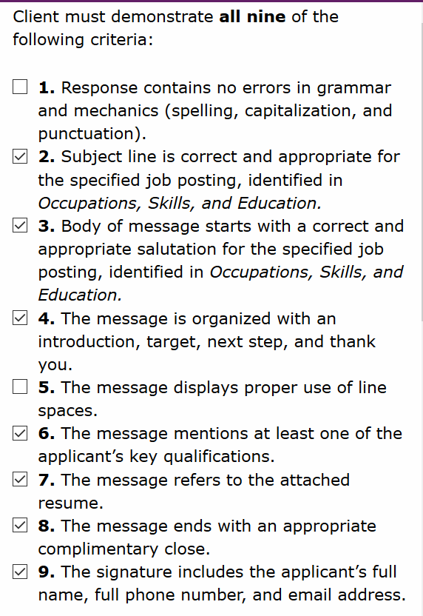 | - Errors include missing word after “opening,” and no comma after “Thank You” (some assessors may count this error in #8), “fabrication welder” shouldn’t be capitalized in the body of the email, should be a colon instead of a comma after salutation (some may mark #3 ND because of this)  - D  - D. See resource for other salutation options.  - Although majority of Assessors in study found this to be ND (22/36), this cover letter does in fact have all four features.  - Need a line between body and closing.  - Although the majority of Assessors marked this D, there is an argument that “I have all the certifications required for the job” is too vague, especially when the resume doesn’t mention any certifications.  - D  - D (although some may mark off because of a missing comma)  - D

Civic Literacy and Community Participation | The Legal System | Activity A | 6th
Rationale: DOK 3 item requiring research, critical reading, revealing an argument and counterargument using evidence from text, and citing sources.
Training Issues Raised:
- Many assessors like to copy and paste the evaluation criteria onto a Word document so that they can take notes while evaluating the essay.
- Illustrates how the entire item must be redone if ND, but only ND parts are reassessed.
- Evaluation criteria aligned to client instructions.
- Discuss how “minor or no errors” might be interpreted (do errors interfere with understanding or distract the reader? Are basic errors repeated?)
- Will the essay have to be reattempted for other content issues? If so, it’s best NOT to mark “minor or no errors” as demonstrated, because once this criterion is checked, it remains checked and won’t be reevaluated. If client revises essay during PTA because criterion 1 or 2 was ND, client may create new errors. Note to client, e.g. “Although this essay contains minor [or no] errors, this criterion will be evaluated only when all of the other components are finalized,” OR “Your essay contains several spelling and punctuation errors.”

T Trainer Client Response | D/ND | Evaluation Guidelines | Rationale for Using in Training
“Miranda rights are such an important part of the legal system. Miranda rights are so important because without them how would an arrestee know what their rights are. We have a right as a people to know that we have legal counsel available to us if ever faced with an arrest. I think police can be intimidating and people have a right to know before being taken on custody that they don’t have to speak without counsel. A person could very easily incriminate themselves without knowledge of Miranda rights.  Police officers are required to give suspects Miranda warnings only when the suspects are being formally arrested and questioned at the same time. At a formal arrest and questioning a suspect is not free to leave, but is held in police custody, and questioning is done in such a way that a reasonable person would have no choice but to submit to the officers will. Police can be very coercive and I think the Miranda rights is a good thing to protect our basic rights.  On the other side of this, our governing authorities in these times that we are living in, need the flexibility to question terrirosm suspects who in my opinion have no rights in this country. An example of thi9s was with Faisal Shahzad who was a supect in the time square case. And there was an argument that he should be interrogated and imprisoned as a military detainee, rather than handled as a normal criminal detainee. The conclusion that Mr. Shazad was involved in an international plot apppeated to come from investigations that began after his arrest and interrogation, including inquiries into his links with the Taliban in Pakistan.  I think policy should always have the purpose to protect and serve people within the confines of the law. But there are circumstances such as terrorism where people are trying to kill innocent people and they should have no type of Miranda right protection.” | ND  1a  32D:  7ND  1b  20D:  19ND  1c  1D:  38ND  1d  20D:  19ND | 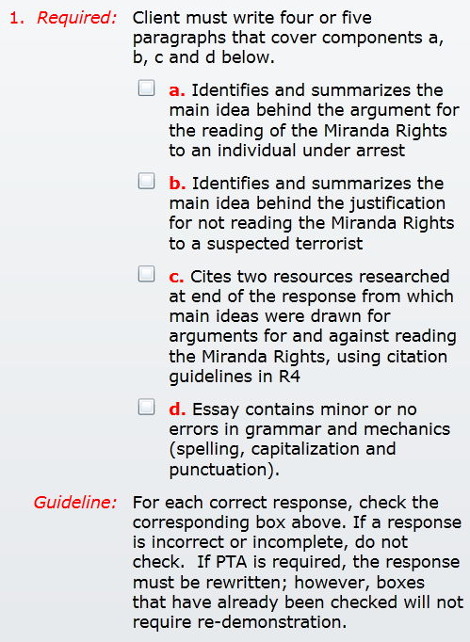 | Criterion 1a:  *Main idea – the whole first paragraph  “….without [Miranda Rights], how would an arrestee know what their rights are.”  “we have a right…to know that we have legal counsel available to use if ever faced with an arrest”  *Criticism- client provides a lot of details to get to the main idea, rather than a cohesive thesis or main idea statement.  Criterion 1b:  *Main idea-“an argument that he should be interrogated and imprisoned as a military detainee, rather than handled as a normal criminal detainee” This does not sufficiently provide the justification for NOT reading Miranda.  Criterion 1c:  Sources missing.  Criterion 1d: 1d.Essay includes the following errors:  *Multiple capitalization errors, including “i” and “miranda”  *Grammatical errors, including “the Miranda rights is a good thing”  *Punctuation errors, including “dont”, lots of missing commas, and no ? at the end of a question in P1.  *Spelling error interferes with understandig “apppeated” (appeared??)  *This item can’t be assessed as having no errors; the question is, does it have “minor” errors? This is highly subjective- discuss what “minor” means. If there are other criterion that will require the essay to be resubmitted (as here), the error box should not be checked. If everything else is D and you’re on the fence about whether the errors are minor, take it to consensus.

