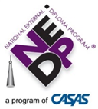
NEDP Implementation Training
Cohort Name Syllabus

All of the instructions to participate in NEDP Implementation Training (NEDP IT) are here. Keep this document in your training binder or electronic folder so that you can access it at each step in the process.
Considering training modules and homework, you should plan to spend about 20 hours on this training series.
Access and Passwords:
Each trainee will be granted access to several portals and websites that will assist in learning about, practicing, and working in the NEDP. You may wish to keep your credentials below so that they’re all in one place.
- T Trainer, the NEDP Training website, at https://training.nedp.org
  - T Trainer Assessor UN: ta___________________ @nedp.org
  - T Trainer Assessor PW: PA__________________
  - T Trainer Client UN: tt______________________@nedp.org
  - T Trainer Client PW: PC___________________
Note: you will not need to log in as the made-up client you create in M1 homework. You will use the system-assigned NEDP client and Assessor for your practice work in T Trainer.
- www.casas.org and the NEDP Professionals Page
  - Username: __________________________
  - Password:___________________________
- The NEDP production website, where you enroll and work with real clients, is at www.mynedp.org .
  - Username: __________________________
  - Password: ___________________________
CASAS/NEDP strongly recommends using your work email as your username on both CASAS.org and mynedp.org. You may opt to use the same passwords for both sites if you wish. However, T Trainer login credentials are set by the system and may not be changed.
Pre-Training:
CASAS Implementation Basics
If you are not already certified to administer CASAS assessments (paper or eTests),
- Create CASAS Account (CASAS.org, Create Account) Please use your agency/work email when creating an account, if possible.
- Click Online Training
  - Take Modules 1 and 2 if you’ll be administering eTests
  - Take Modules 1 and 3 if you’ll be administering paper/pencil tests
  - Take Modules 1, 2, and 3 if you’ll be using both eTests and paper/pencil
- Enroll in Proctor Remote Testing Certification if you’ll be giving the eTests remotely

Zoom™ Webinar Platform
Each person registered for the NEDP training on the CASAS website will also be registered for the webinar series on Zoom. You will receive a welcome email with a link to join the Zoom sessions when your trainer registers you. If you are unable to find the Zoom registration link, please contact your trainer.

Participation expectations via Zoom: For a webinar training to be as interactive as a face-to-face training, trainees must actively participate and give the training their full attention. Questions, feedback, and responses to the questions posed by the trainers are highly encouraged! The more participation, the better the training is for all of the trainees. Trainees whose accounts show “inattentive” for a significant portion of a webinar module may not be given credit for attending the module.

NEDP Professionals
After you’ve created a CASAS account and registered for the NEDP Training, CASAS will grant you access to NEDP Professionals. We will get to know the Professionals Page in Module 2.

Your NEDP Professionals Username and Password are the same as your CASAS log-in.
To access NEDP Professionals:
1. Go to www.nedp.org
2. Click: NEDP Professionals on the left side of the page
3. Click: Login to NEDP Professionals in the middle of the page
4. Enter your CASAS username and password, if not already logged in

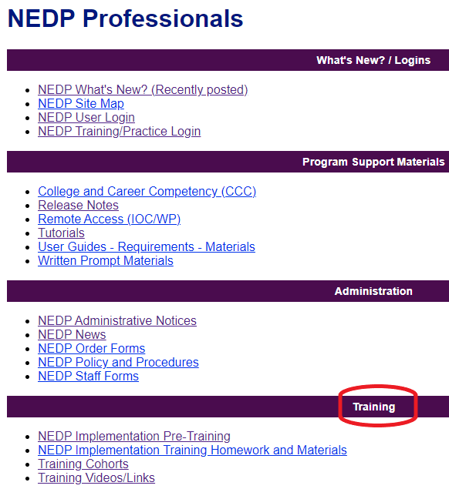
NEDP Professionals- “Training” Folder
After you’ve been granted access to the NEDP Professionals Page, a series of training documents you’ll need to complete NEDP Implementation Training will be available to you on the Training folder of NEDP Professionals.

Pre-Training Activities:
- Read the Pre-Training Introduction Unit. This unit will introduce you to the philosophy and processes of the program, as well as provide you with some of the history of its development. Please read this unit carefully before Module 1.
- NEDP recommends that you create a binder of training materials that you can refer to as you participate in the modules and afterwards as you implement NEDP. If you choose to make a hard copy of the binder, an NEDP Training Folder binder cover and spine are available for you to print.
In NEDP Professionals -> Training -> Training Cohorts, find YOUR TRAINING COHORT.
- Save or print the PDF of the Module 1 presentation and subsequent PDFs as they are posted. Many trainees like to print out the PDFs of the module presentations so they can make notes as the module is delivered; others like to save the presentations electronically and make notes or comments within the PDFs. Either method is allowable so long as every trainee has an annotated copy of the presentations to refer to later.

Module 1: NEDP Overview
Module 1 via webinar: log in 5 – 10 minutes before the training, using the link sent by Zoom.
Module 1 face-to-face: address, directions, parking, room, other instructions (i.e. bring your own laptop) here.
Many trainees like to print out the PDFs of the module presentations so they can make notes as the module is delivered; others like to save the presentations electronically and make notes or comments within the PDFs. Either method is allowable so long as every trainee has a annotated copy of the presentations to refer to later.
Between Modules 1 & 2: Homework
Module 2 face-to-face: no homework between Modules 1 and 2.
Module 2 via webinar: please complete the following before Module 2:
- T Trainer- your trainer will send you your account instructions and credentials. Follow the directions on that document to complete the following activities:
  - Complete four open diagnostic instruments as client (named “T Trainer Yourlastname”)
    - Self-Assessment Checklist (SAC)
    - Technology Self-Assessment Checklist
    - O*Net
    - College and Career Inventory (CCCI)
  - Add a new client into the system
- Read Sections 1 & 2 of the NEDP Test Administration Manual (TAM) carefully.
- Be sure your CASAS IT has been completed.
- Access the NEDP Users’ Guide on NEDP Professionals -> Program Support Materials -> NEDP User Guide. Recommended: save PDF of the Guide in an easily-accessible place or print for your training binder.
- View the NEDP Information Session Video at https://www.youtube.com/watch?v=A3pYCd0IeCw&t=4s
- Go to NEDP Professionals -> Training -> Training Cohorts -> “YOUR TRAINING COHORT” and save or print the Module 2 PDF.
- Be on the lookout for an email from your trainers with a College and Career Competency Inventory to use in the Module 2 breakout groups. Have the CCC Manual available for the meeting as well (hard copy or electronic copy from NEDP Professionals).
Module 2: The Diagnostic Phase
Module 2 via webinar: log in 5 – 10 minutes before the training, using the link sent by Zoom.
Module 2 face-to-face: address, directions, parking, room, other instructions (i.e. bring your own laptop) here.
Remember to print or save your Module 2 presentation PDF for your notes and have the CCCI sent by your trainer and the CCC Manual ready at the meeting.
Between Modules 2 & 3: Homework
If Modules 2 – 4 are delivered face-to-face, complete steps 1 & 2 below.
If Module 2 – 4 are delivered via webinar, please complete all of the following before Module 3.
- Talk to your agency administrator about implementing NEDP Diagnostics:
  - Work with your own client, assigned by your agency admin, OR
  - Shadow an experienced Advisor until a client is available to be assigned to you
  - NOTE: your agency admin has received a new staff code for you so that you can be added to your agency’s staff list.
- Read Section 8: Generalized Assessment Phase of the NEDP Test Administration Manual (TAM).
- Review NEDP Professionals page:
  - Log in to the NEDP Professionals Page
  - Use the NEDP Professionals Tour worksheet (NEDP Professionals -> Training -> NEDP Implementation Training Homework and Materials -> Module 2) to find the frequently-accessed documents on the NEDP Professionals Page
- Practice reviewing a sample CCCI and make recommendations- see homework email for details
- Practice administering the Writing Diagnostic remotely and submit a reflection of the experience- see homework email for details
- Go to NEDP Professionals -> Training -> Training Cohorts -> “YOUR TRAINING COHORT” and save or print the Module 3 PDF.

Module 3: Generalized Assessment
Module 3 via webinar: log in 5 – 10 minutes before the training, using the link sent by Zoom.
Module 3 face-to-face is delivered with Module 4: address, directions, parking, room, other instructions (i.e. bring your own laptop) here.
Remember to print or save your Module 3 presentation PDF for your notes.
Between Modules 3 and 4: Homework
If Module 4 is delivered face-to-face, there is no homework between Modules 3 and 4.
If Module 4 is delivered via webinar, please use your T Trainer staff account to access the six T Trainer competencies listed on the T Trainer instructions. Evaluate each competency, leave notes where appropriate, and submit scores.
Module 4 does not have a PowerPoint Presentation; the module is conducted on T Trainer evaluating the client work that was assigned as homework. You may want to open your T Trainer evaluation screen on another computer or split screen between the training and your T Trainer account to refer to your evaluation of the sample client’s work.
Module 4: T Trainer
Module 4 via webinar: log in 5 – 10 minutes before the training, using the link sent by Zoom via your trainer’s email.
Module 4 face-to-face is delivered with Module 3: address, directions, parking, room, other instructions (i.e. bring your own laptop) here.

Between Modules 4 and 5: Homework
- After Module 4, all trainees should speak to their agency administrators about implementing Generalized Assessment Training, either by
- Being assigned a Generalized Assessment client, or
- Shadowing an experienced Assessor until an Assessment client is available.
- Practice delivering a Remote In-Office Check (RIOC) and submit a reflection of the experience- see homework email.
- Go to NEDP Professionals -> Training -> Training Cohorts -> “YOUR TRAINING COHORT” and save or print the Module 5 PDF.
Module 5: Post-Task Assessment and Portfolio Review
Module 5 via webinar: log in 5 – 10 minutes before the training, using the link sent by Zoom.
Module 5 face-to-face: address, directions, parking, room, other instructions (i.e. bring your own laptop) here.
Remember to print or save your Module 5 presentation PDF for your notes.
Post-Training
By the time each trainee has completed Module 5, the following should have occurred:
- All five modules have been attended,
- Trainee has created a training binder or electronic folder with all training materials and notes,
- All homework has been completed and submitted to trainer,
- Trainee is certified to administer CASAS assessments via CASAS IT,
- Trainee is serving or will soon serve a client in Diagnostics,
- Trainee is serving or will soon serve a client in Generalized Assessment.
Post-Training: Things to Remember
- As soon as you begin working with a client in Generalized Assessment, your agency administrator should contact NEDP Operations Manager at NEDP@CASAS.org to assign a state or national trainer as your Portfolio Reviewer.
- Your first Portfolio Review with a state or national trainer is an extended part of your training. It will include a few elements that are not part of a standard review in order to provide you with extra support as you begin to implement NEDP.
- CASAS/NEDP recommends that you work through a full portfolio with one client, reviewed by a state or national trainer, before you serve multiple clients in Generalized Assessment.
- As a trainee, you may not serve as the Portfolio Reviewer for other clients/Assessors. You may serve as a Portfolio Reviewer when you become certified.
- It is strongly recommended that you begin serving clients in both phases as soon as possible, so that your training can be put into practice.
- It is required that each trainee
  - serve a client in at least one phase within 90 days of training, and
  - serve at least one client in each phase in the first year after training.
- Every NEDP staff, whether a trainee or certified A/A, must serve at least one client in Diagnostics and one client in Generalized Assessment each year. It is not required that the client complete the phase within the year, but the staff must be assigned to a client who is active in each phase each year. Staff who do not serve at least one client in each phase each year may be required to complete a refresher training at the agency’s expense.
- Your trainer will follow up with you and your agency administrator regarding your progress toward certification and compliance with NEDP policies at intervals after your training.

