Dear Student:

You will be taking a CASAS test on ____________ from ______ to __________.

It is necessary to input information about you before the test starts. We would like you to be ready with the information when you come on the testing date(s). Your teacher will be assisting you.

Enter student ID.
Students will enter their current school ID number. The system will ask:
Are you______? If correct, student answers “YES”
Example:

These are the screen shots you will see:
- Indicate male, female or non-binary. (REQUIRED)

Example:
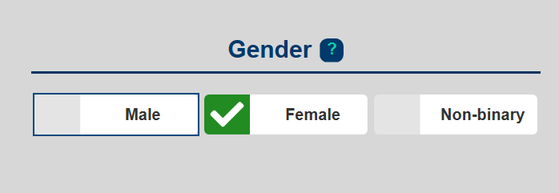

- Enter your date of birth. (OPTIONAL)
Example:
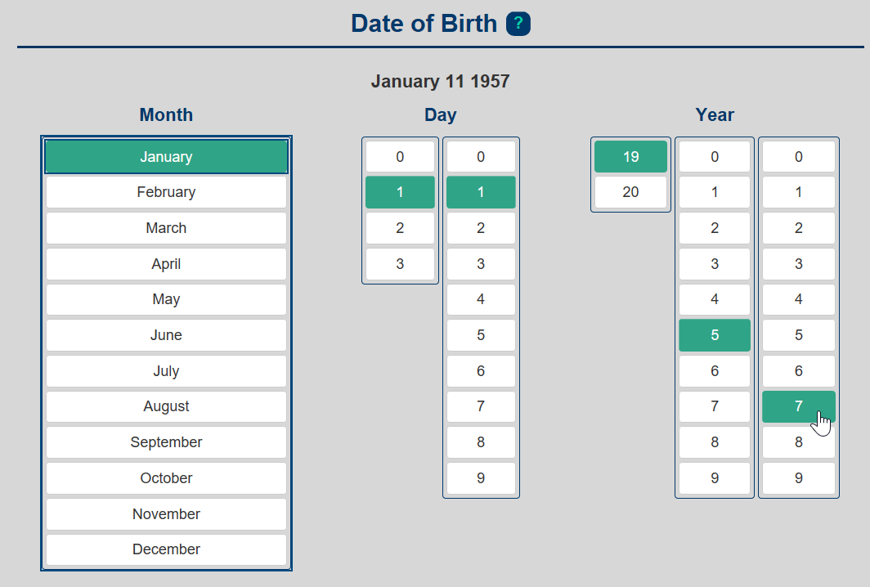

- Check your native language. (This is the first language you spoke at home.) (REQUIRED) Mark One. Example:

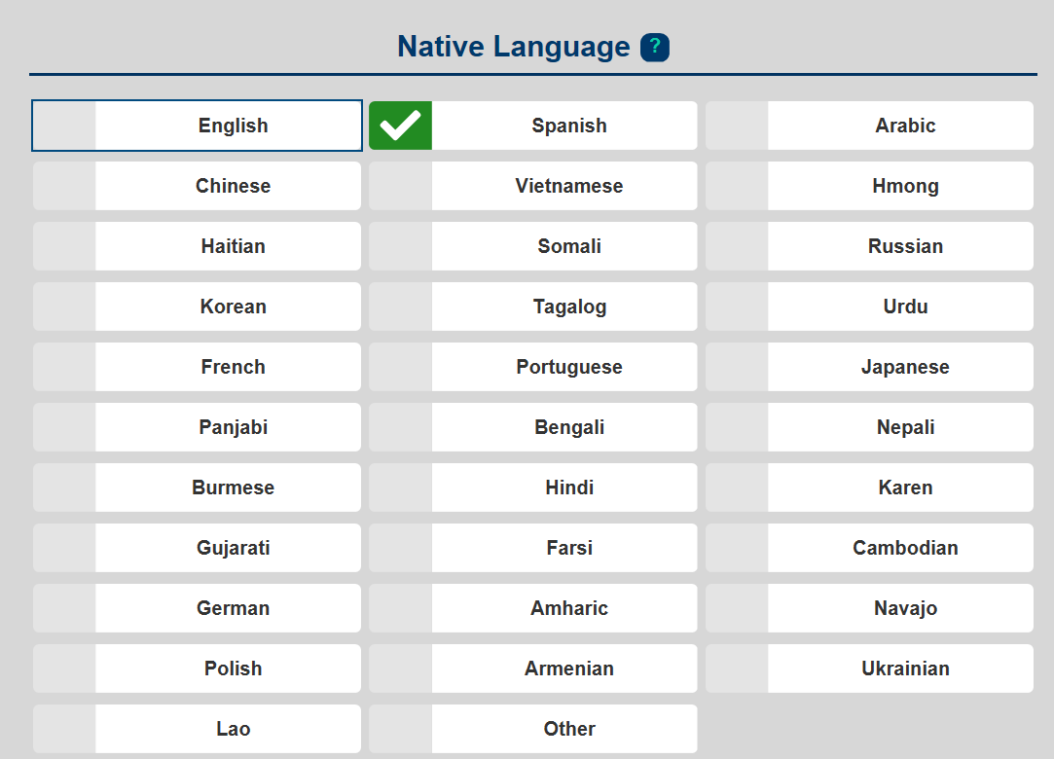

- Ethnicity. Mark One. (REQUIRED)
- Race. Mark one. (REQUIRED)
Example:

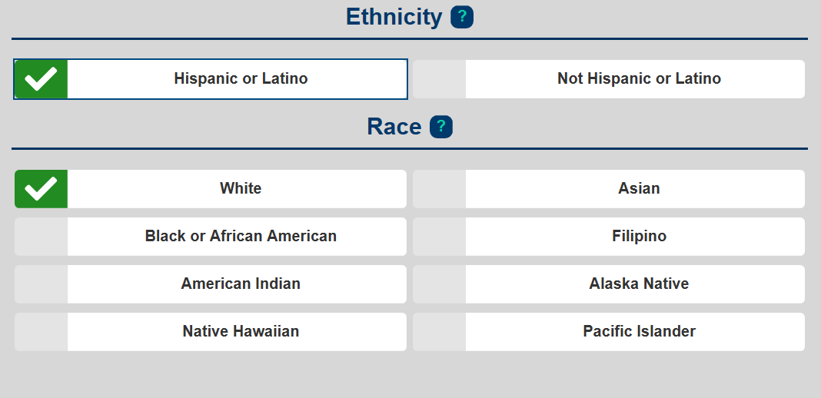

Review Page. Click SAVE.

